**Lesson 2: Java Lab**

**- class header** - consists of the class keyword and the name of the class

**- integrated development environment (IDE)** - a software application for writing, compiling, testing, and debugging program code

○ in our case, that would be Visual Studio Code

**- software** - a collection of instructions that is run by a computer

**- source code** - a collection of programming commands

**- syntax** - the rules for how a programmer must write code for a computer to understand

**- syntax error** - a mistake in the code that does not follow a programming language's syntax

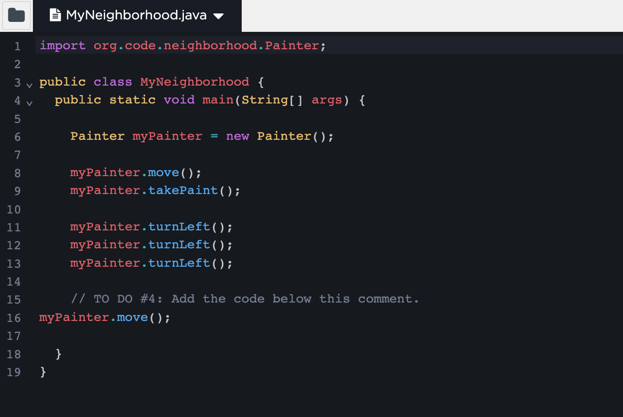

***Key Learnings from Lesson 2***

* made a class and object
* allowed the painter to move and take paint, then turn left
* in other words, learned how to use different methods on the object

**Lesson 3: The Neighborhood**

- **attribute** - a characteristic of an object

- **behavior** - an action that an object can perform

- **bug** - an error in the code

- **class** - a programmer-defined blueprint from which objects are created

- **constructor** - a block of code that has the same name as the class and tells the computer how to create a new object

- **debugging** - finding and fixing problems in an algorithm or program

- **instantiate** - to call the constructor to create an object

- **object** - an instance of a class

- **object-oriented programming** - an approach to creating and using models of physical or imagined objects

- **package** - a collection of similar classes

- **state** - the attributes of an object that are represented by its instance variables

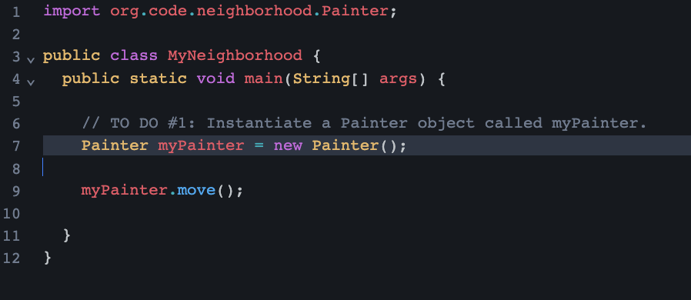

***Key Learnings from Lesson 3***

* Blueprints define the attributes and behaviors than an object can have and can analyze Painter
* Practiced creating Painter objects using the “new” keyword

**Lesson 4: Navigating and Painting**

- **Procedural Abstraction** - allows a programmer to use a method by knowing what the method does even if they do not know how the method was written

- **void method** - a method that performs an action but does not return a value

- **argument** - a value passed to a method or constructor when the method or constructor is called

- **dot operator** - used to call a method in a class

- **method** - a named set of instructions to perform a task

- **parameter** - a variable in the method or constructor signature that defines the type of value to receive when the - method or constructor is called

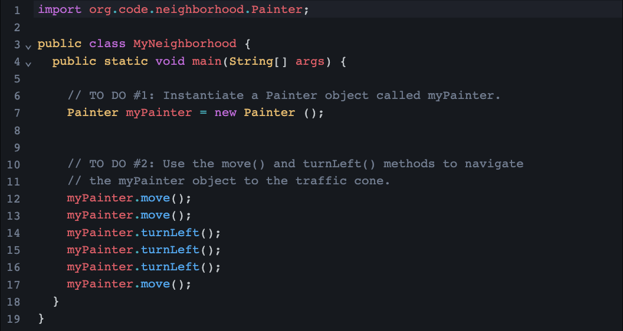

***Key Learnings from Lesson 4:***

* Painter class has methods to navigate and paint the neighborhood
* learned the syntax for calling methods
* learned to debug syntax errors

**Lesson 5: One-Way Selection Statements**

- **boolean** - a primitive data type that can be either true or false

- **if statement** - a conditional statement that only executes when the condition is true

- **condition** - determines whether or not to execute a block of code

- **conditional statement** - a statement that only executes when a condition is true

- **logic error** - an error that occurs when the code runs but does not do what was expected

- **return** - to exit a method and go back to the point in the program that called it with the requested value or information

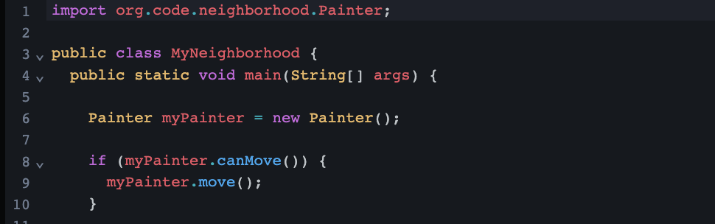

***Key Learnings from Lesson 5***

* learning to use conditional statements in java
* program can make decisions based on the current state of the Painter
* Identifying strategies for debugging

**Lesson 6: PainterPlus**

- **super keyword** - a keyword used to refer to the superclass

- **constructor signature** - the first line of the constructor which includes the public keyword, the constructor name, and the values to specify when an object is created

- **inheritance** - an object-oriented programming principle where a subclass inherits the attributes and behaviors of a superclass

- **subclass** - a class that extends a superclass and inherits its attributes and behaviors

- **superclass** - a class that can be extended to create subclasses

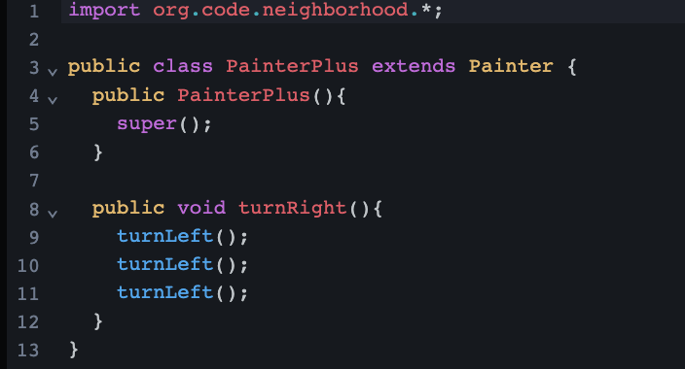

***Key Learnings From Lesson 6***

* needed to consider the need for designing specialized types of classes
* learned about inheritance to create a new type of Painter called PainterPlus
* learned how to add new behaviors to expand capabilities while using old

**Lesson 7: Writing Methods**

- **method signature** - consists of a name and parameter list

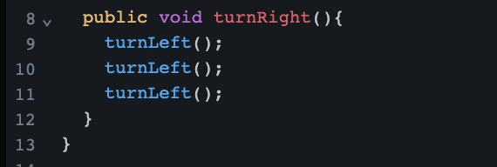

***Key Learnings from Lesson 7***

* write and use a new void method in Painter Plus
* new behaviors between superclasses and sunglasses to identity situations when to write new methods in the superclass versus in the subclass

**Lesson 8: Code Reviews**

- **code review** - the process of examining code and providing feedback to improve the quality and functionality of the program

- **comment** - a text note that is ignored by the compiler to explain or annotate the code

- **documentation** - written descriptions of the purpose and functionality of code

- **programming style** - a set of guidelines for formatting program code

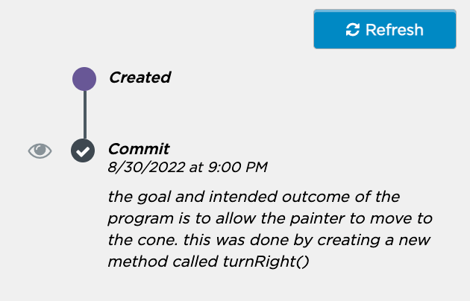

***Key Learnings from Lesson 8***

* // is comment for one line
* /* */ is for comments spanning multiple lines
* learning importance of code reviews to give and receive feedback

**Lesson 9: Loops**

- **while loop** - a control structure which executes a block of code repeatedly as long as a condition is true

- **algorithm** - a set of instructions to solve a problem or accomplish a task

- **control structure** - a conditional or iteration statement which affects the flow of a program

- **efficient** - getting the best outcome with the least amount of waste

- **infinite loop** - a loop where the Boolean expression always evaluates to true

- **iteration statement (loop)** - a control structure that repeatedly executes a block of code

- **pseudocode** - a plain language description of the steps in an algorithm

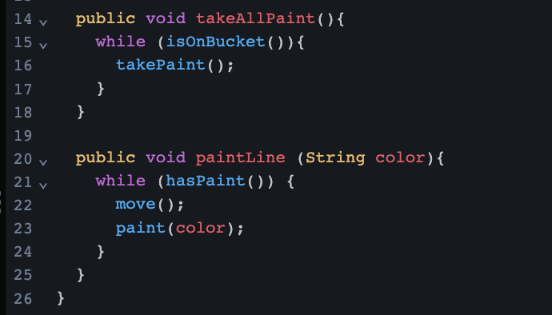

***Key Learnings From Lesson 9***

* selection statements to execute if the condition is true
* iteration using while loops
* developing algorithms using selection statements and iteration along with implement our own algorithms

**Lesson 10: Two-Way Selection Statements**

- **NOT ( ! ) operator** - a logical operator that returns true when the operand is false and returns false when the operand is true

- **if-else statement (two-way selection statement)** - specifies a block of code to execute when the condition is true and a block of code to execute when the condition is false

- **logical operator** - an operator that returns a Boolean value

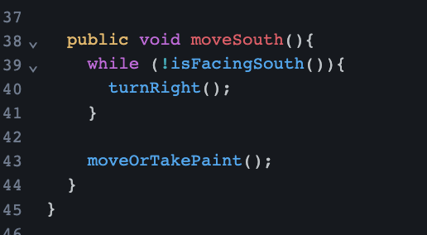

***Key Learnings from Lesson 10***

* expanded knowledge of selection statements and Boolean expressions to use two way selection statements
* NOT (!) logical operator
* checked the state of an object and executed a specific set of instructions

**Lesson 11: Debugging Strategies**

- **concatenation** - joining two strings together

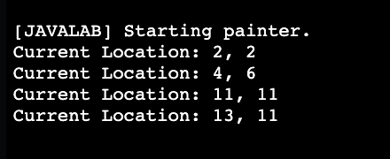

***Key Learnings From Lesson 11***

* learned to print information in console as debugging tool
* expand our PainterPlus to implement a new method that shows the state of the PainterPlus object
* troubleshoot other errors

**Lesson 12: Decomposition and Design**

- **Method Decomposition** - the process of breaking a problem down into smaller parts to write methods for each part

- **edge case** - a bug that occurs at the highest or lowest end of a range of possible values or in extreme situations

- **redundant code** - code that is unnecessary

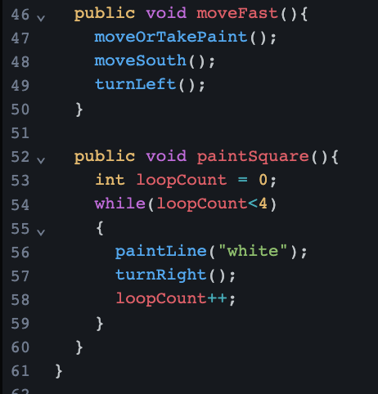

***Key Learnings From Lesson 12***

* learned to write pseudocode to plan algorithms
* Decomposition and top-down design to deconstruct problems into smaller tasks
* Translate algorithms into methods and consider edge cases to improve programs

**Lesson 13: PatternPainter**

- **inheritance hierarchy** - where a class serves as a superclass for more than one subclass

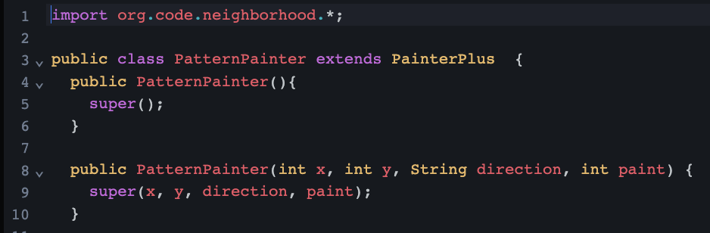

***Key Learnings From Lesson 13***

* creating new types of painters with special behaviors
* writing a new subclass that extends PainterPlus

practicing decomposition to develop new algorithms

**Lesson 14: Background Painter**

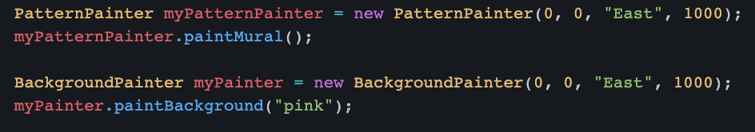

***Key Learnings from Lesson 14***

* creating a new additional subclass that extends PainterPlus
* practice using decomposition to develop algorithms
* multiple objects in order to reach goal and help the painter

**Lesson 15: Open Source Code**

- **open source code** - code that is freely available for anyone to use, study, change, and distribute

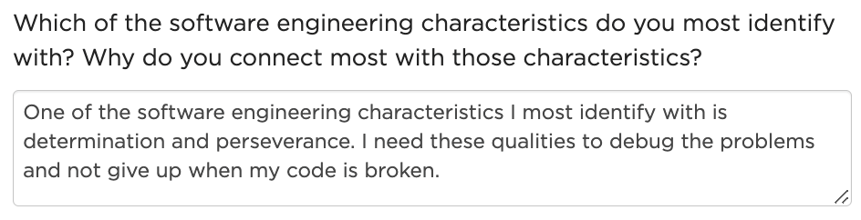

***Key Learnings from Lesson 15***

* examining open source code
* connect real world application and concepts we have learned throughout this unit
* review the characteristics of software engineers