Meeting Notes – 9th July 2026
Workflow
- run preprocessing script "preprocessing.py" -> normalises + log transforms data, applied feature reduction via highly variable gene selection
- output preprocessed data for models: rna_hvg.h5ad, protein_data.hvg, rna_data.hvg
- run model with spatially-aware cross-validation split: load this using the "cross_validation.py" file and the "cv_split.json" file
- evaluate model using pearson r, r², and RMSE – should have
- upload results and model on github

Models
- Ridge regression
- Lasso – Pallavi
- Random Forest – Shreya
- XGBoost – Emily
- MLP – Priya
- GNN – Vaishnavi

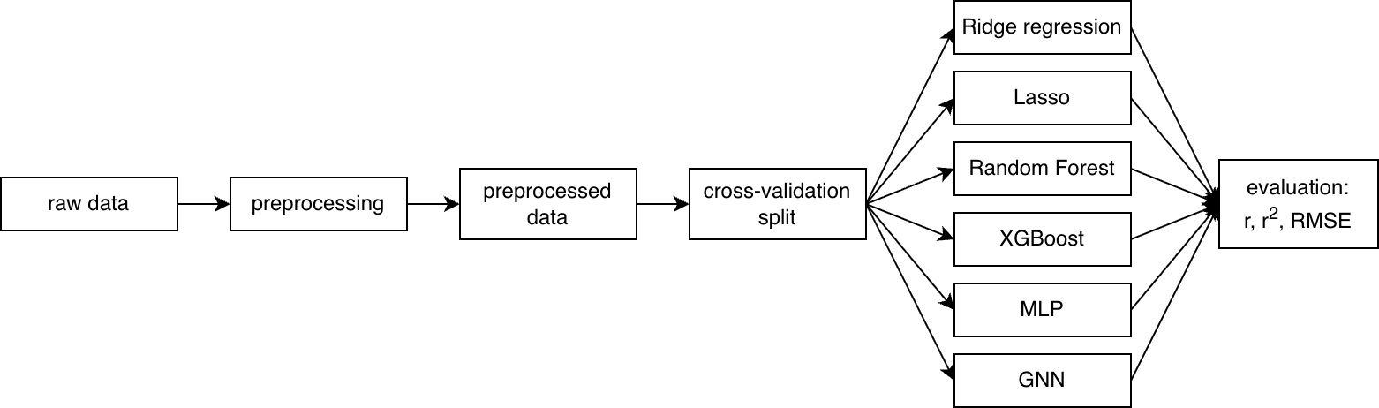

Next steps:
- Upload any results and models to GitHub
- Document model + parameter choices and upload to GitHub
- AWS access

