MediAid
AI-Powered Health Assistant
SDG 3: Good Health and Well-Being
1. Selected SDG and Reason for Selection
SDG 3 — Good Health and Well-Being
Selected Goal: SDG Goal 3 — Ensure healthy lives and promote well-being for all at all ages
Target Focus: 3.4 — Reduce premature mortality from non-communicable diseases by one-third by 2030

SDG 3 focuses on ensuring healthy lives and promoting well-being for people of all ages. It addresses major health challenges including non-communicable diseases (NCDs), mental health, universal health coverage, and access to essential medicines.
Non-communicable diseases such as diabetes, hypertension, cardiovascular disease, and cancer account for over 74% of all global deaths annually (WHO, 2023). A major contributor to poor outcomes in these diseases is low medication adherence — patients either forget to take medications, take incorrect doses, or stop treatment prematurely.
This issue is particularly severe in low- and middle-income countries including India, where:
- Over 77 million Indians live with Type 2 diabetes — the highest number globally
- 1 in 4 Indians over 25 years suffers from hypertension
- Medication adherence rates for chronic diseases in India are estimated at 40-50%
- Preventable hospital readmissions due to non-adherence cost the Indian healthcare system billions annually

MediAid directly addresses this gap by using AI to help patients track, manage, and understand their medications — empowering individuals to take charge of their health.

2. Problem Statement
Medication non-adherence is one of the most critical yet overlooked challenges in global healthcare management.

What is the problem?
Millions of patients with chronic diseases such as diabetes, hypertension, asthma, and heart disease fail to take their prescribed medications consistently and correctly. Studies show that approximately 50% of patients with chronic illnesses do not take medications as prescribed — leading to disease progression, complications, and preventable deaths.

Where does this problem exist?
This problem exists globally, but is most acute in India and other developing nations where:
- Health literacy is low — patients don't understand why consistent dosing matters
- Healthcare access is uneven — follow-up doctor visits are infrequent
- Reminder systems are absent — no digital or physical tracking tools for most patients
- Polypharmacy is common — elderly patients on 5+ medications struggle to manage schedules

Who is affected?
- Patients with chronic conditions (diabetes, hypertension, asthma, cardiac disease)
- Elderly individuals managing multiple medications
- Caregivers and family members of dependent patients
- Healthcare systems burdened by avoidable complications and readmissions

Why is this serious?
Medication non-adherence leads to disease worsening, emergency hospitalizations, irreversible organ damage, and premature death. The World Health Organization estimates that improving adherence would have a greater impact on global health than any new medical discovery. In India alone, diabetic complications from poor medication management contribute to over 77,000 amputations per year.

What happens if this is not solved?
Without intervention, the chronic disease burden will continue to grow. By 2045, India is projected to have 134 million diabetics. Poor adherence will accelerate complications, overwhelm the public health system, reduce quality of life for millions, and dramatically increase healthcare costs.

3. Proposed Solution — MediAid
MediAid is an AI-powered web application designed to help patients with chronic conditions manage their medications, track vital signs, monitor adherence, and receive intelligent health guidance — all in one accessible platform.

How the system works
Medication Tracking  Patients log their medications once. The system tracks every dose against the schedule and flags missed doses automatically. | AI Health Assistant  A conversational AI chatbot answers medication questions, explains side effects, and provides personalized wellness tips.
Vitals Monitoring  Patients log blood pressure, glucose, heart rate, and weight. The system charts trends and alerts on abnormal readings. | Insights & Adherence Analytics  AI analyzes patterns and generates personalized recommendations to improve consistency and health outcomes.

Who will use this application?
- Patients with chronic conditions — primary users for daily tracking
- Caregivers — monitoring family members remotely
- General public — for wellness tracking and health education
- Community health workers — supporting patients with low digital literacy

4. Project Features

Feature 1: Dashboard
The main dashboard gives users a real-time overview of their health status. It shows today's medication schedule, adherence percentage, key vitals, and an AI-generated health tip. A streak counter motivates consistent behavior. Missed doses trigger a visible alert banner with a one-click mark-as-taken action.

Feature 2: Medication Manager
Users can add, view, and manage all their medications in one place. Each entry stores the medication name, dosage, frequency, timing, and purpose. The system checks for potential drug interactions using AI analysis and warns users if conflicts exist. A clean form interface makes adding new medications quick and intuitive.

Feature 3: Vitals Tracker
Patients can log blood pressure, blood glucose, heart rate, and BMI readings. The system displays a 7-day trend chart for blood pressure, showing systolic and diastolic values over time. Each vital is tagged with a status indicator (normal, elevated, critical) based on WHO reference ranges. Users can quickly log new readings with a streamlined form.

Feature 4: AI Health Assistant Chatbot
An intelligent conversational AI assistant helps users understand their medications, learn about side effects, and get wellness advice. The assistant is powered by natural language processing and has contextual awareness of the patient's medication profile. Pre-built quick-action chips allow users to ask common questions without typing. All responses include a disclaimer to consult a qualified healthcare professional.

Feature 5: Health Insights & Analytics
The insights page visualizes adherence trends over 6 months using an interactive bar chart. It shows total doses taken, best streaks, and an overall health score. An AI recommendation engine analyzes behavioral patterns and generates 3 personalized tips per session — such as adjusting reminder times, increasing hydration, or recommending light exercise — based on the patient's own data patterns.

Feature 6: Drug Interaction Check
When viewing the medication list, the AI system checks all current medications against a known interaction database and flags any combinations that may be harmful. This feature is especially valuable for elderly patients on multiple medications (polypharmacy) who may not realize certain combinations are risky.

5. Technology Stack
Category | Technology
Frontend | HTML5, CSS3 (CSS Variables, Grid, Flexbox), Vanilla JavaScript
AI / NLP | Claude API (Anthropic) — claude-sonnet-4-6 model for conversational AI
Data Visualization | Chart.js (v4.4) — line charts for vitals, bar charts for adherence trends
UI Icon System | Tabler Icons (webfont, 5800+ outline icons)
Deployment | Static web app — deployable on GitHub Pages, Netlify, or Vercel
Version Control | Git + GitHub (open-source repository)
Architecture | Single-page application (SPA) with modular JavaScript
Accessibility | ARIA labels, semantic HTML, screen-reader support, keyboard navigation

6. Application Screenshots
The following screenshots demonstrate the working prototype of MediAid across all major features:

Screenshot 1 — Dashboard
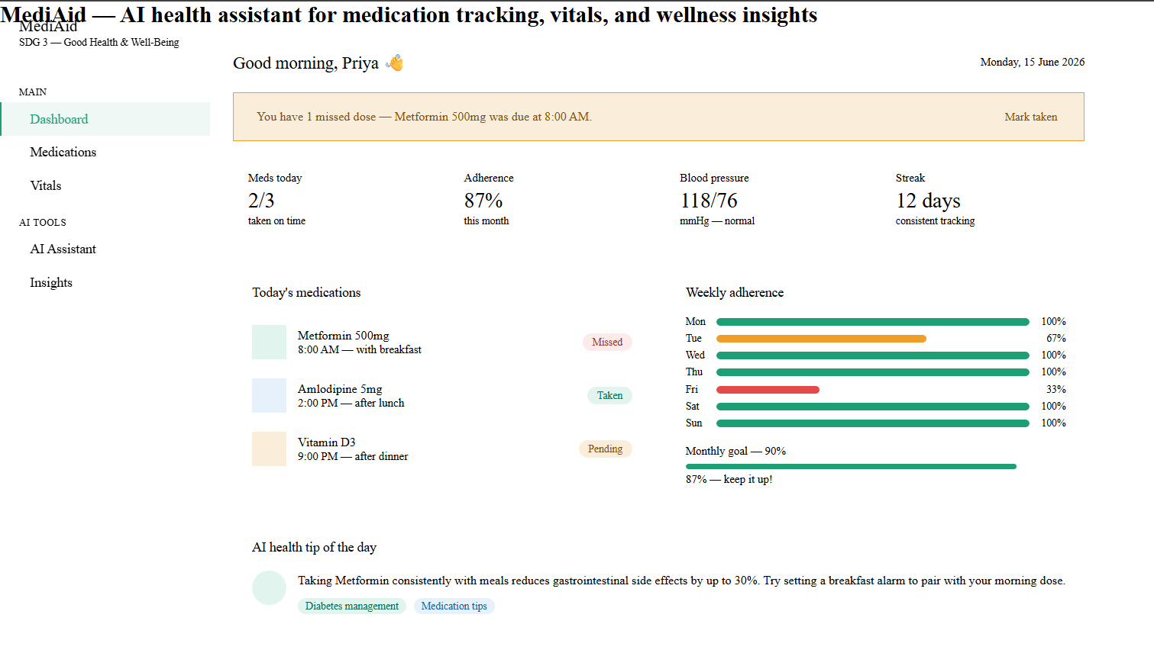Shows: Patient greeting, medication adherence metrics, today's dose schedule, missed dose alert, weekly adherence bar chart, and AI health tip of the day.

Screenshot 2 — Medication Manager
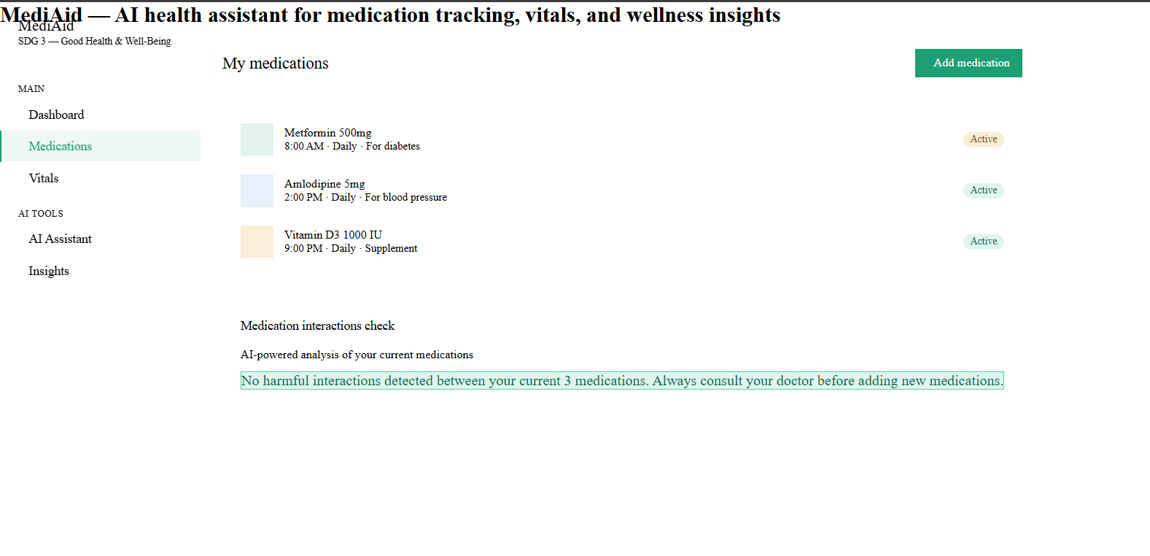
Shows: Full medication list with dosage, timing, and status badges. Add medication form with fields for name, frequency, time, and purpose. AI drug interaction status panel.

Screenshot 3 — Vitals Tracker
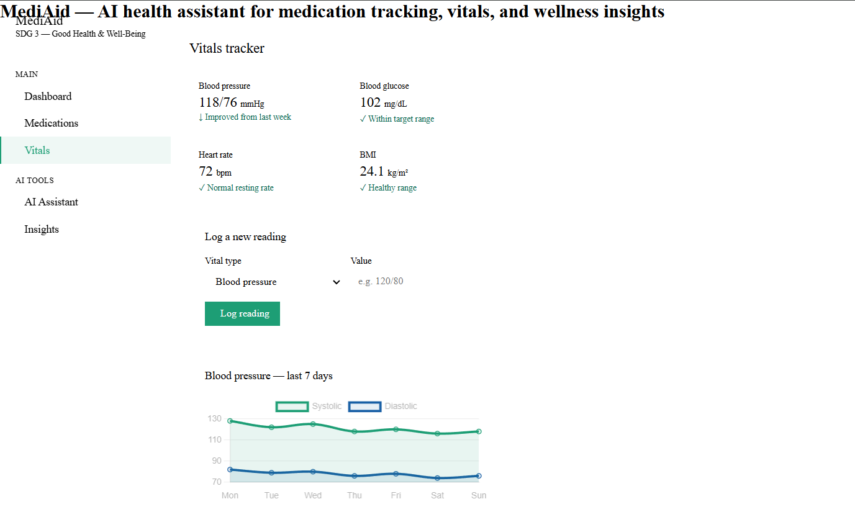
Shows: Vital sign metric cards (blood pressure, glucose, heart rate, BMI), log a new reading form, and 7-day blood pressure trend chart.

Screenshot 4 — AI Assistant Chatbot
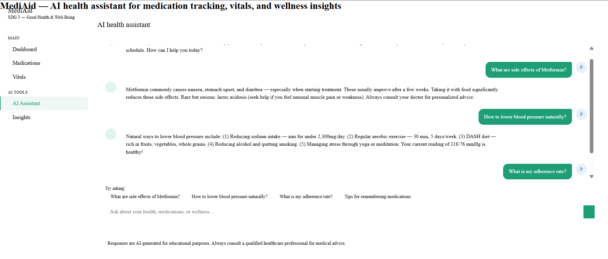
Shows: Active conversation with the AI health assistant. User asked about Metformin side effects. AI provides contextual, safe response with a healthcare disclaimer. Quick-action chips visible.

Screenshot 5 — Insights & Analytics
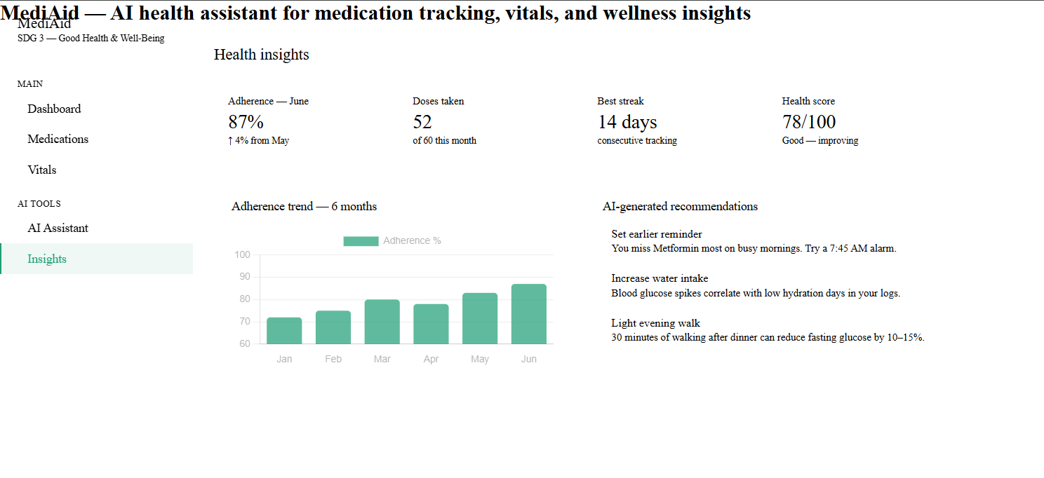Shows: 6-month adherence trend bar chart, health score summary cards, and 3 AI-generated personalized health recommendations based on user behavior patterns.

7. Future Scope
MediAid v1.0 is a working prototype. The following enhancements are planned for future versions:

Short-term improvements (3-6 months)
- Push notifications — SMS and WhatsApp reminders for missed doses using Twilio API
- Backend database — Firebase or Supabase for persistent data storage across sessions
- User authentication — Secure login, family/caregiver account linking
- Doctor dashboard — Allow physicians to view patient adherence reports remotely
- Multilingual support — Hindi, Marathi, Tamil, Telugu for broader accessibility

Medium-term improvements (6-18 months)
- Mobile application — Native Android and iOS apps using React Native for better accessibility
- Wearable integration — Connect with fitness trackers (Fitbit, Apple Watch) for automatic vitals logging
- Hospital system integration — HL7 FHIR API to pull prescriptions directly from hospital records
- AI prescription scanner — Use computer vision to scan and digitize handwritten prescriptions
- Offline mode — Progressive Web App (PWA) functionality for areas with limited internet

Long-term vision (18+ months)
- Predictive health modeling — AI models that predict disease deterioration risk based on adherence and vitals patterns
- Community health worker portal — Enable CHWs to manage and monitor populations of patients
- Government health scheme integration — Link with Ayushman Bharat PMJAY for subsidy-linked medication tracking
- Clinical trials module — Anonymized aggregate data (with consent) shared with researchers for population health insights
- AI-powered symptom checker — Triage feature to help users decide when to seek emergency care

