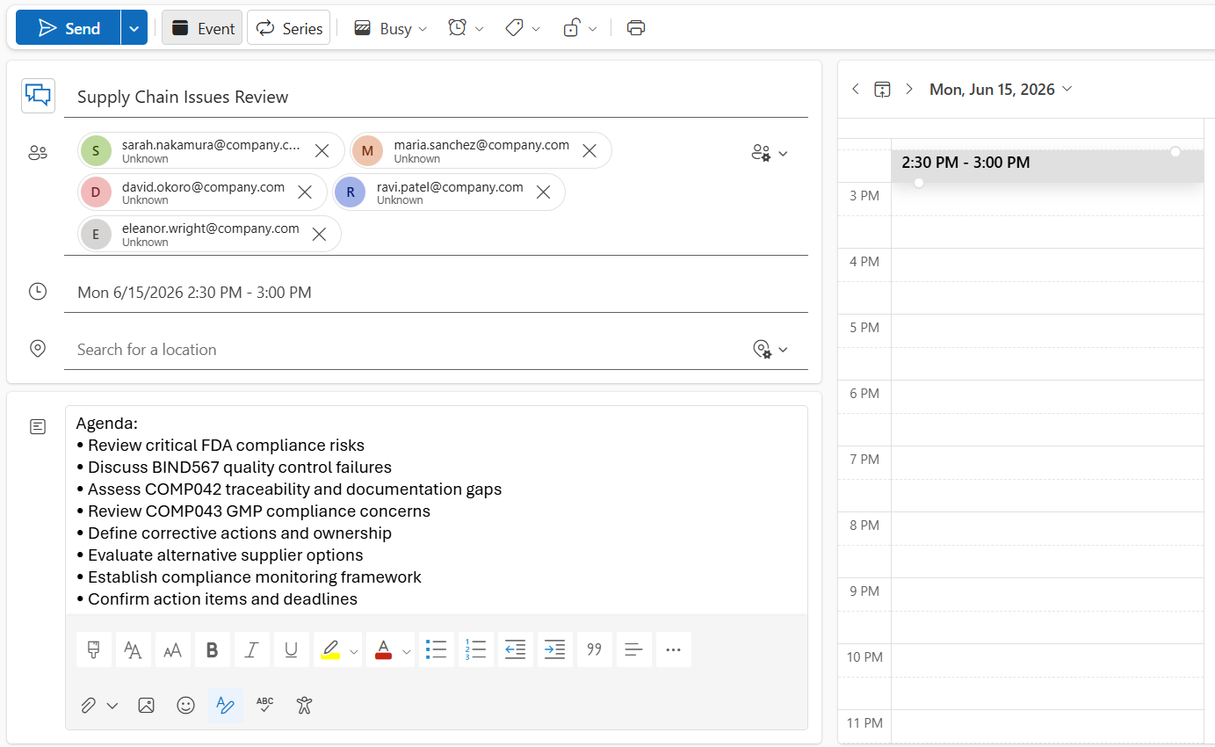
Meeting Title
Supply Chain Issues Review
Meeting Purpose
Review critical supply chain issues affecting FDA compliance and production continuity and establish corrective actions.
Key Discussion Points
BIND567
- Quality control failures due to molecular inconsistencies.
- Product stability concerns.
- Rejection rate approaching 18%.
- Need for immediate batch validation and tighter controls.
COMP042
- Shipment delays and incorrect lot numbers.
- Documentation and traceability deficiencies.
- Compliance risks related to material origin verification.
- Need for supplier audit and corrective actions.
COMP043
- Supplier GMP non-compliance.
- Contamination risks.
- Frequent stockouts and delivery instability.
- Need for remediation and alternative sourcing.
Decisions Made
- Validate all current BIND567 inventory.
- Conduct an audit of PrimeLogistics processes.
- Document traceability gaps for FDA review.
- Develop a remediation plan for COMP043 supplier.
- Initiate parallel sourcing activities.
- Establish a cross-functional oversight team.
Assigned Responsibilities
Action | Owner
Validate BIND567 batches | David Okoro
Source alternative supplier for BIND567 | Ravi Patel
Audit PrimeLogistics | Ravi Patel
Document traceability gaps | Maria Sanchez
Coordinate GMP remediation | Maria Sanchez
Initiate parallel sourcing | Ravi Patel

