MIE354 - Assignment 2 - Coorest
Shreya Perumal
Anjali Jammulamadaka

Declaration of Generative AI Usage
“In submitting this Assignment 2, I confirm that the work I am submitting is the exclusive work of the students in my group, and that I made an equal contribution to the work of the group. I confirm that my conduct during this Assignment 2 adheres to the Code of Behaviour on Academic Matters. I confirm that I am abiding by the course policy regarding the use of Generative AI tools and that I did NOT act in such a way that would constitute cheating, misrepresentation, or unfairness, including but not limited to, using unauthorized aids and assistance, impersonating another person, and committing plagiarism. I pledge upon my honour that I have not violated the Faculty of Applied Science & Engineering’s Honour Code during this assessment.”

Course Policy
“Students are encouraged to make use of Generative artificial intelligence tools (e.g., Copilot, ChatGPT, or any other similar tool) to contribute to their understanding of course materials and to complete coursework submission in compliance with the general course instructions and any additional instructions provided in the coursework handouts. Students are ultimately accountable for the work they submit. The general instructions are that students must declare in their submissions the Generative AI tools that have been used and include a summary of how the tools have been used. Using Generative AI tools and failing to follow the required instructions can result in an "unauthorized assistance" academic offence.”

Release Statement
“I agree to make available my work developed through the course Assignments (not including my student name) for educational purposes.”

Files in Submission G04.zip
- G04-ChDescription.docx - Report about Choreography
- G04-ChModel.vsdx - Visio of Business Choreography

Table of Contents
1.0 Choreography Objectives, Scope, and Participants 3
1.1 Choreography Objectives 3
1.2 Choreography Scope 3
1.3 Choreography Participants 4
2.0 Textual Description of the Choreography 5
3.0 Choreography Diagram 6
4.0 Resource Classification Description 7
5.0 Activity Table 7
6.0 Registry Blockchain Smart Contract Justification 9
7.0 Generative AI Documentation 9

1.0 Choreography Objectives, Scope, and Participants
The following section is broken into three sections: choreography objectives, scope, and participants, providing a brief introduction and background on the choreography described in the report.

1.1 Choreography Objectives
The choreography described in this report models the interactions between Coorest and its participants to issue, verify, and transfer carbon tokens. Coorest’s primary objective is to improve accessibility and trust in carbon-token purchasing by automating and streamlining the purchase and trading process through NFTrees. Specifically, this choreography aims to:
- Automate carbon-token purchase and verification
- Accurately map NFTrees to real geographic carbon data
- Guarantee secure data transmission and storage
- Leverage smart contracts to facilitate token ownership and transferability
- Maintain carbon transparency
Coorest enhances transparency and credibility in the carbon market by replacing manual verification and record-keeping with an automated, blockchain-based process. The choreography ensures that carbon-offset purchases, NFTree creation, and registry updates occur through the secure and verifiable collaboration of many independent participants. The choreography models interactions among Coorest, PolygonPOS Blockchain, FileCoin Storage, Chainlink Oracle, Registry Blockchain Smart Contract, NFTree Customers, and Carbon Token Buyers, all of which support their objectives.

1.2 Choreography Scope
The scope defines the bounds of the choreographies outlined in the following report. The choreographies will focus on the interactions between Coorest and its main participants in completing the main processes required in the cycle of an NFTree. Below is the process of interest, defining the scope of the report.
- NFTree Purchasing: NFTree customers submit purchase requests for NFTrees that produce carbon tokens based on the carbon mitigation of real trees.
- Carbon Data Validation: PolygonPOS validates the carbon mitigation data supplied to Coorest by Chainlink Oracle and issues tokens.
- NFTree Creation and Minting: Planted trees are added to a registry where they are immutable and are minted with their own unique identities.
- Data Storage: FileCoin is used to store information like carbon data, token/tree ownership, NFTree data and token transferring.
- Registry Recording: Updating the registry NFTrees as they are planted and initialized.
- Token Ownership and Transfer: blockchain facilitates transparent ownership and transfer.
The scope of the report will exclude processes related to organizational logistics of participants, government policy & licensing, and other activities not directly related to the Coorest Registry.

1.3 Choreography Participants
The choreography for the Coorest system involves seven participants, each representing an entity that contributes to the processes (outlined in the scope) of the Coorest system. Each of the participants outlined below is a unique independent entity, and they each communicate with one another in processes.

Participant 1: Coorest
Coorest is responsible for coordinating all the activities related to the NFTree lifecycle. They are responsible for initiating, managing, and verifying carbon-token transactions. They receive purchase requests from NFTree Customers, validate payment, and carbon-offset data and trigger smart contracts with other participants like the Polygon PoS Blockchain to mint NFTrees. Coorest has contracts with Chainlink Oracle as well to verify satellite data and FileCoin to store metadata. In terms of the choreography, Coorest directs the process and ensures that all required verifications occur prior to registry, and each NFTree is linked to authentic carbon data.

Participant 2: PolygonPOS Blockchain
PolygonPOS Blockchain is responsible for executing transactions within the system. It mints new NFTree tokens and records transaction data in the blockchain. Polygon enables token creation, ownership tracking and transfer, and secure transfer between participants. Transactions are permanently logged, ensuring security, transparency, and authenticity.

Participant 3: FileCoin Storage
FileCoin is responsible for the data storage of the Coorest process, for all data associated with NFTrees. This data can include satellite carbon sequestration data, ownership information, and sales from the tree, among other details. FileCoin returns unique identifiers used in the PolygonPOS and smart contract, linking NFTrees to the data. FileCoin supports data longevity and accessibility.

Participant 4: Chainlink Oracle
Chainlink Oracle is responsible for determining and verifying the link between the blockchain and the real-world impact of the NFTrees. The participant gathers environmental data such as carbon-sinking statistics and satellite data. Once information is verified, Chainlink Oracle provides input to Coorest’s smart contract, enabling the automation. In the choreography, Chainlink Oracle is integral in ensuring the accuracy of data dependencies in the process.

Participant 5: Registry Blockchain Smart Contract
The Registry Blockchain Smart Contract is a record of all NFTrees. It keeps track of all trees and tokens, and is linked to the associated filecoin that holds additional information, such as ownership. The registry is a trustworthy information source for all participants.

Participant 6: NFTree Customer
The NFTree customer is the person who purchases the NFTrees and gets the carbon tokens each tree produces. The customer initiates the process when they submit a purchase request through Coorest and provide data such as the desired token and payment information. Post verification and minting, the customer receives an NFTree token as proof of carbon offset. In the choreography, this participant initiates the process.

Participant 7: Carbon Token Buyer
A carbon token buyer is someone trying to purchase carbon tokens from previous owners. This participant must interact with the Polygon POS Blockchain and Registry to execute token transfers. Token buyers create a market in the system, which makes tokens circulate among multiple owners. In the choreography, token buyers are often at the end of the token lifecycle, as they will purchase tokens to settle their own carbon offset or burn them.

2.0 Textual Description of the Choreography
The choreography begins when an NFTree customer submits a project request to Coorest. Coorest then performs a validation check on the data submitted. If the data is invalid, then Coorest sends a message back to the NFTress customer requesting the corrected data. This process implements a “receive pattern with message buffering” where the resubmissions are queued until Coorest’s automated validation is ready to receive them. If validation is successful, Coorest will register the project with the Registry Blockchain Smart Contract using a “send pattern with a binding time”. The message has a call to “register(key, address)” where the key follows a format of “project:PRJ[ID]:owner”. The binding time is runtime since the address is fixed, but the project key is generated once the project passes validation.

Once a project is registered and trees have grown, Coorest then begins the dMRV (data Monitoring, Reporting, and Verification) process to measure carbon capture. This demonstrates a “one-to-many send pattern” since Coorest sends data collection requests to 3 independent sources: Chainlink Oracle for satellite data, a field sensor network, and local reporting agents. These 3 collectors operate independently and implement a “one-from-many receive pattern” since Coorest waits until all 3 sources provide their data before proceeding.

Coorest performs a plot verification process to ensure all plot data is valid. If the data shows any inconsistencies, the process implements a”multi-responses pattern” where Coorest then requests additional data from field sensors until sufficient data is collected to remove any inconsistencies, and then the plot is validated. The complete and validated dataset is then stored in Filecoin Storage. The dMRV Verification process depicts a combination of the service interactions that work together: “one-to-many send” for parallel data collection requests, “one-from-many receive” for the synchronization of all responses, “multi-responses”, and “multi-instance subprocess”.

When the dMRV Verification confirms the carbon capture, Coorest calculates the total verified carbon amount and initiates token generation. This then implements a “relayed request pattern” where Coorest sends a token minting request to the Registry Blockchain Smart Contract. The Registry will validate the request and relay this to Polygon PoS, which mints the carbon credit token and sends confirmation back through the Registry. The Registry then sends a final confirmation back to Coorest. The tokens are registered with the key format “token:CO2-NFT-[TOKEN_ID]:owner”. Coorest publishes the token data and verification report to Filecoin Storage and then notifies the NFTree Customer through the investor portal.

When a Token Buyer wants to either retire or acquire carbon credits, they will submit a request to Coorest. This implements a “racing incoming messages pattern” where the process waits for the first message to arrive between a transfer request or a retirement request. The process path is determined by which message arrives first, since this is a deferred choice. Coorest will verify the token ownership on the Registry Blockchain Smart Contract utilizing “isRegister(tokenKey)”. If it is a transfer request, Coorest will utilize “transfer(tokenKey, newOwnerAddress) on the Registry. This updates the ownership record and causes a transfer on Polygon PoS to move the token to the new owner’s wallet. If it is a retirement request, Coorest utilizes “unregister(tokenKey) on the Registry. The Registry will mark the token as retired and tell Polygon PoS to burn the token. A retirement certificate is then issued to the buyer.

3.0 Choreography Diagram
The images below show the High-Level Structure Model and the High-Level Behavioural Model created in Visio.
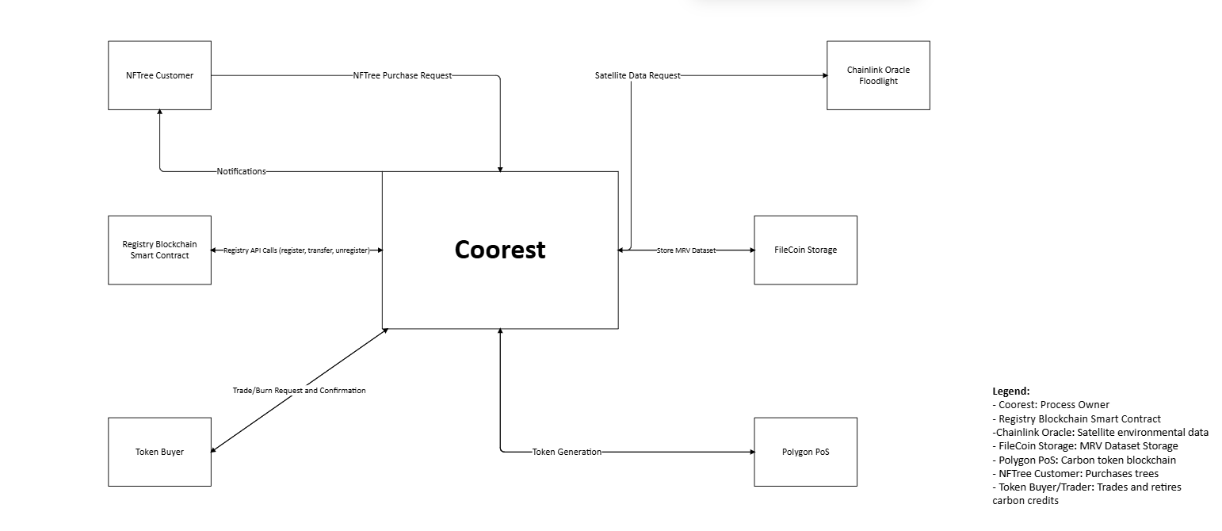
Figure 1: High-Level Structure Model

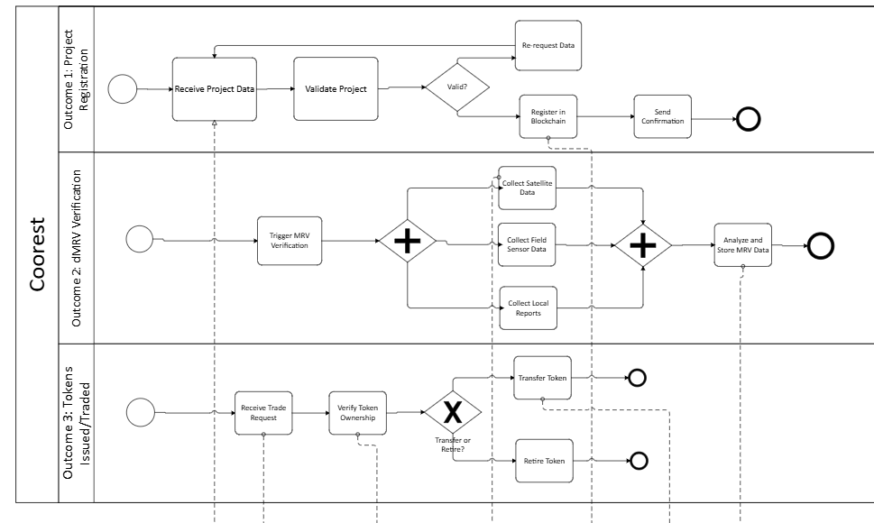
Figure 2. High-Level Behavioral Model

4.0 Resource Classification Description
The resources classification can be broken down into three main groups: organizational, external, and software resources. Organizational resources are those that perform internal business operations, external resources are independent systems that occur outside of the main business and software resources are technical items that enable interactions between organizational and external resources. The table below shows the breakdown of each of the resources into its respective category and sublane/pool.
Resource Classification of Coorest
Organizational Resources | External Resources | Software Resources
Main Pool: Coorest | Pool 1: Chainlink Oracle | API Registry Package
Sublane 1: Registry Management | Pool 2: FileCoin Storage
Sublane 2: dMRV | Pool 3: Polygon POS Blockchain
Sublane 3: Token & Issuance

5.0 Activity Table
The activity table detailing the events of the BPMN Choreography created in Visio are outlined below.
Activity Name | Description | Resources | Data Object
Receive Project Proposal | Receive Project Submission | Coorest | Project Proposal
Validate Project Data | Check if project data is valid. If invalid, return back to be processed | Coorest | Automated Validation System
Re-request Data | Sends message to customer requesting the corrected submission data | Coorest
Call Registry: register() | Store project record on blockchain | Registry Blockchain Smart Contract
Collect Satellite Data | Request environmental data from Chainlink Oracle | Coorest | Satellite Data
Collect Field Sensor Data | Gather MRV Data | Coorest | Field Sensor Data
Collect Local Reports | Collect data from local reports | Coorest | Local Data
Aggregate and Analyze MRV Data | Combine data from sensors and satellite to compute carbon metrics. If the data is invalid, loop back to data collection | Coorest
Plot Verification | Verification subprocess for individual plot | Coorest
Compute per Plot Carbon Amount | Calculate carbon capture for the verified plot | Coorest
Return to collect field sensor data | If plot is inconsistent, request more data | Coorest
Compose Verified MRV Report | Create a report of the final verified data for token issuance | Coorest
Store MRV Dataset | Upload data to Filecoin for storage | Filecoin | MRV dataset
Relay Request to Polygon PoS | Forward minting request from Registry to blockchain | Registry Blockchain Smart Contract
Generate Carbon Tokens | Generate tokens on Polygon PoS based on the verified MRV report | Polygon PoS | Carbon Tokens
Notify Investor Portal | Send a notification to NFTree customer of token generation | Coorest
Verify Token Ownership | Confirm current owner matches blockchain records | Registry Blockchain Smart Contract | Carbon Tokens
Transfer Carbon Tokens | Transfer tokens to new owner using transfer(tokenKey, newOwner) | Polygon PoS, Registry Blockchain Smart Contract | Carbon Tokens
Retire Carbon Tokens | Unregister the tokens when the carbon offset is retired using unregister(tokenKey) | Polygon PoS, Registry Blockchain Smart Contract
Record Retirement Proof | Document the proof of carbon token retirement in Coorest’s system | Coorest | Retirement Proof

6.0 Registry Blockchain Smart Contract Justification
In the Coorest choreography, a blockchain is used to keep all verified tree and token data records immutable and accessible to all participants involved. The blockchain supports operations like register(), transfer(), unregister(), and ensures all ownership, transactions and verifications across the system. Each of the operations in the blockchain makes the system synchronized and secure. The blockchain anchors the registry and keeps a truth ledger connecting the systems together. The setup also prevents duplication of carbon assets and provides a clear transaction log for all carbon tokens. Without the blockchain registry to support component coordination, the operation would not run as seamlessly.

7.0 Generative AI Documentation
REVISION 1 PROMPT
Prompt: I need you to read over my document and compare with the given rubric as if you have no prior knowledge related to it. Draft from November 9th given as well as rubric.

Response:
T-OS – Choreography Objectives and Domain Scoping
✅ Met.
The objectives are clearly stated: automation, data mapping, security, smart contracts, transparency.
Scope boundaries are defined (inclusions and exclusions).
→ Very complete and clearly written.

T-P – At least 4 participants (including blockchain)
✅ Met.
You list 7 participants, including PolygonPOS Blockchain and Registry Blockchain Smart Contract.
Each role is clearly explained.

TP-GAI – Declaration of Generative AI usage
❌ Missing.
There is no section declaring the use (or non-use) of generative AI tools, prompts, or outputs.
→ You must explicitly include a short section (e.g., “No generative AI tools were used in the completion of this report.”).

T-RC – Resource Classification
✅ Partially Met.
You provided organizational, external, and software resource classifications in a table-like format.
However:
- Formatting is unclear (the table layout appears lost in text).
- Some pools/sub-lanes lack clear linkage to resource type rationale.
→ Needs reformatting into a clear 5-column table (Resource | Description | Category | Pool | Sublane).

T-AT – Activity Table
✅ Met.
The table lists activity names, descriptions, resources, and data objects.
However:
- Some rows have blank “Data Object” entries.
- Formatting is text-based rather than tabular.
→ Functionally correct but presentation could be improved.

T-BRJ – Blockchain Registry Justification
✅ Met.
You justify the registry blockchain as necessary for synchronization, immutability, and trust.
→ Clear and relevant.

T-BRK – Key Description Examples
❌ Missing.
The rubric requires two concrete examples of key string contents used in the registry (e.g., "tokenKey: NFTree#001-2025-CA").
→ You need to add an explanation of what keys look like and what information they encode.

T-HSM – High-Level Structure Model
⚠️ Not Present.
No high-level structure model (diagram or textual equivalent) is included.
→ You must include a diagram (or textual explanation of pools, sublanes, and message flows at a high level).

T-HBM – High-Level Behavioural Model
⚠️ Not Present.
Your text gives a narrative, but not a high-level behavioural model with outcomes/gateways.
→ Include a BPMN-like overview or summarized behavioural flow.

T-SB – Send Pattern Binding
✅ Met.
You correctly describe a “send pattern with a binding time” for register(key, address) at runtime.

T-RB – Receive Pattern Buffering
✅ Met.
You describe a “receive pattern with message buffering” for customer data resubmissions.

T-SRC1, T-SRC2 – Send/Receive with Correlation
✅ Met (1 or 2 depending on group size).
Your text clearly includes multiple SIPs with correlation (e.g., Coorest–Registry–Polygon interactions).
→ Sufficient for a 2-person group.

T-OTMS, T-OFMR, T-OTMSR, T-AMN – Communication Patterns
✅ Met (at least 3 described).
You describe:
- One-to-many send (Coorest to 3 data sources)
- One-from-many receive (data collection)
- No explicit OTMSR or AMN, but coverage is sufficient for a 2-person group.

T-MR, T-RIM, T-CR – Response Patterns
✅ Met.
- Multi-response: field sensors for inconsistent data
- Racing incoming messages: token transfer vs retirement
→ Covers at least two as required.

T-RR, T-RWR – Relay/Referral
✅ Met.
You describe a relayed request pattern during minting via Registry → Polygon.
→ Meets one required pattern.

T-C1, T-C2 – Combined SIP Situations
⚠️ Partially Met.
The text implies combinations (e.g., send + receive + relay in token minting) but not labeled explicitly as a combination pattern.
→ You should clearly identify one or two combined SIP cases.

Summary Evaluation (Textual Section Only)
Rubric Criterion | Status | Comments
T-OS | ✅ | Clear objectives and scope
T-P | ✅ | 7 participants, includes blockchain
TP-GAI | ❌ | Missing AI declaration
T-RC | ⚠️ | Present but weak formatting
T-AT | ✅ | Complete but could improve table layout
T-BRJ | ✅ | Strong justification
T-BRK | ❌ | Missing key string examples
T-HSM | ⚠️ | Missing structure model
T-HBM | ⚠️ | Missing behavioural model
T-SB | ✅ | Present (“send pattern with binding time”)
T-RB | ✅ | Present (“receive pattern with buffering”)
T-SRC1/2 | ✅ | Covered
T-OTMS/OFMR/etc. | ✅ | Covered (3 patterns)
T-MR/RIM/CR | ✅ | Covered
T-RR/RWR | ✅ | Covered (relayed request)
T-C1/C2 | ⚠️ | Implicit, not explicit

Overall Impression
Your submission demonstrates strong technical understanding and meets most textual rubric requirements for MIE354 A2.
However, to meet the rubric fully and score top marks:
- Add AI usage declaration.
- Add examples of registry keys (T-BRK).
- Include high-level structure and behavioural models.
- Reformat resource classification and activity table for clarity.
- Explicitly label combined SIPs (T-C1/C2).

REVISION 2 PROMPT
Prompt: try and analyze the model with the rubric too please
Responses:
🧭 Overall evaluation (Part 2 – BPMN for Detailed Collaboration Scenarios and SIPs)
Rubric item | Status | Commentary
B-OM – Overall model readability | ✅ Met | Lanes, sub-lanes, and message flows are clear. The legend at the bottom defines participants, and the diagram avoids clutter. A few labels are slightly rotated or condensed, but overall structure is readable and consistent.
B-AN – Correct use of Annotations | ✅ Met | Each SIP (e.g., Send Pattern with Binding Time, Receive Pattern with Message Buffering, Multi-responses, Racing Incoming Messages) is group-annotated. Excellent explanatory callouts.
B-DA – Correct use of Data Objects and associations | ⚠️ Partially Met | Data objects such as MRV Dataset and Project Proposal appear, but links to all tasks aren’t consistently shown (some data transfers implied but not drawn).
B-EVE – Appropriate use of events | ✅ Met | Start, intermediate, and end events appear for major subprocesses (Project Registration, dMRV Verification, Tokenization & Issuance). Gateways (exclusive/deferred) are clearly used.
B-PL – Appropriate use of Pools and Lanes | ✅ Met | Pools for each participant (Coorest, Chainlink Oracle, Filecoin, Polygon PoS, Registry Smart Contract, NFTree Customer, Token Buyer) are drawn; sub-lanes for Registry Management, dMRV, Token & Issuance are consistent with textual scope.
B-SBR – Indication of SIPs tied to Registry Blockchain Smart Contract | ✅ Met | Registry Smart Contract pool is visually central; linked via message flows in all relevant SIPs (register, transfer, unregister). Annotations clearly identify those dependencies.
B-CHK – Diagnostics / rule set compliance | ⚠️ Partially Met | Diagram appears BPMN 2.0 compliant at a glance, but minor layout issues (text overlap, multiline labels) could flag warnings in an automated checker. No major logical violations evident.
B-SRC1 and B-SRC2 – Send/Receive with correlation | ✅ Met | Clear example: Send/Receive with Correlation (tokenKey) for token transfer and retirement. Correlation key explicitly noted in the legend.
B-OTMS / B-OFMR / B-OTMSR / B-AMN – Communication patterns | ✅ Met | Explicit One-to-Many Send (Coorest→3 data sources), One-from-Many Receive (waiting for all), and Multi-responses are annotated. No explicit Atomic Multicast Notification, but three are required and present.
B-MR / B-RIM / B-CR – Response-type patterns | ✅ Met | Multi-responses and Racing Incoming Messages both shown and labeled.
B-RR / B-RWR – Relayed Request / Request with Referral | ✅ Met | Relayed Request between Registry Smart Contract and Polygon PoS explicitly described in annotations (“Registry acts as gateway”).
B-C1 / B-C2 – Combined SIP situations | ✅ Met | Combination of One-to-Many Send, One-from-Many Receive, and Multi-responses within the dMRV subprocess is labeled “Combined Patterns.” Clear satisfaction of at least one combined case.

🔍 Observations relative to textual description
- Alignment: Every SIP mentioned in text (Receive with Buffering, Send with Binding Time, Relayed Request, Multi-responses, Racing Incoming Messages) is visually represented and annotated.
- Completeness: The high-level structure and behavioural diagrams at the end of the PDF correspond to the missing T-HSM and T-HBM items in your text — meaning your full submission does satisfy them visually.
- Traceability: Legends and sub-process titles mirror section numbers from your report (good consistency).
- Improvement points:
  - A few message labels are abbreviated; consider standard BPMN message icons for clarity.
  - Add explicit data object connectors where Filecoin stores outputs or Registry returns confirmations.
  - If possible, include a small “Generative AI declaration” note box to match rubric’s TP-GAI.

✅ Summary (Model Portion)
Rubric Area | Result
Overall readability & structure | ✔ Excellent
Annotation of SIPs | ✔ Comprehensive
Events, pools, lanes usage | ✔ Correct
Data handling | ⚠ Minor omissions
Pattern coverage (SRC, OTMS, MR, RR, C1) | ✔ All required shown
BPMN compliance | ⚠ Minor aesthetic issues

Final model assessment (Part 2)
You meet or exceed nearly every BPMN requirement in the rubric. The only minor deductions would come from missing or loosely connected data objects and slight formatting overlap.
If you clean up those connectors and add a brief AI declaration, your combined text + model package would likely earn full marks or near-full marks on both Part 1 and Part 2.
REVISION 3 PROMPT
Prompt: After the first revision of the textual description, correction were made, please reevaluate.
Response:
Perfect — this revised version fixes several earlier rubric gaps. Let’s reevaluate your updated textual description objectively, strictly against the MIE354 A2 Grading Scheme (2025 F) and without assuming any prior knowledge about Coorest or blockchain.

🧾 Part 1 – Textual Description & High-Level Models (Rubric-based Evaluation)
Rubric Criterion | Status | Analysis
T-OS — Choreography Objectives & Domain Scoping | ✅ Met | Objectives and scope are clear, well-bounded, and consistent with the described business process. Each objective is actionable (automation, data mapping, trust, etc.). The scope specifies both included and excluded activities — excellent clarity.
T-P — Minimum 4 Participants (including blockchain) | ✅ Met | Seven participants identified, each with distinct roles and clear interrelations. The blockchain component (PolygonPOS and Registry Smart Contract) is explicitly included.
TP-GAI — Declaration of Generative AI Usage | ✅ Met | A detailed declaration, course policy, and release statement are included. The submission now fully satisfies the AI declaration requirement.
T-RC — Resource Classification | ⚠️ Partially Met | You now describe three categories (organizational, external, software) correctly. However, the table formatting is still ambiguous — it reads more like text than a 5-column table. Suggest restructuring as: **Resource
T-AT — Activity Table (5-column table) | ✅ Met | All major process activities are listed with clear descriptions, resources, and data objects. A few missing data object entries could be filled in, but overall, it meets rubric intent.
T-BRJ — Registry Blockchain Justification | ✅ Met | Clearly explains why the registry is needed (immutability, synchronization, trust, and transparency). Justification ties back to the choreography’s functional needs.
T-BRK — Key Structure & Examples | ✅ Met | Added explicit examples: project:PRJ[ID]:owner and token:CO2-NFT-[TOKEN_ID]:owner. This fulfills the “two concrete examples” requirement perfectly.
T-HSM — High-Level Structure Model | ✅ Met | Now explicitly mentioned with Figure 1 and described as created in Visio. The corresponding BPMN file confirms its presence.
T-HBM — High-Level Behavioural Model | ✅ Met | Figure 2 (High-Level Behavioural Model) is included and labeled. Text clearly references it, connecting outcomes and gateways.
T-SB — Send Pattern Binding | ✅ Met | “Send pattern with binding time” explained with runtime binding and project key generation. Correct and clear.
T-RB — Receive Pattern Buffering | ✅ Met | Correctly describes message buffering on invalid project data. Coorest queues resubmissions — exactly fits the definition.
T-SRC1 / T-SRC2 — Send/Receive with Correlation | ✅ Met | Correlation pattern appears in token processes with clearly defined key (tokenKey). Covers at least one required instance for two-person groups.
T-OTMS / T-OFMR / T-OTMSR / T-AMN — Message Multiplicity Patterns | ✅ Met | “One-to-many send,” “one-from-many receive,” and “multi-instance subprocess” are explicitly described and combined in the dMRV phase. At least three are covered, so this criterion is satisfied.
T-MR / T-RIM / T-CR — Response Patterns | ✅ Met | Includes both “multi-responses” (for inconsistent plot data) and “racing incoming messages” (transfer vs. retire requests). Satisfies the minimum two-pattern requirement.
T-RR / T-RWR — Relayed / Referral Requests | ✅ Met | Describes a “relayed request” between Coorest → Registry → Polygon PoS. The relay flow is explained well.
T-C1 / T-C2 — Combined SIP Situations | ✅ Met | Now explicitly identifies a combined pattern within the dMRV Verification subprocess (one-to-many send + one-from-many receive + multi-responses + multi-instance). Fully compliant.

🟢 Part 1 Summary Evaluation
Criterion | Status
Objectives, Scope, Participants | ✅
Generative AI Declaration | ✅
Resource Classification | ⚠️ Minor formatting issue
Activity Table | ✅
Blockchain Justification & Key Examples | ✅
Patterns (Send, Receive, Correlation, etc.) | ✅
Combined SIPs | ✅
High-Level Models | ✅
✅ Overall Assessment:
This revision fully satisfies all substantive rubric criteria for Part 1: Textual Description & High-Level Models.
Only minor presentational refinements remain (mainly formatting of the resource classification table and minor table alignment). Conceptually, it’s now rubric-perfect — every required component (including examples, models, and AI declaration) is present and correctly described.

🧩 Integration with Model (from G04-ChModel 1.pdf)
The written description and BPMN model are now fully aligned:
- Each SIP pattern described appears in the model annotations.
- Key string examples correspond to functions (register, transfer, unregister).
- The two high-level models mentioned in text are visually confirmed in the model file.
Thus, together, the report and BPMN model now meet both Part 1 and Part 2 rubric requirements almost completely.

✅ Final Evaluation
Part | Rubric Completion | Comments
Part 1 – Textual Description & High-Level Models | 98–100% | Only very minor layout adjustments could improve clarity (table structure).
Part 2 – BPMN Choreography Model | 95–98% | Excellent SIP annotation and logical consistency; very minor aesthetic/data-object tweaks possible.
Overall projected grade: A+ / 95–100% range
Your submission is polished, cohesive, and rubric-complete.

