Academic Year 2025-26
List of Events Conducted Under RISE
Sl. No. | Date | Name of the Event | Description
 | 11/09/2025 | Student Induction Program | The Head of the Department Dr. S. P. Bangarashetti, shared the vision, mission, and objectives of the ISE Department, emphasizing academic excellence and industry relevance. Student Development Programs, placement opportunities and strong industry collaborations (MOU) for students providing internships, projects were also discussed during the session
 | 03/09/2025 | Orientation Program on “Electronics and Information Resources” | The objective of this program is to familiarize the students of 4th year with key electronic resources and information tools relevant to their academic and research activities. Dr. S. G. Karkun, Librarian, Basaveshwar Engineering College, Bagalkote, served as the resource.
 | 04/09/2025 | Orientation Program on “Electronics and Information Resources” | The objective of this program is to familiarize the students of 3rd year with key electronic resources and information tools relevant to their academic and research activities. Dr. S. G. Karkun, Librarian, Basaveshwar Engineering College, Bagalkote, served as the resource.
 | 05/09/2025 | Teachers Day Celebration
 | 15/09/2025 | Engineers Day Celebration
 | 15/10/2025 | INCEPTA 2025 | RISE Association conducted the event INCEPTA 2025 consisting of the following technical events:  - Code Quest  - Decode X  - Technical Quiz  Around 62 participants from 3rd semester ISE students attended the event.  The following are the winner:  - Code Quest Winners: Sanjana N and Shardha N.  - Decode X winners: Sumesh P. M. and Subramanya R. M.

Date: 26-12-23

Report

Rise Association Conducted a series of events on the eve of fresher’s day “UTSANGA 2K23” at Information Science and Engg., Basaveshwar Engineering College, Bagalkote. Students of 3rd semester attended and actively participated in the event.
The following are the list of events conducted on 26-Dec-2023:
- Flex box froggy
- Riddles
- Crisscross

The following team members are winner of the events:
1st Prize: Miss. Karsima and Miss Bhoomika
2nd Prize: Mr. Arun R. H. and Mr. Arun G. H.

Screenshots of Talk
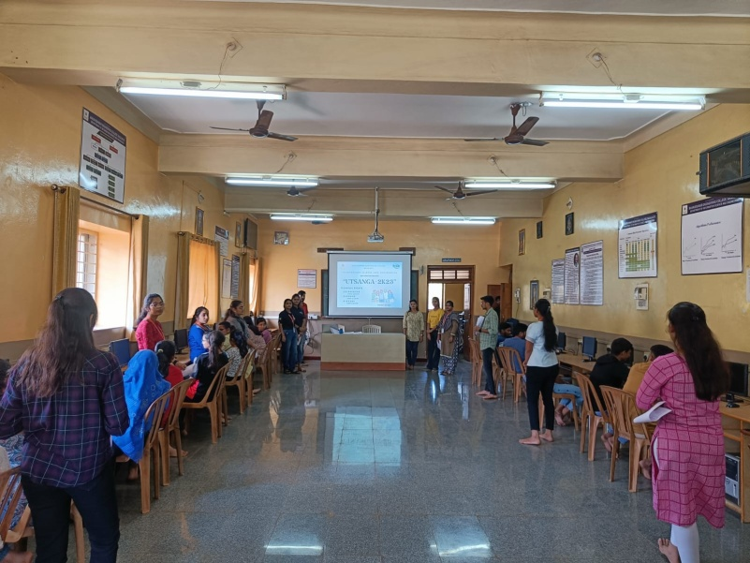 | 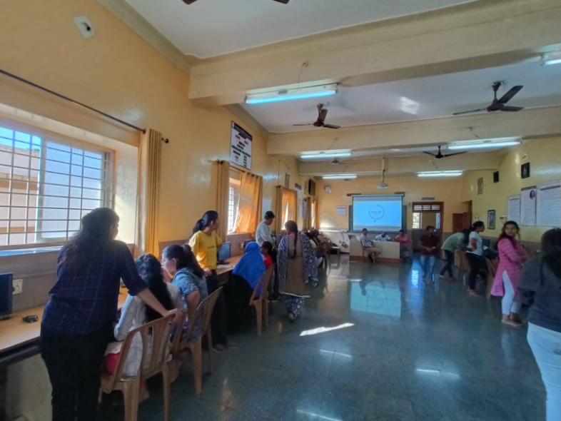
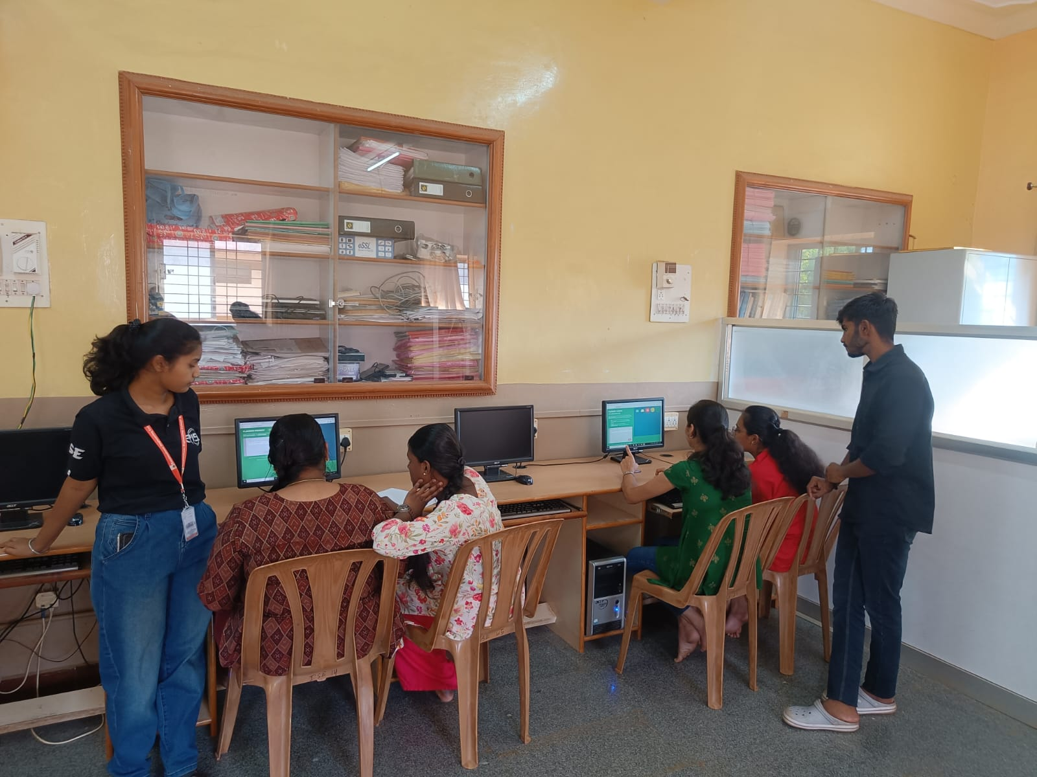 | 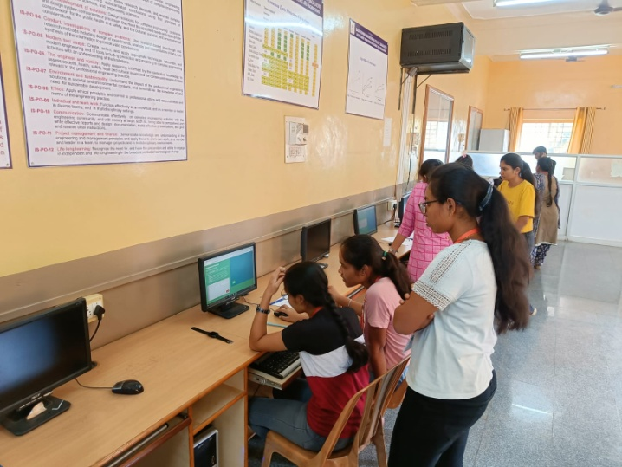

Date: 27-12-2023
Report

Rise Association Conducted an event “Food without Fire” on the eve of fresher’s day “UTSANGA 2K23” at Information Science and Engg., Basaveshwar Engineering College, Bagalkote on 27-12-2023. Students of 3rd semester and 5th semester attended and actively participated in the event.

The following team members are winner of the events:
1st Prize: Miss. Ananya K., Miss. Neha S. & Miss. Kushi K.
2nd Prize: Miss. Nidhi R., Miss. Kritika A. & Miss. Sakshi P.

Screenshots of Talk
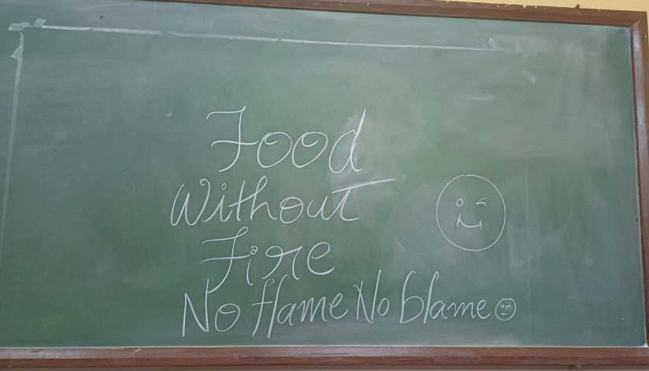 | 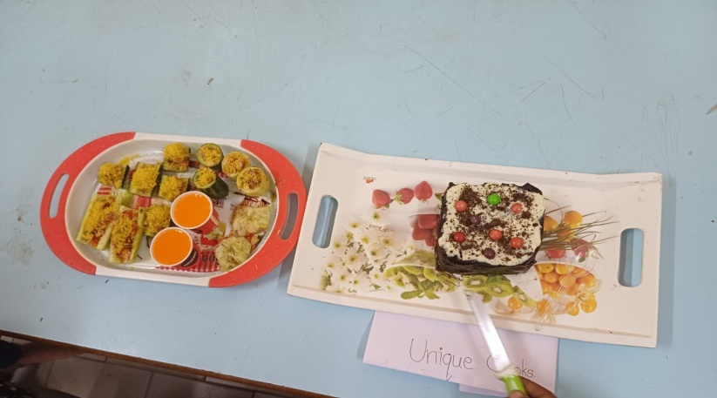
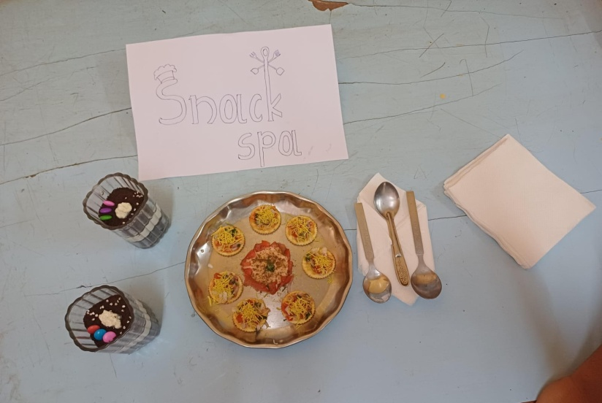 | 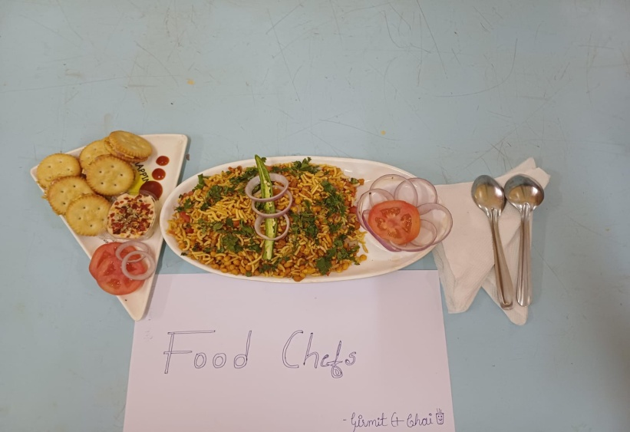
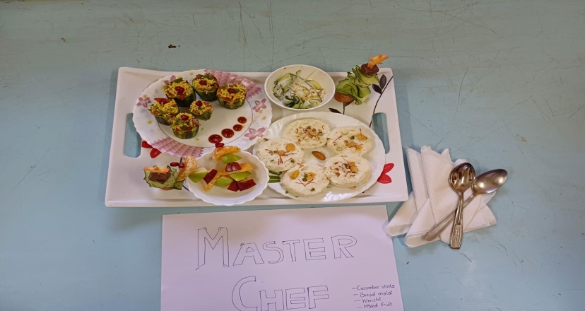 | 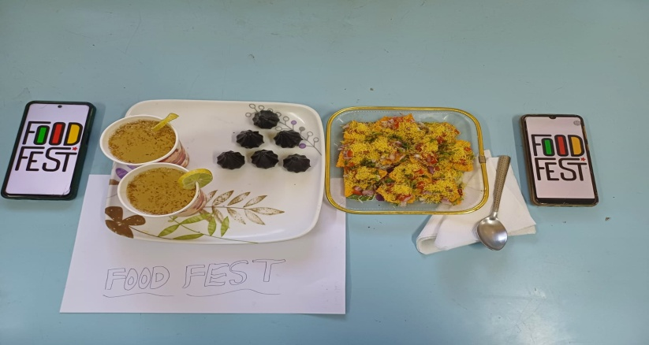

Date: 28-12-2023
Report

Rise Association conducted an talk on “Exploring AI with GenAI, Copilots and LLMs” on 28-12-2023. Mr. Virupaksh Gudagunti, Senior Technical Manager, Primesoft solutions Inc, delivered a sessions from 10.00am to 12pm. The students got knowledge on the using various AI platforms and their usage in software industry.

Screenshots of Talk
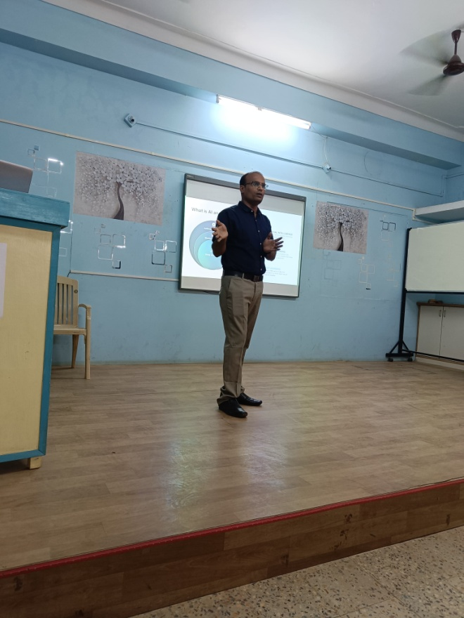 | 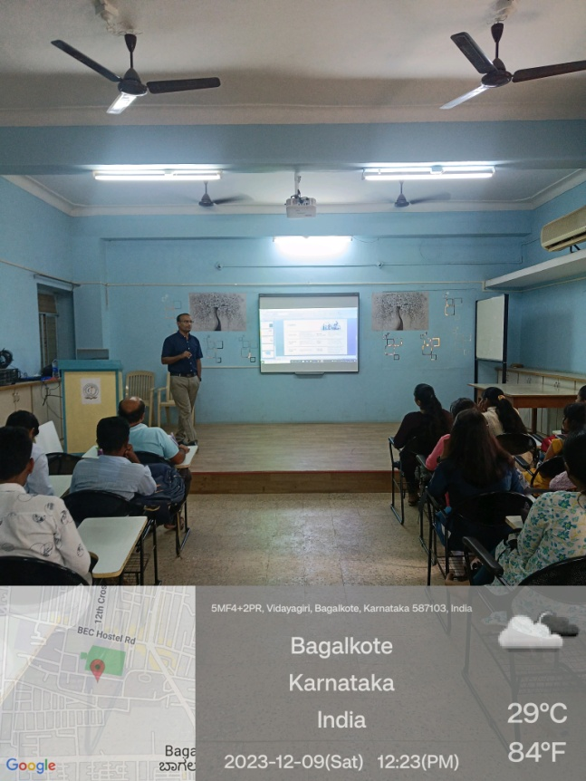
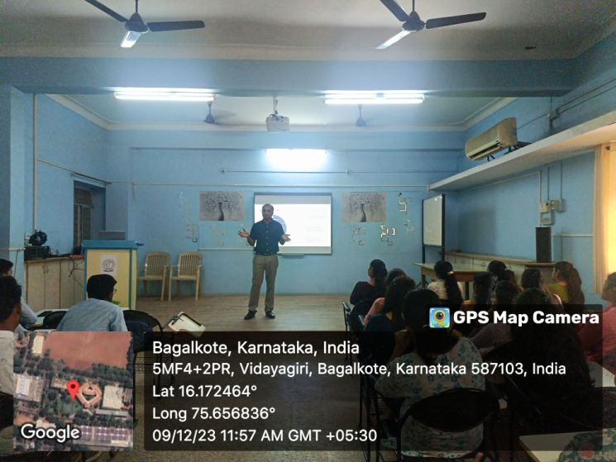 | 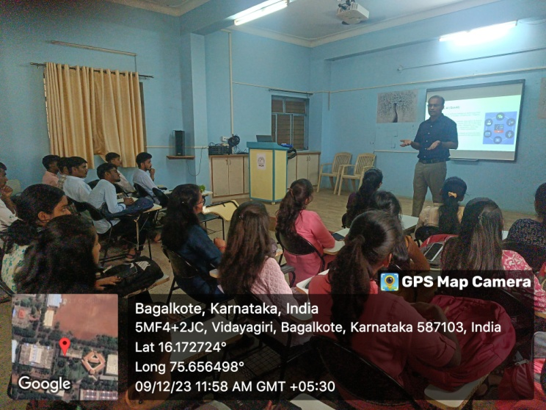

Date: 26-02-24
Report

3 days hands-on workshop on IoT

Rise Association conducted a 3 day’s workshop in association with IDEA Lab From 26-02-2024 to 28-02-2024. The resource person from industry Mr. Mallikarjun Akki and his team conducted a 3 days workshop for final year ISE students. Around 90 students participated in this workshop.

Outcomes:
- Skill Enhancement: Participants reported significant improvements in their understanding of IoT technologies and tools.
- Successful Prototypes: All groups successfully developed and presented their IoT projects, demonstrating creativity and practical application of concepts.
- Increased Engagement: The interactive nature of the workshop resulted in high levels of engagement and participation among students.

Project Highlights:
- Smart Home Automation: A prototype for controlling home appliances via a mobile app.
- Environmental Monitoring System: A device to track temperature and humidity in real time.
- Wearable Health Monitor: A simple prototype for tracking vital health parameters.

Feedback:
Feedback was collected through surveys and informal discussions. Key points included:

Positive Aspects:
Students appreciated the hands-on approach, knowledgeable instructors, and collaborative environment.
Areas for Improvement: Some participants suggested longer sessions for complex topics and more advanced project options.

Conclusion:
The Hands-on Workshop on IoT successfully met its objectives, providing participants with essential skills and knowledge in IoT. The enthusiastic participation and quality of projects produced during the workshop showcased the students' potential to innovate in the field.

Screenshots of IoT Workshop
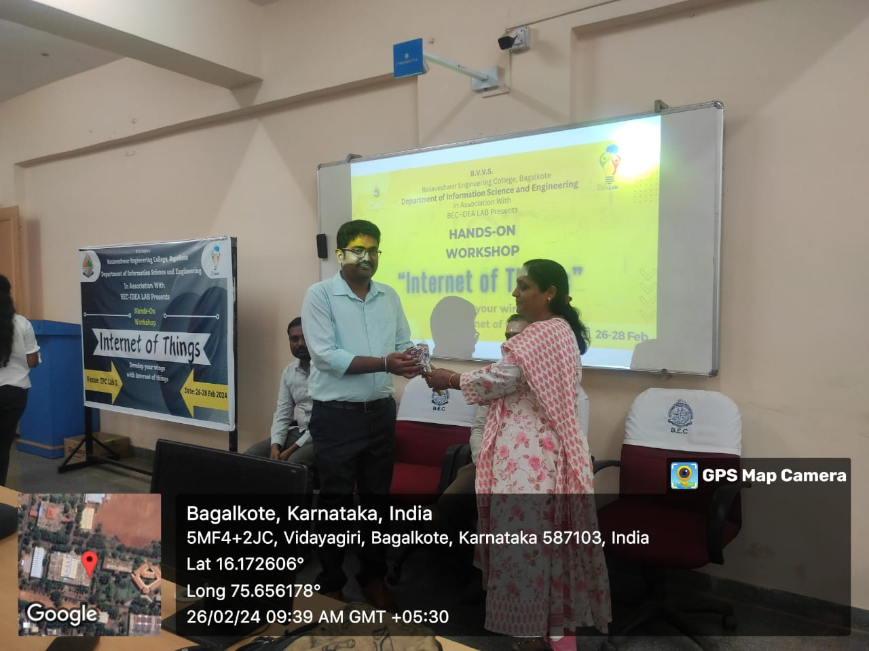 | 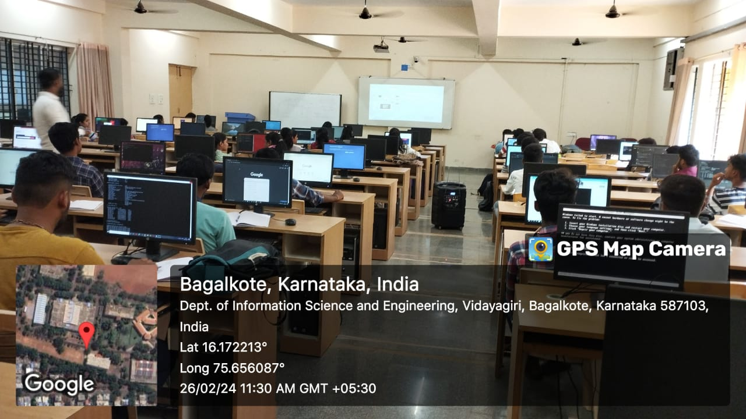
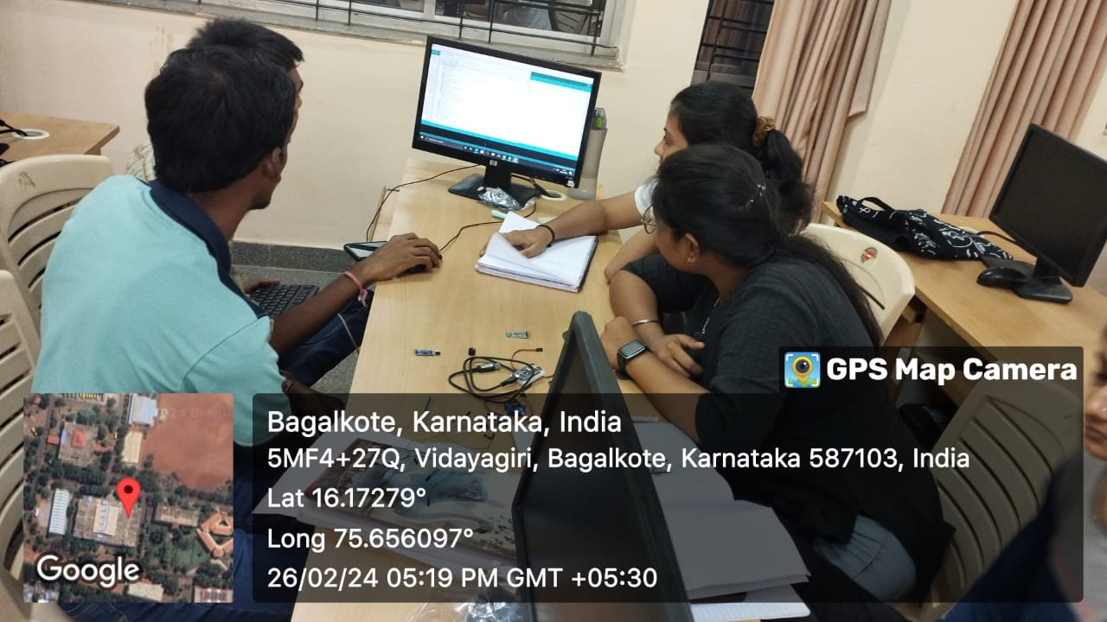 | 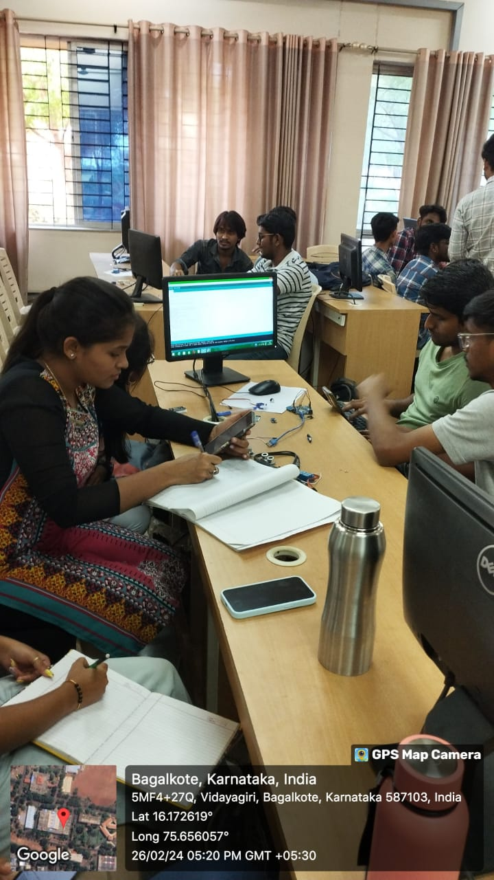

Date: 06-03-24
Report
3 days workshop on Accelerated AI and Machine learning
Rise Association conducted a 3 day’s workshop in association with IDEA Lab from 04-03-2024 to 06-03-2024. The resource person Prof. Karthik S. A. and Prof. Mohan B. A. conducted a 3 days’ workshop for 3rd year ISE students. Around 130 students participated in this workshop.

Outcomes:
- Skill Acquisition: Participants demonstrated increased proficiency in Python and a better understanding of AI concepts.
- Successful Project Implementation: Each group successfully developed an AI project, showcasing practical application of learned skills.
- Enhanced Engagement: The interactive nature of the workshop fostered high levels of engagement and interest in AI technologies.

Project Highlights:
- Predictive Analytics Tool: A model to forecast sales using historical data.
- Image Classification System: A basic neural network to classify images based on predefined categories.
- Chatbot Development: A simple AI-driven chatbot for customer interaction.

Feedback:
Feedback was gathered through surveys and discussions. Key insights included:
- Positive Aspects: Participants appreciated the hands-on approach, practical examples, and the expertise of the instructors.
- Areas for Improvement: Some students suggested extending the duration of the workshop to cover more advanced topics in AI.

Conclusion:
The "Accelerated AI Using Python" workshop successfully met its objectives, providing participants with essential skills and insights into the field of artificial intelligence. The enthusiastic engagement and quality of projects produced highlighted the students' readiness to innovate in AI applications

Screenshots of Workshop
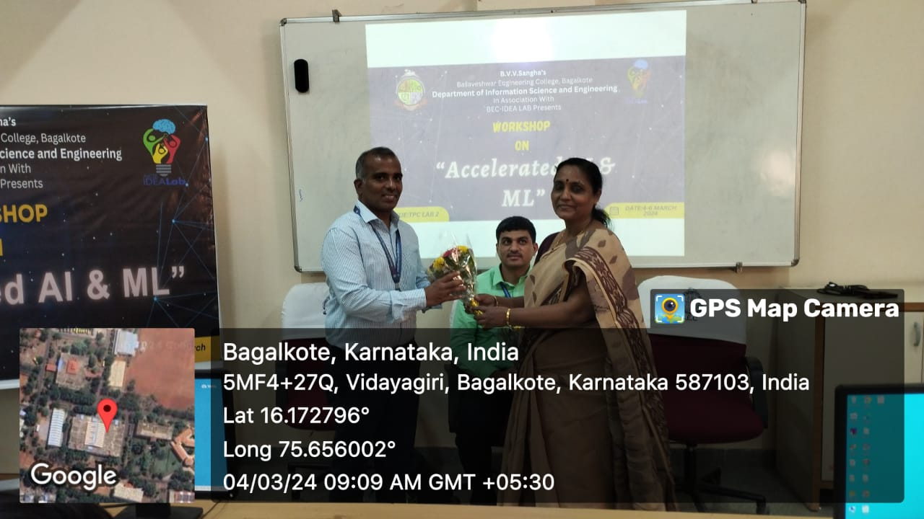 | 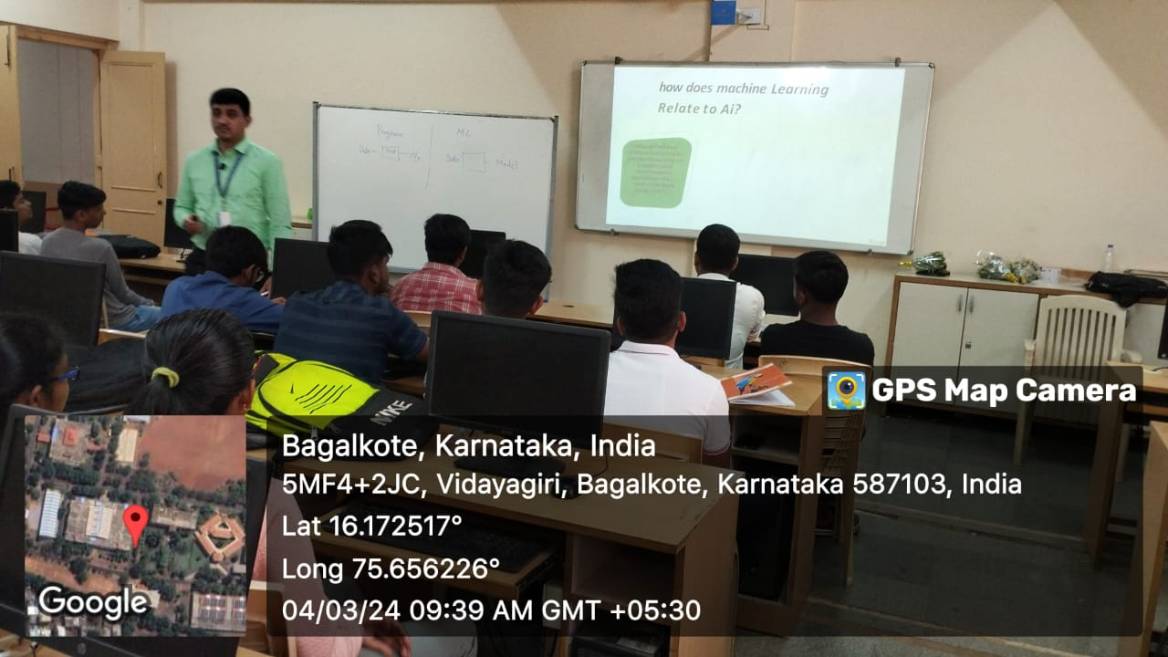
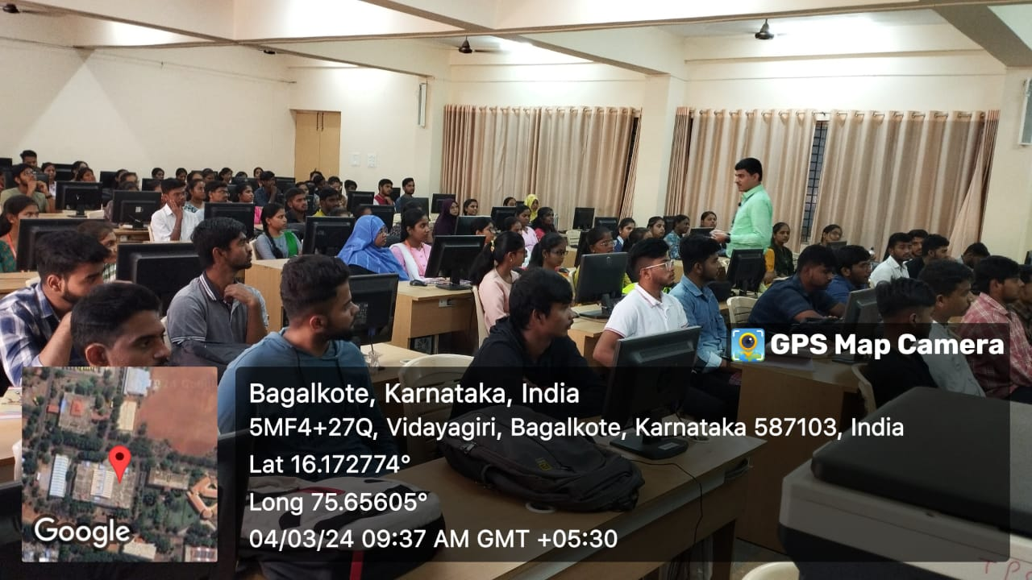 | 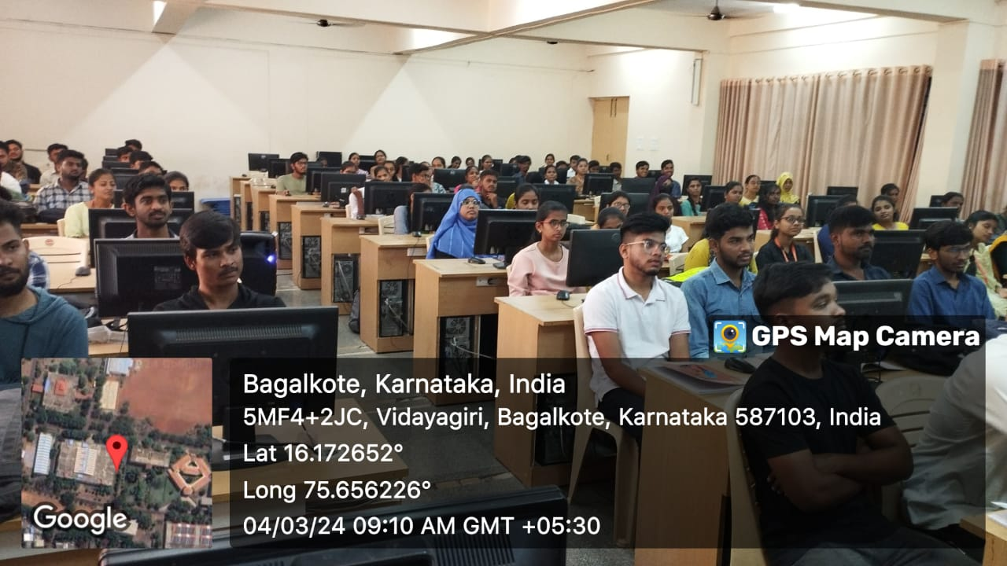

‘
Date: 11-03-2024
Report

Rise Association conducted a technical Event for 3rd and 5th semester ISE students on 11-03-2024. The event consists of 2 rounds: i) Crack & code ii) Web Hive. Around 90 students participated in one day event. The event helped the students in showcasing their skills in problem solving, coding challenges and creativity in designing web application. The winners of the event:
1. Prajwal S. K and Team (Team RCB)
2. Bhoomika Reddy and Team (Team Game of Thrones)

