FULL STACK LAB
LAB SHEET 08: TEMPLATE INHERITANCE BLUEPRINTS & MODULAR UI ENGINEERING
Name: Shreya Choudhary
Course: B.Tech CSE – 3rd Year
Semester: 5th Semester
Roll No.: 61
Section: A
Course Name: Full Stack
Course Code: BTCS303T
Date: 03/09/2026
Primary Syllabus Exercise Reference:
Develop a core master template layout blueprint file containing shared menus and block overrides; inherit properties down across specialized views (Home, About Us, Contact Us).
Task 8.1: Embed custom programmatic markers within the master view framework to dynamically assign context specific CSS structural active utility highlights to the active navigation item.
Code:
<nav>
<a href="{% url 'home' %}"
class="{% if active_page == 'home' %}active{% endif %}">
Home
</a>
<a href="{% url 'about' %}"
class="{% if active_page == 'about' %}active{% endif %}">
About Us
</a>
<a href="{% url 'contact' %}"
class="{% if active_page == 'contact' %}active{% endif %}">
Contact Us
</a>
</nav>

Output:
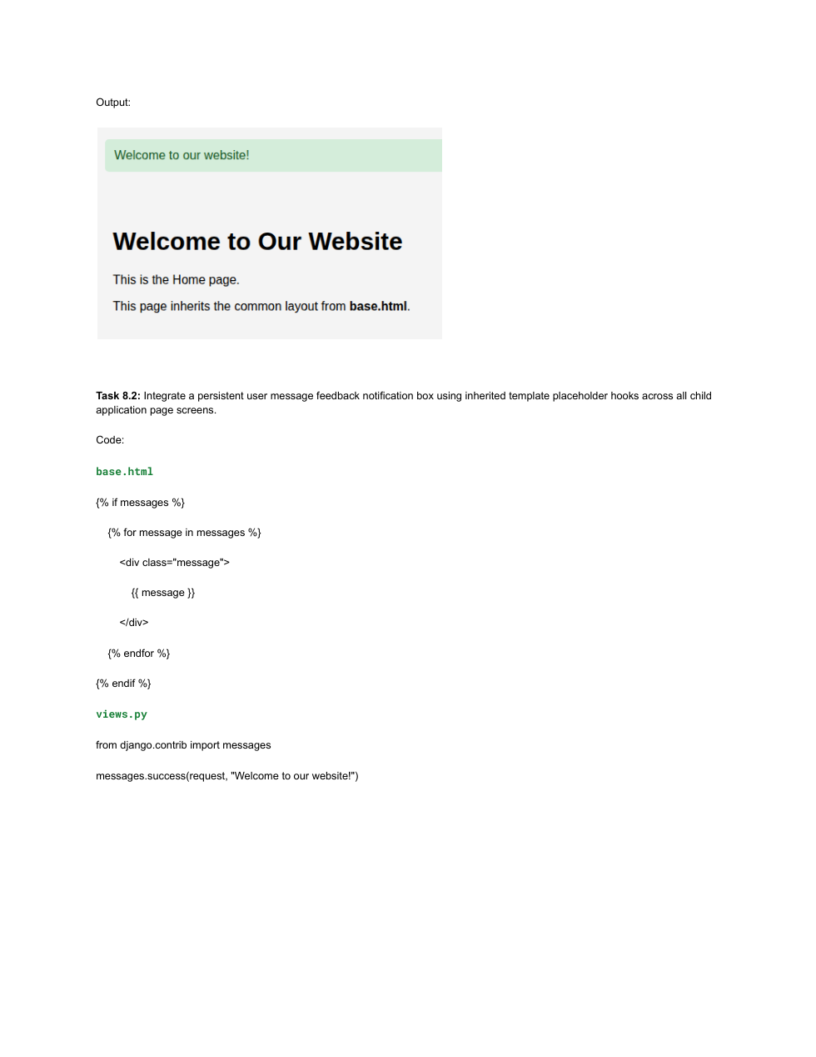
Task 8.2: Integrate a persistent user message feedback notification box using inherited template placeholder hooks across all child application page screens.
Code:
base.html
{% if messages %}
{% for message in messages %}
<div class="message">
{{ message }}
</div>
{% endfor %}
{% endif %}

views.py
from django.contrib import messages
messages.success(request, "Welcome to our website!")

Output:
Task 8.3: Build a professional Contact Us form view page that forwards verified feedback text parameters directly into the server logs for system verification.
Code:
views.py
from django.shortcuts import render
from django.contrib import messages
def contact(request):
if request.method == "POST":
name = request.POST.get("name", "").strip()
email = request.POST.get("email", "").strip()
feedback = request.POST.get("feedback", "").strip()
if name and email and feedback:
print("----- CONTACT FORM SUBMISSION -----")
print(f"Name: {name}")
print(f"Email: {email}")
print(f"Feedback: {feedback}")
messages.success(
request,
"Thank you! Your feedback has been submitted successfully."
)
else:
messages.error(
request,
"Please fill in all the fields."
)
return render(request, "pages/contact.html", {
"active_page": "contact"
})

contact.html
<form method="POST">
{% csrf_token %}
<input type="text" name="name"
placeholder="Enter your name" required>
<input type="email" name="email"
placeholder="Enter your email" required>
<textarea name="feedback"
placeholder="Write your feedback here..."
required></textarea>
<button type="submit">Submit Feedback</button>
</form>

Output:
