SHREYA PANCHAL
Assignment 1: VMware Virtual Machine Setup
QUESTION: 1
Install Windows Server on a virtual machine using VirtualBox or VMware and take a screenshot of the desktop after the installation completes.


Question : 2
Open Server Manager and use the 'Add roles and features' wizard to install the Active Directory Domain Services (AD DS) role. Document each step with a short description and screenshot.

Open Server Manager: Opened the Server Manager dashboard from the taskbar.
Add Roles and Features: Clicked on "Add roles and features" from the Manage menu.
Installation Type: Selected "Role-based or feature-based installation" and clicked Next.
Server Selection: Selected the local server from the server pool.
Server Roles: Checked the box for "Active Directory Domain Services". In the pop-up window, clicked "Add Features" to include required management tools.
Features & Confirmation: Clicked Next through the Features and AD DS informational screens, then clicked "Install" on the confirmation page.
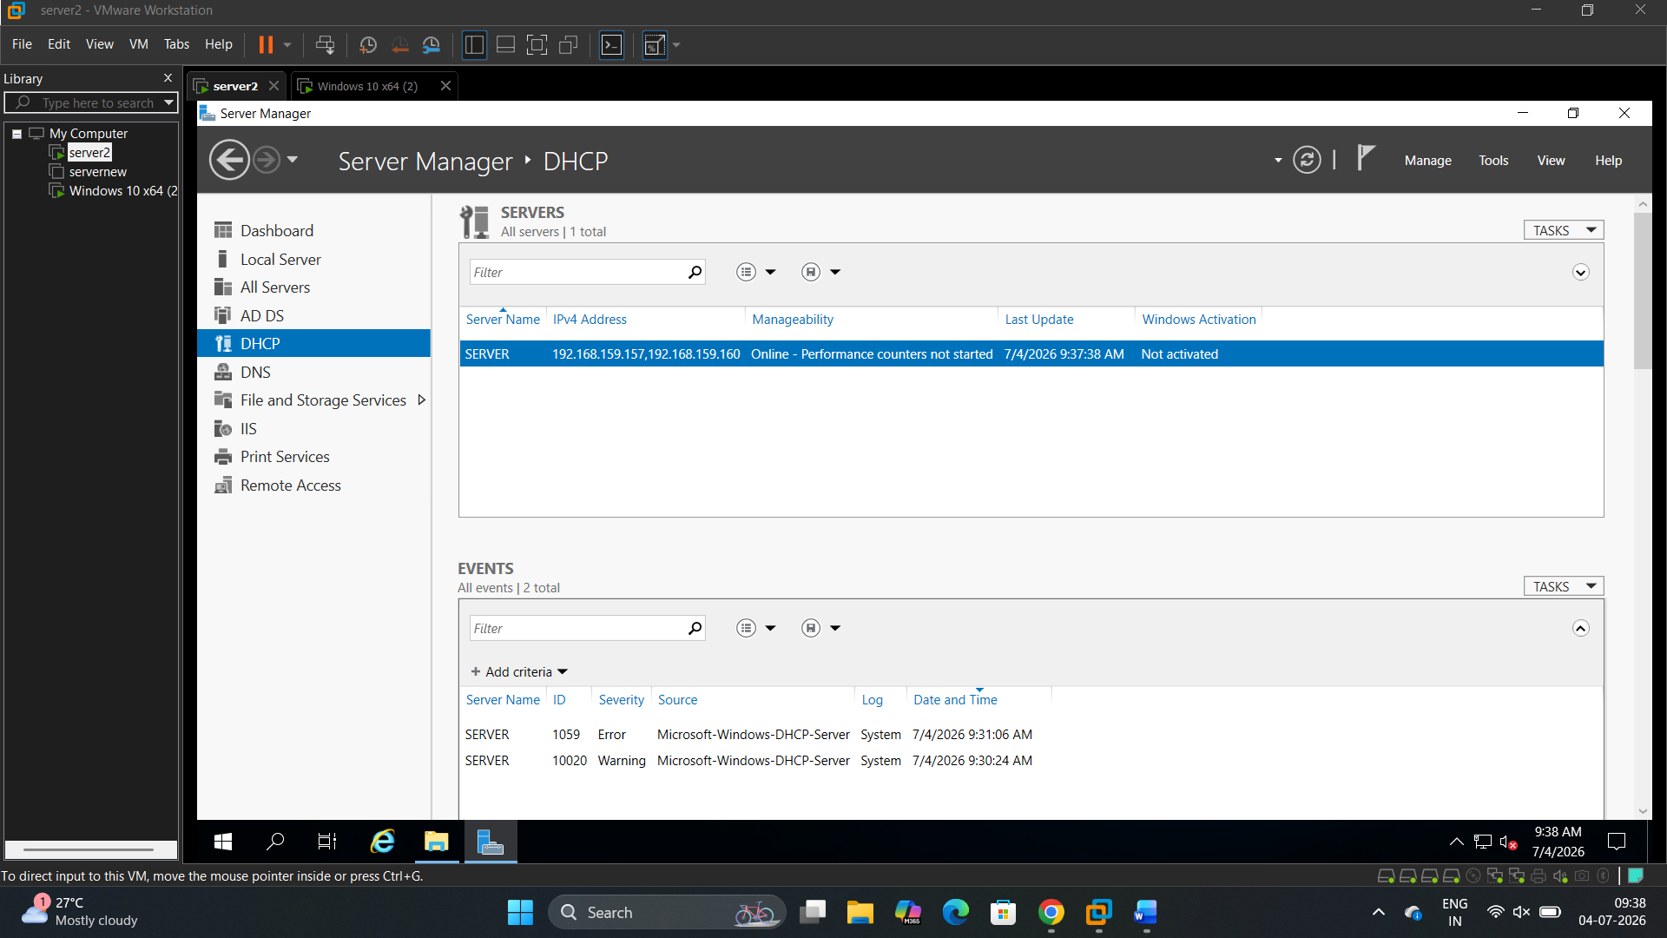

Question : 3
Promote your Windows Server to a Domain Controller by creating a new forest with a root domain name of your choice (e.g., mycollege.local). List the options you selected during the configuration.
>
Deployment Operation: Selected "Add a new forest".
Root Domain Name: Entered Domain.com.
Domain Controller Options:
- Forest and Domain functional levels set to default.
- Checked "Domain Name System (DNS) server" and "Global Catalog (GC)".
- Set a secure Directory Services Restore Mode (DSRM) password.
Prerequisites Check: All prerequisite checks passed successfully, and clicked "Install". The server restarted automatically to complete the process.
Question: 4
Create two new user accounts and one group in Active Directory Users and Computers. Assign both users to the group and describe how you did it.<br><br><em><strong>Hint:</strong> Use the 'Users' container and right-click options in ADUC.</em>
