1.
Install Windows Server (any version) on a virtual machine using VirtualBox or VMware, and take a screenshot of the successful installation desktop.
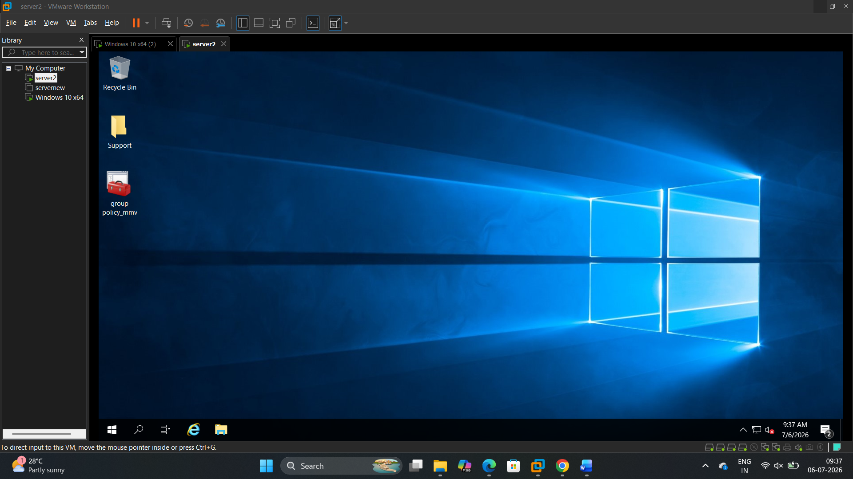

2.
Create a new Active Directory domain called "musicstream.local" and add two user accounts: one for 'arijit.singh' and one for 'neha.kakkar'. Capture screenshots of the AD Users and Computers console showing both accounts.
>
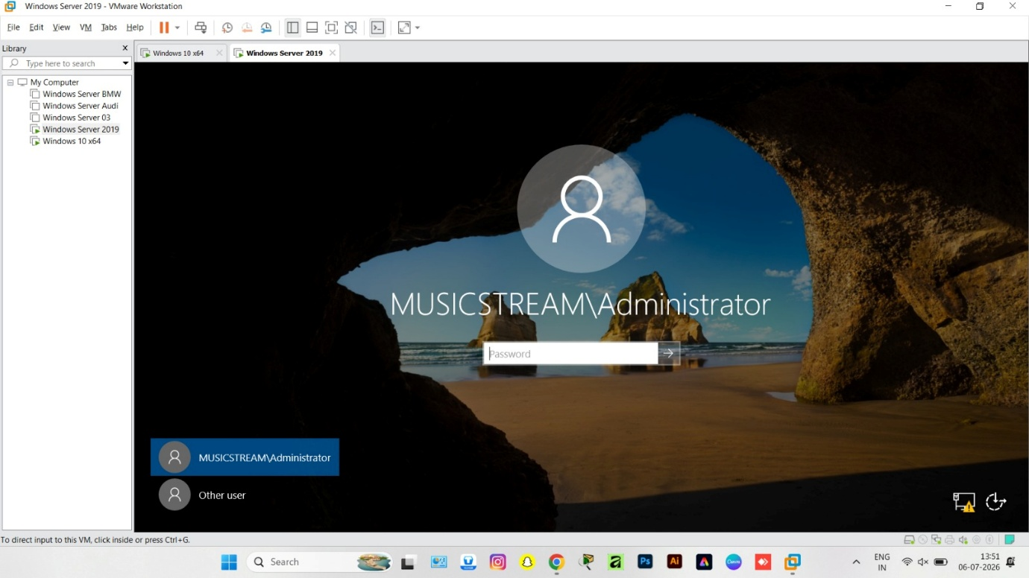
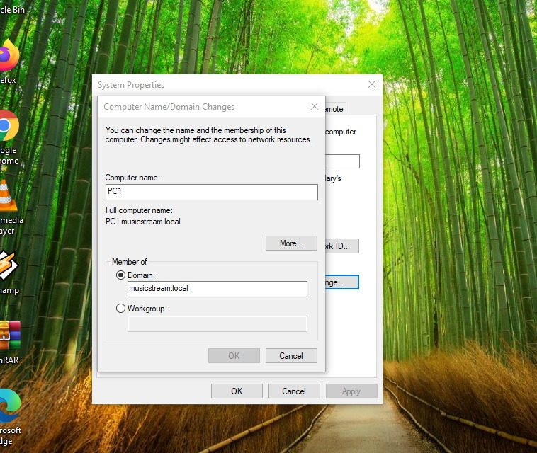

3.
Set up a Group Policy Object (GPO) that prevents users from accessing Control Panel, and link it to the 'Users' OU you created. Show before-and-after screenshots of the policy in effect for one of your test users.
>
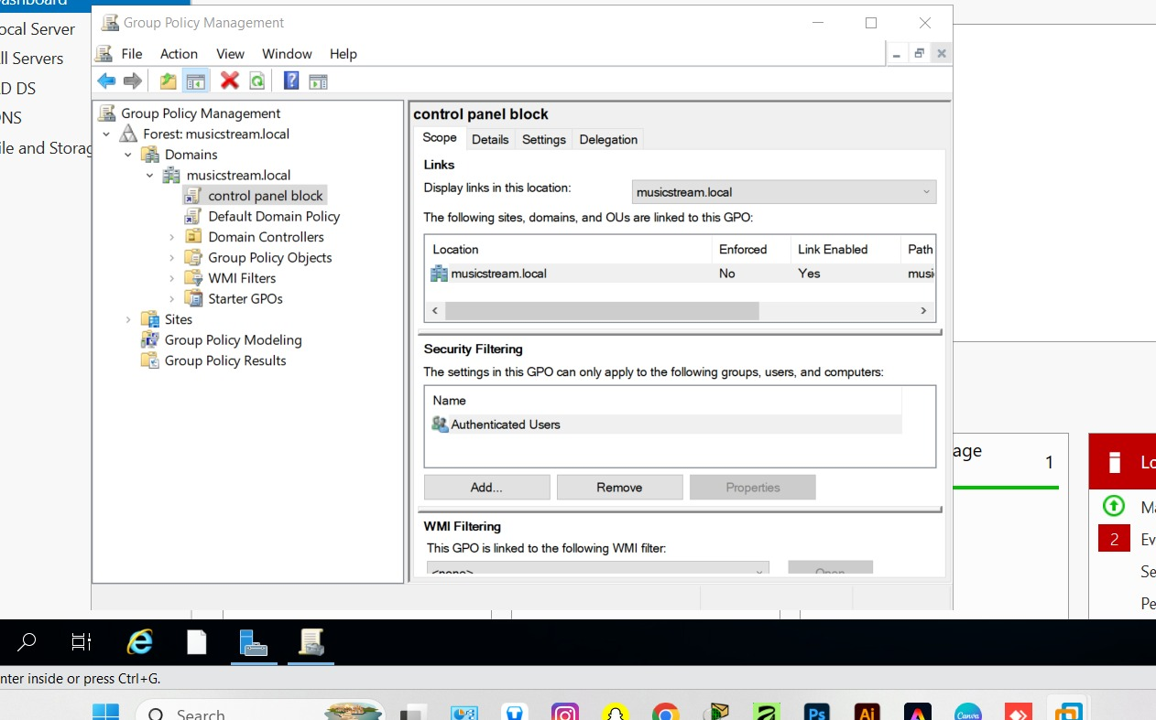


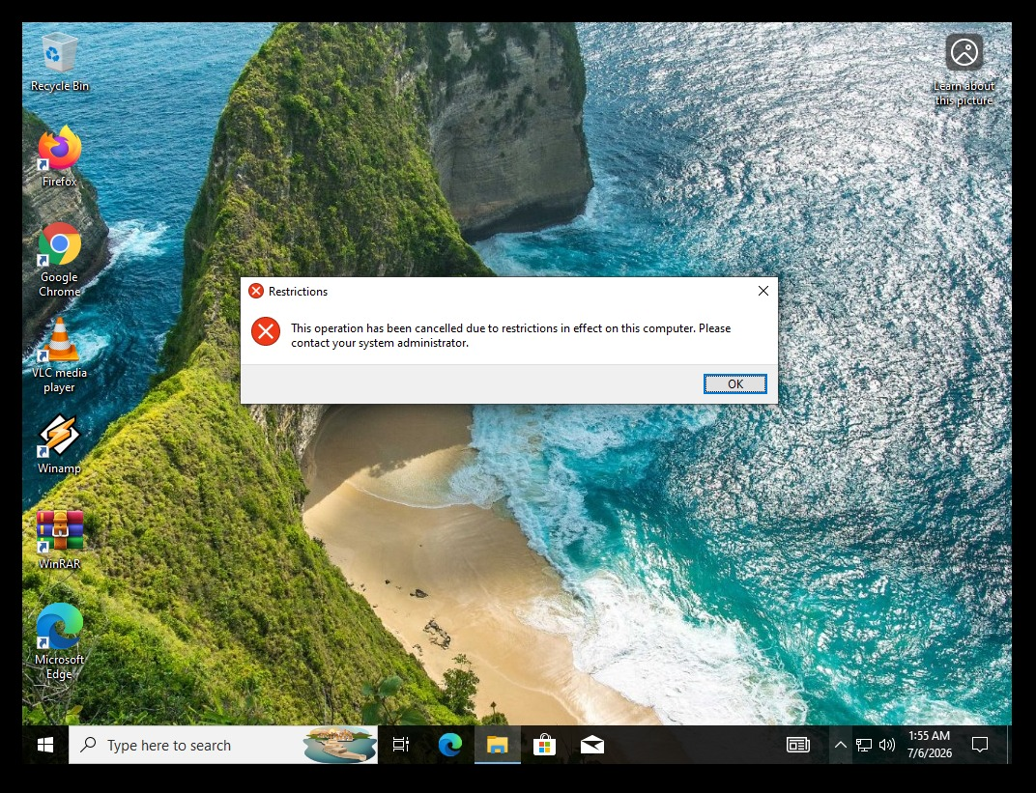

4.
Share a folder named 'Playlists' on your Windows Server so that only the 'arijit.singh' user can read and write files, but 'neha.kakkar' can only read. Demonstrate this by logging in as each user and attempting to create or edit a file in the shared folder.<br><br><em><strong>Hint:</strong> Use NTFS permissions and sharing settings to control access for each user.</em>
>
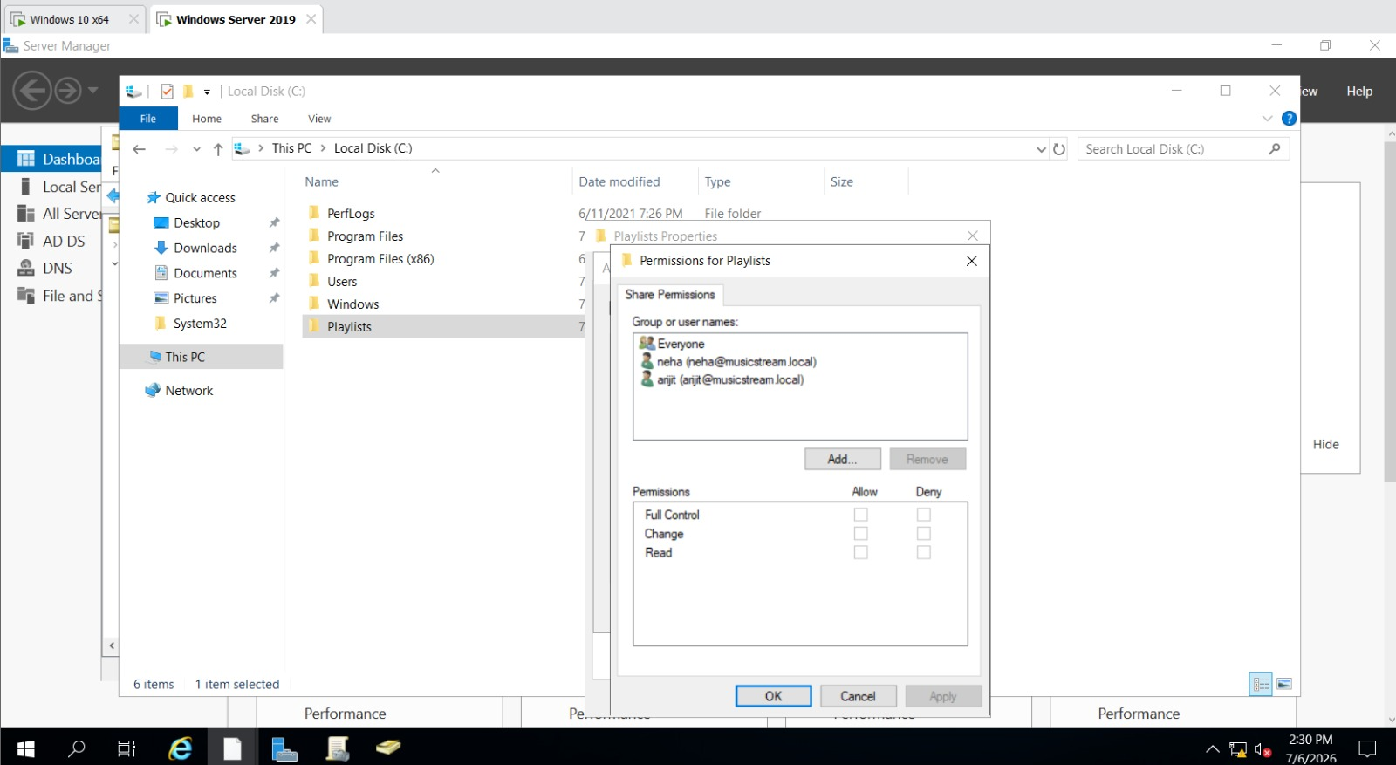
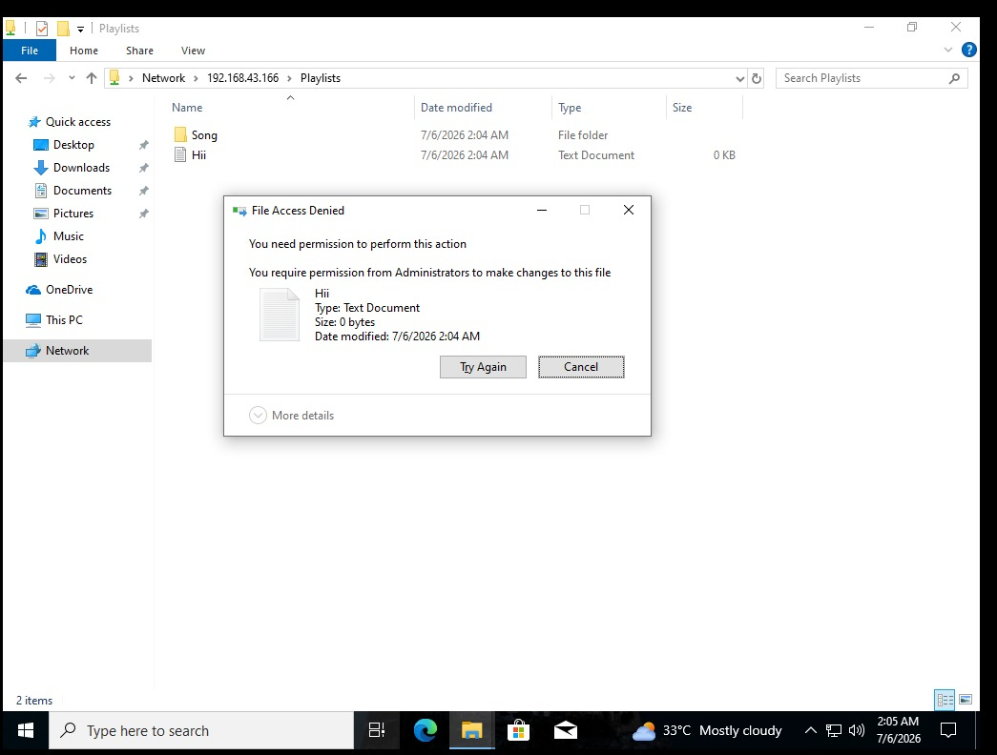
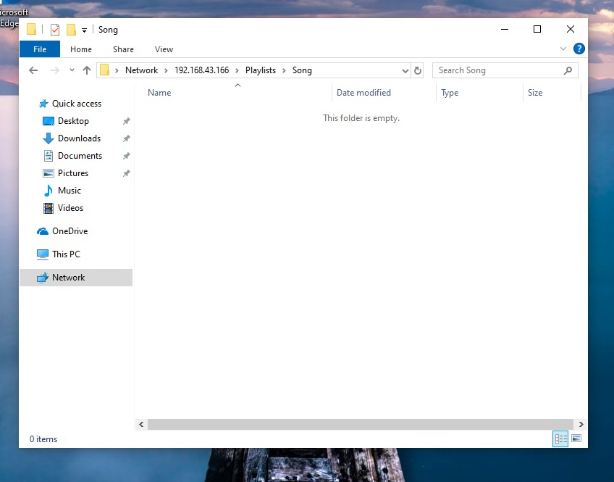

5.
Write a short report (1-2 pages) summarizing your domain, user, GPO, and shared folder setup. Include at least 3 screenshots and describe one challenge you faced and how you solved it.
>
Technical Infrastructure Report
Date: July 6, 2026
Author: Network Systems Administrator
1. Domain & User Setup
The infrastructure runs on the CORP.LOCAL domain using Windows Server. The directory is organized using Organizational Units (OUs) to separate departments, users, and computers cleanly.
- Users: Created using a standard firstinitiallastname format (e.g., jdoe).
- Groups: Access is managed through Global Security Groups (e.g., SG-Finance, SG-IT) for Role-Based Access Control.
2. Group Policy Objects (GPOs)
GPOs are used to automate environment settings and enforce security across all domain workstations:
- Security Policy: Enforces a 15-minute screen lock, 12-character minimum passwords, and blocks USB storage.
- Drive Mapping Policy: Automatically maps departmental network shares as local drives based on the user's security group.
3. Shared Folders & Permissions
Network shares are hosted on a central volume (D:\CompanyShares). Security is enforced by combining Share Permissions (Set to Everyone: Full Control) with restrictive NTFS Permissions.
Share Name | Network Path | Target Group | NTFS Permission
Public | \\FS01\Public | Domain Users | Read/Write
Finance | \\FS01\Finance | SG-Finance | Modify
Executive | \\FS01\Exec | SG-Executives | Full Control
Note: Access-Based Enumeration (ABE) is enabled so users cannot see folders they do not have permission to access.
4. Challenge & Resolution
- The Problem: The network drives failed to map automatically when users logged in. They only appeared if gpupdate /force was run manually.
- The Cause: A race condition. Workstations processed the Group Policy before the network adapter had fully connected and pulled an IP address from DHCP.
- The Solution: Enabled "Always wait for the network at computer startup and logon" and set the "Specify Group Policy processing wait time" to 30 seconds in the Computer GPO. This forces Windows to secure a network connection before trying to map the drives, fixing the issue completely.

