SHREYA PANCHAL
Assignment 2: DHCP Server Configuration in Windows Server

1. Create a DHCP Scope Named 'CampusWiFi'
In Active Directory Users and Computers, create a new Organizational Unit (OU) called 'EventPlanners' to represent a team that manages college fests like those seen in BookMyShow.
>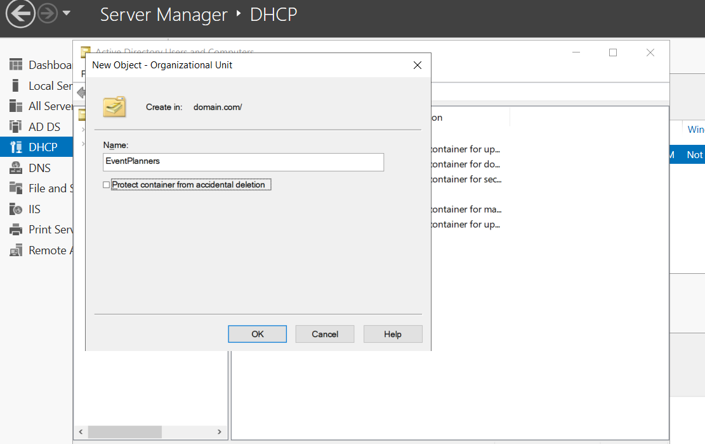
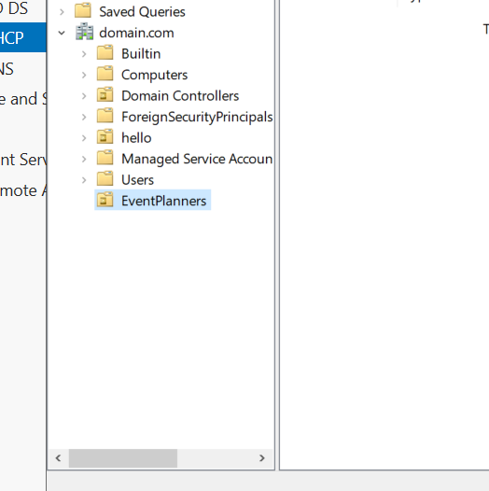

Question: 2
Add three user accounts to the 'EventPlanners' OU with usernames inspired by your favorite IPL cricket players (e.g., viratk, msdhoni, hardikp). Set a strong password for each and ensure 'User must change password at next logon' is enabled.
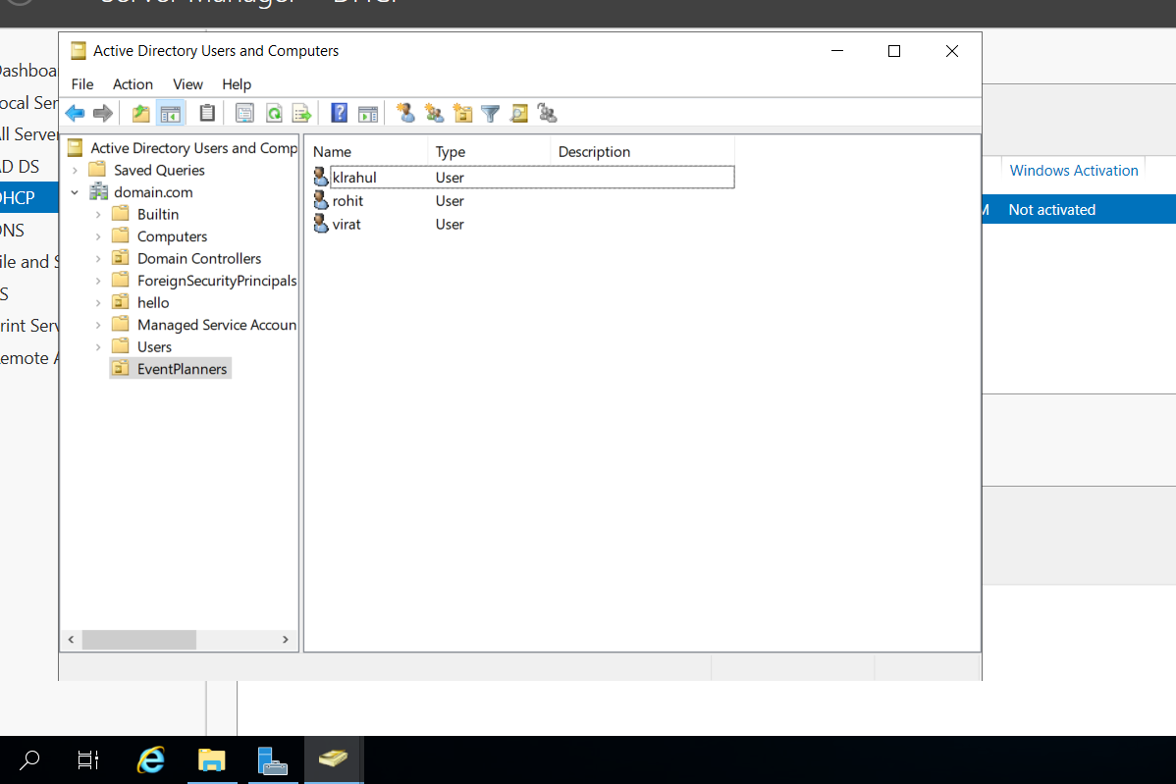

Question: 3
Create a security group named 'FestTicketManagers' inside the 'EventPlanners' OU. Add all three user accounts you created to this group.
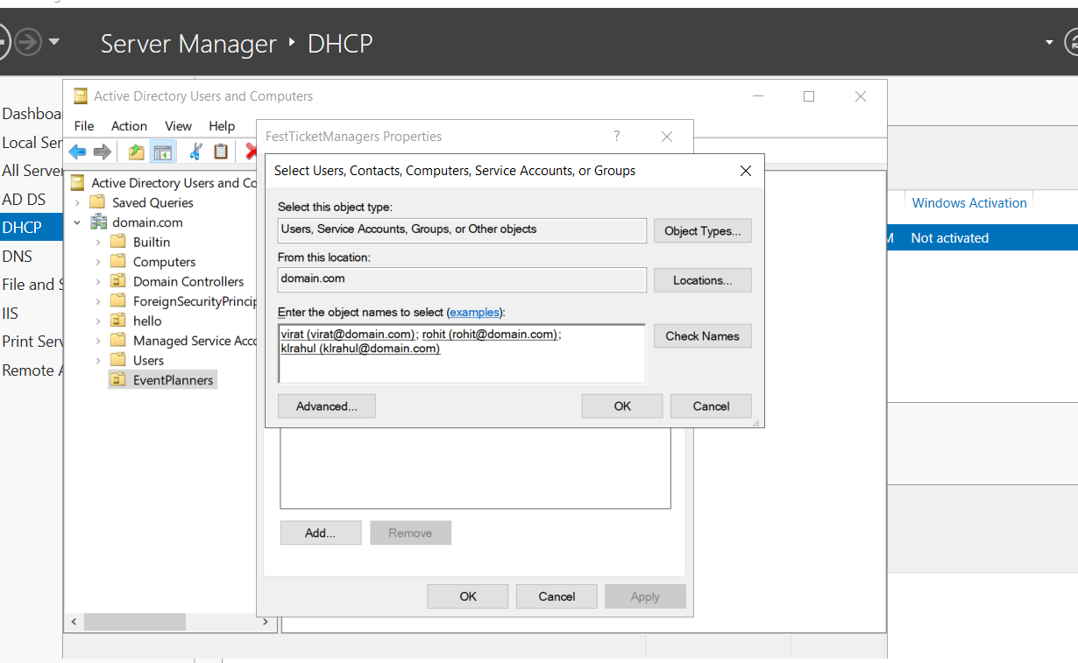
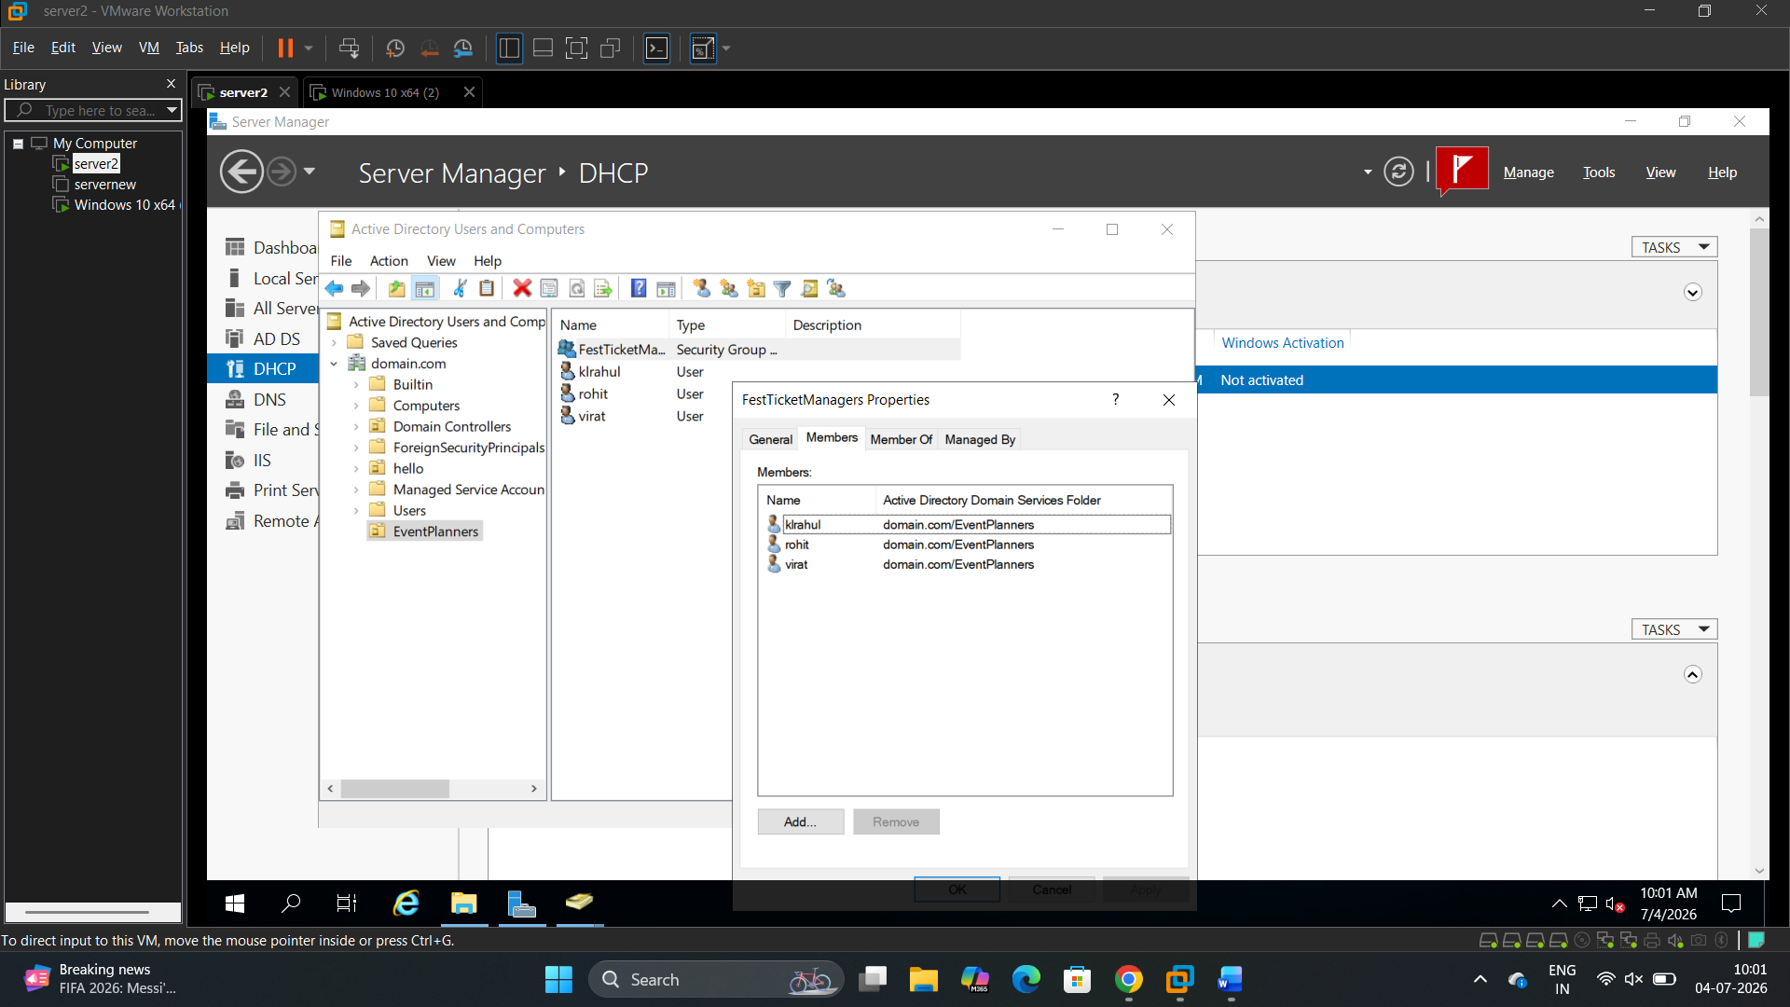

Question:4
Rename one of your user accounts in the 'EventPlanners' OU to match your own first name and update their description field to 'Social Media Manager for College Fest'.
>
