SHREYA PANCHAL
Assignment 4: Windows Server – DNS, DHCP, File Sharing & Print Server
Question: 1
On your Windows Server VM, create a new folder named 'MusicShare' on the D: drive and share it with the network using the Share Wizard.
>
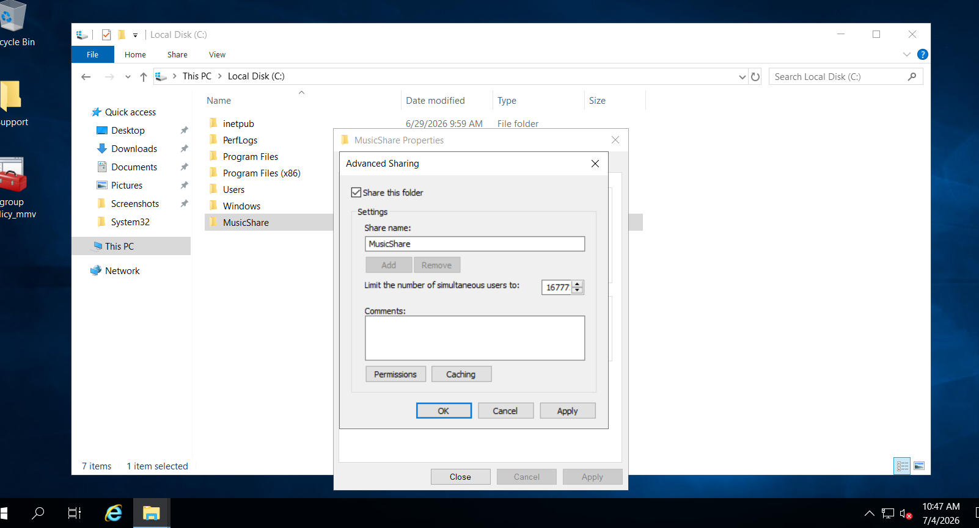

Question:2
Set NTFS permissions on the 'MusicShare' folder so that the user 'Student1' has Read & Write access, while 'Student2' has Read-only access.
>
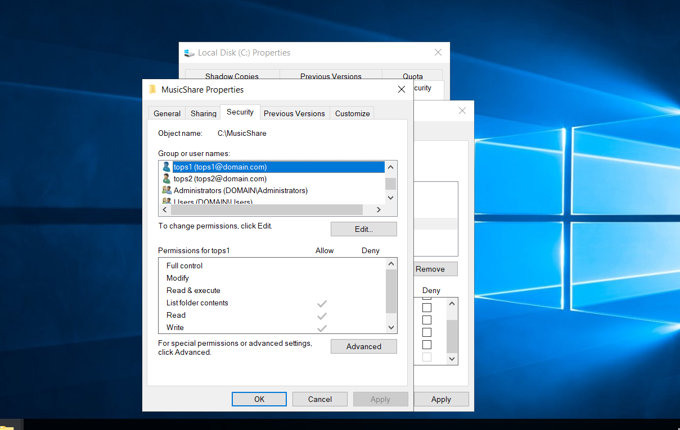
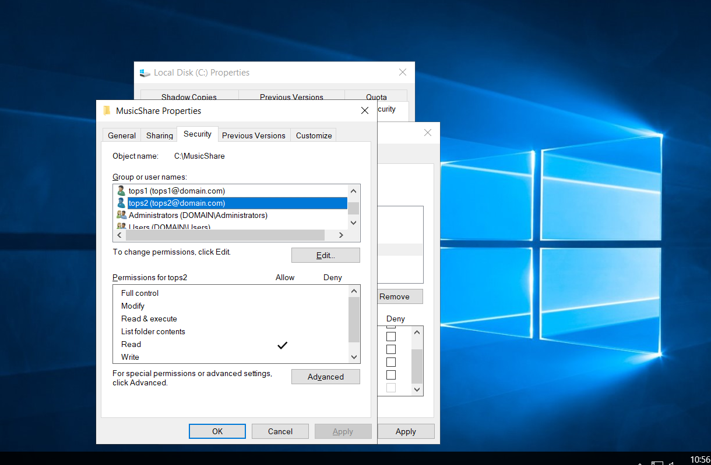
Question: 3
Configure Share permissions for 'MusicShare' so that only members of the 'MusicLovers' group can access the share, and all others are denied.
>
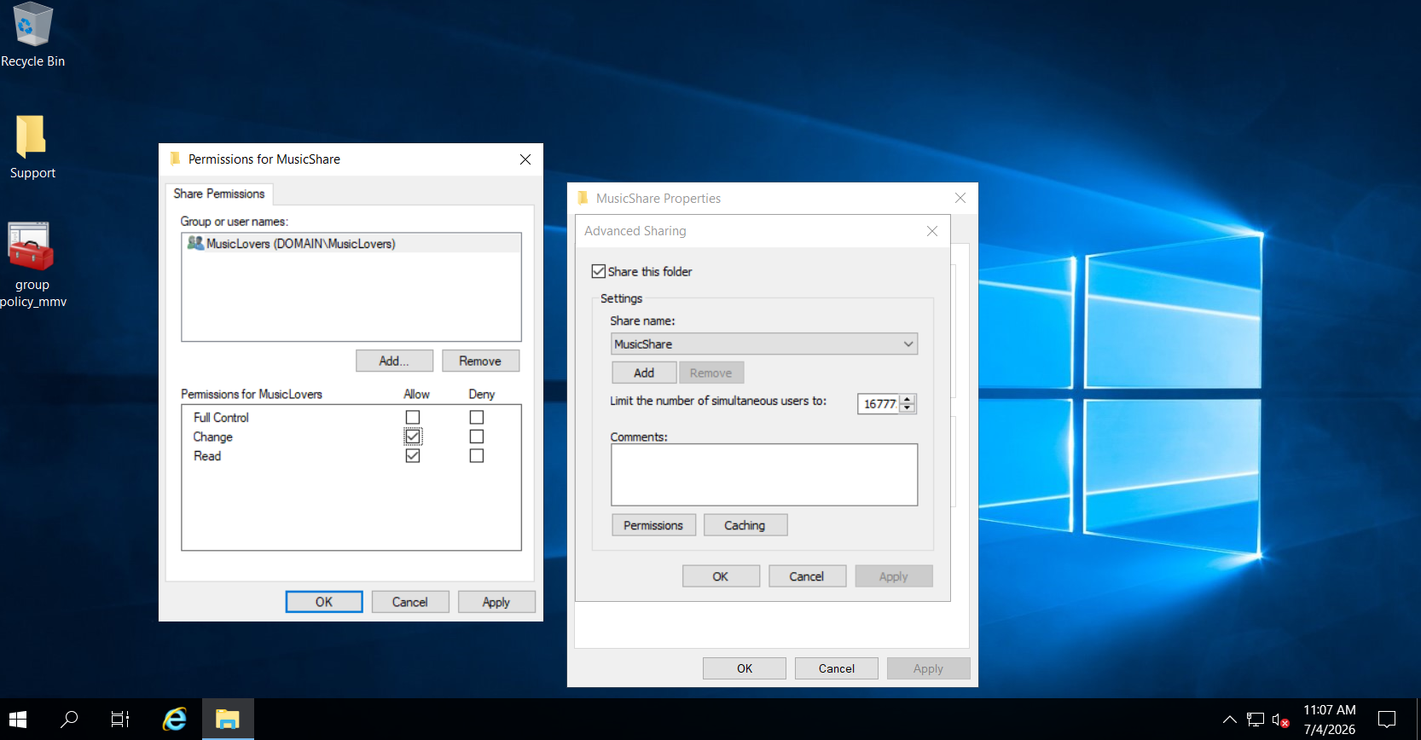

Question: 4
Simulate these access scenarios: log in as 'Student1' and try to copy a file into 'MusicShare', then log in as 'Student2' and attempt to delete a file from the same folder. Write down what happens in each case and explain why based on the permissions set.
>
