Vulnerability Scanner
Name: SHREYA PANCHAL
Organization: THIRANEX Virtual Internship India

Objective
To develop a Python-based Vulnerability Scanner that detects common open ports, identifies basic security issues, and generates a simple vulnerability assessment report.

Key Features
• Scan common open ports (22 and 80).
• Detect open network services.
• Provide security recommendations.
• Generate a simple vulnerability report.
• Learn vulnerability assessment and penetration testing.

Task2: Implementation Steps
1. #pwd - Display current directory
2. #cd ~ - Go to home directory
3. #mkdir VulnerabilityScanner_Project – crate project folder
4. #cd VulnerabilityScanner_Project – open folder
5. #pwd – Verify directory
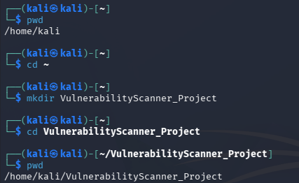
6. #nano vulnerability_scanner.py – create python file
7. Paste Python code – add the code
8. Save (Ctrl+O, Enter, Ctrl+X)
9. #ls – check file
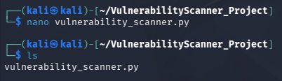
10. #python3 vulnerability_scanner.py – run program
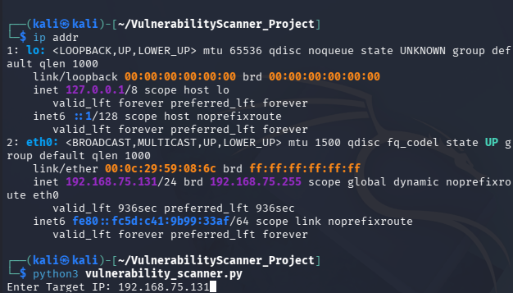
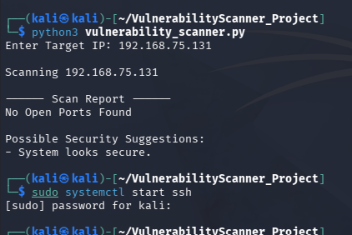
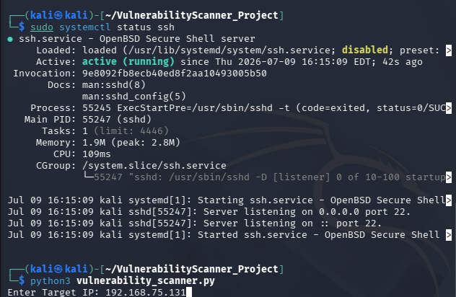
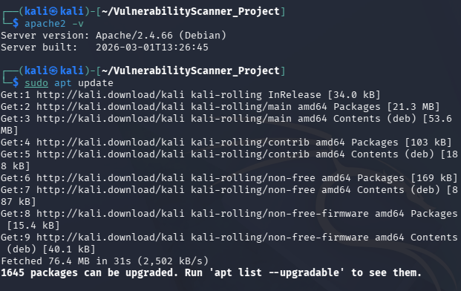
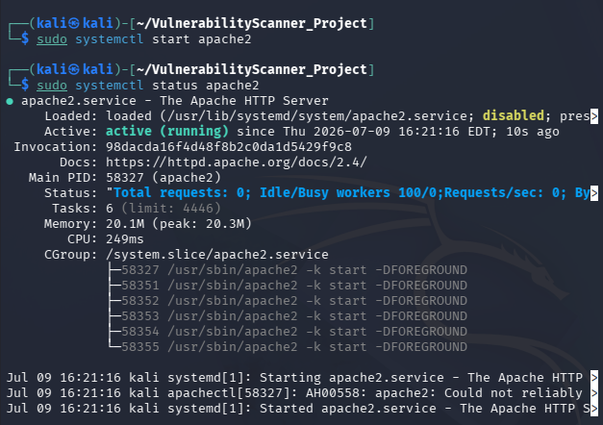
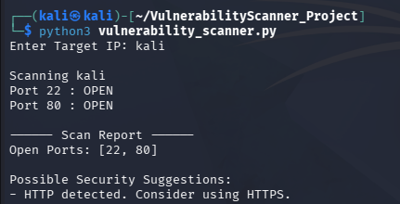
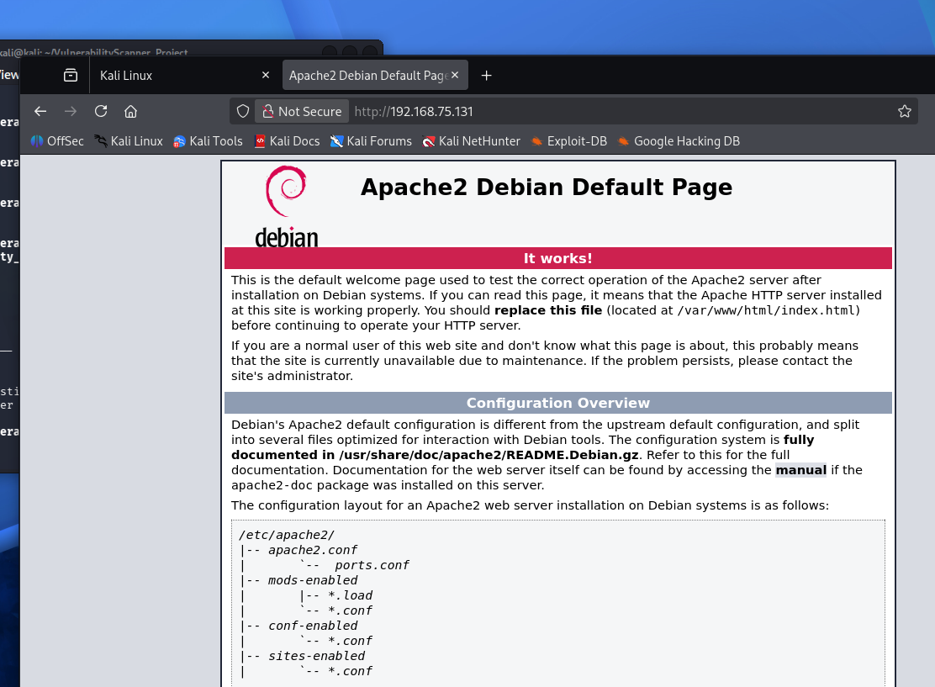

Short Python Code
import socket
target=input("Enter Target IP:")
ports=[22,80]
for port in ports:
s=socket.socket()
if s.connect_ex((target,port))==0:
print(f"Port {port}: OPEN")
s.close()
print("- SSH: Use strong passwords.")
print("- HTTP: Use HTTPS.")

Conclusion
The Vulnerability Scanner successfully detected open ports and generated a simple vulnerability report with security recommendations.

