Password Strength Analyzer
Name: SHREYA PANCHAL
Organization: THIRANEX Virtual Internship India

Objective
To evaluate the strength of user-entered passwords based on length, complexity, and uniqueness.

Key Features
- Check password length, complexity, and uniqueness
- Suggest stronger password alternatives
- Optional: Prevent reuse of old passwords using a database
- Learn password security and basic cryptography concepts

Implementation Steps (Kali Linux)
Step 1: Check Home Directory - #pwd
Step 2: Create Project Folder - #mkdir PasswordAnalyzer_Project
Step 3: Open Project Folder - #cd PasswordAnalyzer_Project
Step 4: Verify Current Directory – #pwd
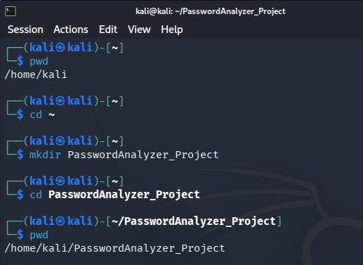
Step 5: Create Python File - #nano password_analyzer.py
Step 6: Paste Python Code - Paste the password strength analyzer code
Code:
password = input("Enter Password: ")
# Check password length and complexity
# Calculate password score
# Display password strength
# Suggest improvements
Step 7: Save File - Ctrl + O, Enter, Ctrl + X
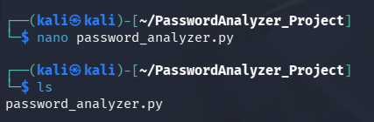
Step 8: List Files - #ls
Step 9: Run Program - #python3 password_analyzer.py
Step 10: Test Password - Enter Password: Kali@12345

Output:
Password Score: 5/5
Strength: Strong
