Phishing Email Detection Model
Name: SHREYA PANCHAL
Organization: THIRANEX Virtual Internship India
Objective
To develop a machine learning model using Scikit-learn that classifies emails as Phishing or Safe based on email text and URL-related features.
Key Features
- Train on a dataset of phishing and legitimate emails
- Extract and analyze email features (URLs, keywords, etc.)
- Classify emails as “Phishing” or “Safe”
- Display accuracy and confusion matrix

Task3: Kali Linux Steps
Step 1: Display current directory- #pwd
Step 2: Go to Home Directory- #cd ~
Step 3: Create Project Folder- #mkdir Phishing_Email_Detection
Step 4: Open Folder- #cd Phishing_Email_Detection
Step 5: Check Directory- #pwd
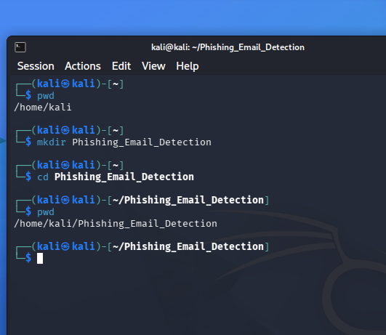

Step 6: Install Required Libraries- #sudo apt update
#sudo apt install python3-pip -y
#pip3 install pandas
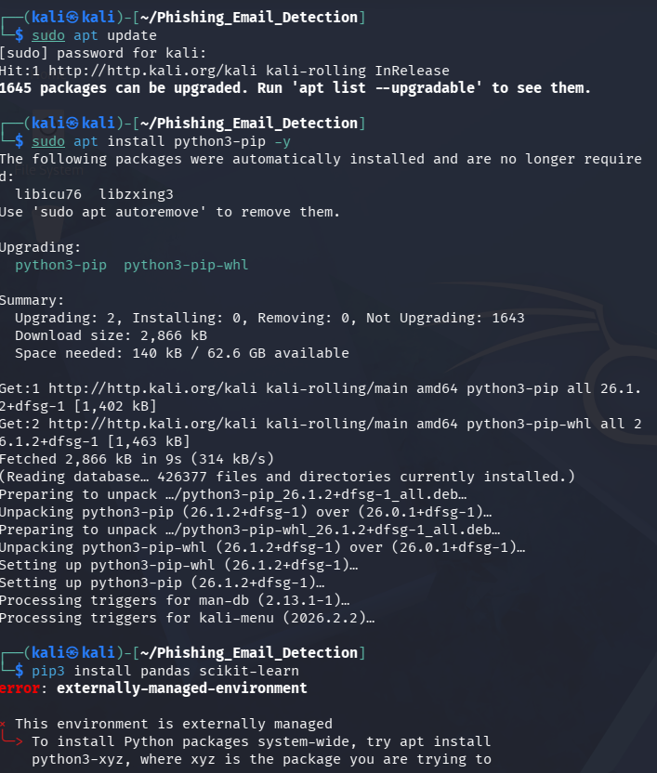
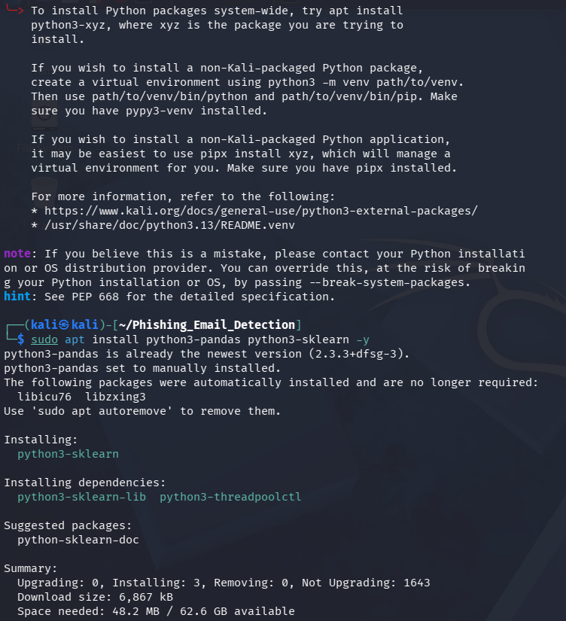
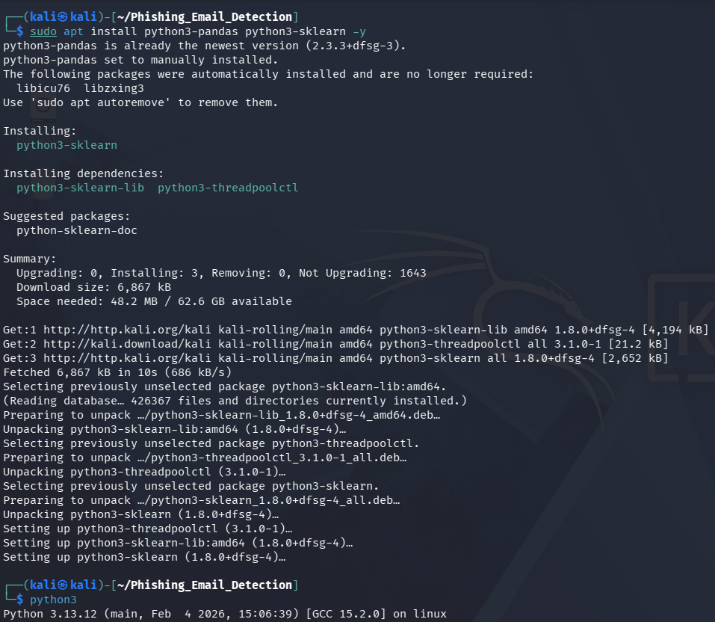
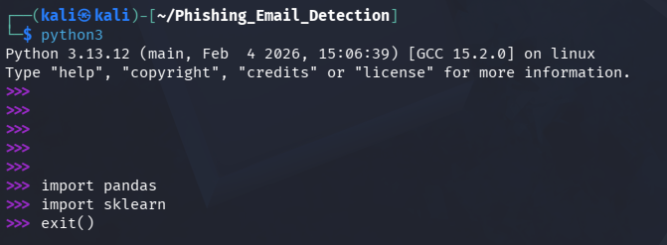

Step 7: Create Python File- #nano phishing_detector.py
Step 8: Paste Python Code - Paste the code

Step 9: Run Program- #python3 phishing_detector.py
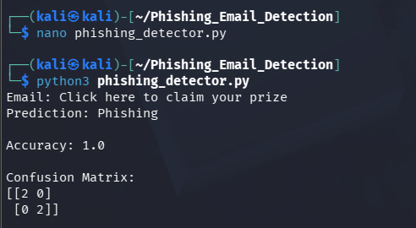
Output:
Email: Click here to claim your prize
Prediction: Phishing

