

Kinematics of machinery

Biaxial Universal Testing



SHREYA SINGH 190103092 hARSH RANA 190103108

Universal Testing Machine

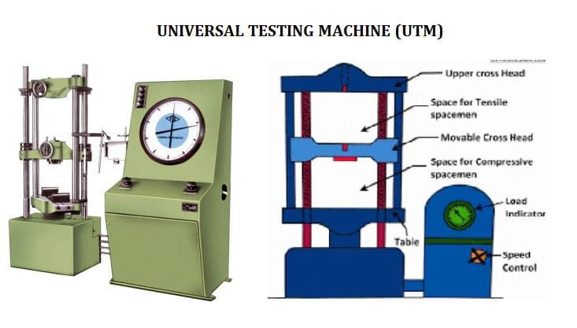

Loading Unit:

* Load Frame
* Upper Crosshead
* Lower Crosshead

Control unit:

* Hydraulic Power unit
* Electromechanical motor
* Variable frequency drive

Sensor Devices:

* Pendulum Dynamometer (To measure the oil flow pressure)
* Load cell (To measure the load applied directly on our specimen)
* Limiting switch (For safety)
* Inductive proximity sensor

The motor will provide a pulsating oil flow which will be channeled through pipes, that will rotate our lead screws resulting in a linear motion of the crossheads.

Biaxial Universal Testing Machine

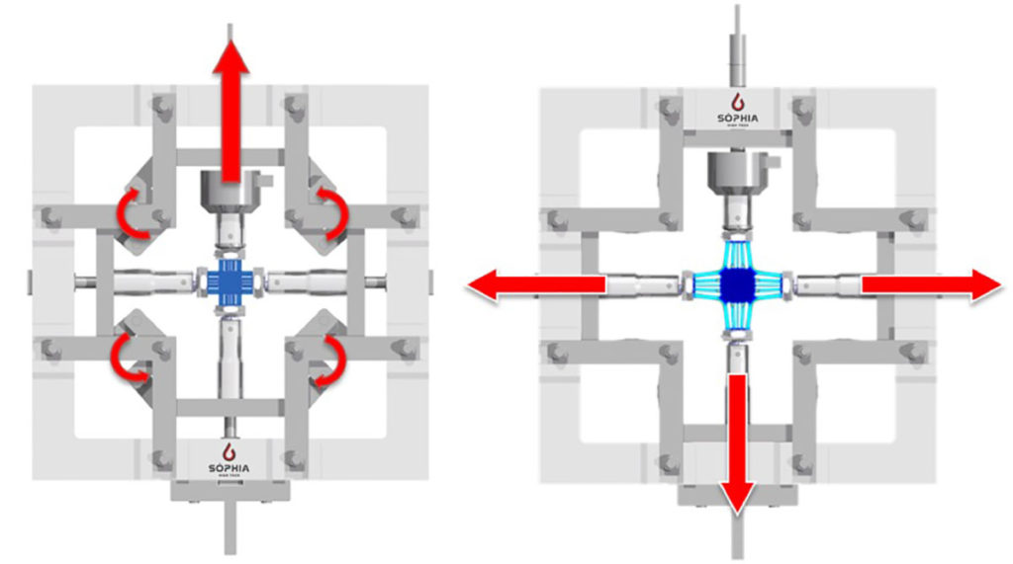

* A machine that can test the tensile and compressive load bearing properties of a sample along two axes.
* When a material is Isotropic, we can go for the Uniaxial tests which are sufficient to give accurate results. But when the mechanical behaviour of the material is quite complex, Uniaxial tests are not enough to properly characterise it.
* Biaxial testing is basically used to get the characterization of the material that has Anisotropic behaviour or different responses for tensile and compressive loadings.
* For instance, polymers behave differently under the tensile and compressive loadings. Thus Multiaxial (Bi-axial) testing make it possible to obtain a wider knowledge of the material.
* Bi-axial testing thus provides the balance between the significance and the complexity of the results.
* This testing is valid for both Static and Dynamic loading tests, the latter being particularly interesting for High frequency multiaxial fatigue testing and also for Strain rate dependent materials.
* Biaxial testing method is used to get the microscopic information on the Elastoplastic deformation of a thin steel specimen and improve the accuracy of the plastic processing of steel materials.

Importance of Biaxial Universal Testing Machine

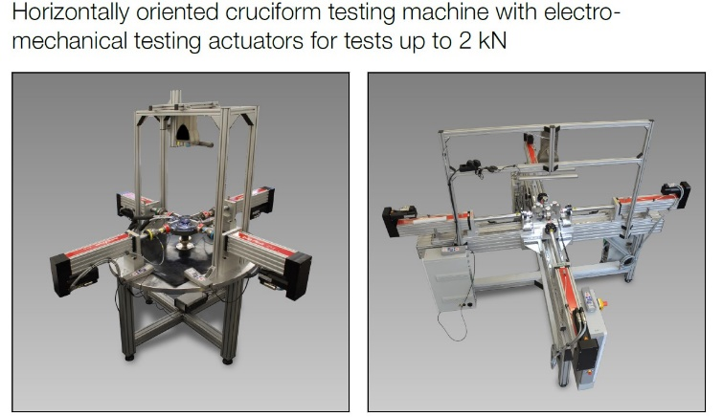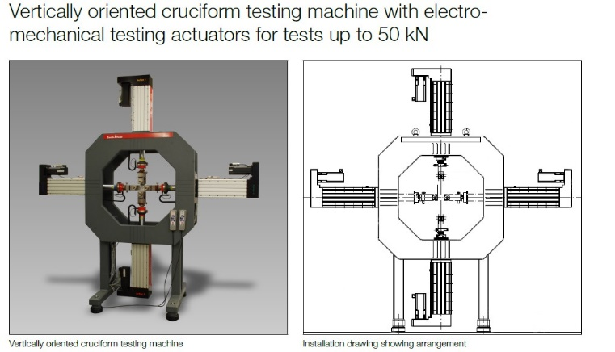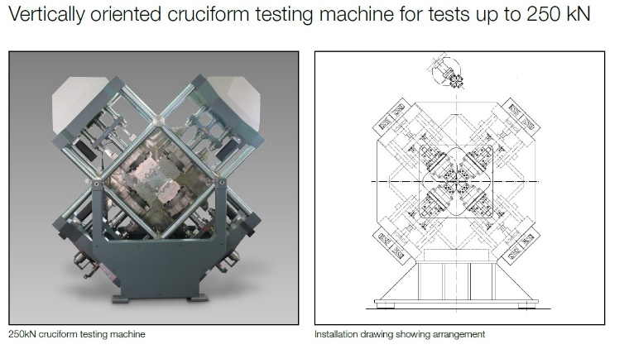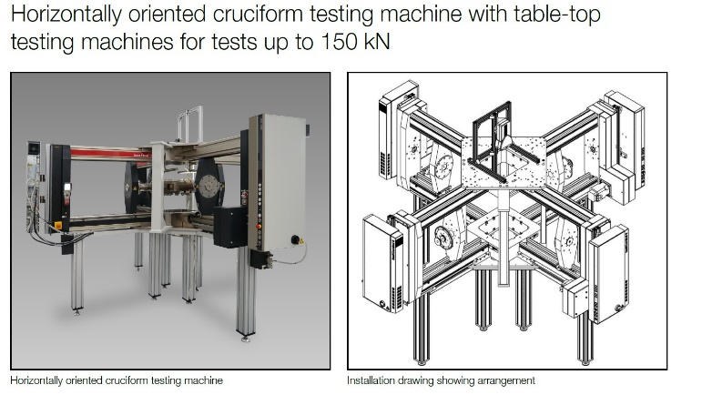

Examples

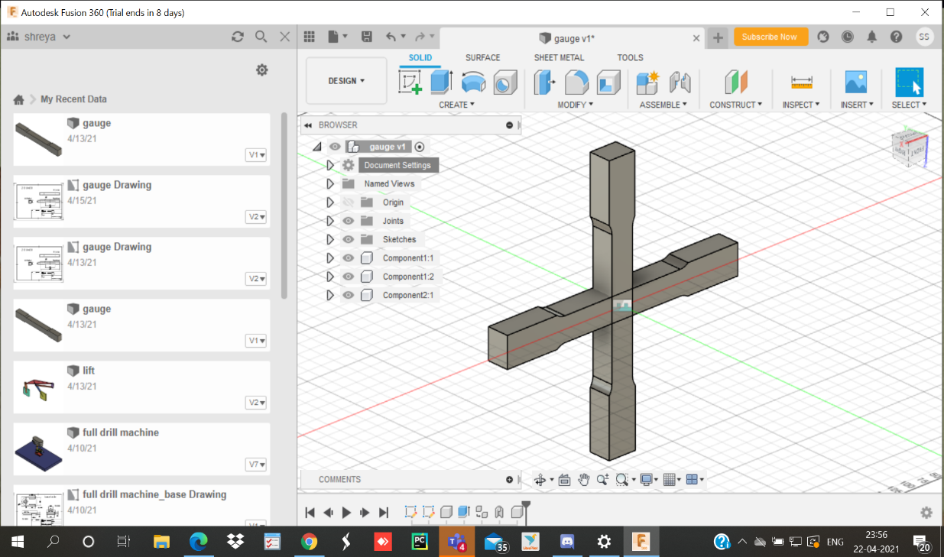

* Sample is in plus configuration with one arm to be attached to the vertical chucks and other to be attached to the Horizontal chucks.
* Such sample provides us much more accurate results.

Sample

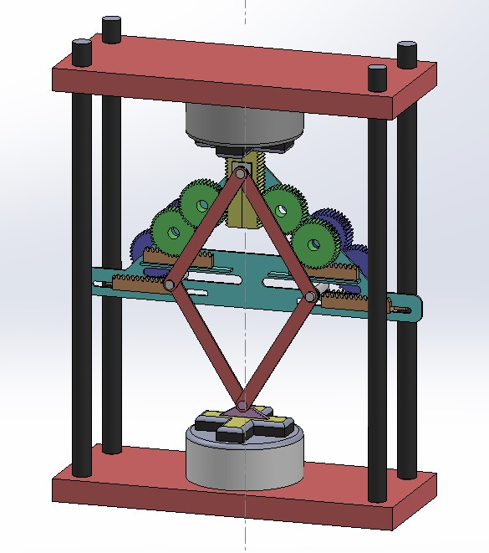

Prototype – 1

* A mechanism that can be retrofitted onto the Universal Testing Machine.
* This mechanism only uses the linear motion of the Upper Cross head to convert it into two equal Biaxial motions.
* Here we are using the constant Displacement type scheme to ensure that the specimen deforms equally on both the axes.

4- bar mechanism

* Mechanism to keep the Specimen-centre at the intersection of the line passing through the horizontal and the vertical axes (chucks)
* This is to ensure that the specimen always remains in its plus configuration and the angles between both the specimen axes always stays 90 degrees.

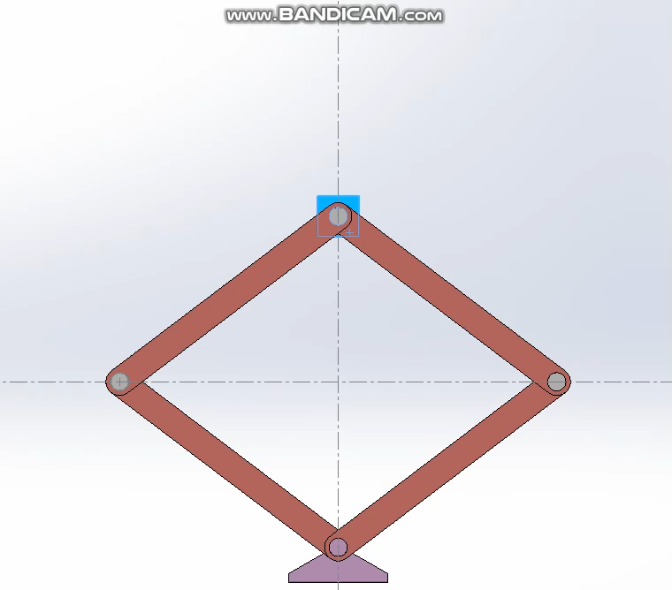

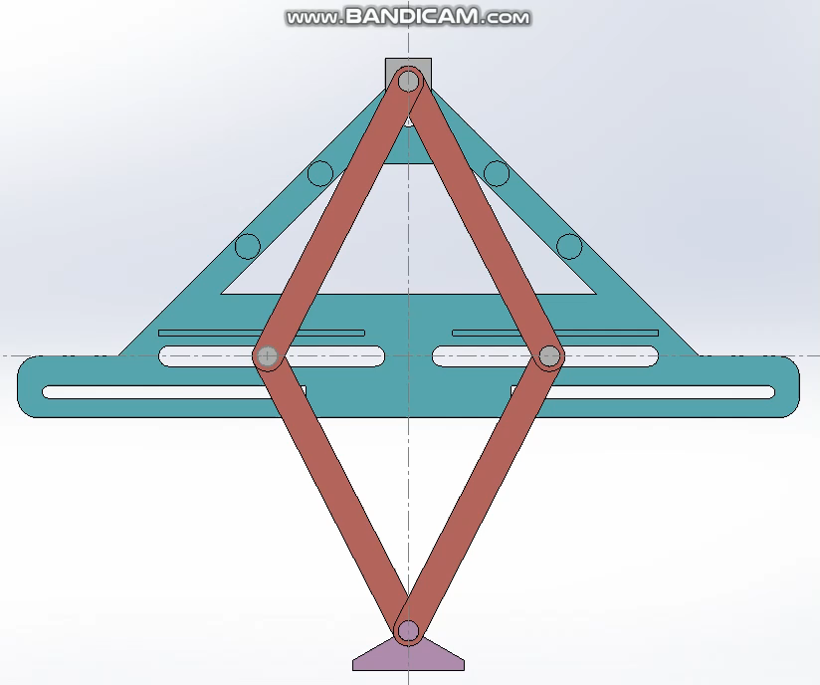

* This plate provides the rigid base to the Gear mechanisms that will be attached to it.
* It also moves up and down as it is attached to the 4-bar mechanism, this again, is to ensure that the centre of the specimen remains at the chuck axes intersection.

Triangular plate

Gear Mechanism

* The Rack gear on the top is directly attached to the chuck of the Upper crosshead, hence can move linearly Up and Down.
* This Rack is connected to spur gears with 1:1 gear ratio so that the velocity of linear motion in the vertical axis is equal to the linear velocity in the horizontal direction.
* This is done as we were following constant displacement scheme.

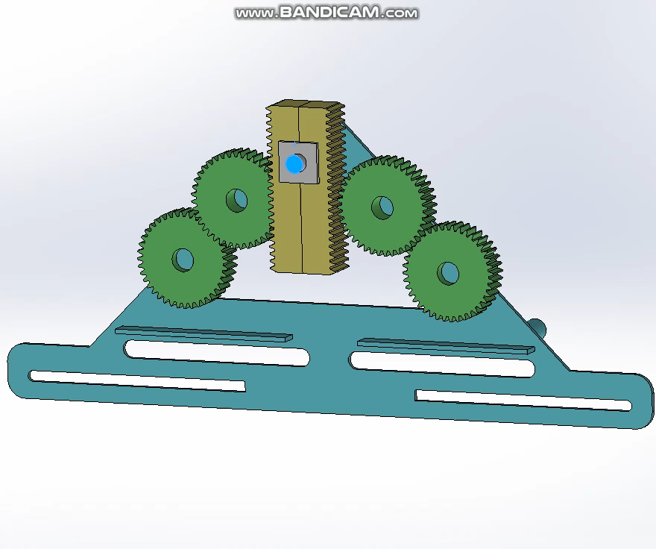

* The Spur gears are again attached with the Rack gear.
* We can see that the horizontal rack gear moves by the same amount as the vertical rack gear.
* Gears were used so as to get precise and accurate motion in the horizontal axis.
* In future prototypes, we may consider using the best method i.e. lead screws to generate a similar mechanism.

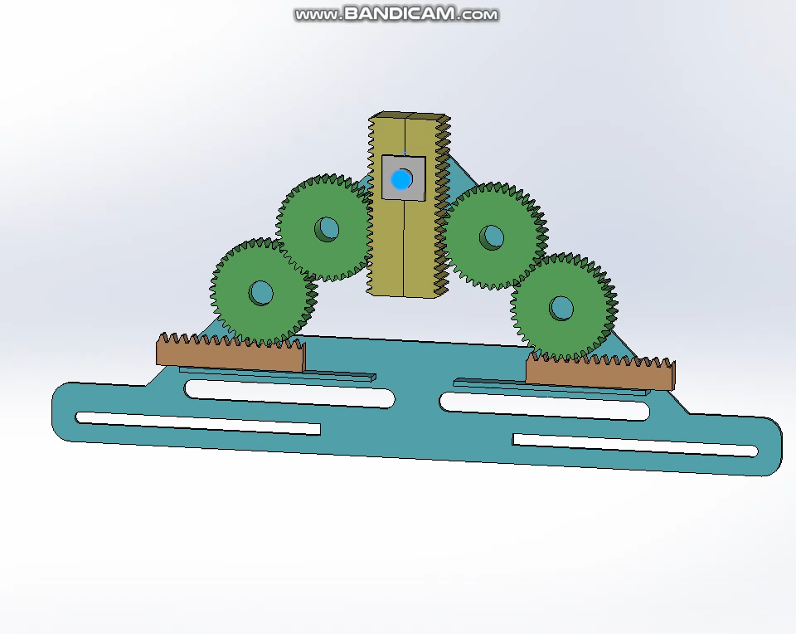

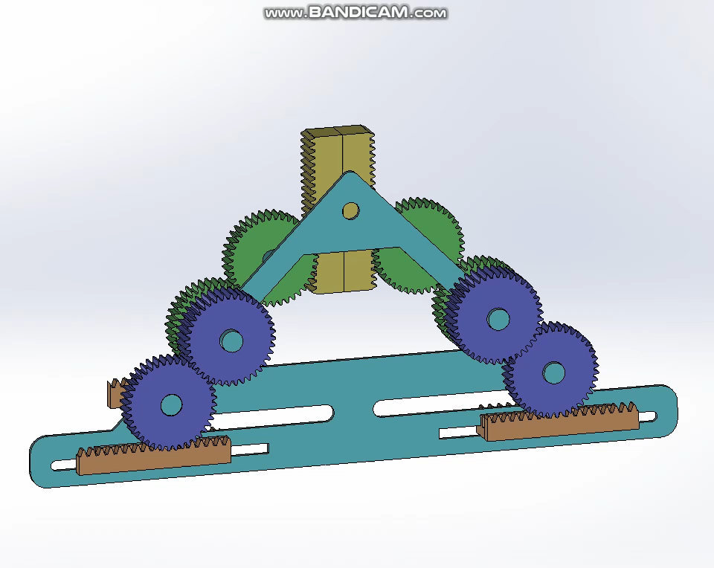

Backside Gears

* In front we had an even number (2) of spur gears. Thus, a compression in the vertical rack would cause compression in the horizontal racks as well, and vice versa.
* At the back we have an odd number (3) of spur gears. Thus, a compression in the vertical rack would cause expansion in the horizontal racks and vice versa.
* Hence, we successfully got our both desirable compression-compression and compression-expansion conditions.

Chuck Attachments

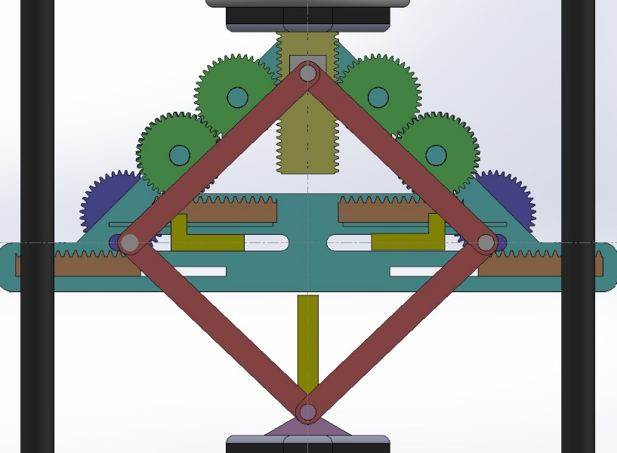

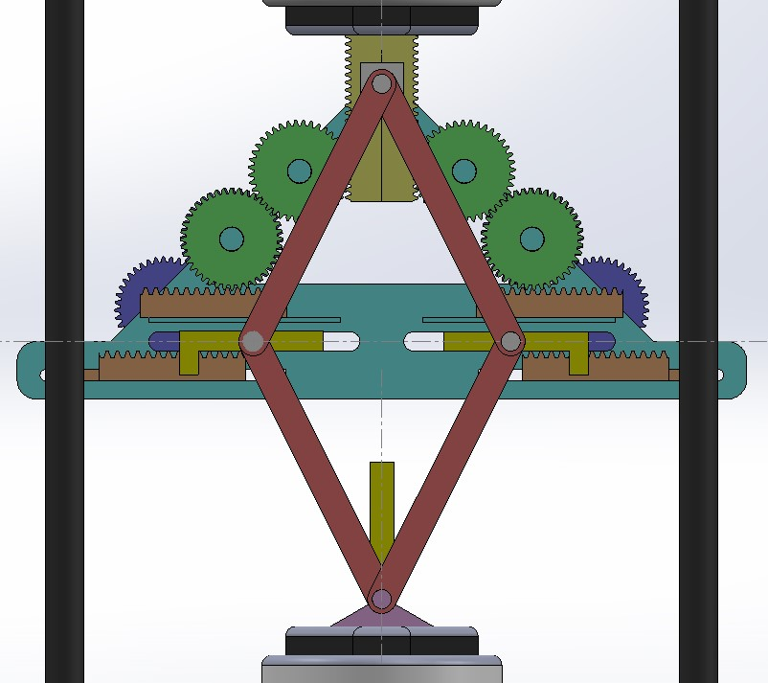

Future Improvements

* Instead of gears, to use lead screws for best results
* To develop a lever mechanism so that we can change the position of the horizontal chucks from upper horizontal racks to lower horizontal racks.
* To make this model 3D printable.