 | SCTR’s PUNE INSTITUTE OF COMPUTER TECHNOLOGY, PUNE - 411043
 | DEPARTMENT OF ELECTRONICS & TELECOMMUNICATION ENGINEERING

Lab Practice -2 [404184C] : ELECTIVE-III(C) - JavaScript
ACADEMIC YEAR: 2024-25
CLASS | : BE | DIV | : 7 | Batch | : R-7 | DATE | : 24/09/25
Roll No | 42325 | ABC ID | : |  |  | SEMESTER | : I

Experiment No.: 08
1) HTML:

<!DOCTYPE html>
<html lang="en">
<head>
<meta charset="UTF-8">
<meta name="viewport" content="width=device-width, initial-scale=1.0">
<title>Java Script EXP-08</title>
<link rel="stylesheet" href="exp8.css">
</head>
<body>
<div class="container">
<h1> Experiment 08: Background Color Events</h1>

<h2>Mouse Over Event</h2>
<label>Enter Name: </label>
<input type="text" placeholder=" Write here" id="hoverBox" onmouseover="changeColorOnHover(this)" onmouseout="resetColor(this)">

<h2>Focus Event</h2>
<label>Enter Batch</label>
<input type="text" id="focusInput" onfocus="changeColorOnFocus(this)" onblur="resetInputColor(this)" placeholder="Click here">

<div id="result"></div>

<div class="info">
<h3>Name: Shreya Gawade</h3>
<h3>Batch: R7</h3>
<h3>Roll Number: 42325</h3>
</div>
</div>

<script src="exp08.js"></script>
</body>
</html>

2) CSS:

body {
font-family: Arial, sans-serif;
background-color: #63ddf0;
display: flex;
justify-content: center;
align-items: center;
min-height: 100vh;
margin: 0;
}

h1 {
margin-bottom: 20px;
color: #333;
}

.shape-box h2 {
color: #000000;
}

input {
display: block;
width: 90%;
margin: 8px auto;
padding: 8px;
border: 1px solid #0b0b0b;
border-radius: 4px;
}

.info {
margin-top: 15px;
}

.info h3 {
margin: 3px;
color: #000700;
}

3) JavaScript:
function changeColorOnHover(element) {
element.style.backgroundColor = "#4fff5bff";
document.body.style.backgroundColor = "#4fff5bff";
document.getElementById("result").innerHTML= "Mouse over detected: Background changed!";
}

function resetColor(element) {
element.style.backgroundColor = "#ffffff";
document.body.style.backgroundColor = "#63ddf0";
document.getElementById("result").innerHTML = "Mouse out: Background reset.";
}

function changeColorOnFocus(input) {
input.style.backgroundColor = "#f682b6ff";
document.getElementById("result").innerHTML = "Focus detected: Input background changed!";
}

function resetInputColor(input) {
input.style.backgroundColor = "#ffffff";
document.getElementById("result").innerHTML = "Blur detected: Input background reset.";
}

3) Output:
CASE 1: Default Webpage Setup
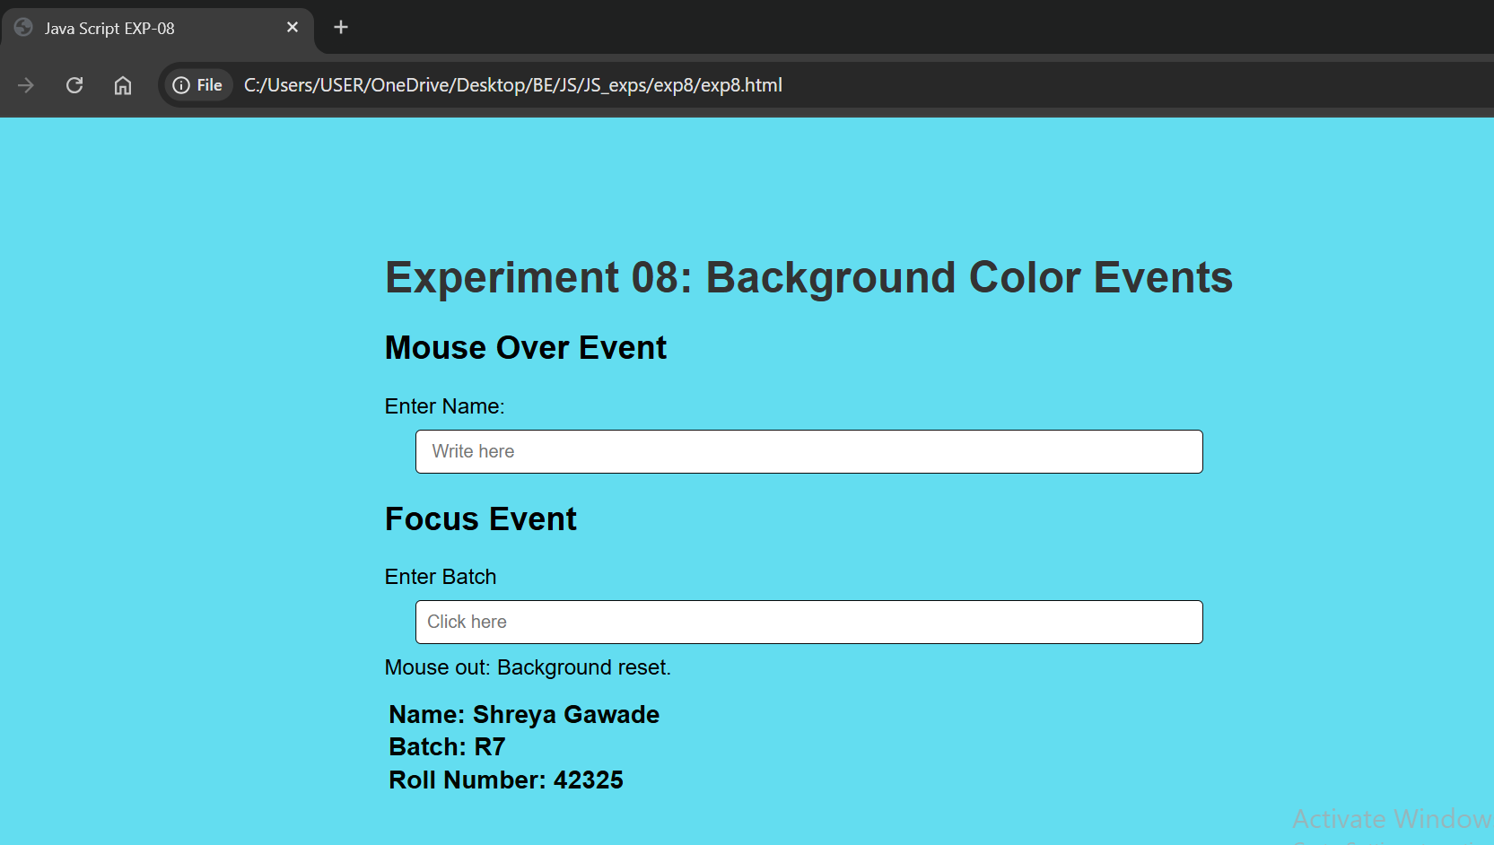

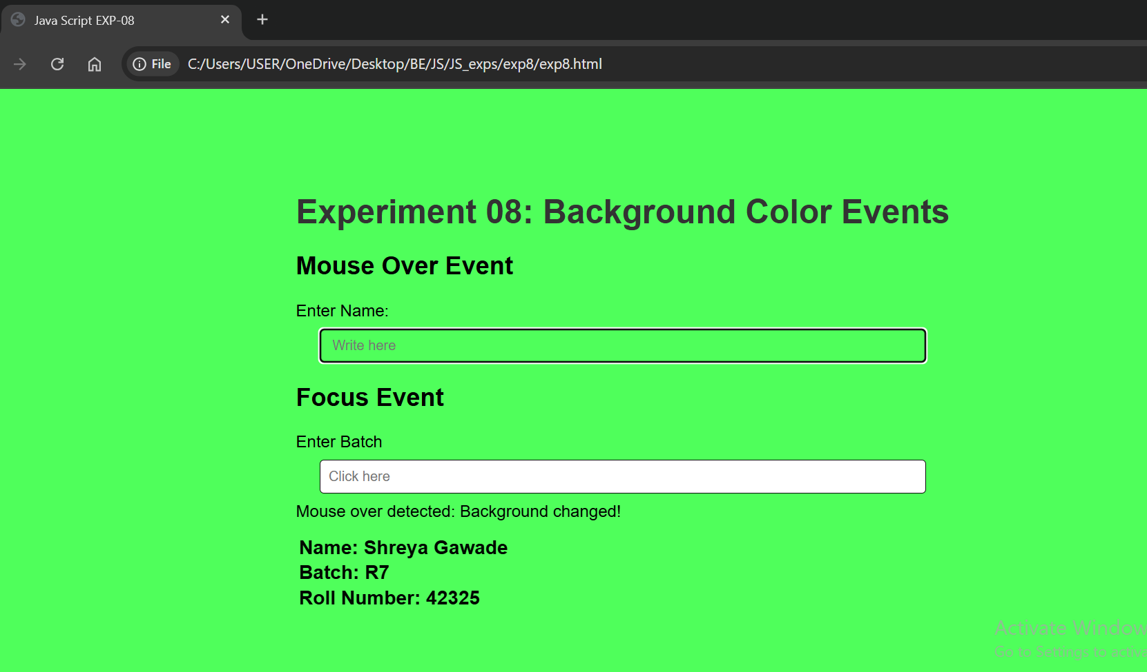
CASE 2: On Mouse Over Event Webpage

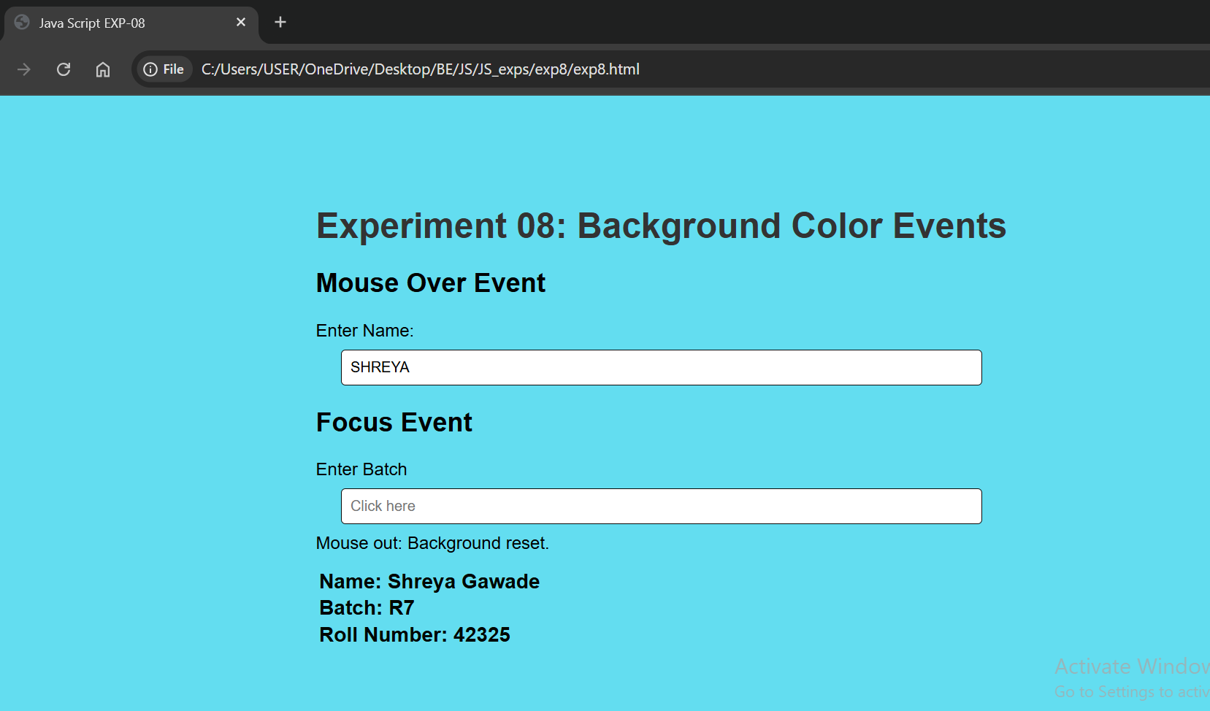
CASE 3: On Mouse Out Event Webpage

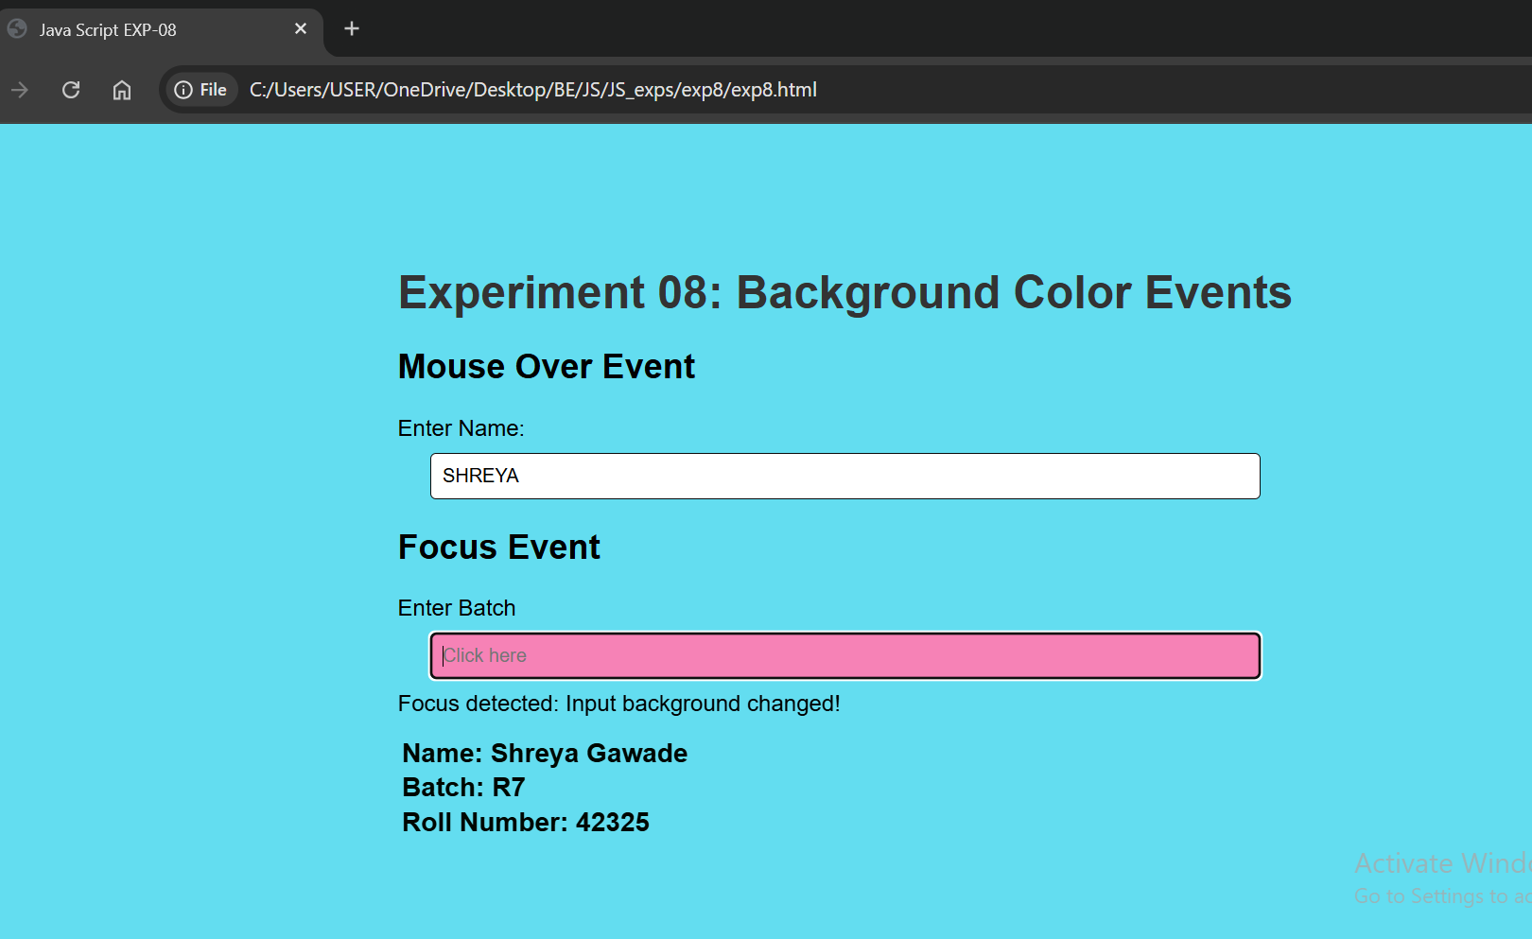
CASE 4: On Focus Event Webpage

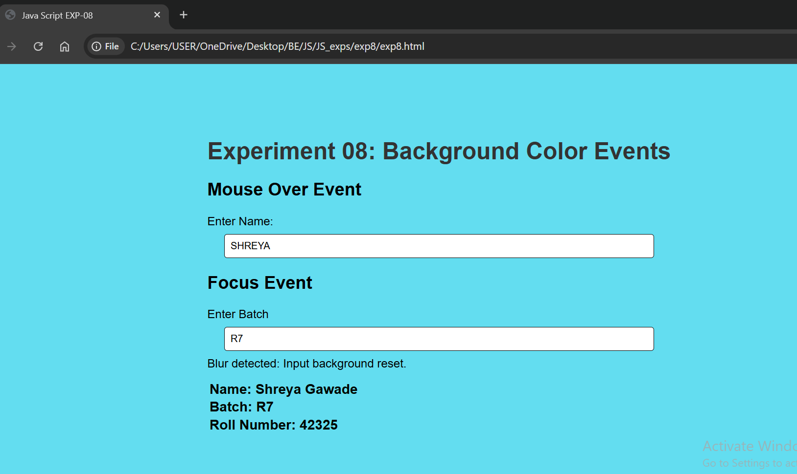
CASE 5: On Blur Event Webpage
Date: |  | Course Teacher Sign

