**FOLLOWING ARE THE BASIC PROGRAMS IN C LANGUAGE:**

1.PROGRAM TO PRINT “HELLO WORLD”

2.PROGRAM TO PRINT “BASIC INTRODUCTION”

3.PROGRAM TO CALCULATE “SIMPLE INTEREST”

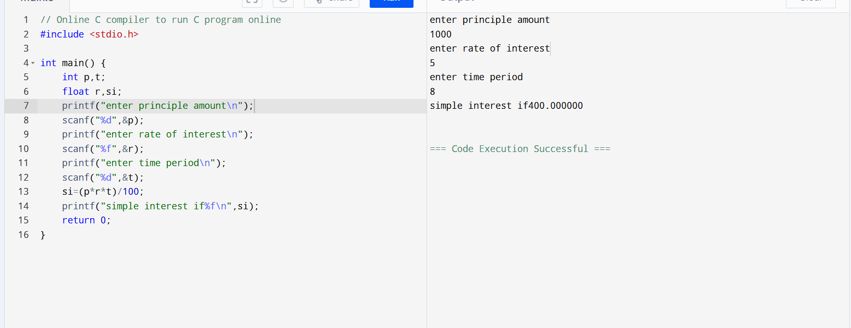

4.PROGRAM TO CALCULATE “AREA OF A CIRCLE”

5.PROGRAM TO CONVERT THE TEMPERATURE FROM

“ CELSIUS TO FAHRENHEIT”

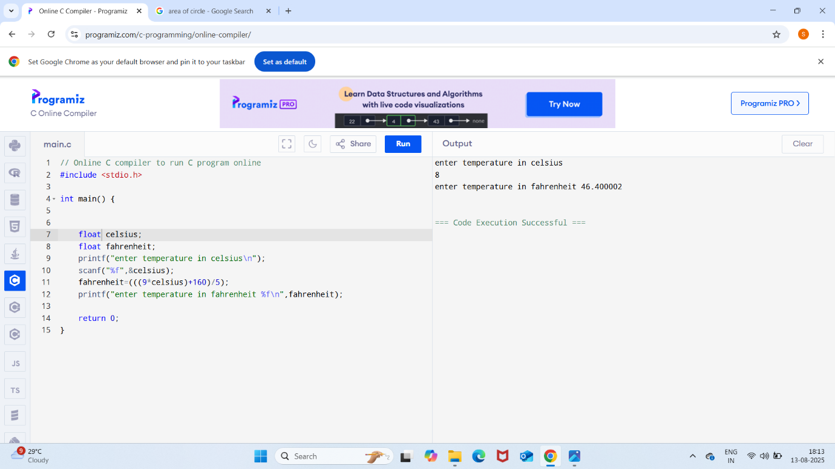

6.PROGRAM TO CONVERT THE TEMPERATURE FROM “FAHRENHEIT TO CELSIUS”

7.PROGRAM TO “SWAP TWO NUMBERS”

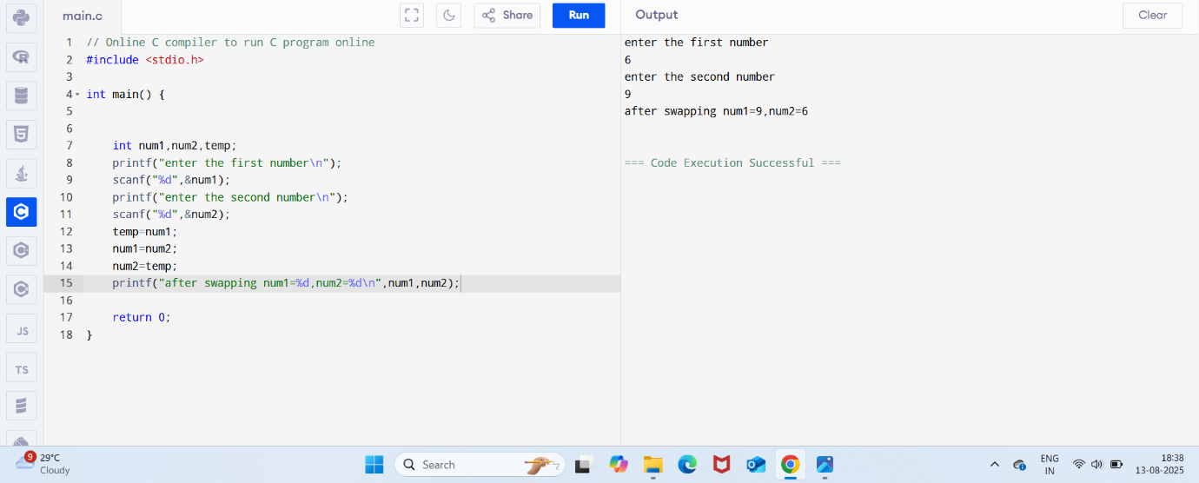

8.PROGRAM TO CALCULATE “AREA AND PERIMETER OF RECTANGLE”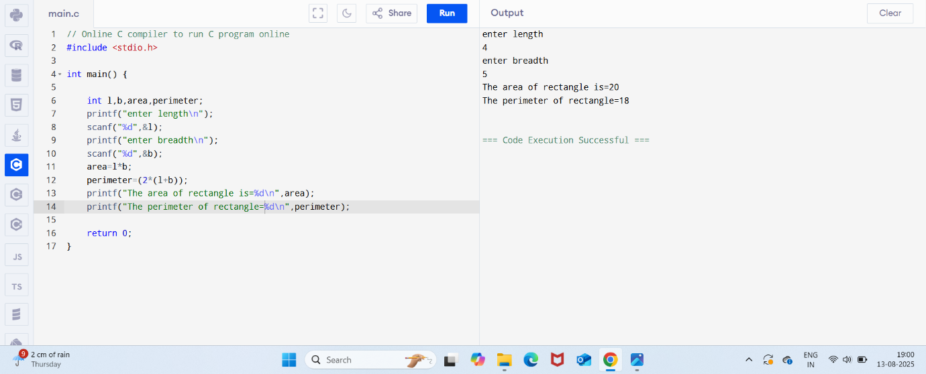

9.PROGRAM TO CALCULATE BASIC CALCULATION I.E.”

SIMPLE CALCULATOR”

