1. Create a Flask application with an /api route. When this route is accessed, it should return a JSON list. The data should be stored in a backend file, read from it, and sent as a response.

[app.py](http://app.py)

from flask import Flask, request, jsonify, render_template

import json

app = Flask(__name__)

@app.route('/')

def index():

return render_template('index.html')

@app.route('/api')

def get_data():

try:

with open('data.json') as f:

data = json.load(f)

print("Data loaded:", data)

return jsonify(data)

except Exception as e:

print("Error:", e)

return jsonify({"error": str(e)}), 500

if __name__ == '__main__':

app.run(debug=True)

index.html

<!doctype html>

<html>

<head>

<title>Flask API Example</title>

</head>

<body>

<h1>Welcome to Flask API Demo</h1>

<p><a href="/api">Click here to see JSON data</a></p>

</body>

</html>

data.json

[

{"id": 1, "name": "Alice"},

{"id": 2, "name": "Bob"},

{"id": 3, "name": "Charlie"}

]

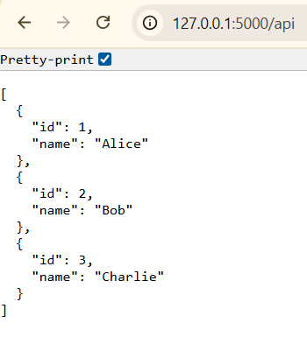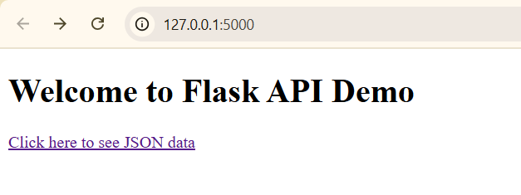

2. Create a form on the frontend that, when submitted, inserts data into MongoDB Atlas. Upon successful submission, the user should be redirected to another page displaying the message "Data submitted successfully". If there's an error during submission, display the error on the same page without redirection.

[app.py](http://app.py)

from flask import Flask, render_template, request, redirect, url_for

from pymongo import MongoClient, errors

app = Flask(__name__)

client = MongoClient("mongodb://localhost:27017/")

db = client["DevOps"]

collection = db["ArtGallery"]

@app.route("/", methods=["GET", "POST"])

def gallery_form():

error = None

if request.method == "POST":

art_title = request.form.get("art_title")

artist_name = request.form.get("artist_name")

year_created = request.form.get("year_created")

medium = request.form.get("medium")

price = request.form.get("price")

try:

if not art_title or not artist_name:

raise ValueError("Artwork title and artist name are required.")

collection.insert_one({

"art_title": art_title,

"artist_name": artist_name,

"year_created": year_created,

"medium": medium,

"price": price

})

return redirect(url_for("success"))

except (errors.PyMongoError, ValueError) as e:

error = str(e)

return render_template("gallery_form.html", error=error)

@app.route("/success")

def success():

return render_template("success.html")

if __name__ == "__main__":

app.run(debug=True)

success.html

<!DOCTYPE html>

<html>

<head>

title>Success</title>

</head>

<body>

<h1>Data submitted successfully!</h1>

<a href="/">Submit another artwork</a>

</body>

</html>

gallery_form.html

<!DOCTYPE html>

<html>

<head>

<title>Art Gallery Submission</title>

</head>

<body>

<h1>Submit Artwork Information</h1>

{% if error %}

<p style="color: red;">{{ error }}</p>

{% endif %}

<form method="POST">

<label>Artwork Title:</label><br>

<input type="text" name="art_title"><br><br>

<label>Artist Name:</label><br>

<input type="text" name="artist_name"><br><br>

<label>Year Created:</label><br>

<input type="text" name="year_created"><br><br>

<label>Medium:</label><br>

<input type="text" name="medium"><br><br>

<label>Price (optional):</label><br>

<input type="text" name="price"><br><br>

<button type="submit">Submit Artwork</button>

</form>

</body>

</html>

