1. Create a new GitHub repository.

* Clone the repository to your local machine using SSH (generate an SSH key if needed, add the public key to your GitHub account).

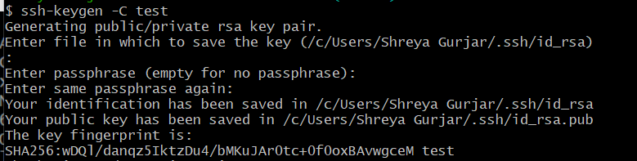

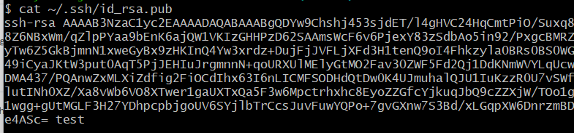

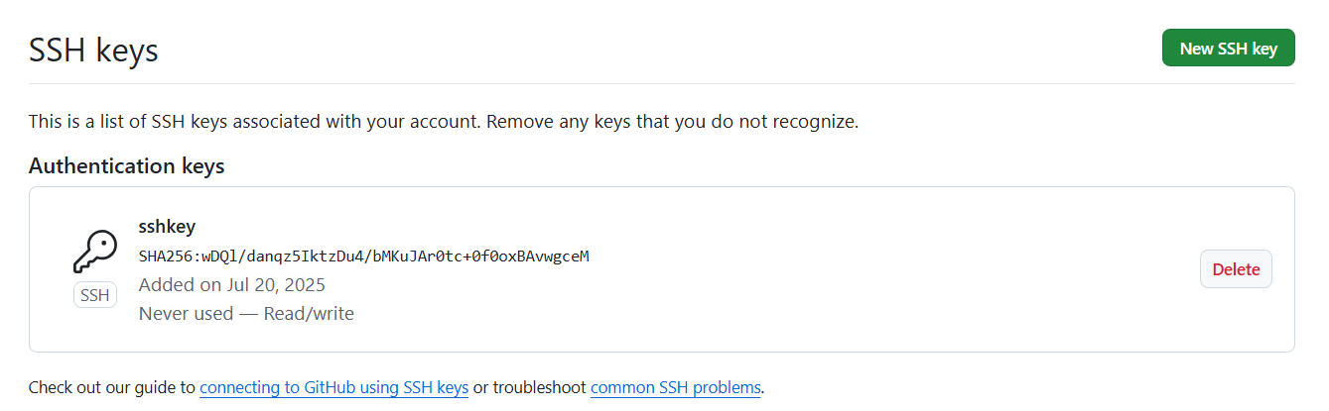

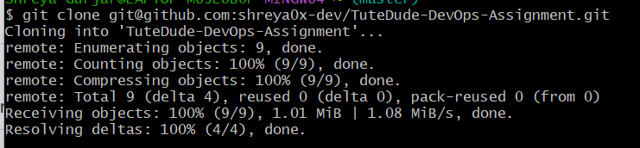

* Create a new branch named after your username (e.g., Tutedude).

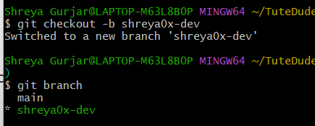

* Add your Flask project files to this branch.

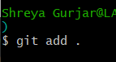

* Commit the changes and merge the branch into the main branch.

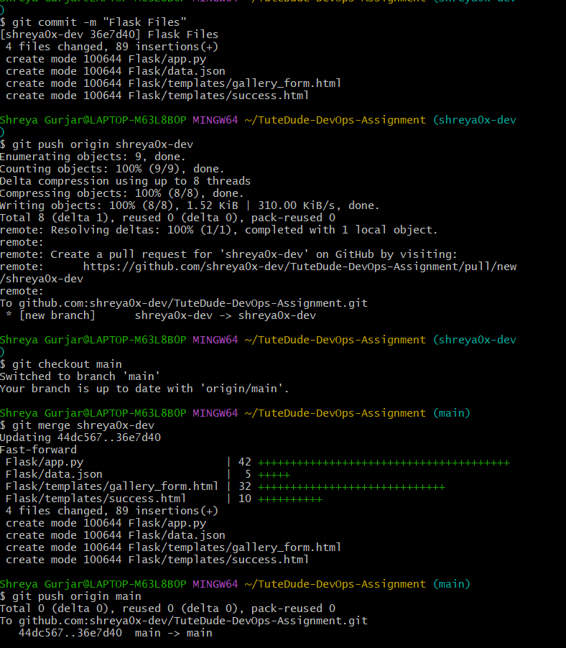

2. Create a new branch named <your_name>_new (e.g., Tutedude_new).

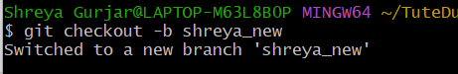

* Update the content of the JSON file used for the /api route in this branch.

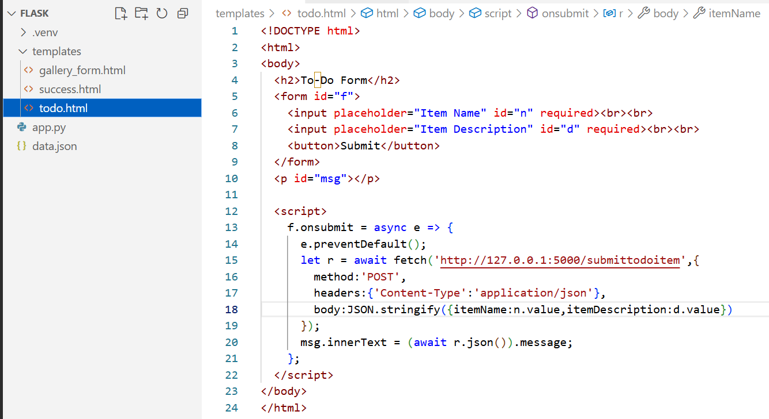

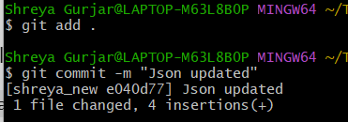

* Merge the <your_name>_new branch into the main branch.

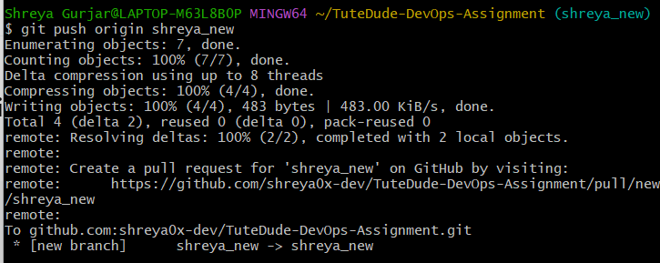

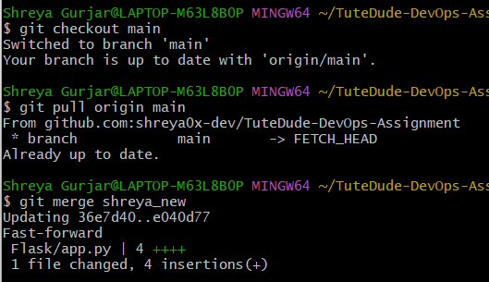

3. Branch Creation:

* Create two branches: master_1 and master_2 from the main branch.

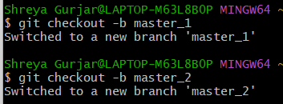

* Feature Development in master_1:
* In the master_1 branch, create a To-Do Page in the frontend.
  + The page should contain a form with the following fields:
    - Item Name
    - Item Description

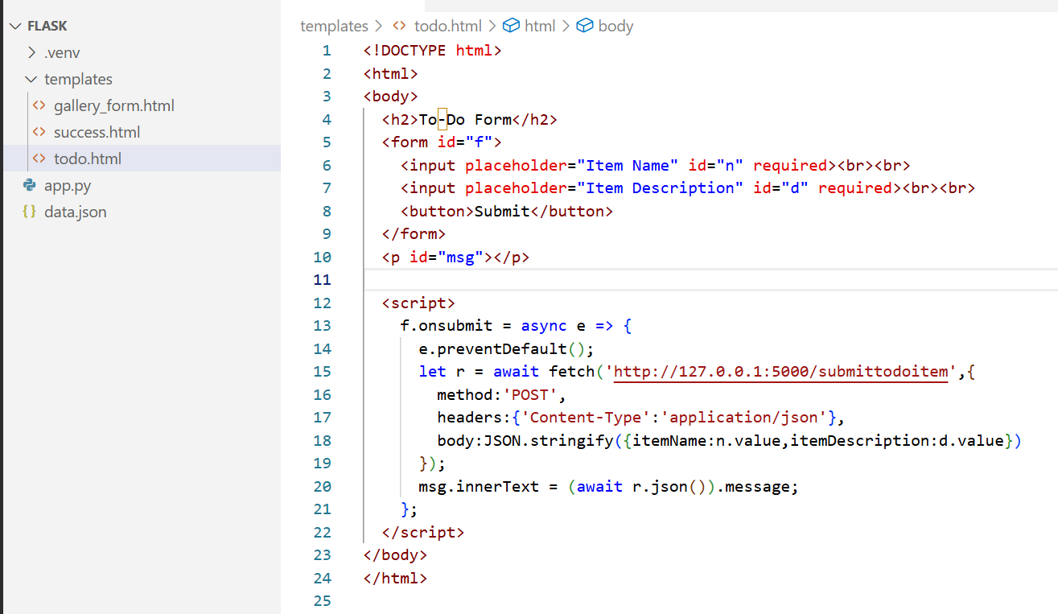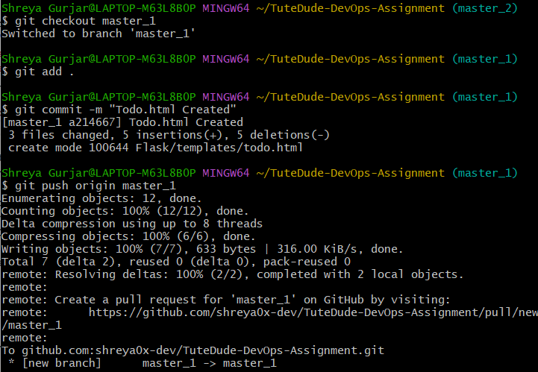

* Backend API in master_2:
* In the master_2 branch, create a backend route named /submittodoitem.
* This route will:
  + Accept itemName and itemDescription via a POST request.
  + Store these details in a MongoDB database.

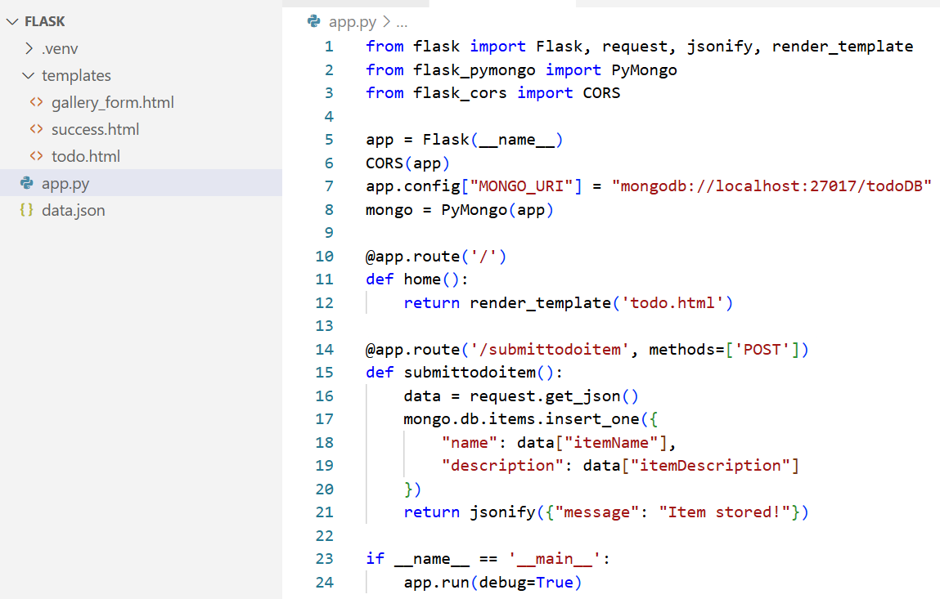

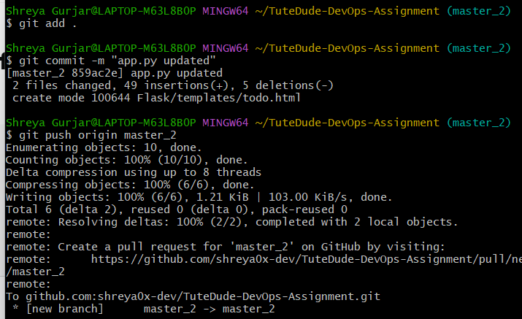

* Merging Changes:
* Merge the changes from both master_1 and master_2 into the main branch.

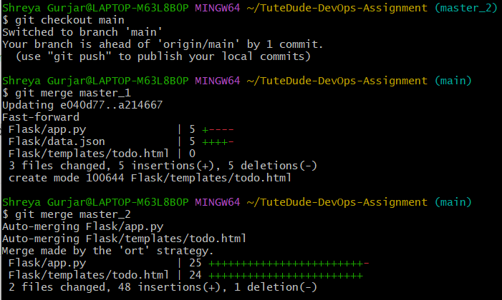



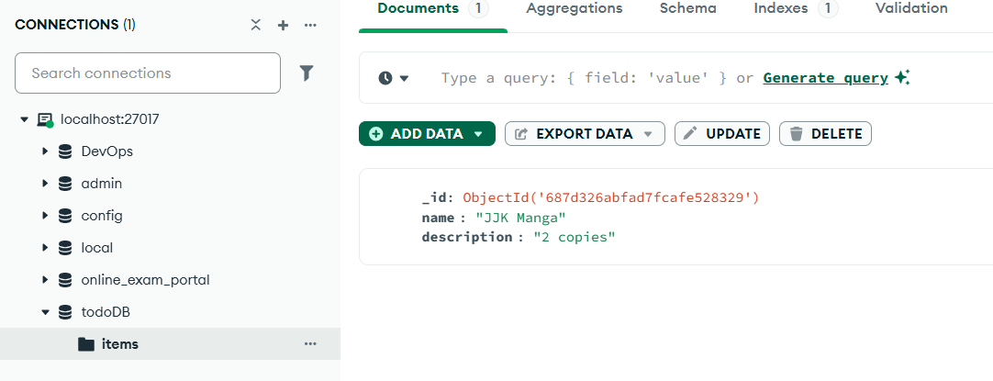

4. Enhancing the To-Do Form in master_1:

* In the master_1 branch, add the following fields to the To-Do form:
  + Item ID
  + Item UUID
  + Item Hash

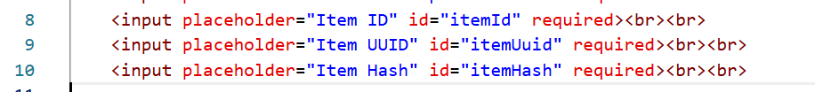

* Committing in Sequence:
* Add and commit each field separately in the following order:
  + First commit: Add Item ID field.
  + Second commit: Add Item UUID field.
  + Third commit: Add Item Hash field.

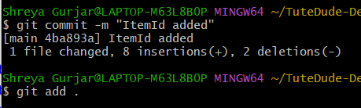

* Merging to main:
* Merge the master_1 branch into the main branch.



* Git Reset and Commit Deletion:
* In the main branch, use Git Reset to roll back to the commit where only the Item ID field was added.

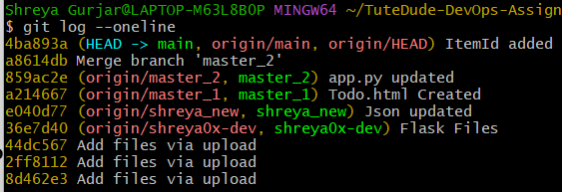

* Use git reset --soft to ensure changes remain staged.



* Re-commit this state to the main branch.

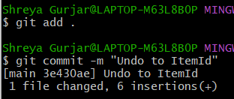

* Merge this updated state to the main branch.

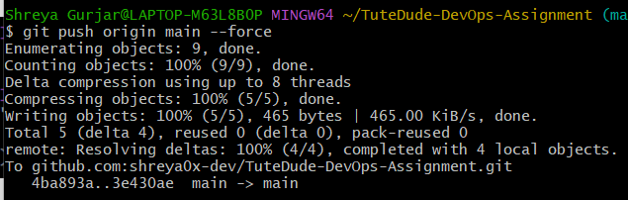

* Rebasing Changes:
* Rebase the updated changes in the main branch to the master_1 branch.  
  Clarification:
  + During rebasing, preserve individual commits to maintain the commit history for each change (i.e., do not squash commits).
  + Use git rebase main master_1 to integrate changes from the main branch back into the master_1 branch.

