1. Creating and Renaming Files/Directories

1. Create a directory named test_dir using mkdir.

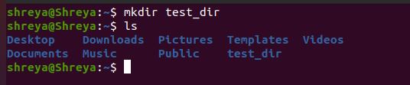

*Creates a new directory named test_dir in the current location.*

1. Inside test_dir, create an empty file called example.txt.

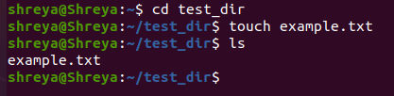

*Creates an empty text file named example.txt inside test_dir.*

1. Rename example.txt to renamed_example.txt using mv

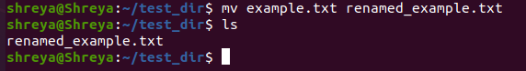

*Renames the file example.txt to renamed_example.txt within the same directory.*

2. Viewing File Contents

1. Use cat to display the contents of /etc/passwd.

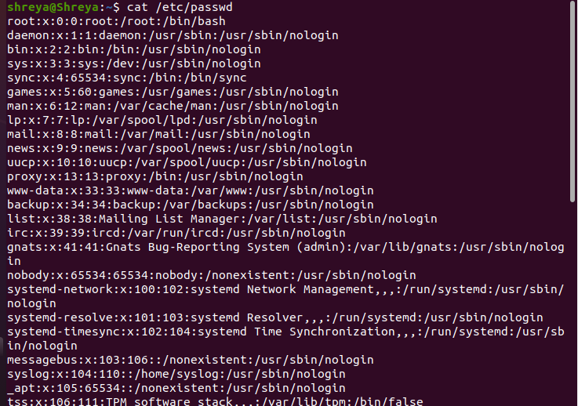

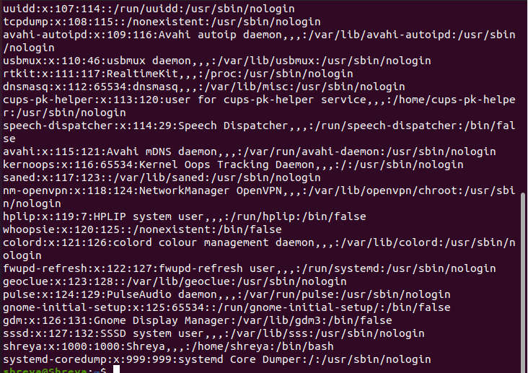

*Displays the full content of /etc/passwd, a file that stores user account information.*

1. Display only the first 5 lines of /etc/passwd using head.

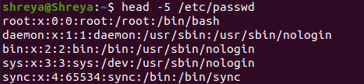

*Shows the first 5 lines of /etc/passwd, often showing root and system users.*

1. Display only the last 5 lines of /etc/passwd using tail.

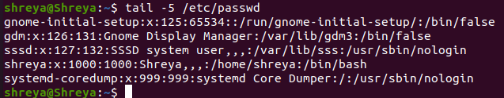

*Displays the last 5 lines, usually showing the most recently added users.*

3.Searching for Patterns

1. Use grep to find all lines containing the word "root" in /etc/passwd.

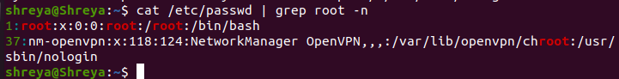

*Searches for all lines containing the word "root" in /etc/passwd, helping identify the root user and related entries.*

4. Zipping and Unzipping

1. Compress the test_dir directory into a file named test_dir.zip using zip.

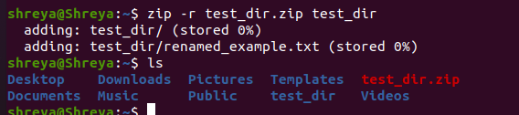

*Recursively compresses the test_dir folder and all its contents into a zip archive named test_dir.zip.*

1. Unzip test_dir.zip into a new directory named unzipped_dir.

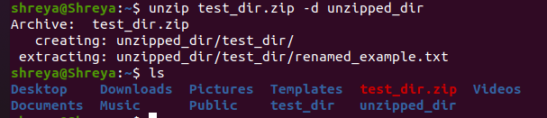

*Extracts the contents of test_dir.zip into a new directory called unzipped_dir.*

5. Downloading Files

1. Use wget to download a file from a URL (e.g., <https://example.com/sample.txt>).

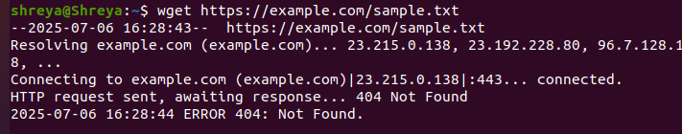

*Downloads a file from the specified URL and saves it in the current directory. It’s useful for getting files directly from the web.*

*File doesn't exist*

6. Changing Permissions

1. Create a file named secure.txt and change its permissions to read-only for everyone using chmod.

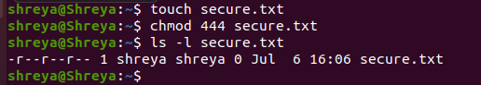

*Creates a file named secure.txt and sets its permission to read-only for owner, group, and others. No one can edit it unless permissions are changed.*

*The chmod 444 command sets:*

* *4 (read permission) for owner*
* *4 (read) for group*
* *4 (read) for others*

*This makes the file read-only for everyone.*

7. Working with Environment Variables

1. Use export to set a new environment variable called MY_VAR with the value "Hello, Linux!".

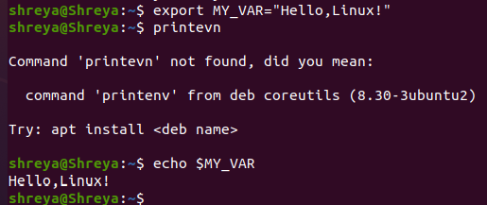

*export: Makes the variable available to child processes (like scripts or other programs run from the shell).*

*MY_VAR: The name of your environment variable.*

*"Hello, Linux!": The value assigned to MY_VAR.*