1. Grade Checker

Take a score as input and print the grade based on the following:

90+ : "A"

80-89 : "B"

70-79 : "C"

60-69 : "D"

Below 60 : "F"

here we used a basic if else statement to carry out marks and all.

CODE:

*for i in range(5):*

*score = int(input("Enter your score: "))*

*if score >= 90:*

*print("A")*

*elif score >= 80:*

*print("B")*

*elif score >= 70:*

*print("C")*

*elif score >= 60:*

*print("D")*

*else:*

*print("F")*

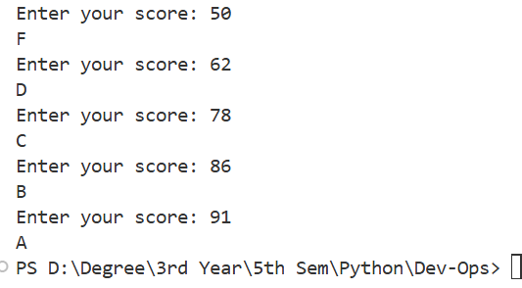

*The is a loop that runs 5 times.Each time, it asks the user to enter a score.*

*User input (score) as a number using int() is taken.*

*elif checks the score and prints the grade*

2. Student Grades

Create a dictionary where the keys are student names and the values are their grades. Allow the user to:

Add a new student and grade.

Update an existing student’s grade.

Print all student grades.

Used dictionary and basic operations. Using if else:

CODE:

*students = {}*

*while True:*

*print("\nChoose an option:")*

*print("1. Add a new student")*

*print("2. Update a student's grade")*

*print("3. Print all student grades")*

*print("4. Exit")*

*choice = input("Enter your choice (1-4): ")*

*if choice == "1":*

*name = input("Enter student name: ")*

*if name in students:*

*print("Student already exists.")*

*else:*

*grade = input("Enter grade: ")*

*students[name] = grade*

*print("Student added successfully.")*

*elif choice == "2":*

*name = input("Enter student name to update: ")*

*if name in students:*

*grade = input("Enter new grade: ")*

*students[name] = grade*

*print("Grade updated successfully.")*

*else:*

*print("Student not found.")*

*elif choice == "3":*

*if not students:*

*print("No student data available.")*

*else:*

*print("\n--- Student Grades ---")*

*for name, grade in students.items():*

*print(f"{name}: {grade}")*

*elif choice == "4":*

*print("Exiting program.")*

*break*

*else:*

*print("Invalid choice. Please enter a number between 1 and 4.")*

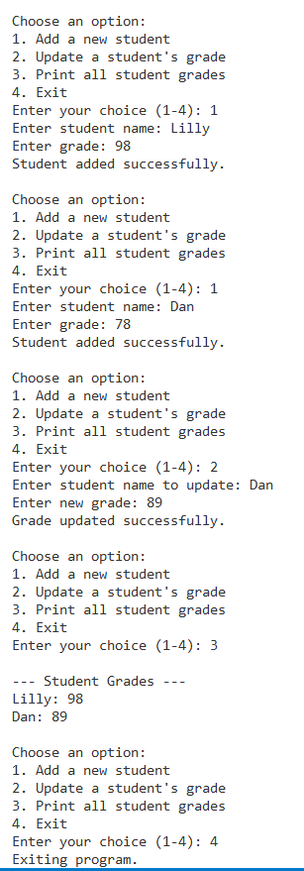

*A while True loop keeps showing the menu until the user chooses to exit.*

*A dictionary (students) stores student names as keys and grades as values.*

*if-elif-else checks user’s menu choice and performs actions: Add, Update, Print, Exit.*

3.Write to a File

Write a program to create a text file and write some content to it.

Using file functions like write and open.

CODE:

*file = open("Saphire.txt", "w")*

*file.write("Touching on your body while you're pushing on me. \n")*

*file.write("Don't you end the party, I could do this all week.\n")*

*file.write("We'll be dancing till the morning, go to bed, we won't sleep.\n")*

*file.write("Cham-cham chamke sitare wargi (Sapphire)\n")*

*file.close()*

*print("Content written to myfile.txt successfully.")*

**

*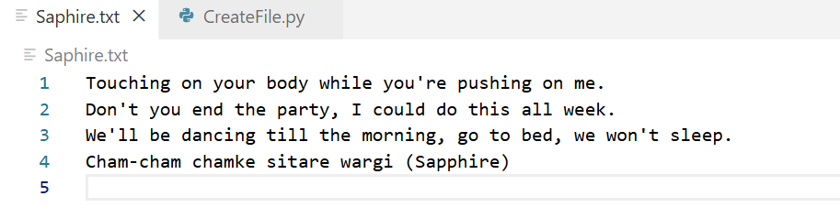*

*Open the file named Saphire.txt in write mode. If it doesn't exist, it will be created. If it does exist, content will be overwritten*

*Writes string content to the file*

*Always close the file to save changes and free resources*

4. Read from a File

We used open in read mode and file.read to read and print to display.

CODE:

*file = open("Saphire.txt", "r")*

*content = file.read()*

*print("File content:\n")*

*print(content)*

*file.close()*

*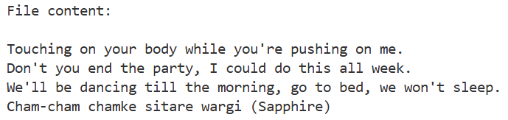*

*"r" → Read mode (default if no mode is specified)*

*Reads the whole file as a single string*

*Always use file.close() to properly close the file*