**Function in python**

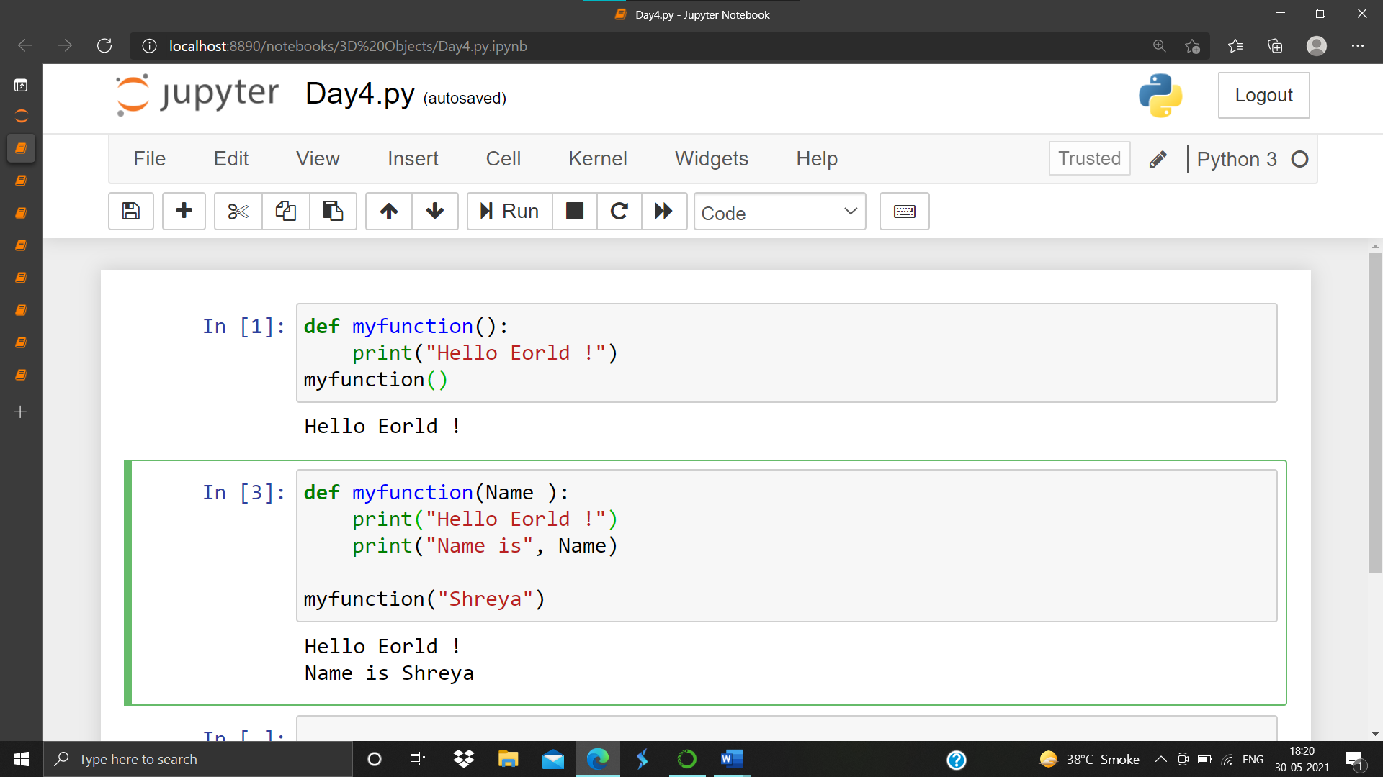

**Return Statement**

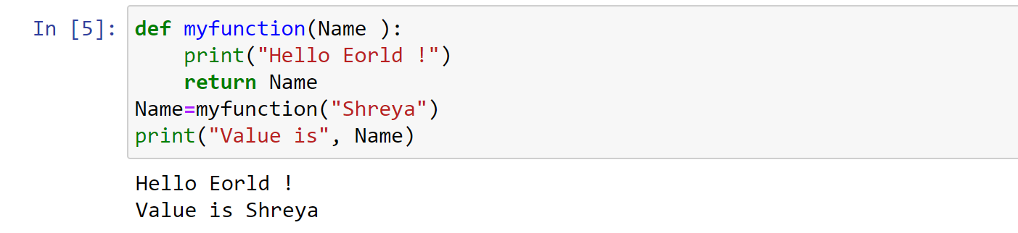

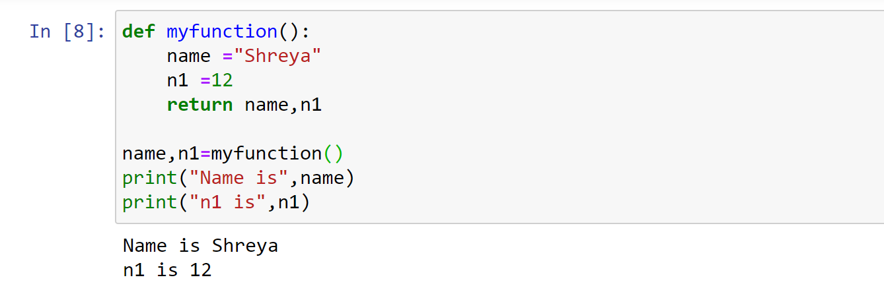

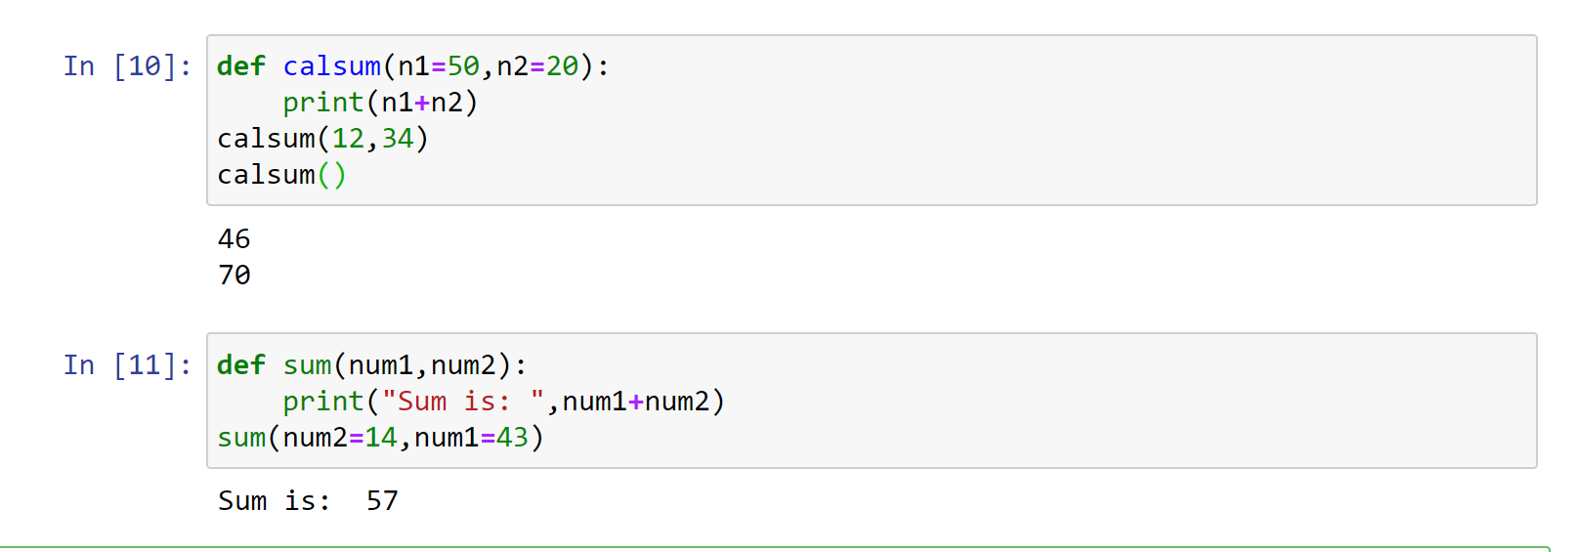

**Non Keyword Arguments and Keyword Argument**

Keyword


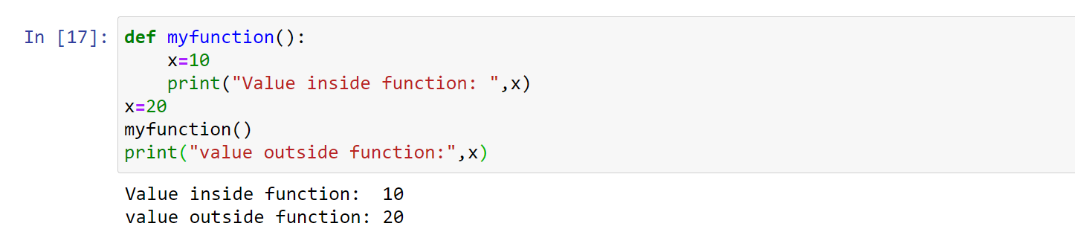

**Arithmetic Operator**

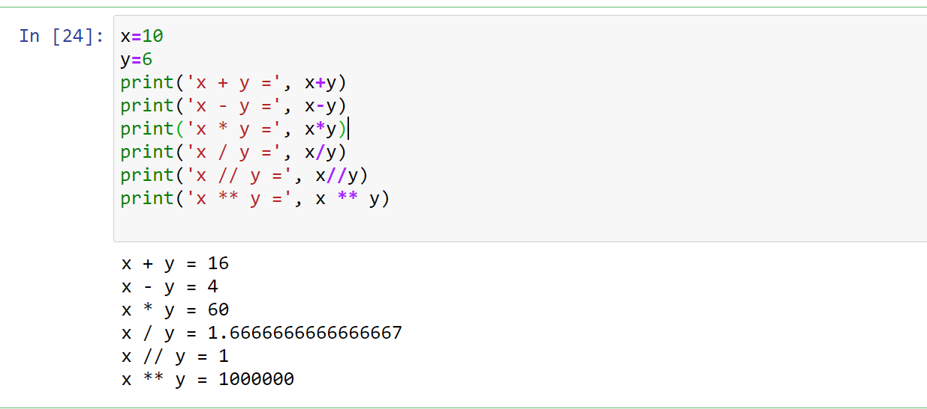

**Comparision Operator**

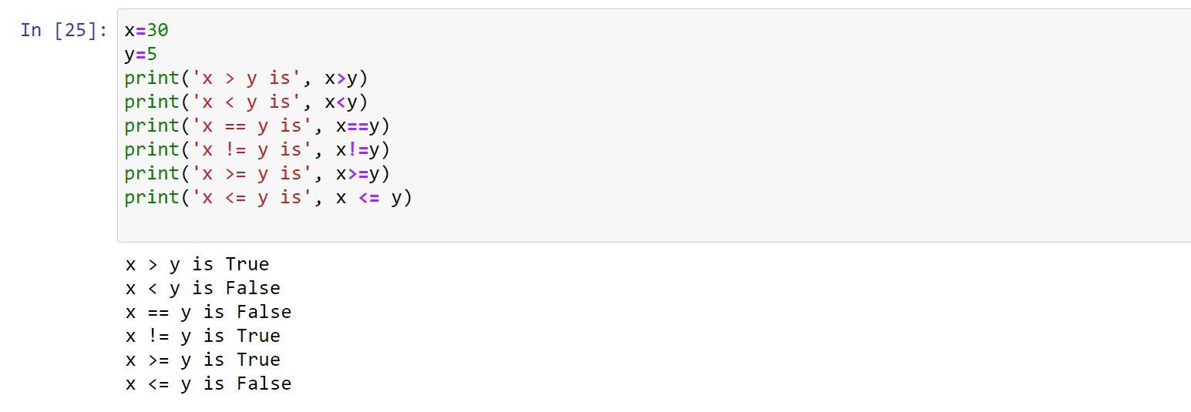

**Logical Operator**

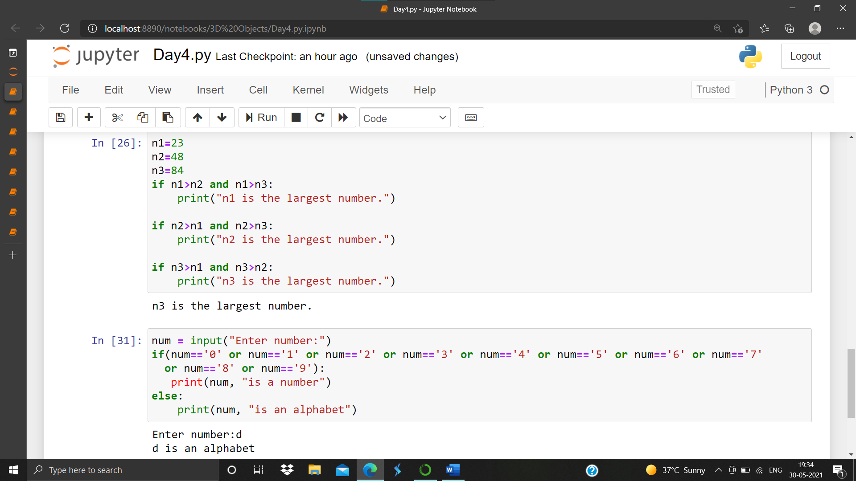

**Membership operators**

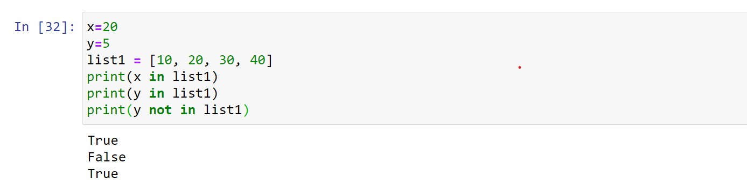

**Identity Operators**

