LINUX PRACTICE QUESTIONS

SHREYA M

17MIS1193

SCRIPT 1

CODE:

apt-get install sl

sl

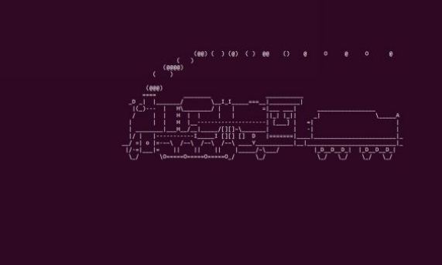

SCRIPT 2

CODE : rev

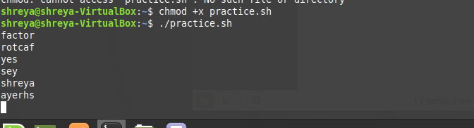

ADDITIONAL QUESTION

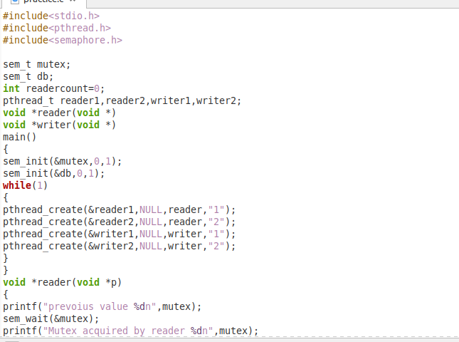

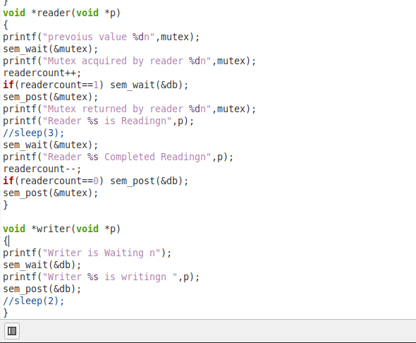

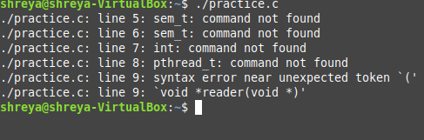

HOT QUESTION

vmstat :to check the virtual machine state and condition of cpu

code:vmstat 1200 > vmstat1.data

filename= "/home/shreya/vmstat1.data"

tail -f $filename |

while read $line do

if [ (cat vmstat1.data | grep "swap")>0 ]

then

echo "some rogue process has consumed massive amounts of memory"> swap.txt

fi

if [ (cat vmstat1.data | grep "r")>1 ]

then

echo "some process are waiting to execute"> runqueue.txt

fi

if [ (cat vmstat1.data | grep "cpu")>1000 ]

then

echo "cpu usage is more"> cpu.txt

fi

End

