1. Upsert Operation
Updates a document if it exists, or inserts it if it doesn't — using updateOne() with { upsert: true }. The response shows insertedId when a new document is created.
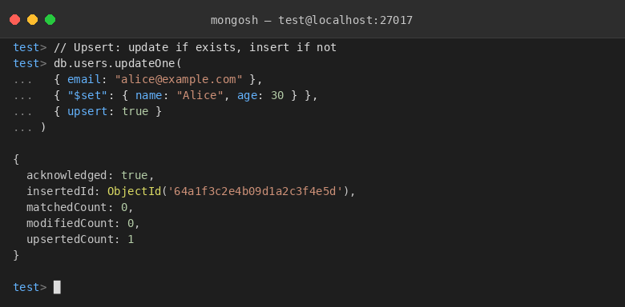

2. Rename Collection
Renames an existing collection using renameCollection(). The follow-up getCollectionNames() confirms the rename was successful.
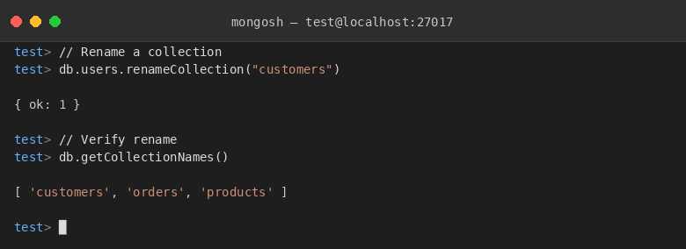

3. Delete One
Removes the first document matching the filter using deleteOne(). A subsequent findOne() returning null confirms the document was deleted.
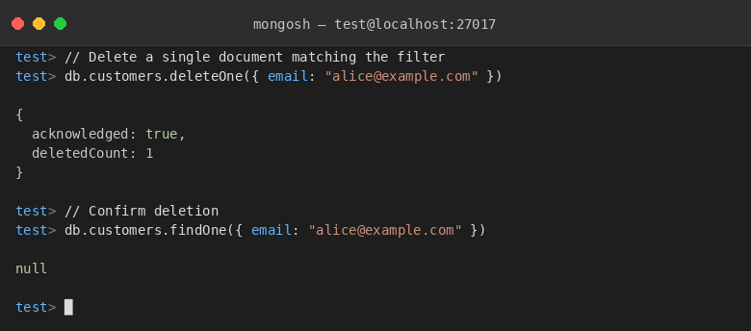

4. Delete Many
Deletes all documents matching the filter using deleteMany(). countDocuments() is used afterward to verify the remaining document count.
