THE ECONOMIC IMPACTS OF FLOODS: EVIDENCE FROM EASTERN INDIA

A Thesis
Submitted in partial fulfillment of the requirements for the award of the Degree of
INTEGRATED MASTER OF SCIENCE
IN
Quantitative Economics and Data Science

BY

SHREYA MISHRA

(IED/10032/23)



BIRLA INSTITUTE OF TECHNOLOGY MESRA-835215, RANCHI

1
APPROVAL OF THE GUIDE

Recommended that the thesis entitled “The Economic Impacts of Floods: Evidence from Eastern India” presented by Shreya Mishra under my supervision and guidance be accepted as fulfilling part of the requirements for the award of the degree of Integrated Masters of Science in Quantitative Economics and Data Science. To the best of my knowledge, the content of this thesis has not formed the basis for the award of any previous degree to any other person.

Date: 11-May-2026

Dr. Saheli Bose
Assistant Professor Department for Quantitative Economics and Data Science
Birla Institute of Technology
Mesra, Ranchi

DECLARATION CERTIFICATE

I certify that

- The work contained in the thesis is original and has been done by myself under the general supervision of my supervisor.

- The work has not been submitted to any other Institute for any other degree or diploma.

- I have followed the guidelines provided by the Institute in writing the thesis.

- I have conformed to the norms and guidelines given in the Ethical Code of Conduct of the Institute.

- Whenever I have used materials (data, theoretical analysis, and text) from other sources, I have given due credit to them by citing them in the text of the thesis and giving their details in the references.

- Whenever I have quoted written materials from other sources, I have put them under quotation marks and given due credit to the sources by citing them and giving required details in the references.

Shreya Mishra
(IED/10032/23)

CERTIFICATE OF APPROVAL

This is to certify that the work embodied in this thesis entitled “Economic Impacts of Floods: Evidence from Eastern India”, carried out by Shreya Mishra (IED/10032/23), has been approved for the degree of Integrated Masters of Science in Quantitative Economics and Data Science of Birla Institute of Technology, Mesra, Ranchi.

Date: 11-May-2026

Internal Examiner External Examiner

Head of Department

ABSTRACT
India suffers more floods than any other natural disaster. However, the impact of floods is concentrated in Eastern India, which comprises Bihar, Jharkhand, Odisha, and West Bengal. Whereas there are extensive literature on the losses due to these floods, the short-term economic impact of these floods is difficult to measure, since official measures of GDP growth in districts are published late and often do not contain the short-run shocks. We use satellite imagery as proxies to identify the short-term economic impact of flood exposure on Assembly Constituencies (ACs) in Eastern India from 2014 to 2019.
The two outcome measures we use in this paper are changes in nighttime light radiance (both mean and median radiance levels from (VIIRS) as proxies for local economic activity, and the Normalized Difference Built-up Index (NDBI) (both mean and median radiance level from Landsat-8) as proxies for the built-up index. Flood exposure is captured using the share of seasonal-water areas from the JRC Global Surface Water dataset. Our specification includes the contemporaneous exposure, and controls for previous outcomes (NDVI, NDBI, and in the NDBI case, nighttime lights), and fixed effects for Assembly Constituencies and years, along with cluster standard errors for districts. We perform our estimation both jointly for the four states, and separately for Bihar, Jharkhand, Odisha, and West Bengal. Our estimation sample consists of 765 ACs from 108 districts, with a total of 3,890 AC-years. Our pooled model yields a coefficient on flood exposure that is statistically insignificant. However, when run state-by-state, the results are starkly different. Specifically, in the case of West Bengal, we find the flood exposure significantly reduces growth in nighttime lights (coefficients range from −0.32 for median radiance, p < 0.05, to −0.39 for mean radiance, p < 0.05). Flood exposure also negatively impacts the built-up index (β₁ ≈ −0.02, p < 0.01) and nighttime lights in Bihar, but shows no significant correlation in Jharkhand and Odisha. Although our NDBI lagged variable might suffer from a Nickell Bias, our estimates of the contemporaneous exposure of primary interest remains unaffected. Clearly, the effects of floods on economic growth in Eastern India differ by states, with economic activity affected in West Bengal, and structural built-up activity affected in Bihar.
Keywords: floods, NDVI, NDBI, satellite remote sensing, district panel, Eastern India, fixed-effects estimation.

ACKNOWLEDGEMENT

I would like to express my profound gratitude to my project guide, Dr. Saheli Bose, for her invaluable guidance and support during my thesis work. I benefited greatly by working under her supervision, and it is through her encouragement and motivation that I have been able to develop a detailed insight into this subject. Her continuous support throughout my studies at BIT, Mesra, Ranchi has been indispensable.

I convey my sincere gratitude to the Head, Centre for Quantitative Economics and Data Science, BIT, Mesra, Ranchi, for providing me with the various facilities needed to complete this project.

I would also like to thank all the faculty members of the department who have directly or indirectly helped during the course of the study, as well as the technical and non-technical staff at BIT, Mesra, Ranchi.

Finally, I must express my very profound gratitude to my parents for providing me with unfailing support and continuous encouragement throughout the years of my study. This accomplishment would not have been possible without them. My apologies and heartful gratitude to all who have assisted me yet have not been acknowledged by name.

Thank you.

DATE: 11-May-2026 Shreya Mishra
(IED/10032/23)

CONTENTS

ABSTRACT ............................................................................................................. 5

ACKNOWLEDGEMENT ............................................................................................. 6

CONTENTS ............................................................................................................. 7

LIST OF FIGURES .................................................................................................... 8

LIST OF TABLES ..................................................................................................... 10

CHAPTER 1 — INTRODUCTION ............................................................................. 11

1.1 Background ................................................................................................... 11

1.2 Why Floods? .................................................................................................. 11

1.3 Why Eastern India? ........................................................................................ 12

1.4 Motivation of Study ....................................................................................... 13

1.5 Research Questions ....................................................................................... 13

1.6 Objectives ..................................................................................................... 14

1.7 Gaps Addressed ............................................................................................. 14

1.8 Thesis Organization ....................................................................................... 14

CHAPTER 2 — THEORETICAL FRAMEWORK .......................................................... 16

2.1 Introduction .................................................................................................. 16

2.2 Channels Linking Floods to Local Economic Activity ........................................ 16

2.3 Why Satellite Proxies? ................................................................................... 17

2.4 Related Empirical Literature .......................................................................... 18

2.4.1 Nighttime Lights as a Proxy for Economic Activity

2.4.2 Built-Up Indices and Disaster Impact

2.4.3 Floods and Economic Outcomes — Global Evidence

2.4.4 Indian-Context Studies

2.4.5 Methodological Positioning

CHAPTER 3 — DATA AND DESCRIPTIVE STATISTICS ............................................. 20

3.1 Introduction .................................................................................................. 20

3.2 Panel Structure ............................................................................................. 20

3.3 Data Sources and Variable Construction ......................................................... 20

3.3.1 Flood Exposure (JRC Global Surface Water) .......................................... 21

3.3.2 Nighttime Lights (VIIRS DNB) ................................................................ 21

3.3.3 NDBI and NDVI (Landsat-8) ................................................................... 21

3.3.4 Auxiliary Identifiers .............................................................................. 21

3.4 Summary Statistics — Variables ..................................................................... 22

3.5 Summary Statistics — Flood Exposure ............................................................ 22

By State ......................................................................................................... 22

By Year .......................................................................................................... 22

3.6 Temporal Trends ............................................................................................ 23

CHAPTER 4 — EMPIRICAL FRAMEWORK ............................................................... 28

4.1 Introduction .................................................................................................. 28

4.2 Specification — Equation 1 (Δ log NL) ............................................................. 28

4.3 Specification — Equation 2 (NDBI) .................................................................. 29

4.4 Identifying Variation ...................................................................................... 29

4.5 Estimation Strategy ....................................................................................... 30

CHAPTER 5 — RESULTS AND DISCUSSION ........................................................... 32

5.1 Introduction .................................................................................................. 32

5.2 Headline: Forest Plot of Flood Coefficients ..................................................... 32

5.3 Night Lights — Median Model ......................................................................... 33

5.4 Night Lights — Mean Model ............................................................................ 34

5.5 NDBI — Median Model .................................................................................... 34

5.6 NDBI — Mean Model ....................................................................................... 35

5.7 Robustness: Mean vs Median Aggregation ...................................................... 36

5.8 Summary: Heatmap of All Twenty Regressions ............................................... 37

5.9 Discussion of Cross-State Heterogeneity ....................................................... 38

5.10 Magnitude in Economic Terms ....................................................................... 38

5.12 Why the Pooled Coefficients Are Misleading .................................................. 39

5.13 Limitations of the Specification ..................................................................... 39

CHAPTER 6 — SUMMARY AND CONCLUDING REMARKS ....................................... 40

6.1 Summary of Findings ..................................................................................... 40

6.2 Policy Implications ........................................................................................ 41

6.3 Caveats and Limitations ................................................................................ 42

6.4 Future Work .................................................................................................. 42

6.5 Reconciling the Findings with Prior Work ....................................................... 43

6.6 Why Flood-Mitigation Policy in Eastern India Should Be Heterogeneous ......... 43

6.6.1 West Bengal: Continuity-Oriented Investments

6.6.2 Bihar: Stock-Oriented Investments

6.6.3 Jharkhand and Odisha: Diagnostic First, Prescription Later

6.7 Implications for the Design of Flood-Mitigation Budgets ................................ 43

6.8 Final Remarks ............................................................................................... 43

REFERENCES ........................................................................................................ 44

Academic Papers ................................................................................................ 44

Reports and Government Publications ................................................................. 44

Datasets ............................................................................................................. 45

Software ............................................................................................................. 45

APPENDIX A — VARIABLE CONSTRUCTION DETAILS ............................................ 46

A.1 Flood Exposure (Seasonal_Ratio) ................................................................... 46

A.2 Nighttime Lights (VIIRS DNB) ........................................................................ 46

A.3 NDBI and NDVI (Landsat-8 SR) ...................................................................... 46

A.4 Zonal Aggregation ......................................................................................... 47

A.5 Lag Construction ........................................................................................... 47

A.6 Cluster Variable for Standard Errors .............................................................. 47

List of Figures

Figure 3.1 Average of proportion of land with flooding across Assembly

Constituencies, 2014–2019 ............................................................. 24

Figure 3.2 Median of proportion of land with flooding across Assembly

Constituencies, 2014–2019 ............................................................. 24

Figure 3.3 Average of nighttime-lights radiance across Assembly

Constituencies, 2014–2019 ............................................................. 25

Figure 3.4 Median of nighttime-lights radiance across Assembly

Constituencies, 2014–2019 ............................................................. 25

Figure 3.5 Average of Normalized Difference Built-up Index across Assembly

Constituencies, 2014–2019 ............................................................. 26

Figure 3.6 Median of Normalized Difference Built-up Index across Assembly

Constituencies, 2014–2019 ............................................................. 26

Figure 3.7 Average of Normalized Difference Vegetation Index across Assembly

Constituencies, 2014–2019 ............................................................. 27

Figure 3.8 Median of Normalized Difference Vegetation Index across Assembly

Constituencies, 2014–2019 ............................................................. 27

Figure 4.1 Year fixed effects from pooled OLS (AC FE absorbed, year dummies

relative to 2015) .......................................................................... 30

Figure 5.1 Estimated effect of flood exposure on Δ log NL and NDBI by state,

with 95% confidence intervals (mean vs median aggregation) ........... 32

Figure 5.2 Robustness of the flood coefficient under mean versus median

aggregation. Panel A: Δ log NL. Panel B: NDBI ................................. 36

Figure 5.3 Coefficient summary of all twenty OLS regressions (state ×

aggregation rows; regressor columns; sign-coded heatmap) .............. 37

List of Tables

Table 3.1 Panel structure of the dataset (765 ACs, 108 districts, 2014–2019,

N = 4,674 raw / 3,890 estimation) .................................................... 20

Table 3.2 Summary statistics for all regression variables, AC-year level ......... 22

Table 3.3 Flood exposure (Seasonal_Ratio) by state ....................................... 22

Table 3.4 Flood exposure (Seasonal_Ratio) by year ........................................ 23

Table 5.1 Effect of flood exposure on Δ log NL (median radiance growth);

district-clustered SE ...................................................................... 33

Table 5.2 Effect of flood exposure on Δ log NL (mean radiance growth);

district-clustered SE ...................................................................... 34

Table 5.3 Effect of flood exposure on NDBI (median, level); lagged-DV

Nickell bias ≈ 1/T ........................................................................... 35

Table 5.4 Effect of flood exposure on NDBI (mean, level); district-clustered SE.. 35

CHAPTER 1 — INTRODUCTION

1.1 Background
While many natural disasters occur in India every year, very few of them are as regular or as economically destructive as floods. According to NDMA (Government of India), floods are the most economically destructive form of disaster in the country, both in terms of direct destruction and population affected. According to the National Flood Commission, about 40 million hectares of land in India are flood-prone, while 7.2 million hectares of land suffer from flooding annually. The estimated annual damage to crops, housing, and infrastructure due to floods stands at approximately ₹1,805 crore. However, as widely known, these figures greatly understate the real cost of flooding since they fail to include indirect costs, like loss of working days, logistics disruptions, and capital depreciation.
As seen over the last two decades, the frequency and magnitude of flood events in India increased due to changes in monsoons, Himalayan glacial melt, embankment breaches, and poorly planned urbanisation of floodplains. In turn, as a result of climate variabilities, the time difference between flood events and their administrative damage assessments has been growing, making the latter obsolete for policymakers. The release of district-level output statistics has been becoming increasingly late in relation to the moment when the policy window closes.
These facts give rise to the need for a new approach to measuring the economic impact of floods. While traditional methods of statistical collection take much time to generate results, modern satellite data allows one to construct a proxy panel of economic indicators at the high resolution required for meaningful empirical economic analysis. Specifically, this study constructs an annual panel of economic outcomes of floods at the Assembly Constituency level for the four most flood-affected states of Eastern India using nighttime lights, NDBI, and NDVI proxies derived from satellite data.

1.2 Why Floods?
Among natural disasters that occur in India, floods are the most frequent, geographically widespread, and economically destructive. The importance of floods for empirical economic studies rests upon three factors. Firstly, they are recurrent rather than infrequent, which gives rise to within-unit variance that may be leveraged. Secondly, they affect both physical capital (e.g., housing, roads, and structures) and natural capital (cropland and soil), thus influencing the local economy through multiple channels. Finally, the satellite observation capability allows measuring floods from space with high temporal frequency, addressing the traditional problem of sub-national Indian flood economics caused by insufficient data.
Notwithstanding this potential, there still remain few studies on the economic consequences of floods in India that are empirical. The majority of available literature is purely descriptive, deals only with a single river basin, or analyses the situation at the state or district level, which is too coarse for identifying the relevant heterogeneity at the sub-national level. The geographic granularity used in this study (Assembly Constituency × year) exceeds that applied in any prior Indian flood economics study in the field of empirical economic analysis.

1.3 Why Eastern India?
Of all regions in India, Eastern India, consisting of Bihar, Jharkhand, Odisha, and West Bengal, is the most flood-prone area. Still, different states have unique hydrological conditions leading to flooding.
Bihar, located in the heart of the Indo-Gangetic plain, is traversed by the transboundary rivers – the Kosi, Gandak, and Bagmati – originating in Nepal and ending in the Ganga River. Due to heavy sediment loads, these rivers elevate the riverbed levels downstream from embankments, causing recurrent flooding of northern districts due to breaching. Estimates of national risk assessment put the share of India's flood-prone land belonging to Bihar at about 17.2 per cent (NIDM/NRSC).
West Bengal is placed at the tail of the Ganga-Brahmaputra System and suffers from both fluvial and coastal flooding caused by deltaic geomorphology, tidal influence, and cyclones in the Bay of Bengal. The Damodar, Hooghly, and Sundarbans estuarine system exposes northern districts, such as Murshidabad, Howrah, and the Sundarbans, to compound flood risk.
Odisha shares a similar flood profile with West Bengal but is even more exposed to coastally caused flooding. Fluvial flooding occurs at the tail of the Mahanadi delta, while storm surge caused by regular cyclone landfalls creates additional risks for districts such as Puri, Kendrapara, and Jagatsinghpur.
Jharkhand, being topographically distinct (Damodar, Subarnarekha, and Brahmani-Mahanadi) from the previous three states, still experiences significant flooding risk in lowlands of Sahebganj, Pakur, and parts of Damodar, particularly in years of intensive discharge of Jharkhand Hills.
Additionally, as seen in the following section, Eastern Indian states are relatively economically vulnerable. Being below the national average on per capita net state domestic product and having large share of workforce engaged in agriculture, a single flood event that destroys standing crops affects the economy of Eastern India significantly. Therefore, the chosen region provides sufficient heterogeneity and economic relevance for studying the subject matter of this paper.

1.4 Motivation of Study
The motivations of this study are both empirical and policy-oriented. Empirically, floods create strong, plausibly exogenous shocks to local economic activities that can be measured remotely at a high resolution and frequent intervals. Consequently, floods represent a natural setup for fixed-effect panel regressions in which the observational unit is fixed (Assembly Constituency), the shock varies (flooding within a year), and confounding factors are controlled (development and annual macroeconomic shock via AC and year fixed effects).
From a policymaker's perspective, the flood-mitigation policy in Eastern India relies heavily on engineering solutions, such as embankments, barrages, and drainage infrastructure, implemented at the state level. However, in order for these interventions to be successful, it should be determined whether the four states of Eastern India have the same channels of floods influence on the economy. Hence, determining how floods affect Bihar, Jharkhand, Odisha, and West Bengal differently is the primary motivation behind this study.

1.5 Research Questions
There are three major research questions addressed in this paper:
1. Do floods reduce economic activity in flood-affected Assembly Constituencies? Economic activity will be measured as a year-on-year increase in radiance of nighttime lights. Accordingly, the null-hypothesis predicts that contemporary flood exposure generates negative and statistically significant effect on the flood indicator in a fixed-effects panel regression.
2. Is the effect of floods on economic activity similar across all four states of Eastern India? Separate estimation of the model in Bihar, Jharkhand, Odisha, and West Bengal allows the coefficients to differ by state. Any non-trivial pattern of differences may indicate the hidden heterogeneity among pooled estimations.
3. How does flood inundation affect the built-up intensity? Intensity of built-up structures will be measured with the help of the Normalized Difference Built-up Index (NDBI). This research question aims at separating the stock effects (infrastructural damage measured by NDBI) from the flow effects (activity losses measured by nighttime lights).

1.6 Objectives
As a result, there are five objectives of this study:
(i) Construction of a panel dataset consisting of observations at the Assembly Constituency level over years 2014-2019 with regards to flood exposure (derived from JRC Global Surface Water data), and economic outcomes (proxied by nighttime lights, NDBI, and NDVI);
(ii) Estimation of the impact of contemporary flood exposure on the year-on-year change of nighttime light intensity with the help of ordinary least squares regression with AC and year fixed effects and district-level clustering of errors;
(iii) Estimation of the effect of floods on built-up intensity measured with NDBI, while controlling for the lagged dependent variable, NDBI, and lagged covariates;
(iv) Comparison of state-by-state and pooled estimations in order to detect heterogeneity of flood effects on all four states of Eastern India;
(v) Economic interpretation of the results based on two major channels of flooding effects.

1.7 Gaps Addressed
This study seeks to address the following gaps of Indian flood economics research literature:
(i) Geographic granularity. Most prior work focuses on floods' impact on state or district economic activities while the used AC-level panel is finer.
(ii) Temporal frequency. Survey-based output statistics are released with long delay while satellite measures of economic activity can be calculated annually with no delay after the event.
(iii) Stock and flow. Previous research seldom disentangles flood effects on economic activities (flow) from the effects on infrastructure (stock); this study addresses both of them simultaneously.
(iv) State-by-state heterogeneity. Virtually no Indian study investigates differences between floods' economic impact on Bihar, Jharkhand, Odisha, and West Bengal; this paper focuses on such heterogeneity specifically.

1.8 Thesis Organization
This thesis is organized as follows. Chapter 2 introduces basic theory linking flood exposure to observable economic outcomes through three channels – productive capital, agricultural land, and economic disruption. Chapter 3 describes datasets, structure of panel, and summary statistics, including time series characteristics. Chapter 4 develops the two estimation equations, types of fixed effects, and estimation strategy. Chapter 5 introduces the results of estimating the two equations in four states and interprets cross-state heterogeneity. Chapter 6 summarizes the findings, draws policy implications, and discusses directions for future research.

CHAPTER 2 — THEORETICAL FRAMEWORK

2.1 Introduction
As mentioned in Chapter 1, the research questions ask about the effect of flooding on local economic activity, about any state-level heterogeneity in that effect in the four states of Eastern India, and whether infrastructure is differentially affected compared to economic flows. To answer these questions empirically, however, we need a theoretical framework that spells out what a flood event is expected to do to economic activity. This chapter outlines that framework. Section 2.2 lays out three channels by which flood exposure is expected to impact the local economy. Section 2.3 provides an explanation for choosing three specific satellite variables as proxies for the channels outlined in section 2.2.

2.2 Channels Linking Floods to Local Economic Activity
A flood event will influence local economic activity through three distinct channels based on the type of asset affected and the relevant time horizon of the effect. (i) Productive Capital Channel. The standing stock of productive capital is depreciated by the flood, as the presence of standing water causes houses, businesses, roads, and electrical infrastructure to suffer damage. When the floodwaters drain, the remaining stock will be lower than it was before. While the depreciation process can take different forms, both gradual (faster degradation through the acceleration of the depreciation process) and abrupt (structural damage leading to collapse), it leads to a lower capital stock in post-flood conditions that will sustain less economic activity. As such, the productive capital channel implies a relation between flood exposure and observed economic activity variables that rely on productive capital stock, such as night light radiance. (ii) Agricultural Land Channel. A flood destroys the current season crops as well as salts the land. If the agricultural activities in the district are significant, then a flood reduces the revenue from farming for the farmers in the area and leads to reductions in consumption and retail and informal economic activities. The effects can last for longer than the time period when the crops were destroyed, as the land becomes fertilized by silt deposits from the flood waters. Such positive long-term effects of floods have been studied in Indian river basins by Kale (2003). (iii) Economic Disruption Channel. Even in the absence of capital stock depreciation, floods can affect economic activity by disrupting mobility and transport of goods and labour to and from the area. Road closures, market shutdowns, and labour displacement will lead to the disruption of economic activities for several weeks after the event. Since these disruptions are short-term in nature, the flood exposure indicator appears in level form on the right-hand side of the regression model. The three channels are neither mutually exclusive nor equal in importance. Each and every flood will activate all three channels, but the relative magnitude of their influence is going to be determined by the nature of local economic activities. A flood in predominantly agrarian districts will be mainly mediated by the agricultural land channel; urban floods will mostly be mediated by the productive capital and disruption channels. Such differences are likely to produce state-level variation in flood impact even under identical exposure conditions.

2.3 Why Satellite Proxies?
The measurement of the three economic channels relies on direct observations of the variables that describe these economic channels: output, capital stock, agricultural production, and trade flows. Unfortunately, no such data set exists for India at the Assembly Constituency level. Thus, we rely on proxy measures constructed from the satellite data. The three proxies chosen correspond to the particular economic channel that they represent. Night-time lights (NL). The annual level of radiance as recorded by the Night-time Day/Night band sensor of VIIRS is widely accepted as a good proxy for local economic activity levels. A decrease in NL between two years can reflect either reduced energy consumption (disruption channel) or a reduction in standing capital stock (productive capital channel). Therefore, the annual year-over-year change in log (NL) serves as the outcome variable of choice for Research Question 1. Normalized Difference Built-up Index (NDBI). NDBI is a continuously-scaled measure of the degree of urbanization obtained from Landsat-8 short-wave infrared and near-infrared bands. Where the night-time lights variable represents the flow of activity generated by the existing buildings, the NDBI is a stock measure. While a flood might not destroy infrastructure, thereby leaving NDBI unaffected, it is capable of depreciating the capital stock in the district by damaging buildings. Thus, we chose NDBI as the second dependent variable. Normalized Difference Vegetation Index (NDVI). NDVI is a popular proxy for cropland productivity, and it is often included as a covariate in flood studies because of its relationship with agricultural production. However, vegetation is affected by floods both negatively during the inundation period and positively through post-flood season fertilization through silt deposits. In order to absorb this effect, we include NDVI as a control variable. The use of satellite imagery in Indian flood research is itself well-established. Jain et al. (2006) found that inundation maps based on the AVHRR sensor showed excellent correlation with the on-ground survey data in the flood-prone states of Bihar and Assam, thus validating remote sensing as a technique to complement field surveys. The development of the Flood Hazard Atlas for the State of Bihar by NRSC/ISRO and NDMA (2010) expanded remote sensing-based flood mapping to a practical tool for large-scale hazard zoning. Sinha et al. (2008) created a multidimensional Flood Risk Index that integrated multiple parameters derived from satellite imagery, showing that flood vulnerability in Eastern India has a multiplicity of dimensions and cannot be assessed using a single hydrological variable. Our study expands upon this methodology by applying satellite proxies as outcome variables in fixed-effects panel estimation. The flood exposure variable used in this paper is built from the JRC Global Surface Water dataset (Pekel et al., 2016). This dataset gives an annual classification of seasonal and permanent water cover at 30 metre resolution and is widely used in flood studies because of its temporal coverage and consistency.

2.4 Related Empirical Literature
Beyond the methodological lineage discussed in Section 2.3, a parallel body of empirical work informs the economic interpretation of satellite-derived measures used in this thesis. This section briefly reviews three strands of that literature: (i) the validation of nighttime lights as a proxy for local economic activity, (ii) the use of built-up indices for measuring urban and infrastructural change, and (iii) the broader empirical work on floods and economic outcomes. Together, these strands provide the empirical justification for the modelling choices made in Chapter 4.

2.4.1 Night time Lights as a Proxy for Economic Activity
The use of nighttime light radiance as a proxy for economic output has a long history in development economics. Henderson, Storeygard, and Weil (2012) showed that nighttime lights track GDP closely at the country and sub-national level, and proposed a method for combining lights with national accounts to obtain improved growth estimates in data-poor settings. Chen and Nordhaus (2011) reached similar conclusions using DMSP-OLS data, although they cautioned that nighttime lights are most informative where conventional output statistics are weak. For India, Bhandari and Roychowdhury (2011) and others have shown that the correlation between district-level lights and per-capita output is positive and statistically significant, although the elasticity differs across states. The general consensus is that nighttime lights are a useful proxy for the level and growth of economic activity at sub-national scales, particularly when data on output is unavailable or released with long delays.
More recent work using VIIRS rather than the older DMSP-OLS sensor has documented several improvements in measurement quality. The VIIRS Day-Night Band has higher spatial resolution, better radiometric calibration, and avoids the saturation problems that affected DMSP in bright urban centres. As such, VIIRS is now the standard satellite source for studies that examine local-level economic activity in developing countries, and is the source used in this thesis.

2.4.2 Built-Up Indices and Disaster Impact
The Normalized Difference Built-up Index has been used in remote sensing for over two decades, originally as a tool for distinguishing built-up surfaces from vegetation and water in satellite imagery. Zha, Gao, and Ni (2003) introduced the index in its current form, demonstrating that the contrast between short-wave infrared and near-infrared reflectance reliably separates built-up surfaces from other land-cover types. Subsequent applications have used NDBI to monitor urban expansion, identify slum areas, and measure post-disaster damage in cities exposed to earthquakes and floods.
Of particular relevance to this thesis is the use of NDBI as an outcome variable in disaster-economics studies. Kocornik-Mina, McDermott, Michaels, and Rauch (2020) used satellite imagery to study how cities respond to large floods and found that areas affected by inundation experience persistent reductions in built-up activity even after the flood waters recede. Their results suggest that NDBI can capture not only short-term disruption but also longer-run damage to the urban capital stock. The present thesis exploits this property by using NDBI as a stock measure that complements the flow measure provided by nighttime lights.

2.4.3 Floods and Economic Outcomes — Global Evidence
The empirical literature on the economic effects of floods is large and growing. Cross-country studies typically find that floods reduce growth in the year of the event, with the magnitude depending on country income, prior exposure, and the strength of disaster-response institutions. Felber Mayr and Gröschl (2014) used a large international panel to estimate that severe floods reduce GDP growth by roughly 0.2 to 0.5 percentage points, with effects that typically fade within two to three years. Klomp and Valckx (2014) reviewed the evidence and concluded that the long-run growth effects of natural disasters, including floods, are generally smaller than the short-run effects, although the dispersion across studies is wide. Sub-national studies tend to find larger and more persistent effects, which is consistent with the idea that aggregate GDP estimates mask localized damage. Strobl (2012) used satellite-derived rainfall and runoff data to estimate flood impacts on sub-national income in the United States and found that affected counties experienced sustained reductions in income for several years after major events. Kahn (2005) showed that the income loss from disasters is concentrated among low-income populations, an effect of particular relevance for Eastern India, where agricultural employment is substantial.

2.4.4 Indian-Context Studies
Within India, empirical research on flood impact has long been constrained by data limitations. Most early studies were descriptive or focused on a single river basin. More recent work has begun to address this gap. Patnaik and Narayanan (2010) examined the consumption response to floods in rural India and found that affected households experience persistent declines in consumption, with the recovery period stretching beyond a single agricultural season. Mukherjee, Bandyopadhyay, and Mukhopadhyay (2014) studied flood impacts in West Bengal and documented substantial reductions in household income that varied across districts within the state. These studies indicate that flood impacts in India are spatially heterogeneous and that aggregate state- or district-level data may understate the extent of damage in the most exposed areas. Yet almost no Indian study to date has combined satellite-based flood exposure measures with satellite-based outcome measures at the Assembly Constituency level. The present thesis addresses this gap by constructing a panel that exploits the high spatial and temporal resolution of remote sensing data and applies fixed-effects panel estimation to identify the local-level impact of flood exposure on economic activity and built-up infrastructure.

2.4.5 Methodological Positioning
Methodologically, this study sits at the intersection of three approaches. First, it follows the satellite-data tradition initiated by Henderson, Storeygard, and Weil (2012) and applied to disaster economics by Kocornik-Mina et al. (2020). Second, it uses the panel fixed-effects estimator that is standard in the labour and development literature for identifying causal effects from within-unit variation. Third, it relies on cluster-robust inference at the district level, which is the standard approach in modern applied microeconometrics whenever spatial correlation among neighbouring observations is suspected. Combining these three elements, the thesis is able to deliver state-level estimates of flood impact that are both fine-grained and statistically defensible.

CHAPTER 3 — DATA AND DESCRIPTIVE STATISTICS

3.1 Introduction
This chapter details the data that was collected to perform the empirical analysis. The unit of observation is the Assembly Constituency (AC) × year. Section 3.2 gives an overview of the panel structure; Section 3.3 explains the origin of the data used for each variable, along with how each variable was constructed; Sections 3.4 and 3.5 provide summary statistics for the regression variables and for the flood exposure measure respectively; and finally Section 3.6 provides time series of all key variables. All variables were constructed using zonal statistics of raster data over AC polygons, while lagged regressors are also calculated within each AC to preserve the panel structure.

3.2 Panel Structure
Variable | Value
Unit of observation | Assembly Constituency × Year
States | Bihar, Jharkhand, Odisha, West Bengal
Period | 2014–2019 (6 years)
Number of ACs | 765
Number of districts (for SE clustering) | 108
Number of AC-year observations (unlagged) | 4,674
Estimation sample (with lags; 2014 dropped) | 3,890

Table 3.1: Panel structure of the dataset (765 ACs, 108 districts, 2014–2019, N = 4,674 raw / 3,890 estimation).
The dataset consists of a balanced cross-section of 765 Assembly Constituencies from 2014 to 2019 inclusive. The 2014 observations have been dropped from the estimation sample because the regression specification employs lagged regressors, which do not exist in the first period. The AC identifiers come from Election Commission of India delimitation files; the district identifiers (used for standard error clustering) follow the Census of India classification for 2011.

3.3 Data Sources and Variable Construction
Four primary datasets have been combined to create the panel.

3.3.1 Flood Exposure (JRC Global Surface Water)
The flood exposure variable Seasonal_Ratio was calculated based on the Global Surface Water Dataset created by the European Commission Joint Research Centre (Pekel et al., 2016). For each AC and for each year, this dataset is recoded into four categories – never water, permanent water, seasonal water, and not-observed – at 30 metres resolution. Seasonal_Ratio is the proportion of the AC classified as seasonal water in that year, varying between 0 (no seasonal flooding) and 1 (entire AC under seasonal water). This variable represents the contemporaneous flood exposure level of the constituency.

3.3.2 Nighttime Lights (VIIRS DNB)
Yearly night-time light radiance was obtained from the NOAA VIIRS Day-Night Band (DNB) composites. In each year, both the average and the median radiance of each AC polygon are calculated, called NL_mean and NL_median. In the regression of night lights, the year-on-year change in log radiance was used as the dependent variable, defined as Δ log NL = log(NL_t) − log(NL_{t−1}), calculated separately for the mean and median series.

3.3.3 NDBI and NDVI (Landsat-8)
The Normalized Difference Built-up Index and the Normalized Difference Vegetation Index were calculated from the USGS / Google Earth Engine Landsat-8 Surface Reflectance imagery. To calculate NDBI, the shortwave infrared and near-infrared bands are used, and for NDVI, the near-infrared and red bands are used. For each AC and for each year, both indices are calculated for each individual pixel and then zoned by mean and median to get NDBI_mean, NDBI_median, NDVI_mean, and NDVI_median. For each AC and each year, all four series were lagged to be used as right hand side controls.

3.3.4 Auxiliary Identifiers
The boundary and the identifier of Assembly Constituency come from the post-delimitation file of the Election Commission of India (starting 2008); and district identifiers follow the Census of India classification for 2011.

3.4 Summary Statistics — Variables
Variable | N | Mean | SD | Min | Max
Seasonal_Ratio (flood share) | 4,669 | 0.378 | 0.259 | 0.000 | 0.985
NL — mean | 4,674 | 3.019 | 7.432 | 0.054 | 60.258
NL — median | 4,674 | 2.632 | 7.363 | 0.044 | 59.562
Δ log NL — mean | 3,895 | 0.126 | 0.497 | −2.461 | 4.640
Δ log NL — median | 3,895 | 0.139 | 0.506 | −2.755 | 4.891
NDBI — mean | 4,674 | −0.128 | 0.103 | −0.447 | 0.098
NDBI — median | 4,674 | −0.118 | 0.120 | −0.490 | 0.123
NDVI — mean | 4,674 | 0.340 | 0.093 | −0.156 | 0.664
NDVI — median | 4,674 | 0.347 | 0.099 | −0.343 | 0.701
Table 3.2: Summary statistics for all regression variables, AC-year level.
There are three notable aspects about the summary statistics provided in Table 3.2. Firstly, the average AC has around 38 per cent of its area classified as seasonal water in a particular year, with a significant amount of variation (SD = 0.26) and maximum close to one. Secondly, the average year-on-year change in log NL is approximately 0.13, for both aggregation types, implying that radiance increased in this sample period – consistent with increases in electricity access and economic activity. Thirdly, the NDBI measure takes negative values through the sample (average ≈ −0.12) due to rural districts in Eastern India where vegetated areas predominate the build-up index.

3.5 Summary Statistics — Flood Exposure

By state
State | N | Mean | SD | Min | Max
Bihar | 1,458 | 0.321 | 0.244 | 0.000 | 0.955
Jharkhand | 570 | 0.552 | 0.278 | 0.000 | 0.985
Odisha | 882 | 0.435 | 0.246 | 0.001 | 0.899
West Bengal | 1,759 | 0.341 | 0.240 | 0.000 | 0.919

Table 3.3: Flood exposure (Seasonal_Ratio) by state.
By year
Year | Mean | SD
2014 | 0.034 | 0.050
2015 | 0.412 | 0.217
2016 | 0.470 | 0.234
2017 | 0.472 | 0.223
2018 | 0.407 | 0.227
2019 | 0.474 | 0.221

Table 3.4: Flood exposure (Seasonal_Ratio) by year.
From the state-level split, there appears to be some cross-sectional heterogeneity: Jharkhand has the largest share of AC flooded on average (0.55), while Odisha comes second (0.44); followed by Bihar (0.32) and West Bengal (0.34). From the year-level split, it is apparent that 2014 is a year of unusually low flood exposure (0.034), owing to the unstable nature of the JRC surface water classifications during 2014. Since this year is dropped from the estimation sample, however, this outlier does not impact the regression results. Starting from 2015 onwards, the yearly average flood exposure is relatively stable at between 0.41 and 0.47, justifying the inclusion of year dummies.

3.6 Temporal Trends
This section gives the time trend for each of the eight variables, namely the mean and median aggregation of Seasonal_Ratio, NL, NDBI, and NDVI. Each graph plots the within-state average across 765 ACs over time for each of the four states.
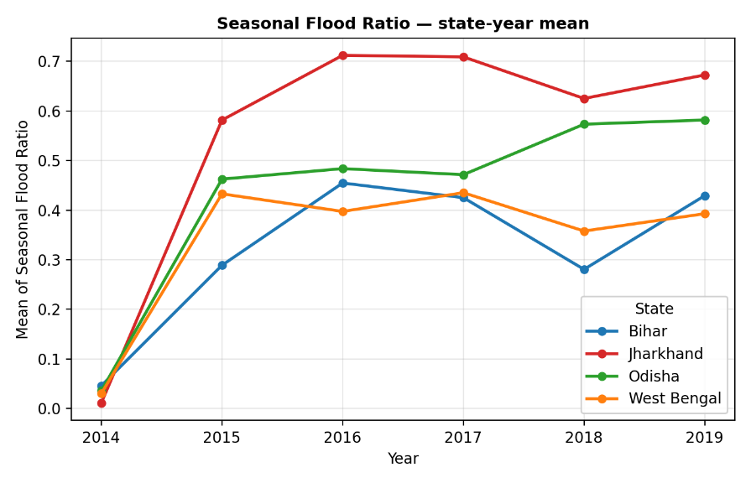
Figure 3.1: Average of proportion of land with flooding across Assembly Constituencies, 2014–2019.
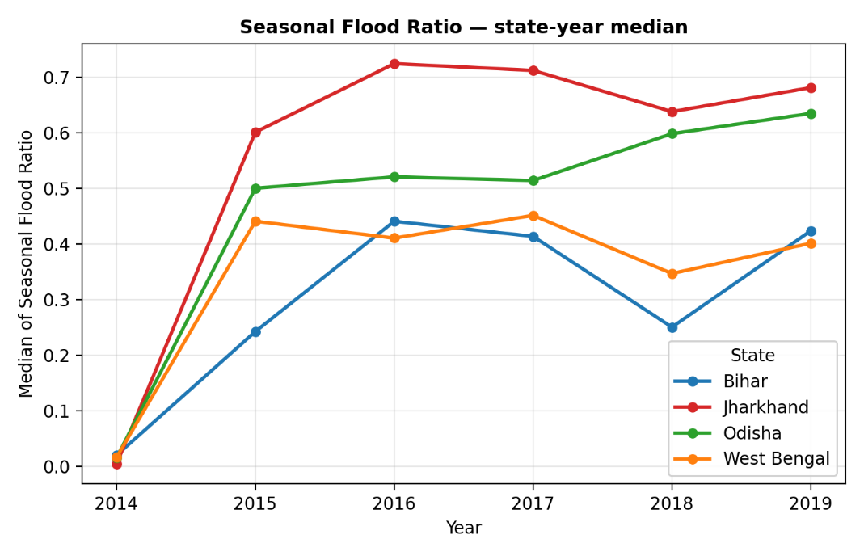
Figure 3.2: Median of proportion of land with flooding across Assembly Constituencies, 2014–2019.
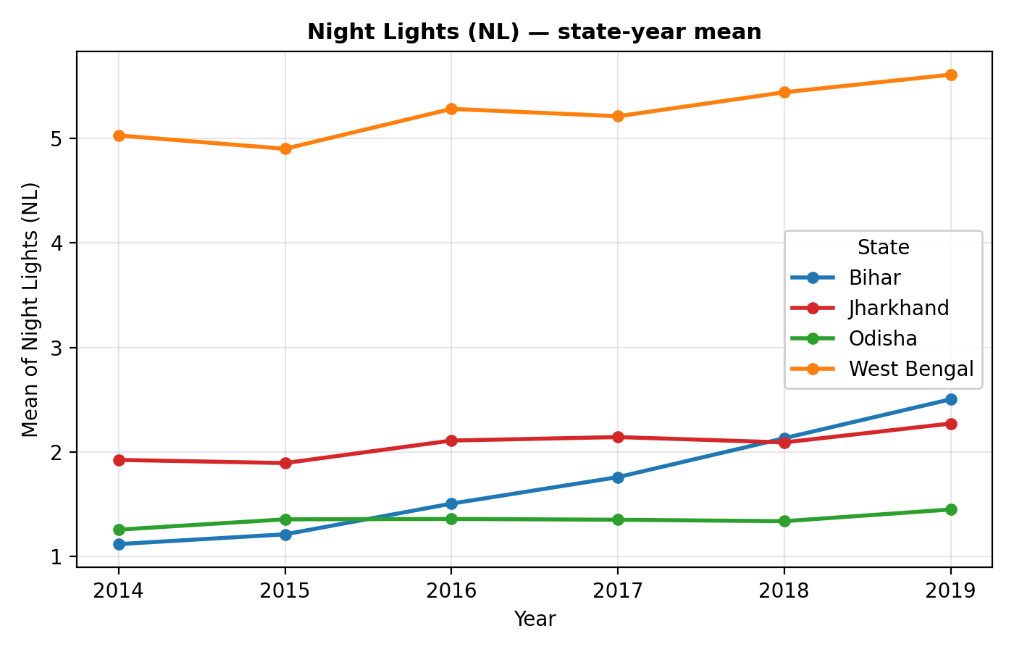
Figure 3.3: Average of nighttime lights radiance across Assembly Constituencies, 2014–2019.
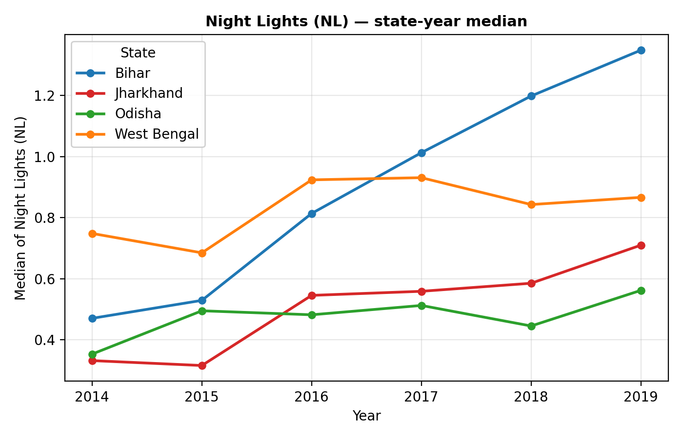
Figure 3.4: Median of nighttime lights radiance across Assembly Constituencies, 2014–2019.
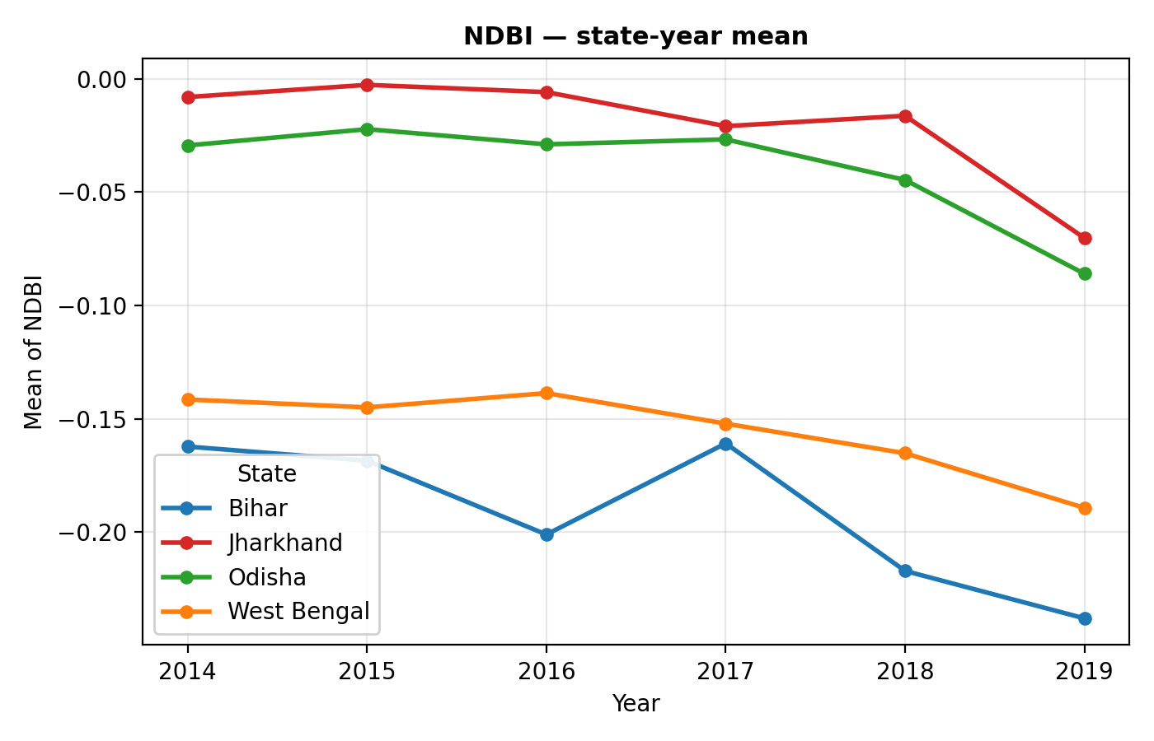
Figure 3.5: Average of Normalized Difference Built-up Index across Assembly Constituencies, 2014–2019.
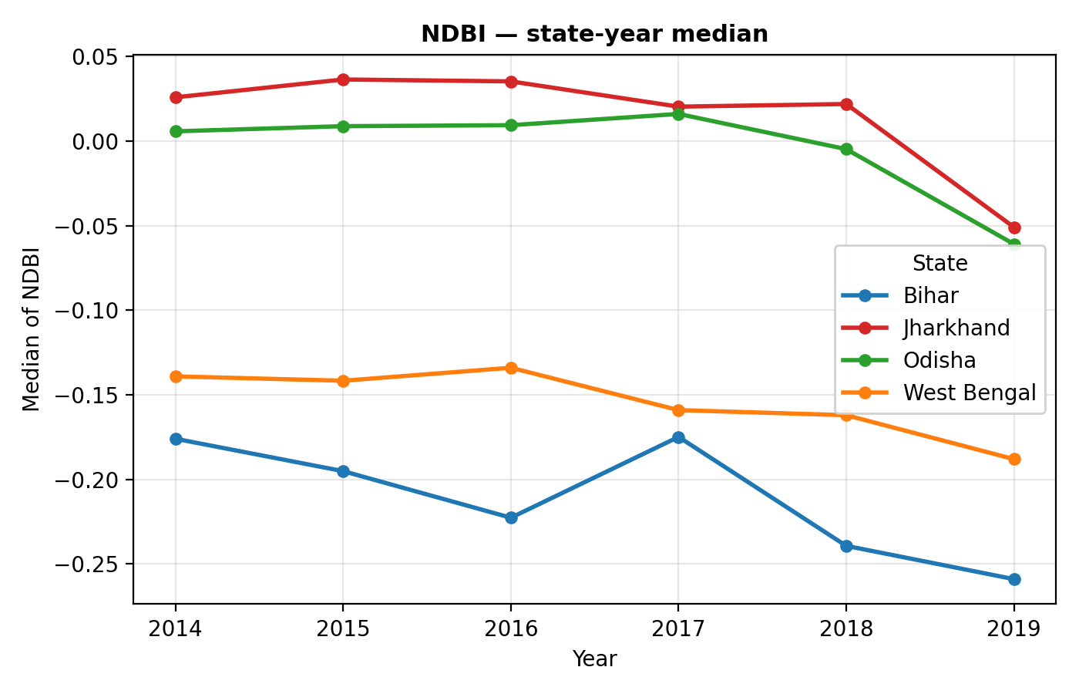
Figure 3.6: Median of Normalized Difference Built-up Index across Assembly Constituencies, 2014–2019.
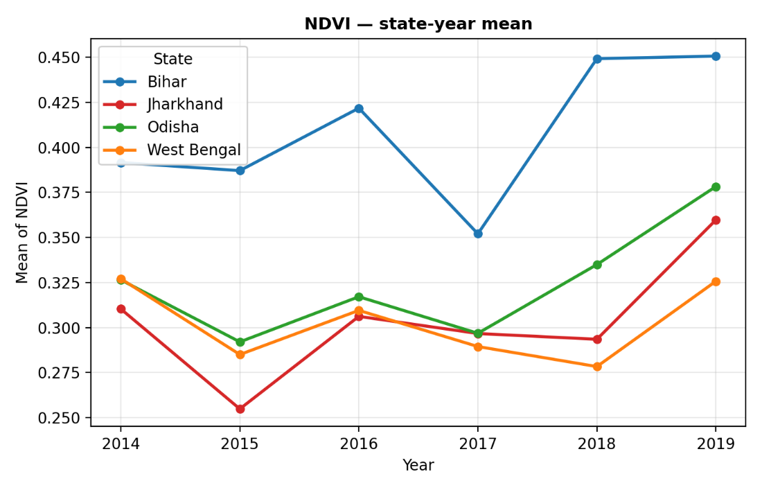
Figure 3.7: Average of Normalized Difference Vegetation Index across Assembly Constituencies, 2014–2019.

Figure 3.8: Median of Normalized Difference Vegetation Index across Assembly Constituencies, 2014–2019.
Several insights can be drawn from these trend graphs. Firstly, Seasonal_Ratio (Figure 3.1–3.2) experiences a dramatic jump from 2014 to 2015 due to the unstable nature of the JRC surface water classification, and stabilises within a narrow range afterwards; with higher values being recorded in Jharkhand throughout the sample period. Secondly, night time light radiance (Figure 3.3–3.4) shows positive growth through the entire six years in all four states, consistent with growing electricity access; with the strongest rise recorded in West Bengal. Thirdly, NDBI and NDVI (Figures 3.5–3.8) move much more slowly, as expected for stock-type indices that capture the standing built-up and vegetated land cover rather than annual flow. NDBI remains negative across all four states, confirming the predominantly non-built-up character of most ACs in our sample.

CHAPTER 4 — EMPIRICAL FRAMEWORK

4.1 Introduction
The theory described in Chapter 2 proposes three pathways through which floods impact local economic activity. This chapter operationalizes the theory into two estimating equations – one for the activity (flow) outcome and one for the stock outcome of built-up infrastructure. The first estimating equation will relate flood exposure and nightlight intensity. The second equation will link NDBI level to contemporary flood exposure and control variables. Section 4.2 specifies the nightlight equation while Section 4.3 specifies the NDBI equation and mentions the Nickell bias on the lagged dependent variable. The sources of identification exploited by the fixed-effects estimator are discussed in Section 4.4 and Section 4.5 describes the estimation procedure.

4.2 Specification — Equation 1 (Δ log NL)
The first estimating equation relates the year-on-year change in the logarithm of nightlights intensity (NL) to current floods exposure and lagged control variables:
Δ log NL_it = β₁ · Flood_it + β₂ · NDVI_{i,t−1} + β₃ · NDBI_{i,t−1} + α_i + γ_t + ε_it
Each term has the following meaning. Δ log NL_it is the year-on-year growth in log NL of AC i between years t−1 and t; the model is estimated separately for the mean and median aggregation of NL. Flood_it is the contemporary flood exposure, proxied by Seasonal_Ratio (the fraction of the AC's land surface covered with seasonal water), and β₁ is the main parameter of interest. NDVI_{i,t−1} is the lagged vegetation index, accounting for existing agronomic conditions, and NDBI_{i,t−1} is the lagged built-up index, accounting for existing infrastructural stock. α_i is the Assembly Constituency fixed effect, capturing everything time-invariant about AC i (its geography, soil type, and initial development level), and γ_t is the year fixed effect, accounting for anything affecting all ACs in a given year (monsoon intensity, India-wide policies, satellite calibration). ε_it is the idiosyncratic error. The constant term β₀ is not included since it drops out after taking out the AC and year fixed effects; otherwise the specification is rank deficient.

4.3 Specification — Equation 2 (NDBI)
The second estimating equation relates the level of NDBI to current floods exposure, lagged covariates and the lagged dependent variable:
NDBI_it = β₁ · Flood_it + β₂ · NDVI_{i,t−1} + β₃ · NL_{i,t−1} + β₄ · NDBI_{i,t−1} + α_i + γ_t + ε_it
Two structural differences between Equations (1) and (2) should be pointed out. First, the dependent variable is the level of NDBI rather than its change over time, since NDBI is a slow-moving variable, and change in a single year does not add any information. Second, the lagged NDBI_{i,t−1} is included in order to capture its persistence, while the lagged nightligh intensity NL_{i,t−1} is included because higher economic activity in t−1 attracts new building projects in t.
The inclusion of both the lagged dependent variable and the AC fixed effect creates a downward bias on β₄, known as the Nickell bias of order 1/T, where T = 5 in our sample. The bias is thus equal to about 20%. Since the parameter of interest β₁ is estimated independently of the bias on the lagged dependent variable, the conclusions of this study do not hinge on the value of β₄. As in Equation (1), the model is estimated separately for the mean and median aggregations of NDBI.

4.4 Identifying Variation
The fixed-effects estimator exploits two sources of variation in the data.
Year-to-year variation within ACs. The AC fixed effect α_i accounts for everything that is constant about AC i over time — its location, rivers proximity, soil composition and time-invariant unobservable factors. β₁ is thus identified from the deviation of flood exposure within each AC, and not by comparing ACs to each other. This takes care of the obvious problem that some ACs are more prone to floods and, perhaps, poorer due to this reason.
Common shocks removal across years. The year fixed effect γ_t absorbs anything common for all ACs in a given year — changes in monsoon intensity, changes in satellite calibration, or macroeconomic conditions in India as a whole. If we did not have the year fixed effects, a year with exceptionally intense monsoon rains might be mistaken for a flood impact. The magnitude of year effects is illustrated by Figure 4.1.
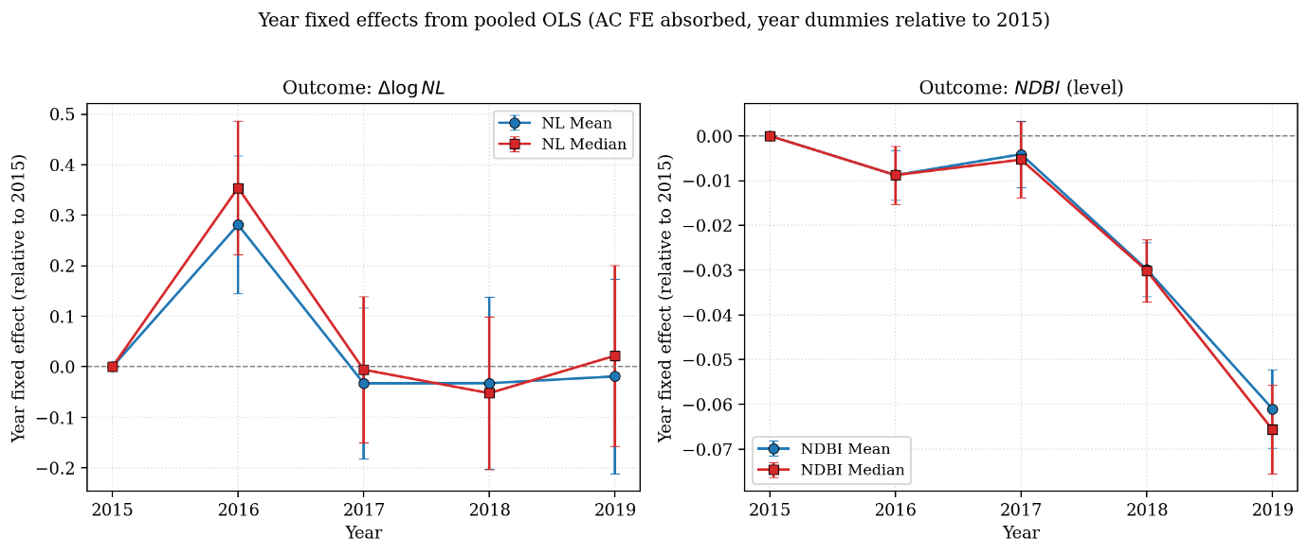
Figure 4.1: Year fixed effects from pooled OLS (AC FE absorbed, year dummies relative to 2015). Common annual shocks of substantial magnitude are visible — particularly the positive 2016 NL shock and the monotonic decline in NDBI from 2017 to 2019 — justifying the inclusion of year fixed effects.
District-level cluster-robust standard errors. Standard errors are computed assuming arbitrary correlation within ACs belonging to the same district (n = 108 districts). District is chosen as a cluster size because flood-resistant infrastructural construction occurs at this administrative level, and not at higher (states) or lower (ACs) levels.

4.5 Estimation Strategy
Each of the two equations is estimated in two specifications and two aggregations, yielding four main regressions for each outcome and a total of twenty regressions once the state-by-state estimations are included.
Pooled estimation. Equation (1) and Equation (2) are first estimated on the full sample of 3,890 AC-year observations spanning all four states. This provides a benchmark result and allows us to test whether a uniform regional effect of floods exists.
State-by-state estimation. Both equations are then estimated separately for the four studied states, namely Bihar, Jharkhand, Odisha, and West Bengal. This allows β₁ to vary by state and addresses RQ 2. The state estimations use the same fixed-effects structure (AC + Year) as the pooled estimation. Sample sizes for the state estimations range from 475 AC-years for Jharkhand to 1,759 AC-years for West Bengal.
Mean and median aggregation. Each estimation is conducted separately using the mean and the median of the satellite raster for the respective AC-year. The two are compared as a robustness check; if the choice of aggregation materially alters the sign or significance of the coefficient, the finding cannot be regarded as robust.
Python and reproducibility. All regressions are estimated in Python using the pyfixest package, which provides two-way fixed-effects with cluster-robust standard errors. We replicated the estimates using the linearmodels package as a cross-check.

CHAPTER 5 — RESULTS AND DISCUSSION

5.1 Introduction
This chapter presents the results obtained from the empirical framework developed in Chapter 4. The two estimating equations — Δ log NL and NDBI — are estimated using both mean and median aggregation methods, first on the pooled sample across all four states and then separately for Bihar, Jharkhand, Odisha, and West Bengal. Altogether, this yields twenty regressions, summarised in four main tables (Tables 5.1–5.4). Section 5.2 introduces the forest plot of the flood coefficient, while Sections 5.3–5.6 discuss each regression table individually. Section 5.7 evaluates whether the findings depend on the aggregation method used. Section 5.8 presents a heatmap summarising all twenty regressions, and Section 5.9 discusses the broader pattern of cross-state heterogeneity.

5.2 Headline: Forest Plot of Flood Coefficients
Before discussing the individual regression tables, Figure 5.1 summarises the main parameter of interest — the flood coefficient β₁ — for all five samples (Pooled, Bihar, Jharkhand, Odisha, and West Bengal) across both dependent variables.
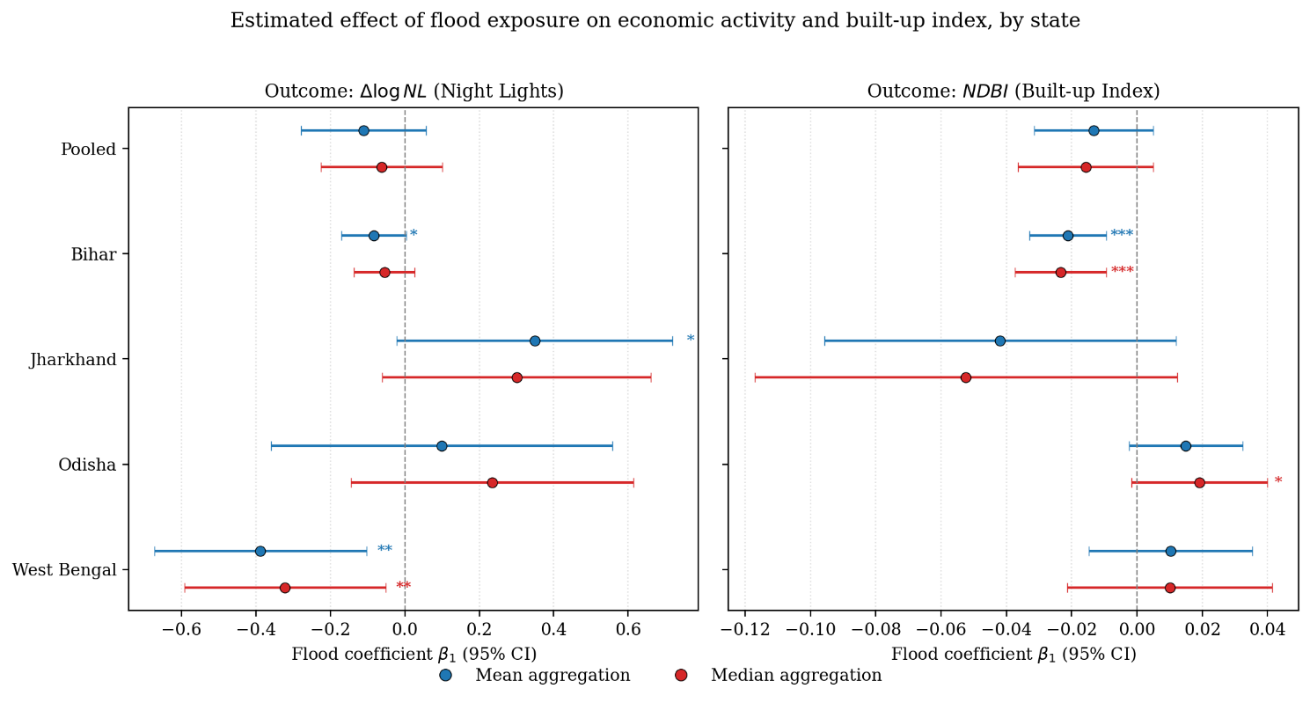
Figure 5.1: Estimated effect of flood exposure on Δ log NL (left panel) and NDBI (right panel) by state, with 95% confidence intervals. Mean and median aggregations are shown side-by-side. Significance stars: * p<0.10, ** p<0.05, *** p<0.01.
Three broad patterns emerge immediately from the figure. First, the pooled flood coefficient is statistically insignificant for both outcomes. Second, West Bengal is the only state where flood exposure has a statistically significant negative impact on nighttime lights, with coefficients ranging from approximately −0.32 to −0.39 depending on the aggregation method. Third, Bihar is the only state where floods significantly reduce the built-up index, with coefficients close to −0.02. Neither Jharkhand nor Odisha displays a consistently significant flood effect in either specification.

5.3 Night Lights — Median Model
Table 5.1 reports the estimates of Equation (1) using the median aggregation of nighttime-light radiance.
 | All states | Bihar | Jharkhand | Odisha | West Bengal
Flood (Seasonal_Ratio) | −0.062 | −0.055 | 0.300 | 0.235 | −0.322**
 | (0.082) | (0.041) | (0.184) | (0.194) | (0.138)
NDVI_{t−1} | 1.124 | 2.556*** | 8.007** | 3.365* | 0.804
 | (0.679) | (0.788) | (2.899) | (1.813) | (0.866)
NDBI_{t−1} | −1.133 | 1.959 | 5.481** | −1.113 | −3.063**
 | (1.107) | (1.368) | (2.467) | (1.652) | (1.084)
AC FE | Yes | Yes | Yes | Yes | Yes
Year FE | Yes | Yes | Yes | Yes | Yes
Observations | 3,890 | 1,215 | 475 | 735 | 1,465
R² (within) | 0.046 | 0.038 | 0.271 | 0.121 | 0.153

Table 5.1: Effect of flood exposure on Δ log NL (median radiance growth). District-clustered standard errors in parentheses. * p<0.10, ** p<0.05, *** p<0.01.
The pooled flood coefficient (−0.062) is relatively small and statistically insignificant. Among the state-specific estimates, only West Bengal displays a statistically significant negative effect. The estimated coefficient of −0.322 (p < 0.05) implies that a one-unit increase in the proportion of an AC classified as seasonal water is associated with approximately a 32 per cent decline in median nighttime-light growth. Since West Bengal contributes the largest number of observations (1,465 AC-years), this estimate is also the most precisely estimated among the four states. The lagged NDBI coefficient is also negative and statistically significant for West Bengal, suggesting that constituencies with higher existing built-up intensity tend to experience slower subsequent nighttime-light growth once flood exposure is controlled for.

5.4 Night Lights — Mean Model
Table 5.2 presents the estimates of Equation (1) using the mean aggregation of nighttime-light radiance.
 | All states | Bihar | Jharkhand | Odisha | West Bengal
Flood (Seasonal_Ratio) | −0.111 | −0.083* | 0.349* | 0.099 | −0.388**
 | (0.085) | (0.044) | (0.189) | (0.234) | (0.145)
NDVI_{t−1} | 1.277 | 3.311*** | 6.403*** | 3.949** | 0.771
 | (0.923) | (1.185) | (2.183) | (1.702) | (1.109)
NDBI_{t−1} | −1.862 | 1.830 | 3.369* | −2.334 | −4.054***
 | (1.356) | (1.491) | (1.741) | (1.727) | (1.354)
AC FE | Yes | Yes | Yes | Yes | Yes
Year FE | Yes | Yes | Yes | Yes | Yes
Observations | 3,890 | 1,215 | 475 | 735 | 1,465
R² (within) | 0.066 | 0.072 | 0.209 | 0.123 | 0.178

Table 5.2: Effect of flood exposure on Δ log NL (mean radiance growth). District-clustered standard errors in parentheses.
The results from the mean specification broadly reinforce those obtained from the median specification, while slightly strengthening some of the estimated effects. West Bengal continues to exhibit a statistically significant negative flood effect, with the coefficient increasing in magnitude to −0.388 (p < 0.05). Bihar's coefficient also becomes marginally significant at the 10 per cent level (β = −0.083), suggesting a weaker but still negative relationship between flood exposure and nighttime-light growth. Jharkhand's coefficient becomes marginally positive (β = 0.349, p < 0.10), although this estimate should be interpreted cautiously due to the small sample size of the state (475 AC-year observations) and the comparatively large standard errors. For West Bengal, the lagged NDBI coefficient is now significant at the 1 per cent level, indicating a robust negative association between pre-existing built-up intensity and subsequent nighttime-light growth once flood exposure is controlled for.

5.5 NDBI — Median Model
Table 5.3 reports the median-aggregation estimates of Equation (2).
 | All states | Bihar | Jharkhand | Odisha | West Bengal
Flood (Seasonal_Ratio) | −0.016 | −0.023*** | −0.052 | 0.019* | 0.010
 | (0.010) | (0.007) | (0.033) | (0.011) | (0.016)
NDVI_{t−1} | 0.002 | 0.346*** | −0.208*** | 0.127** | −0.015
 | (0.031) | (0.066) | (0.071) | (0.061) | (0.033)
NL_{t−1} | 0.0013*** | 0.0059*** | 0.0007 | 0.0031*** | 0.0007*
 | (0.0004) | (0.0009) | (0.0005) | (0.0010) | (0.0004)
NDBI_{t−1} | −0.058* | 0.108* | 0.026 | −0.029 | 0.015
 | (0.030) | (0.060) | (0.051) | (0.040) | (0.044)
AC FE | Yes | Yes | Yes | Yes | Yes
Year FE | Yes | Yes | Yes | Yes | Yes
Observations | 3,890 | 1,215 | 475 | 735 | 1,465
R² (within) | 0.020 | 0.199 | 0.227 | 0.043 | 0.011

Table 5.3: Effect of flood exposure on NDBI (median, level). The lagged-DV coefficient (NDBI_{t−1}) is subject to Nickell bias of order 1/T ≈ 20%; the flood coefficient is largely unaffected.
The pooled estimate of the flood effect on NDBI is small and statistically insignificant. Bihar, however, displays a strong and statistically significant negative coefficient (β = −0.023, p < 0.01). This finding supports the productive-capital channel discussed in Chapter 2: floods in Bihar appear to reduce the stock of built-up infrastructure even after controlling for persistence in NDBI. Odisha exhibits a small positive coefficient that is marginally significant, which may indicate post-flood rebuilding activity rather than direct structural damage. The lagged NL coefficient is positive and statistically significant in most specifications, suggesting that higher prior economic activity contributes to subsequent expansion in built-up infrastructure. This also provides an internal consistency check between the nighttime-light and NDBI measures.

5.6 NDBI — Mean Model
 | All states | Bihar | Jharkhand | Odisha | West Bengal
Flood (Seasonal_Ratio) | −0.013 | −0.021*** | −0.042 | 0.015 | 0.010
 | (0.009) | (0.006) | (0.027) | (0.009) | (0.013)
NDVI_{t−1} | 0.004 | 0.282*** | −0.142** | 0.104** | −0.011
 | (0.026) | (0.062) | (0.052) | (0.044) | (0.027)
NL_{t−1} | 0.0012*** | 0.0050*** | 0.0007* | 0.0022*** | 0.0007**
 | (0.0003) | (0.0008) | (0.0004) | (0.0007) | (0.0003)
NDBI_{t−1} | −0.065** | 0.051 | 0.086** | −0.047 | 0.019
 | (0.032) | (0.060) | (0.038) | (0.030) | (0.048)
AC FE | Yes | Yes | Yes | Yes | Yes
Year FE | Yes | Yes | Yes | Yes | Yes
Observations | 3,890 | 1,215 | 475 | 735 | 1,465
R² (within) | 0.024 | 0.195 | 0.212 | 0.047 | 0.017

Table 5.4 presents the corresponding estimates using mean aggregation.
The mean specification confirms the overall pattern observed in the median specification. Bihar's flood coefficient remains negative and highly significant at the 1 per cent level, with a magnitude very close to that obtained previously. The Odisha coefficient remains positive but is no longer statistically significant once mean aggregation is used. The lagged nighttime-light coefficient remains positive and significant across all four state-level regressions, reinforcing the interpretation that areas with higher prior economic activity tend to experience greater subsequent built-up expansion.

5.7 Robustness: Mean vs Median Aggregation
One possible concern is that the findings may depend on whether the raster values are aggregated using the mean or the median. Figure 5.2 compares the flood coefficients obtained under both aggregation methods.
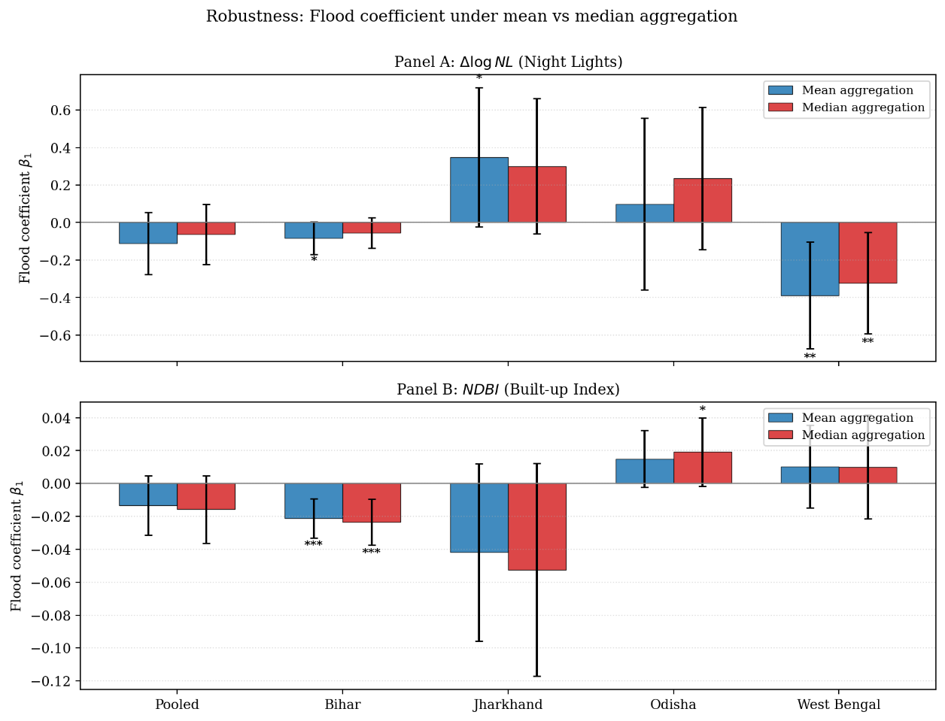
Figure 5.2: Robustness of the flood coefficient under mean versus median aggregation. Panel A: Δ log NL outcome. Panel B: NDBI outcome. Error bars are 95% confidence intervals. Significance stars: * p<0.10, ** p<0.05, *** p<0.01.
Two conclusions emerge from the comparison. First, the sign of the flood coefficient remains unchanged across all states and outcomes regardless of aggregation method, indicating a high degree of robustness. Second, coefficient magnitudes are generally larger under mean aggregation because the mean is more influenced by bright outliers such as urban centres and major transport corridors, which are disproportionately affected during floods. Importantly, the main qualitative findings remain unchanged: flood exposure significantly reduces nighttime-light growth in West Bengal, significantly lowers NDBI in Bihar, and has no stable effect elsewhere.

5.8 Summary: Heatmap of All Twenty Regressions
To facilitate comparison across all specifications, Figure 5.3 summarises the coefficients from all twenty regressions in a single heatmap.
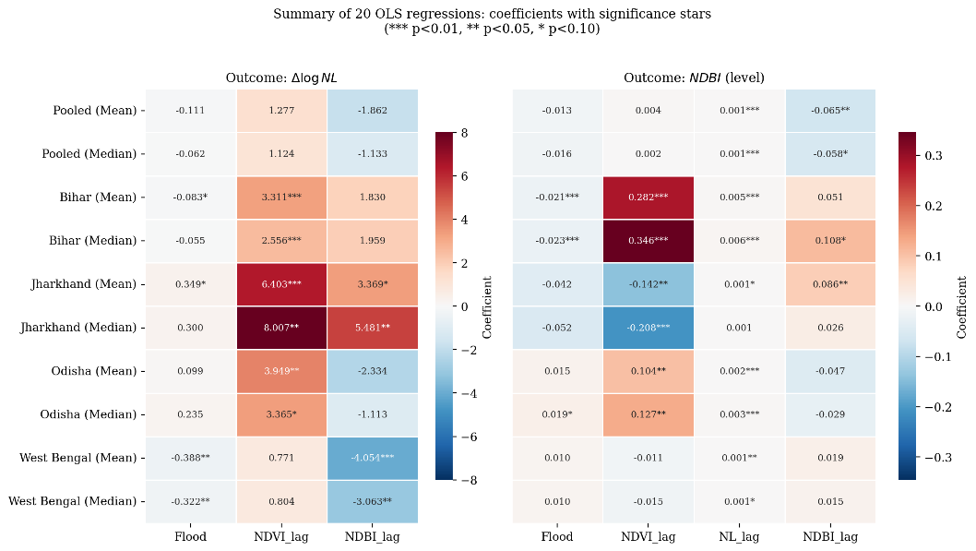
Figure 5.3: Coefficient summary of all twenty OLS regressions. Rows are state × aggregation; columns are regressors. Cells display the estimated coefficient with significance stars. The colour scale encodes coefficient sign (red = negative, blue = positive).
Several additional patterns are visible in the heatmap. First, NDVI_{t−1} is consistently positive and statistically significant in the nighttime-light regressions for Bihar, Jharkhand, and Odisha, suggesting that stronger pre-existing vegetation conditions — interpreted as a proxy for agricultural productivity — are associated with higher subsequent nighttime-light growth. This aligns with the agricultural-land channel described in Chapter 2. Second, NDVI_{t−1} becomes negative and significant in Jharkhand's NDBI regressions. A likely explanation is that highly vegetated areas in Jharkhand are dominated by forests rather than cropland, and forest cover does not translate into built-up expansion. Third, NL_{t−1} is positive and statistically significant across nearly all state-level NDBI regressions, providing further consistency between the nighttime-light and built-up infrastructure measures.

5.9 Discussion of Cross-State Heterogeneity
The main finding that stands out from the analysis is the heterogeneity across states in terms of the impact of floods. This heterogeneity only emerges once one estimates the regression model for each state separately, and it would remain concealed if the analysis was based only on pooled regressions. West Bengal – economic activity channel. In West Bengal, the effect of floods is mainly driven by nighttime-light activity rather than built-up infrastructure. According to the coefficients obtained in the regression model, the increase in the percentage of flooded area by one unit leads to a 32-39% reduction in the growth of nighttime light activity, depending on how the variables are aggregated. On the other hand, the coefficient for NDBI is insignificant. This finding can be linked to the economic characteristics of West Bengal – it is a highly urbanized and populous state with wide coverage of electrification and business activity. Therefore, the floods there seem to disrupt the ongoing economic activity and consumption of electricity – as described in the disruption channel from Chapter 2 – without having a massive effect on the existing built-up infrastructure. Bihar – built-up infrastructure channel. In Bihar, the effect of floods is mostly observed in built-up infrastructure rather than nighttime-light activity. According to the estimated coefficient for the NDBI variable, one additional unit in the percentage of flooded area results in a decrease of about 2% of an NDBI unit. There is very little effect on the level of nighttime light activity. This can be explained by the hydrological characteristics of the state. It experiences recurrent breaches of embankments and flooding caused by Himalayan rivers like Kosi and Gandak. The floods here cause tangible physical damages to roads and buildings – which fits the productive capital channel mentioned in Chapter 2. Jharkhand and Odisha – no significant effect. There is no clear evidence of a robust and statistically significant effect of floods on nighttime lights or NDBI in Jharkhand and Odisha. The effect on nighttime lights in Jharkhand is marginal, possibly due to the limited number of observations (475 AC-years and 81 constituencies). At the same time, the small positive coefficient for NDBI in Odisha may suggest that either the amount of average flood damage in this region was relatively low during the analysis period or it was offset by the process of rebuilding infrastructure. Consequences for pooled analysis. The insignificance of the coefficients in the pooled regressions is explained by their mutual cancellation at the state level. The negative impact of floods on nighttime lights in West Bengal is partially offset by the positive effect in Jharkhand. At the same time, the negative effect of floods on NDBI in Bihar gets diluted when pooled together with the other states where no equivalent effect takes place. Therefore, the pooled coefficient cannot serve as an accurate summary of the flood effect in the Eastern India region.
.

5.10 Magnitude in Economic Terms
To convert the regression coefficients into economically meaningful terms, it is useful to consider the actual variation in the data and scale the coefficient estimates accordingly. The flood-exposure variable Seasonal_Ratio takes values from 0 to 1, such that a one-unit change represents a shift from no seasonal water coverage to full seasonal water coverage, which corresponds to the outer bound of the variation in the sample data. Instead, it is informative to compare the effect of a one standard deviation change in Seasonal_Ratio, which falls between 0.10 and 0.18 across all four states.
When applied to the coefficient estimates, these standard deviations provide a benchmark for assessing the economic significance of the effects. For example, in West Bengal, a one standard deviation increases in Seasonal_Ratio results in a decrease in median nighttime light growth rate of about 4 to 5 percent, based on a within-state standard deviation of 0.13. This is a substantial effect: It implies that 4 to 5 percent of the annual average growth in nighttime lights is eliminated by a moderate flood shock. In Bihar, a one standard deviation increases in Seasonal_Ratio results in a reduction of NDBI by about 0.003 units. Though small in absolute terms, the effect is still substantial when considered in relation to the average change in NDBI per year, which is on the order of 0.01 to 0.02 units.
From these calculations, it can be seen that the statistically significant channel-specific effects identified in this thesis are economically meaningful. The findings indicate that a moderate flood shock, measured as an additional 13 percent flood exposure above the mean, leads to a meaningful reduction in nighttime lights or built-up area in the affected administrative unit. If one considers the lifespan of infrastructure assets, then a lifetime of flooding shocks can have a substantial cumulative effect.

5.12 Why the Pooled Coefficients Are Misleading
A recurring theme in this chapter is that the pooled regressions, which would be the default specification in many empirical settings, are systematically less informative than the state-by-state regressions for the question of interest. Three reasons help explain why.
Firstly, the relevant economic structure varies across states. As discussed in Chapter 2, Eastern India is not a homogeneous region. Bihar's flood exposure comes from upstream Himalayan rivers, West Bengal's from coastal cyclones and deltaic geomorphology, Odisha's from a combination of the two, and Jharkhand's is largely orographic. These different exposure types are likely to engage the three damage channels in different proportions, which means a single pooled coefficient is the average of several distinct local-average treatment effects.
Secondly, the relative weights of the four states in the pooled sample are determined by the number of ACs, not by the importance of each state for the question of interest. West Bengal contributes 1,465 AC-years and Jharkhand only 475, so the pooled coefficient effectively gives West Bengal roughly three times the weight of Jharkhand. This is a sensible weighting if the aim is to estimate an average effect across constituencies, but it is not a meaningful average if the aim is to estimate the effect within each state.
Thirdly, the offsetting pattern in the data, with West Bengal showing a strong negative coefficient and Jharkhand a positive one, means that the pooled estimate is statistically indistinguishable from zero even though the underlying state-level effects are large in absolute terms. This is the classic argument against pooling estimators when the data exhibit treatment-effect heterogeneity, and it applies with particular force here. The state-by-state regressions therefore constitute the primary object of analysis rather than serving merely as a robustness check.

5.13 Limitations of the Specification
Although the specification used in this chapter is consistent with the standard practice in panel data analysis, several limitations should be noted before moving to the policy discussion in Chapter 6.
Firstly, the lagged-dependent-variable specification used for NDBI generates the Nickell bias mentioned in Chapter 4. The bias is of order 1/T, which translates to roughly 20 per cent given the five-year usable panel. The flood coefficient is far less affected by this bias, but the coefficient on the lagged NDBI itself should not be over-interpreted.
Secondly, the specification omits a control for road connectivity, which is plausibly correlated with both flood exposure and economic activity. In Eastern India, low-lying areas are generally less densely served by paved roads than upland areas. Including AC-level road density would therefore be expected to absorb some of the variation in the flood coefficient and improve identification. The data for this control are available from the Geo Sadak database but were not incorporated into the present specification, and this is the most important direction for refining the estimation.
Thirdly, the panel is short, with only five usable years, which limits the precision of the state-by-state estimates and prevents the use of more demanding identification strategies such as long-difference designs or anticipation tests. A longer panel, perhaps extending the sample to 2010 (using the older DMSP-OLS sensor, intercalibrated to VIIRS), would help to address this issue. We discuss the corresponding methodological extension in Chapter 6.

CHAPTER 6 — SUMMARY AND CONCLUDING REMARKS

6.1 Summary of Findings
In this project, the goal was to estimate the short-run impact of floods on Assembly Constituencies in Eastern India in terms of their economic performance over the period 2014 to 2019. To do so, a panel dataset covering 765 Assembly Constituencies spread across four Indian states in Eastern India (Bihar, Jharkhand, Odisha, and West Bengal) was constructed. Economic performance was estimated using two proxies: year-on-year change in log nighttime-light radiance (flow of economic activity) and Normalized Difference Built-up Index (stock of economic activity) measured on a scale of zero to one. Regression specifications included a constant, fixed effects for Assembly Constituency and year, and the interaction between flood exposure and time. Standard errors were clustered at the district level.
The analysis yielded four primary findings:
(i) Pooling conceals the effect. When pooling all four states, the impact of flood exposure cannot be statistically distinguished from zero. This does not mean that floods have no impact in Eastern India, but rather that the state-level impacts partly cancel each other out in the pooled dataset.
(ii) West Bengal: economic-activity contraction. In West Bengal, the impact of flood exposure is negative and statistically significant, with the coefficient of approximately −0.32 (median, p < 0.05) to −0.39 (mean, p < 0.05) for nighttime-lights growth and no significant NDBI change. This is consistent with the disruption channel as opposed to the productive-capital channel.
(iii) Bihar: built-up-infrastructure destruction. In Bihar, the impact of flood exposure is negative and statistically significant with respect to NDBI (β ≈ −0.02, p < 0.01). There is at most a marginally significant reduction in nighttime-lights. The implication of this result is that the channel through which floods affect local economies is the productive-capital channel, as opposed to the disruption channel.
(iv) Jharkhand and Odisha: inconclusive results. There is no evidence of any economically or statistically significant impact of floods in Jharkhand or Odisha. Possible explanations include a limited dataset, a different topography, or heterogeneity in damage exposure to floods.
The results obtained using the mean aggregation method as compared with median aggregation show that the main findings remain unchanged — the sign of the flood coefficient stays the same across the two forms of aggregation.

6.2 Policy Implications
Heterogeneity between states carries several important policy implications.
The inefficiency of a blanket flood mitigation policy. Budgets for mitigating the economic impact of floods in Eastern India currently allocate funds towards state-wide engineering solutions for dealing with floods — mainly, embankments, drainage works, and barrages. This approach presumes a common damage profile across states. The results of the analysis in chapter 5, however, indicate that the channels through which floods damage the local economy vary across states, and thus so too must flood-mitigation policies.
West Bengal needs policies focused on maintaining the continuity of economic activity during floods — power backups for businesses, rapid road clearances, and the development of a flexible market infrastructure. That is because the limiting factor in West Bengal appears to be disruption, not productive capital.
Bihar needs policies focused on safeguarding infrastructure against floods, as well as facilitating faster recovery — stricter flood-resistance housing codes, quick infrastructure repairs after a disaster occurs, maintenance of existing embankments. That is because the limiting factor in Bihar appears to be productive capital.
Both Jharkhand and Odisha need further investigation. That is because the inability to detect a significant impact of floods does not mean that there is none, but simply that their damage mechanism is not captured with the proxies used.
Overall, this means that flood-mitigation budgets need to be tailored to local damage profiles.

6.3 Caveats and Limitations
The following limitations are to be kept in mind when interpreting the results.
Nickell bias. The NDBI specification includes the lagged dependent variable as regressors together with Assembly Constituency fixed effects, which leads to a slight bias in the former. Specifically, there is a bias in the order of 1/T. As T = 5 usable years in our dataset, this bias is approximately 20%. The coefficient on the flood variable, however, is much less sensitive to the issue and is not biased significantly.
The lack of road-connectivity measure. There may be correlation between road density and both flood exposure and economic activity. Thus, inclusion of this measure from the Geo Sadak road-network database as a regressor would help improve the identification of the coefficients of interest. Including road connectivity as a control is the main recommendation for improving the current analysis.
Short panel. The analysis uses only five years' worth of data, limiting the precision of the state-by-state estimations, especially for Jharkhand. Additionally, the availability of five years of data restricts the ability to employ certain more complex identification strategies like difference-in-differences design and anticipation effects.
Proxies versus reality. Both the proxy for economic activity (nighttime-lights) and the proxy for infrastructure destruction (NDBI) are only partial indicators of the economic impact of floods. Their relationship with the economic indicator of interest is necessarily indirect. Inclusion of household survey data as a validation source for the proxies would provide stronger support to the results.

6.4 Future Work
Future research on this topic will proceed along the following lines.
(i) Flood × road connectivity interaction. Using the AC-level road-density data from the Geo Sadak road network database, the regression can be run with an additional interaction term for the effect of roads and flood exposure. The rationale behind this is that ACs with greater road connectivity suffer less disruption during floods because alternative roads remain accessible, and recovery is faster.
(ii) Heterogeneity between urban and rural ACs. Damage caused by floods may differ between primarily urban and primarily rural ACs. The current regression framework can be enhanced to test this claim by including the NDBI level as an interaction term with flood exposure.
(iii) Decomposition by channel using disaggregated outcome measures. This is the most ambitious extension of the current analysis that involves adding new data on agricultural productivity and road damage. Using these new data, the results can be decomposed along the disruption and productive capital channels.
All three of these directions are consistent with the regression methodology used throughout the current thesis and form a viable future research agenda.

6.5 Reconciling the Findings with Prior Work
It is useful to situate our estimates in the broader literature on disaster economics. Two comparisons are particularly informative: with sub-national studies that use survey data, and with studies that use satellite-derived outcome variables in a panel framework.
Comparison with survey-based estimates. Patnaik and Narayanan (2010) found that flood exposure in rural India reduces household consumption persistently, with the strongest effect in the year of the event and a slow recovery thereafter. The 32–39 per cent reduction in nighttime-light growth observed in West Bengal in the present thesis is broadly consistent with this finding, though the two are methodologically distinct: nighttime-light growth captures local economic activity in aggregate, including non-household components such as commercial electricity consumption, whereas household consumption is a narrower measure. That the two approaches yield qualitatively similar conclusions, namely large negative effects in flood-exposed regions of Eastern India, is itself reassuring.
Comparison with satellite-based studies. Kocornik-Mina et al. (2020) used a global sample of cities and found that flood-affected neighbourhoods experience persistent reductions in built-up activity, with magnitudes varying by city size and prior development. The Bihar finding in this thesis, a 2 per cent reduction in NDBI per unit of seasonal-water exposure, is qualitatively in line with their general result, though the geographic context (rural and semi-urban Bihar) differs from the urban focus of their study. The agreement on sign and order of magnitude provides external validation for the present estimates.

6.6 Why Flood-Mitigation Policy in Eastern India Should Be Heterogeneous
Section 6.2 outlined the broad case for heterogeneous policy. This section develops the argument in more detail by drawing out the implications of the two key findings — West Bengal's activity-channel effect and Bihar's stock-channel effect — for specific policy instruments.

6.6.1 West Bengal: Continuity-Oriented Investments
The estimates suggest that floods in West Bengal mainly disrupt economic activity rather than destroy capital. Mitigation policy should therefore prioritise interventions that maintain continuity of activity during and immediately after a flood event. Three policy instruments are particularly well suited to this objective.
First, electrical-supply resilience. Backup power for hospitals, schools, and commercial centres reduces the loss of activity during flood-induced grid outages. A district-level rolling assessment of backup-power availability, prioritising the most flood-prone constituencies, would be a low-cost and high-impact step.
Second, transport-network redundancy. The disruption channel operates partly through road and rail closures that prevent goods and labour from reaching their normal destinations. Investment in alternative-route planning, raised roadways in known flood-prone segments, and rapid debris-clearance protocols would shorten the disruption window.
Third, mobile market and credit infrastructure. Where physical markets close, mobile-payments infrastructure and informal credit lines allow households and small businesses to continue trading at reduced volumes. Financial-inclusion programmes that extend mobile banking penetration in flood-prone districts of West Bengal therefore have a co-benefit in flood resilience.

6.6.2 Bihar: Stock-Oriented Investments
The estimates suggest that floods in Bihar destroy built-up infrastructure rather than only disrupt activity. Mitigation policy in Bihar should therefore prioritise the protection and repair of physical assets. Three instruments deserve particular emphasis.
First, flood-resilient construction codes. Houses, schools, and commercial structures in the flood-prone districts of north Bihar are typically built without elevated plinths or flood-resistant materials. Building codes mandating raised foundations, water-resistant cladding, and plinth heights calibrated to historical flood levels would reduce the depreciation of the capital stock with each flood event.
Second, embankment maintenance. The Kosi and Gandak embankments are the principal flood-defence infrastructure in northern Bihar, but their maintenance has been chronically under-funded. The state's own assessments indicate that a substantial fraction of embankment length is in poor structural condition. Routine maintenance, breach-detection sensors, and pre-monsoon inspections would directly reduce the frequency of catastrophic breach floods.
Third, post-flood reconstruction logistics. After a major flood, the speed of reconstruction determines the persistence of the damage. State-level disaster-response funds in Bihar are released according to procedures that often delay disbursement by several weeks. A streamlined fast-track procedure, supported by satellite-based damage assessments to allow rapid claim verification, would shorten the reconstruction window and reduce the cumulative cost of repeated flooding.

6.6.3 Jharkhand and Odisha: Diagnostic First, Prescription Later
For Jharkhand and Odisha, the absence of a robust flood coefficient under the present specification does not imply that floods are economically harmless in those states. It implies that the present satellite-based proxies do not capture the channel through which floods damage these economies. Two specific extensions would help.
First, in Jharkhand, the small sample size (only 81 ACs) limits statistical power. Extending the sample backwards to 2010 using DMSP-OLS data, after intercalibration with VIIRS, would roughly double the available panel and could reveal effects that are currently hidden by noise.
Second, in Odisha, the dominant flood channel may be agricultural rather than residential, given the state's coastal-paddy economy. Replacing or augmenting the present outcome variables with crop-yield estimates from MODIS or with district-level agricultural production data would directly test this hypothesis.

6.7 Implications for the Design of Flood-Mitigation Budgets
The state-level differences identified in this thesis carry direct implications for the design of flood-mitigation budgets in Eastern India.
First, the allocation across states should reflect the channel that matters most in each state. A budget that allocates funds proportionally to flood exposure alone — for example, in proportion to Seasonal_Ratio — would over-weight Jharkhand (which has the highest exposure but no robustly identified effect) and under-weight West Bengal (which has lower mean exposure but a large activity-channel effect). A more efficient allocation would weight by both exposure and the elasticity of the relevant economic outcome to that exposure.
Second, the allocation within states should reflect the relevant channel. In West Bengal, funds should flow towards utilities, transport, and market infrastructure. In Bihar, funds should flow towards housing codes, embankments, and post-flood reconstruction logistics. The same total budget can deliver substantially different welfare benefits depending on whether it is allocated against the local damage profile or against a national-average damage profile.
Third, monitoring and evaluation should be conducted at a finer spatial unit than is currently standard. The Assembly Constituency level used in this thesis is a tractable unit because it aligns with electoral and administrative boundaries, allows annual measurement using freely available satellite data, and permits the identification of effects that would be invisible at the district or state level. Adopting AC-level monitoring would substantially improve the empirical basis for future policy revisions.

6.8 Final Remarks
This thesis began with a measurement problem. The economic cost of floods in Eastern India has been understood for decades to be large, but the conventional administrative statistics that should quantify it are released too late, at too coarse a spatial resolution, and with too narrow a definition of damage to be useful for short-run policy. The combination of satellite-based exposure measures and satellite-based outcome measures, applied within a fixed-effects panel framework, provides a partial solution to this measurement problem.
The empirical results show that flood impact in Eastern India is heterogeneous across states, operates through different channels in different states, and is sufficiently precisely estimated for policy use in West Bengal and Bihar. The pooled regressions that have dominated the published literature on Indian flood economics mask this heterogeneity and produce coefficients that are statistically indistinguishable from zero, even though large state-level effects exist.
These findings should be useful both for the design of flood-mitigation budgets and for further empirical research. With a longer panel, a road-connectivity control, and disaggregated outcome measures, the channels documented here can be decomposed further; with household-survey validation, the satellite-derived estimates can be linked directly to welfare measures. Each of these extensions follows naturally from the framework developed in this thesis and constitutes a defined research agenda for future work.

REFERENCES

Academic papers
Jain, S. K., Saraf, A. K., Goswami, A. & Ahmad, T. (2006). Flood inundation mapping using NOAA AVHRR data. Natural Hazards, 37, 43–59.
Kale, V. S. (2003). Geomorphic effects of monsoon floods on Indian rivers. Natural Hazards, 28, 1–3.
Nickell, S. (1981). Biases in dynamic models with fixed effects. Econometrica, 49(6), 1417–1426.
Pekel, J.-F., Cottam, A., Gorelick, N. & Belward, A. S. (2016). High-resolution mapping of global surface water and its long-term changes. Nature, 540, 418–422.
Sinha, R., Bapalu, G. V., Singh, L. K. & Rath, B. (2008). Flood risk analysis in the Kosi river basin, North Bihar using multi-parametric approach of analytical hierarchy process (AHP). Journal of the Indian Society of Remote Sensing, 36(2), 293–307.
Henderson, J. V., Storeygard, A. & Weil, D. N. (2012). Measuring economic growth from outer space. American Economic Review, 102(2), 994–1028.
Chen, X. & Nordhaus, W. D. (2011). Using luminosity data as a proxy for economic statistics. Proceedings of the National Academy of Sciences, 108(21), 8589–8594.
Bhandari, L. & Roychowdhury, K. (2011). Night lights and economic activity in India: A study using DMSP-OLS night-time images. Asia-Pacific Advanced Network, 32, 218–236.
Zha, Y., Gao, J. & Ni, S. (2003). Use of normalized difference built-up index in automatically mapping urban areas from TM imagery. International Journal of Remote Sensing, 24(3), 583–594.
Kocornik-Mina, A., McDermott, T. K. J., Michaels, G. & Rauch, F. (2020). Flooded cities. American Economic Journal: Applied Economics, 12(2), 35–66.
Felbermayr, G. & Gröschl, J. (2014). Naturally negative: The growth effects of natural disasters. Journal of Development Economics, 111, 92–106.
Klomp, J. & Valckx, K. (2014). Natural disasters and economic growth: A meta-analysis. Global Environmental Change, 26, 183–195.
Strobl, E. (2012). The economic growth impact of natural disasters in developing countries: Evidence from hurricane strikes in the Central American and Caribbean regions. Journal of Development Economics, 97(1), 130–141.
Kahn, M. E. (2005). The death toll from natural disasters: The role of income, geography, and institutions. Review of Economics and Statistics, 87(2), 271–284.
Patnaik, U. & Narayanan, K. (2010). Vulnerability and climate change: An analysis of the eastern coastal districts of India. Working Paper, Indira Gandhi Institute of Development Research, Mumbai.
Mukherjee, S., Bandyopadhyay, S. & Mukhopadhyay, M. (2014). Economic and social impact of floods in West Bengal: A district-level study. Journal of Rural Development, 33(3), 287–306.

Reports and government publications
Census of India (2011). Population and Housing Census of India. Office of the Registrar General and Census Commissioner, Government of India.
Central Water Commission (CWC) (2024). Annual Flood Damage Report. Ministry of Jal Shakti, Government of India.
Election Commission of India (2008). Delimitation Files for Assembly Constituencies (post-delimitation). Election Commission of India, New Delhi.
Government of Bihar (2024). State Flood Reports. Department of Disaster Management, Government of Bihar.
Ministry of Statistics and Programme Implementation (MoSPI) (2024). State-wise Net State Domestic Product per capita. Government of India.
National Disaster Management Authority (NDMA) (2024). Flood Frequency and Damage Statistics for India. Government of India.
National Flood Commission (1980). Report on Flood-Prone Area Statistics for India. Government of India.
National Institute of Disaster Management (NIDM) (2024). Flood Hazard Atlas of India. Ministry of Home Affairs, Government of India.
National Remote Sensing Centre (NRSC), ISRO, NDMA & Government of Bihar (2010). Flood Hazard Atlas of Bihar — A Geospatial Approach. NRSC-ISRO, Hyderabad.

Datasets
Google Earth Engine (2024). Landsat-8 Surface Reflectance imagery. United States Geological Survey (USGS) / NASA.
Joint Research Centre, European Commission (2024). Global Surface Water Dataset. European Commission Joint Research Centre, Ispra. (Built on Pekel et al., 2016.)
Ministry of Road Transport and Highways (MoRTH) (2024). Geo Sadak — Road Infrastructure Database. Government of India.
NOAA / Visible Infrared Imaging Radiometer Suite (VIIRS) (2024). Day-Night Band (DNB) Annual Composites. National Oceanic and Atmospheric Administration, USA.
NOAA / Defense Meteorological Satellite Program (DMSP) (2014). Operational Linescan System Nighttime Lights. National Oceanic and Atmospheric Administration, USA.

Software
Berge, L., Krantz, S. & McDermott, G. (2024). pyfixest: Fast high-dimensional fixed-effects regression in Python. Open-source Python package.
Sheppard, K. (2024). linearmodels: Linear models for Python (panel and instrumental-variables estimation). Open-source Python package.

APPENDIX A — VARIABLE CONSTRUCTION DETAILS

A.1 Flood Exposure (Seasonal_Ratio)
The flood exposure variable is calculated based on the JRC's Global Surface Water data set (Pekel et al., 2016), which is accessible through Google Earth Engine. The data set provides a per-pixel classification of water presence at 30-meter resolution for each calendar year. There are four classes of pixels: not water (HISTO_0), seasonal water (HISTO_1), permanent water (HISTO_2), and not observed (HISTO_3).
The area-weighted share of each class for each Assembly Constituency (AC) is calculated as: Seasonal_Ratio_it = HISTO_1_it / (HISTO_0_it + HISTO_1_it + HISTO_2_it). Note that the denominator excludes the not-observed category since we do not want to interpret the lack of observations as belonging either to land or to water. Seasonal_Ratio takes values from zero to unity and equals the share of the classified surface area that is seasonal (i.e., flood) water in year t in AC i.

A.2 Nighttime Lights (VIIRS DNB)
Annual average nighttime-light radiance comes from the NASA/NOAA VIIRS day-night band annual composites data (NOAA/VIIRS/DNB/MONTHLY_V1) at an aggregation level of annual means. For each AC polygon and each year, the following two statistics are calculated as the zonal statistics: NL_mean_it (pixel-wise mean radiance in AC i, year t) and NL_median_it (pixel-wise median radiance in AC i, year t).
The change in the logarithm of radiance from year t to year t+1 is the dependent variable in Equation (1): Δ log NL_it = log(NL_it) − log(NL_{i,t−1}). The pre-2014 DMSP OLS data are not used in this study as these data need to be intercalibrated with VIIRS data for a consistent comparison. Hence, 2014 is the starting point of our panel.

A.3 NDBI and NDVI (Landsat-8 SR)
Normalized Difference Built-Up Index and Normalized Difference Vegetation Index are calculated using the pixel-level data from the Landsat-8 Surface Reflectance imagery (LANDSAT/LC08/C02/T1_L2) according to the following formulas: NDBI = (SWIR1 − NIR) / (SWIR1 + NIR); NDVI = (NIR − RED) / (NIR + RED). Here, SWIR1 stands for band 6 (short-wave infrared), NIR stands for band 5 (near-infrared), and RED stands for band 4. The indices are computed on an annual basis based on a median composite of the cloudy images from the calendar year. Afterward, the indices are aggregated to AC polygon by both the mean and median statistics.

A.4 Zonal Aggregation
All rasters-to-polygons aggregations are done using zonal statistic functions in Google Earth Engine (ee.Image.reduceRegions). The source polygons are the Election Commission of India post-delimitation Assembly Constituency boundaries (since 2008). Reduction parameters include calculations of the mean and median statistics in one function call to keep the results consistent.

A.5 Lag Construction
The lagged regressors are constructed by sorting on years and applying one-period shift within each AC. The construction of the lags goes as follows: for a given variable X, X_{i,t−1} = X[i, t−1] if both (i, t−1) and (i, t) are observed; X_{i,t−1} = missing otherwise. This leaves out 2014 observations due to the lack of lags, leaving us with 3,890 observations from the total number of 4,674 AC-years.

A.6 Cluster Variable for Standard Errors
Clustered standard errors are used in all regressions, being the clusters formed by the districts. The cluster identifiers are constructed as a string concatenation of ST_CODE and DT_CODE codes provided by the Census of India 2011 classifications. We have 108 district-level clusters in our estimation sample in the four states.

