|  |
| --- |
| C:\Users\HP\AppData\Local\Microsoft\Windows\INetCache\Content.Word\healthcare.jpg |
| Health Center Management System  Software Requirement Specification |
| |  |  |  | | --- | --- | --- | |  | 11/30/17 | UCS503 | |

**TABLE OF CONTENTS**

|  |  |  |
| --- | --- | --- |
| *SNo* | *Title* | *Page No* |
| *1* | ***Group Introduction*** | ***3*** |
| *2* | ***Primary Investigation*** | ***3*** |
| *2.1* | *Need of Project* | *3* |
| *2.2* | *Project Scope* | *4* |
| *2.3* | *Project Limitation* | *4* |
| *2.4* | *Profile* | *5* |
| *2.5* | *Mission* | *5* |
| *2.6* | *Existing System* | *5* |
|  | *2.6.1 Disadvantages of existing system* | *5* |
| *2.7* | *Proposed System* | *6* |
| *2.8* | *Feasibility Study* | *7* |
|  | *2.8.1 Need of feasibility study* | *7* |
|  | *2.8.2 Technical Feasibility* | *7* |
|  | *2.8.3 Behavioral Feasibility* | *8* |
|  | *2.8.4 Economic Feasibility* | *9* |
| *2.9* | *Reflective Diary* | *10* |
| *3* | ***Data Flow Diagrams(DFDs)*** | ***13*** |
|  | *0 Level DFD(context level)* | *13* |
|  | *1st Level DFD* | *14* |
|  | *2nd Level DFD* | *15* |
| *4* | ***Software Requirement Specification*** | ***17*** |
| *4.1* | *Introduction* | *17* |
| *4.2* | *System Architecture* | *18* |
| *4.3* | *System Requirement Specification* | *19* |
|  | *4.3.1 Functional Analysis* | *19* |
|  | *4.3.2 Non-Functional Analysis* | *22* |
| *4.4* | *Software Process Model* | *24* |
| *4.5* | *Entity Relationship Diagram* | *25* |
| *4.6* | *Description of Tables* | *26* |
| *5* | ***System Design*** | ***31*** |
| *5.1* | *Use Case Diagram* | *31* |
| *5.2* | *Activity Diagram* | *32* |
| *5.3* | *Class Diagram* | *33* |

1. GROUP INTRODUCTION

|  |  |  |
| --- | --- | --- |
| SNo | Roll no | Name |
| 1 | 101503208 | Shivam Sharma |
| 2 | 101503211 | Shobhit Jain |
| 3 | 101503213 | Shreya Aggarwal |
| 4 | 101503217 | Shubham Arora |

1. **PRIMARY INVESTIGATION**

2.1.Need of system :

In the Health Center management project we are trying to reduce the paper work done at Center and bring everything online so that most of the work is done automatically (like Patient information is filled in receipt automatically by scanning bar code of the ID Card of Patient).

Some advantages of our system over which is currently followed are:

* Easy to collect information of patients.
* Saves lot of manpower, time and resources (ex: Paper, Carbon-paper).
* Makes routine work easy.
* Error free process.
* This process is more user friendly.
* Patient data can be stored for a longer period of system.
* Stock of pharmacy is also maintained online so we can get notification regarding expiry of medicines and which medicines are out of stock.

**2.2. Project Scope*:***

* Patient Management in Health Center.
* Stock Management of medicines in pharmacy.
* Attendance of doctors and other staff members are also maintained online.
* Data of every patient is kept so that at the time of emergency particular groups can be informed (like: in case of blood requirements person with same blood group can be notified).

**2.3. Project Limitation:**

* Data of only 20 years is stored.
* Some unique ID required to manage patients.

**2.4. Profile*:***

Name : Health Center

Address : Thapar University Patiala, 147001

Phone No : 0175 239 3021

Fax : 0175 239 3021

Email : [healthcenter@thapar.edu](mailto:healthcenter@thapar.edu)

**2.5. Mission:**

Our main aim is to make routine work of Health Center easy by reducing manpower and implementing everything online. We shall enhance the patient quality life through providing specialized medical treatment.

**2.6. Existing System**:

* The existing system is fully pen and paper based.
* Receipt are taken from the receipt book and details are entered by hand and the data is maintained in registers.
* There are many chances of error while entering the details.
* Data storage is not efficient and are not saved for long time.
* Work Load is more.
* Previous data search is difficult (like which medicine was provided by the pharmacy).

*2.6.1 Disadvantages of Existing:-*

* Work load is more.
* More manpower is required.
* Problems in finding data.
* Information

**2.7. Proposed system**:

The health center will be fully computerized in the proposed system. This system will help in managing the data (like doctor’s information, patients’ information, medical stocks, etc.), registering new patient, maintaining patient records and blood group information.

* Patients will first go to the reception if the patient is there for the first time they will have to register (students can register by their ID cards and others can register by providing their details).Then the receipt will be generated and the patient will get the receipt number (Or token number).
* Patient will visit the doctor according to their token number and will get the treatment and prescription.
* Patient can visit the pharmacy if need be.
* At last at the reception the patient will get the receipt with the prescription and the doctor they visited.

**2.8. Feasibility Study:**

2.8.1 NEED FOR FEASIBILITY STUDY

Feasibility study is a test of system proposed regarding its work ability, its impact on the organization ability to meet user needs and effective use of resources. The feasibility study is carried out to test whether the proposed system is worth being implemented. It is usually carried out by a small number of people who are familiar with the information system techniques, understand the part of the business or organization that will be involved or effected by the project and are skilled in the system analysis and design process.

The key consideration involve in the feasibility study are:

1. Technical Feasibility

2. Behavioral Feasibility

3. Economic Feasibility

2.8.2 Technical feasibility:-

The new system aims to reduce the manpower and store the data in proper and effective way for a large time, and also the proposed system reduces the data redundancy and minimizes error. The registration of new patient is fast and receipt generation time is reduced. The new system will be more user friendly to both the patients and staff.

* *Software Requirements:*

Some software that will be required are:-

* + 1. Operating system (Windows XP or above)
    2. My SQL
    3. Web Browser (chrome 32 or upper version)
    4. XAMPP (Server creation tool)
* *Hardware Requirements:*
  + - 1. Desktop System-5
      2. Printer-1
      3. Bar code reader
      4. Lan Cable
      5. Lan Switches

2.8.3 Behavioral feasibility:-

With the proposed system the patients will be not be required to wait for long time for receipts and to get the desired medicines, and it is more environment friendly as it saves paper. This is also helpful to the working staff and pharmacy in many ways such as maintaining their attendance and leave records, will decrease the mechanical work the staff needs to do and the stocks can be properly managed in pharmacy by keeping proper track record of the purchases and notifying the manager to buy more stocks of a particular product when required. Initially staff can face some difficulties while interacting with the system but will overcome with that by the time.

2.8.4 Economic feasibility:-

In our proposed system economy based changes are as follows:

* Man power : No changes
* Printer :  ₹12000
* Desktop System :  ₹32000*5 = ₹160000
* Bar code Scanner : ₹2500

Total Cost : **₹174500**

* *Hardware:*
* Developers Requirement :-
  + Ram 4 GB
  + Processor Intel core I5
  + Hard disk 500 GB
* User Requirement :-
  + Processor Intel core I5
  + Hard disk 500GB
  + RAM 4GB
* *Software:*
* Operating system : Windows XP or above
* Database : My SQL
* Xampp
* Web Browser

**2.9 Reflective Diary*:***

|  |  |  |  |
| --- | --- | --- | --- |
| **SNo** | **START DATE** | **END DATE** | **TITLE** |
| 1. | 15/08/2017 | 15/08/2017 | Decided project – HEALTHCENTRE, THAPAR UNIVERSITY |
| 2. | 17/08/2017 | 18/08/2017 | Primary investigation   * Need of project * Project Scope * Project Limitation |
| 3. | 20/08/2017 | 22/08/2017 | Primary Investigation   * Profile * Mission * Existing System * Proposed system |
| 4. | 23/08/2017 | 25/08/2017 | Feasibility Study   * Need of feasibility study * Technical Feasibility * Software Requirements * Hardware Requirements * Behavioral Feasibility * Economic Feasibility * Software * Hardware |
| 5. | 01/09/2017 | 08/09/2017 | Data Flow Diagrams(DFDs)   * 0 level DFD * 1st  level DFD * 2nd level DFD |
| 6. | 11/09/2017 | 12/09/2017 | System Architecture |
| 7. | 12/09/2017 | 14/09/2017 | Functional Analysis |
| 8. | 14/09/2017 | 15/09/2017 | Non-Functional Analysis |
| 9. | 15/09/2017 | 15/09/2017 | Software Process Model - SPIRAL |
| 10. | 22/09/2019 | 25/09/2017 | System Design - Use Case Diagram |
| 11. | 26/09/2017 | 30/09/2017 | System design – Activity Diagram |
| 12. | 05/10/2017 | 08/10/2017 | Database design |
| 13. | 08/10/2017 | 11/10/2017 | Behavioral Design – Class Diagram |
| 14. | 13/10/2017 | 17/10/2017 | * Designed Home Page * Vision * Contact Us |
| 15. | 18/10/2017 | 19/10/2017 | * Feedback Module * Developers Module |
| 16. | 20/10/2017 | 27/10/2019 | * Student Registration * Staff Registration   (Doctor/Pharmacy/Helping Staff)   * Admin Registration * Receipt Generation |
| 17. | 05/11/2017 | 08/11/2017 | * Admin login * Doctor login * Pharmacy login |
| 18. | 12/11/2017 | 14/11/2017 | Entity Relationship Diagram (ER Diagram) |
| 19. | 15/11/2017 | 23/11/2017 | Pharmacy Dock(complete) |
| 20. | 24/11/2017 | 25/11/2017 | Presentation |
| 21. | 25/11/2017 | 26/11/2017 | Poster |
| 22. | 27/11/2017 | 29/11/2017 | Video – Making and Editing |

**3. DATA FLOW DIAGRAMS (DFDs):**

A data flow diagram is graphical representation that depicts the information flow and the transformations that are applied as data moves from input to output. It can be used to represent a software at any level of abstraction. In fact DFDs may be partitioned in to levels. DFDs are defined in levels with every level decreasing the level of abstraction as well as defining a greater detail of the functional organs of the system.

* ***0 Level DFD(context level)***

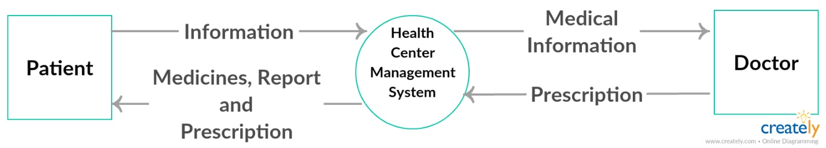

* ***1st Level DFD***

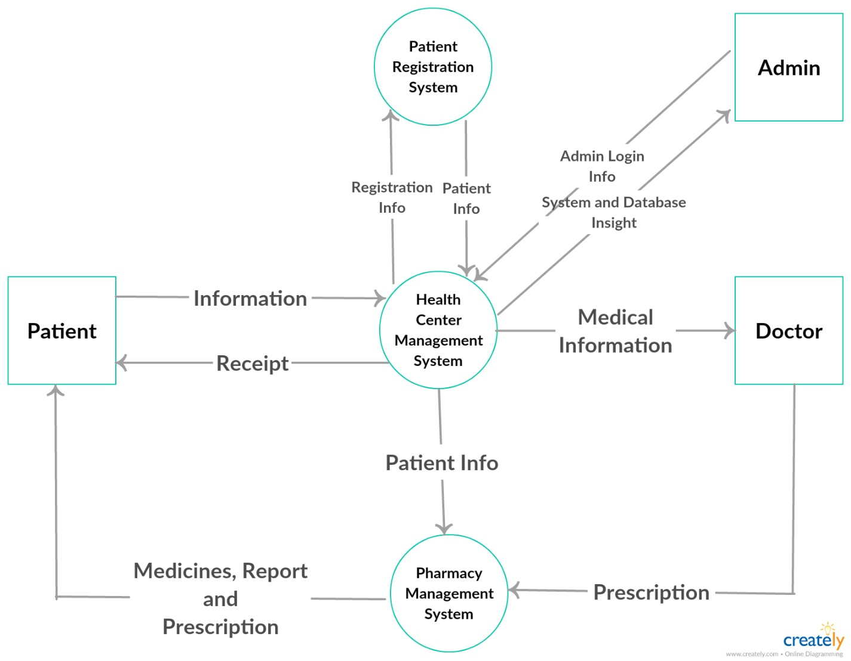

* ***2nd Level DFD***

1. **Patient Registration System**

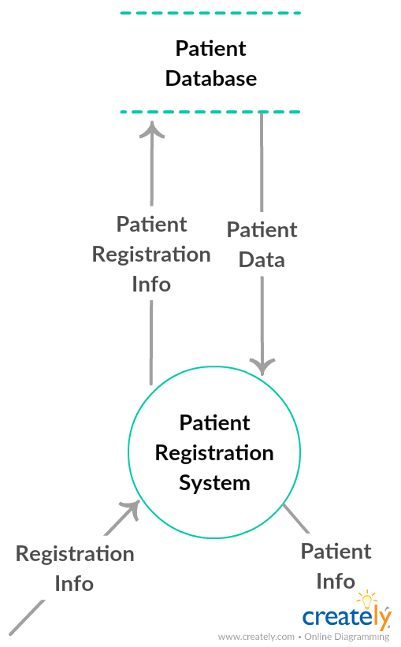

1. **Pharmacy Management System**

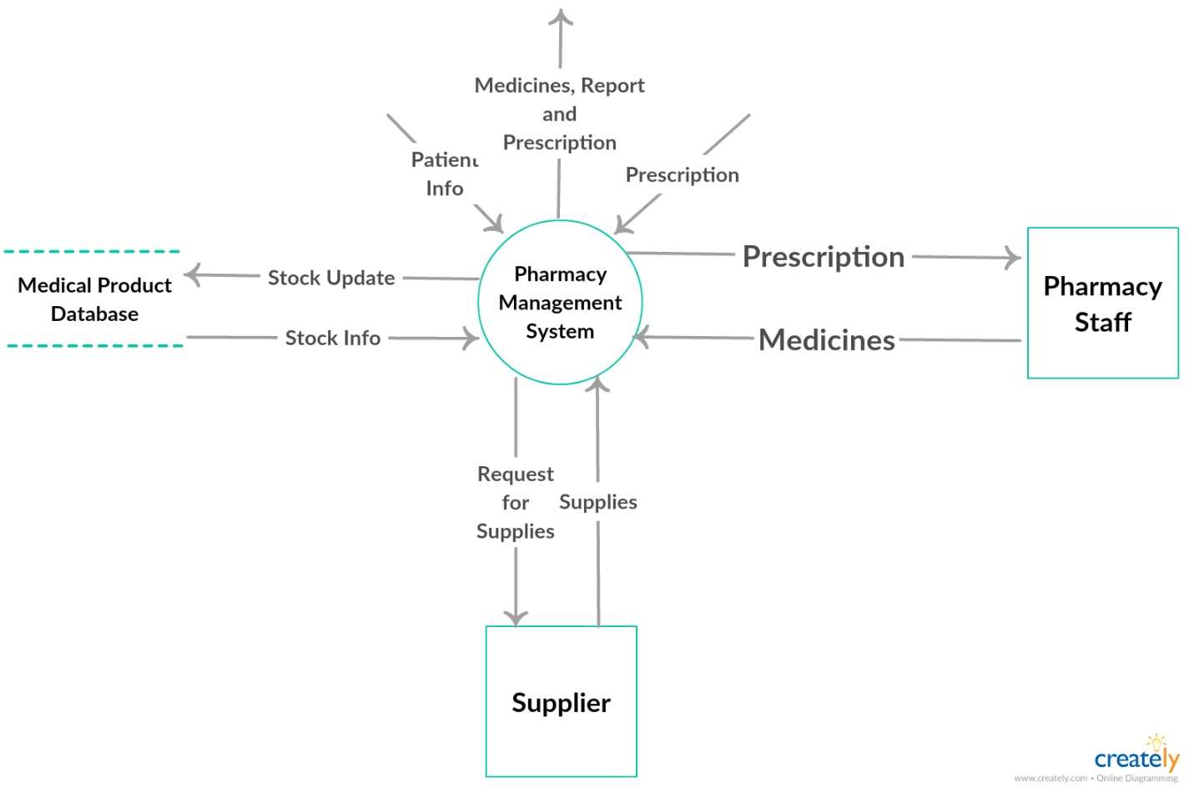

**4. SOFTWARE REQUIREMENT SPECIFICATION:**

**4.1 Introduction:**

In the Health Center management project we are trying to reduce the paper work done at Center and bring everything online so that most of the work is done automatically (like Patient information is filled in receipt automatically by scanning bar code of the ID Card of Patient).

Some advantages of our system over which is currently followed are:

* Easy to collect information of patients.
* Saves lot of manpower, time and resources (ex: Paper, Carbon-paper).
* Makes routine work easy.
* Error free process.
* This process is more user friendly.
* Patient data can be stored for a longer period of system.
* Stock of pharmacy is also maintained online so we can get notification regarding expiry of medicines and which medicines are out of stock.

**4.2 System Architecture:**

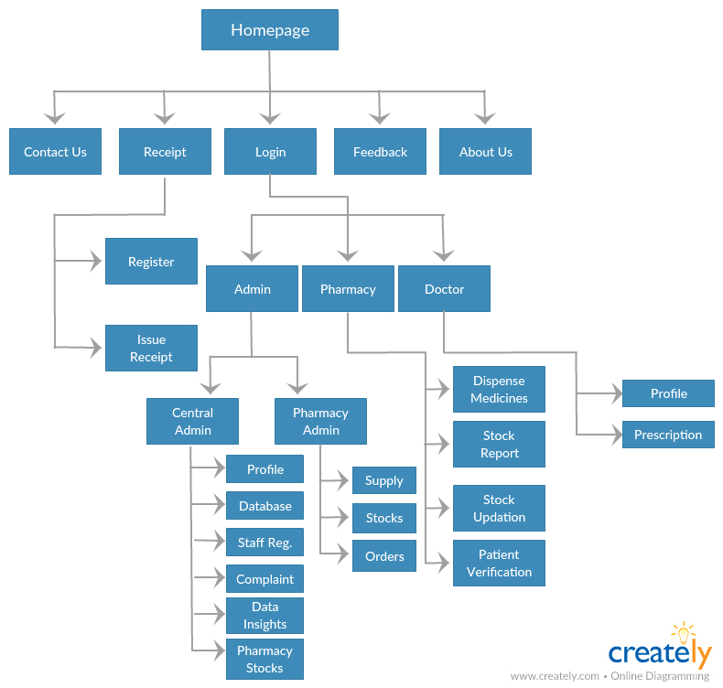

**4.3 Functional Analysis:**

***ADMIN MODULE***

* The admin manages the health center database. The admin can view all the databases by logging into the system.
* All the registrations of staff are authenticated by the admin.
* There is an admin for pharmacy which only manages the pharmacy system.
* Pharmacy admin logins to view the medicines’ stocks.
* Pharmacy admin controls the medicine supplies and also has privileges to order medicines.
* The main admin, along with the above privileges has the privilege to view complaints (feedback).
* The main admin has the facility of data insights and viewing profiles.

***PHARMACY MODULE***

* The main function of this module is to dispense medicines to the patient.
* It also does patient verification through the patient’s roll no, given by patient at the time of collecting medicines, against the patient’s name (in the prescription).
* This module of the system has the privilege to update medicine stocks.
* Stock reports are provided by this module.

***DOCTOR MODULE***

* The doctor logins into the system (attendance is marked automatically).
* The doctor writes the prescription (after checkup of the patient) by the patient’s name (and not the roll no).
* The doctor can view his profile and see details such as attendance etc.

***RECEIPT MODULE***

* This module of the system registers the patient into the health center by the patient’s roll no.
* If the patient’s record does not exists, he asks for more relevant details such as patient name, hostel, contact no, blood group etc.
* The module then asks the patient whether he/she is there for only registration or for checkup.
* If the patient has come for checkup, the details are passed onto the doctor.
* This module issues the receipt to the patient at the time of exit.

***FEEDBACK MODULE***

* In this module the staff can give their positive or negative feedback.
* The main admin of the health center will regularly monitor these feed-backs.

***ABOUT US MODULE***

* It will provide the staff with vision of the health center.

***CONTACT US MODULE***

* It will give admin details to the staff.

***DEVELOPER MODULE***

* This is the direct link to contact the developers in case of assistance or any further improvement.

**4.4 Non-Functional Analysis:**

Non functional requirements specifies criteria that can be used to judge the operation of a system rather than specific behaviors.

*I. Performance Requirements:*

* Our software is based on web and has to be run on a web server.
* 20 years of data will be stored for any further assistance.
* Software performance is solely is dependent on the hardware system provided. It may take some time to load based on the net connection.

*II. Safety Requirements:*

* There is admin privilege which will be authenticated using bio-metrics.
* Staff registration can only be done by a Central Admin.
* Pharmacy stocks can only be managed by the admins either pharmacy admin or main admin. So as to ensure that expired medicines are removed and a minimum stock of medicines are maintained.
* Patient can get the medicines only if doctor prescribes. To minimize the risk of taking wrong medicines directly by the patient from the pharmacy
* If the patient takes medicines from the pharmacy it will be verified using bar code or roll number.

*III. Security Requirements:*

Some of the factors that are identified to protect the software from accidental or malicious access, use, modification, destruction or disclosure are described below:

* + Since all the data is stored locally it is not prone to theft.
  + All the logins provided in the system make the system much more secure.

*IV. Product Cost:*

Since it is a web based software so these expenditures may occur:

* + - Man Power Cost.
    - Hardware Cost.

*V. Hardware Requirements:*

* + Developers Requirement :-
  + Ram 4 GB
  + Processor Intel Core i5
  + Hard disk 500 GB

*VI. User Requirement:*

* + Processor Intel core I5
  + Hard disk 500GB
  + RAM 4GB

*VII. Software Requirements:*

* + Operating system : Windows XP or above
  + Database : MySQL
  + Web Creation Tool :Xampp
  + Web Browser :Google Chrome, Firefox, etc. (any one)
  + Programming Language :PHP

**4.4 Software Process Model:**

The process model used for the development of this project is – Spiral Model. As the team was not perfectly clear about the specifications of the final product we used an iterative model which aided the step-wise development procedure.

**4.5 Entity Relationship Diagram:**

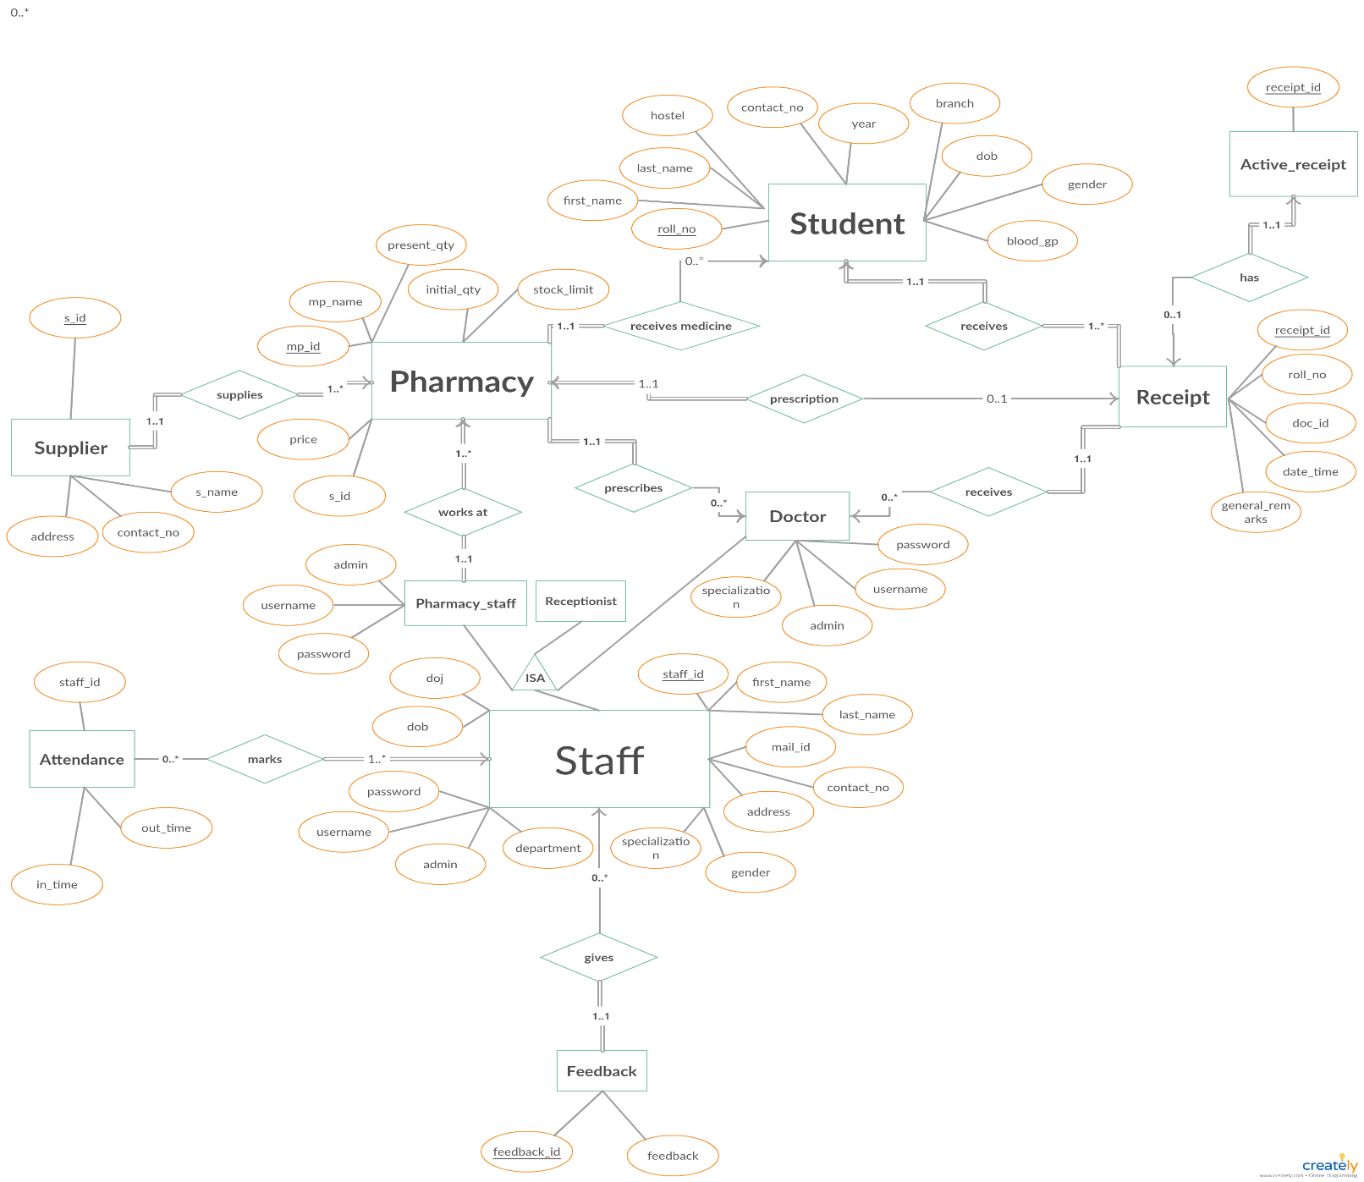

**4.6 Description of Tables:**

We have a total of 10 tables which are as follows :

* 1. Student_data Table

**PRIMARY KEY – ROLL_NO**

This table contains the data specific to a specific visitor. This table is intended to provide all the information of all the students to other table since it has the column ROLL_NO as the primary key which will be referenced in other table. This table also serves the purpose of keeping the data regarding Blood Group of the students.

|  |  |  |  |  |  |  |  |  |  |
| --- | --- | --- | --- | --- | --- | --- | --- | --- | --- |
| **ROLL_NO** | **FIRST_NAME** | **LAST_NAME** | **CONTACT_NO** | **HOSTEL** | **YEAR** | **BRANCH** | **DOB** | **GENDER** | **BLOOD_GROUP** |
|  |  |  |  |  |  |  |  |  |  |
|  |  |  |  |  |  |  |  |  |  |

* 1. Receipt Table

**PRIMARY KEY – RECEIPT_ID**

**FOREIGN KEY – ROLL_NO, DOC_ID**

This table is created to keep all the record of the visitors to the health center such as the date and time of visit, doctor who attends them (using DOC_ID as reference to the Doctor Table) and also general remarks, if any.

|  |  |  |  |  |
| --- | --- | --- | --- | --- |
| **RECEIPT_ID** | **ROLL_NO** | **DOC_ID** | **DATE_TIME** | **GENERAL_REMARKS** |
|  | 10XXXXXX |  | timestamp | xyzabc |
|  |  |  |  |  |
|  |  |  |  |  |

* 1. Pharmacy Table

**PRIMARY KEY – MP_ID**

**FOREIGN KEY – S_ID**

This table is created to keep the record of the medical products available in the dispensary. A record of presently available quantity (using column Present_Qty) along with the price of the product and the initial stock (using column Init_Qty) is maintained using this table. A minimum stock limit column is also added which will signal the admin to order stock whenever present qty becomes lesser than this value. A record of the supplier(s_id) of a particular product is also made (using column Supplier).

|  |  |  |  |  |  |  |
| --- | --- | --- | --- | --- | --- | --- |
| **MP_ID** | **MP_NAME** | **PRESENT_QTY** | **INITIAL_QTY** | **PRICE** | **STOCK_LIMIT** | **S_ID** |
|  |  |  |  |  |  |  |
|  |  |  |  |  |  |  |

* 1. Staff Table

**PRIMARY KEY – STAFF_ID**

This table serves the purpose of keeping a record of the staff (Doctor/Pharmacy/Helping Staff) who works at the health center. Since the STAFF_ID column acts as a Primary Key hence it is referenced in various tables. The ADMIN column checks whether the person is given admin privileges or not (0-none,1-system admin,2-pharmacy admin). USERNAME and PASSWORD stores the username and password for Doctor and Pharmacy staff. SPECIALIZATION column stores the specialization of Doctor.

|  |  |  |  |  |  |  |  |  |  |  |  |  |  |
| --- | --- | --- | --- | --- | --- | --- | --- | --- | --- | --- | --- | --- | --- |
| **STAFF_ID** | **FIRST_NAME** | **LAST_NAME** | **MAIL_ID** | **CONTACT_NO** | **ADDRESS** | **DOB** | **DOJ** | **DEPARTMENT** | **GENDER** | **SPECIALIZATION** | **ADMIN** | **USERNAME** | **PASSWORD** |
|  |  |  |  |  |  |  |  |  |  |  |  |  |  |
|  |  |  |  |  |  |  |  |  |  |  |  |  |  |

* 1. Prescription Table

**PRIMARY KEY – RECEIPT_ID, MP_ID**

**FOREIGN KEY – RECEIPT_ID, MP_ID**

This table stores the medicines prescribed to a particular receipt(patient), their quantity and medical information related to them such as when to take the medicine (before/after breakfast/lunch/dinner). This is done through the composite primary key – combination of RECEIPT_ID (from receipt table) and MP_ID (from pharmacy table).

|  |  |  |  |
| --- | --- | --- | --- |
| **RECEIPT_ID** | **MP_ID** | **QUANTITY** | **MEDICAL_INFO** |
|  |  |  |  |
|  |  |  |  |

* 1. Attendance Table

**FOREIGN KEY-STAFF_ID**

This table is created to keep the individual record of the staff about when was that particular doctor was available or not. This helps in verifying the data of the Reception Table.

|  |  |  |
| --- | --- | --- |
| **STAFF_ID** | **IN-TIME** | **OUT_TIME** |
|  |  |  |
|  |  |  |

* 1. Supplier Table

**PRIMARY KEY-S_ID**

This is a record of all the suppliers.

|  |  |  |  |
| --- | --- | --- | --- |
| **S_ID** | **S_NAME** | **CONTACT_NO** | **ADDRESS** |
|  |  |  |  |
|  |  |  |  |

* 1. Active_receipt Table

**PRIMARY KEY, FOREIGN KEY – RECEIPT_ID**

This table records the active receipt which will be available to the doctor and the pharmacy.

|  |
| --- |
| **RECEIPT_ID** |
|  |
|  |

* 1. Buffer Table

**PRIMARY KEY – RECEIPT_ID, MP_ID**

**FOREIGN KEY – RECEIPT_ID, MP_ID**

This table stores the last 50 receipts along with the medicine id so as to provide the pharmacy staff with the undo option, when they select the wrong option by mistake. The primary key is composite i.e. combination of RECEIPT_ID and MP_ID.

|  |  |
| --- | --- |
| **RECEIPT_ID** | **MP_ID** |
|  |  |
|  |  |

* 1. Feedback Table

**PRIMARY KEY – FEEDBACK_ID**

This table stores the feedback and can be viewed by the system admin only.

|  |  |
| --- | --- |
| **FEEDBACK_ID** | **FEEDBACK** |
|  |  |
|  |  |

1. **SYSTEM DESIGN:**

*5.1 Use Case Diagram:*

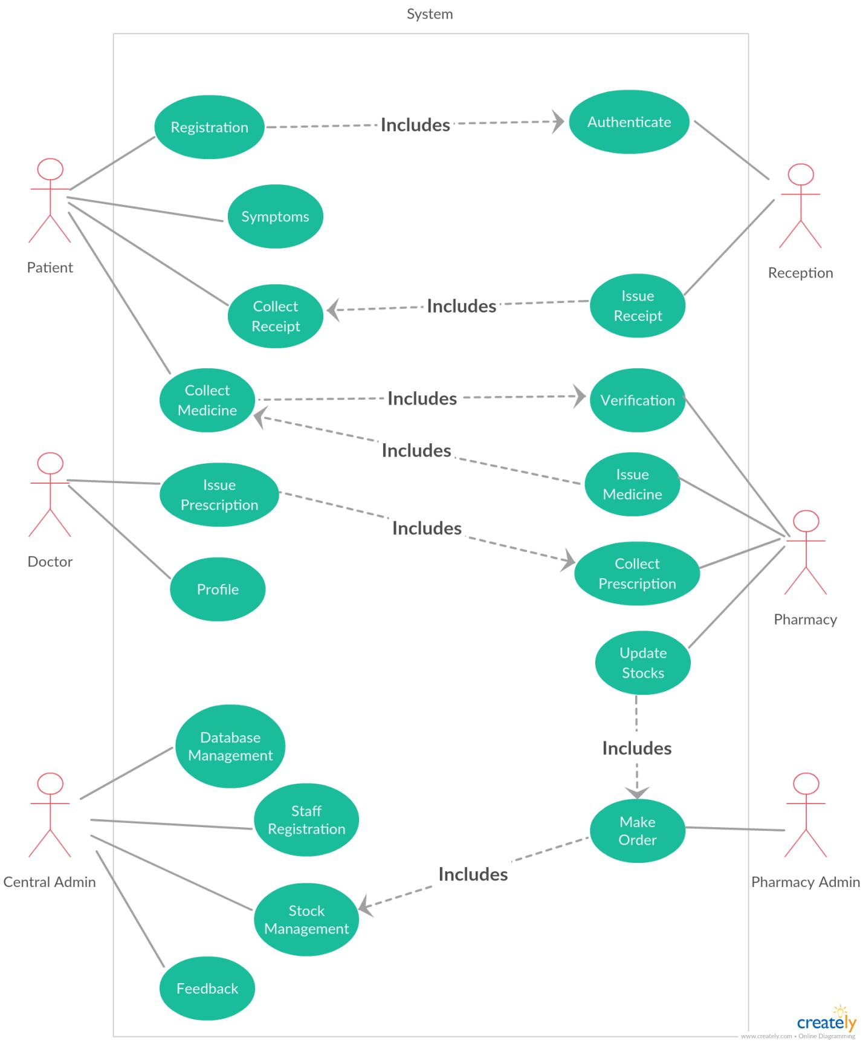

*5.2 Activity Diagram:*

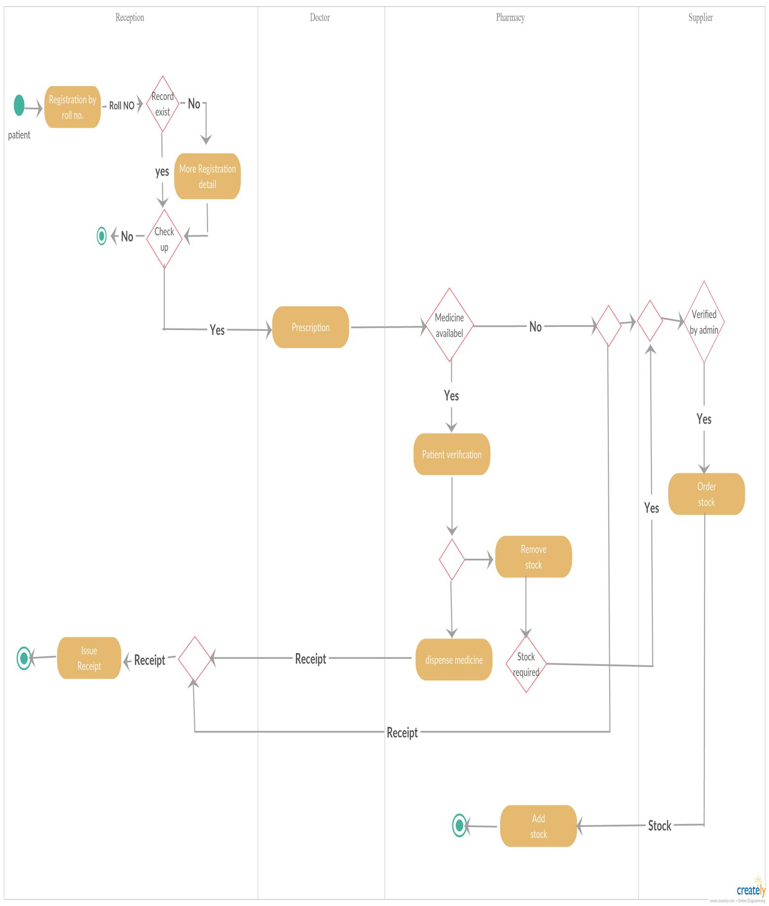

* 1. *Class Diagram:*

