Here's the live site: <https://prismix.netlify.app/>

my suggestions:

1. On the home page: The video and the next part get harshly cut off, to change that either we can put a carousel of your services (content similar to what we do section) or videos from your youtube channel (ref: devgn films website)

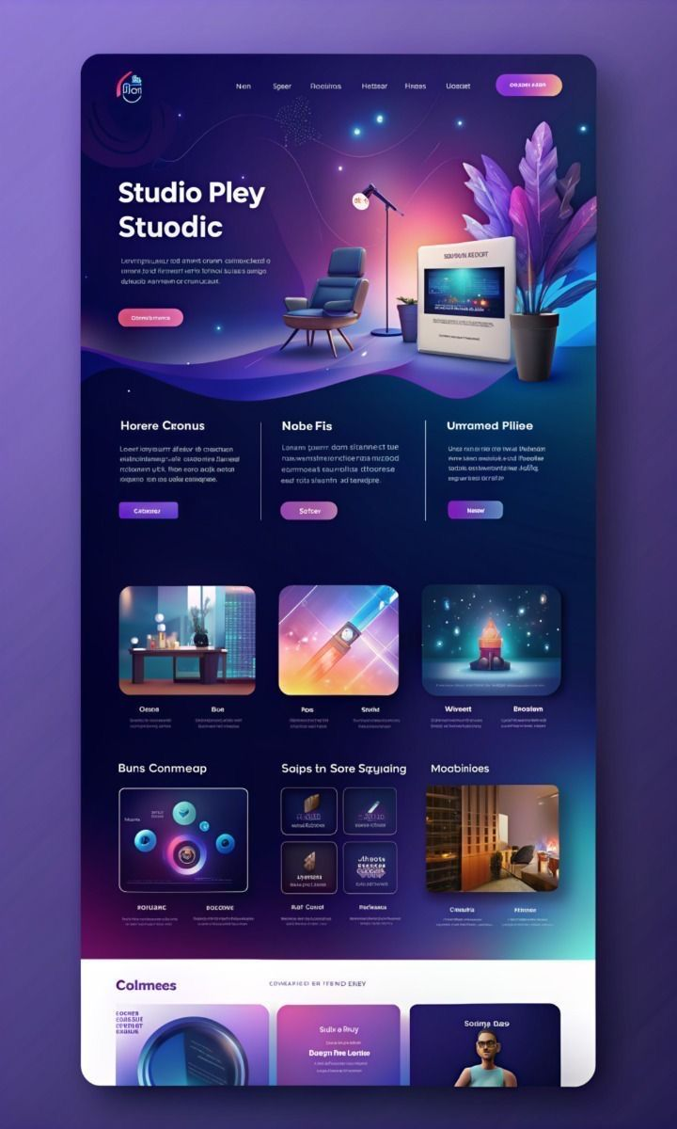

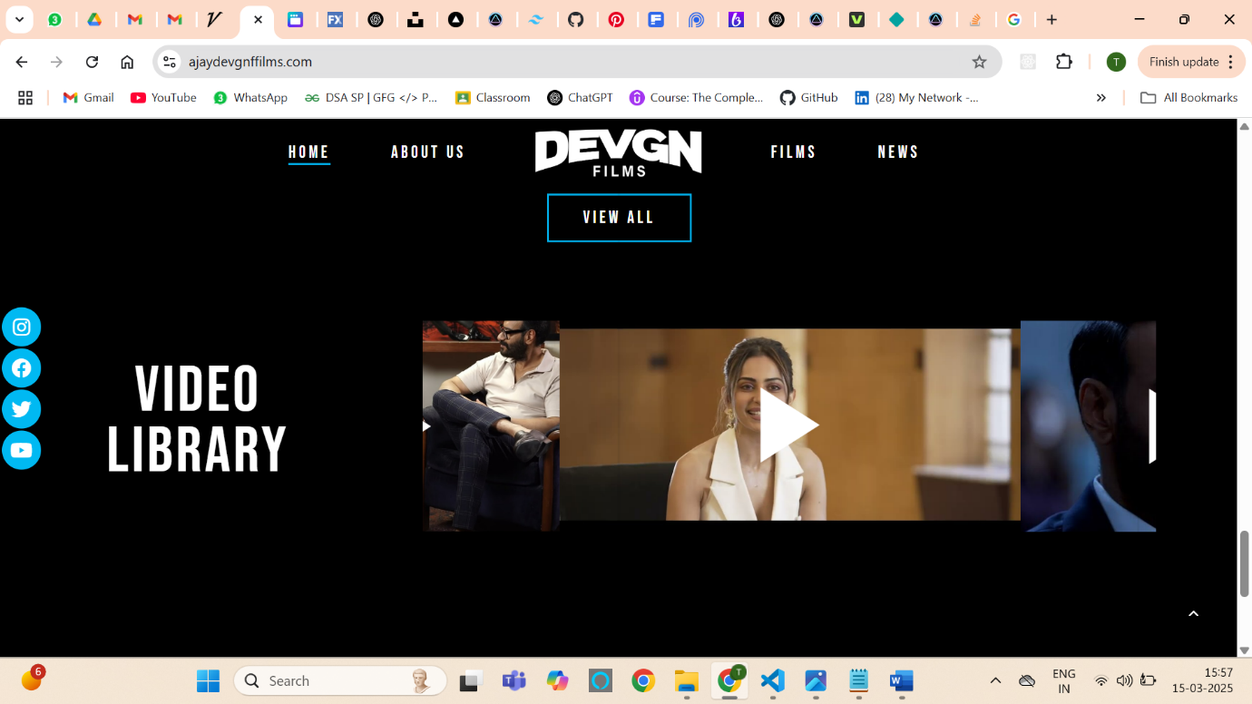

1. Home page: Where should I redirect when clicked on the Partner with us button. I mean directly lead to email or the contact page? We can remove it too if it’s unnecessary there. I will add links to both the buttons at once when you confirm.
2. About us page: Want media to put in the collage. We can make something like this as well:

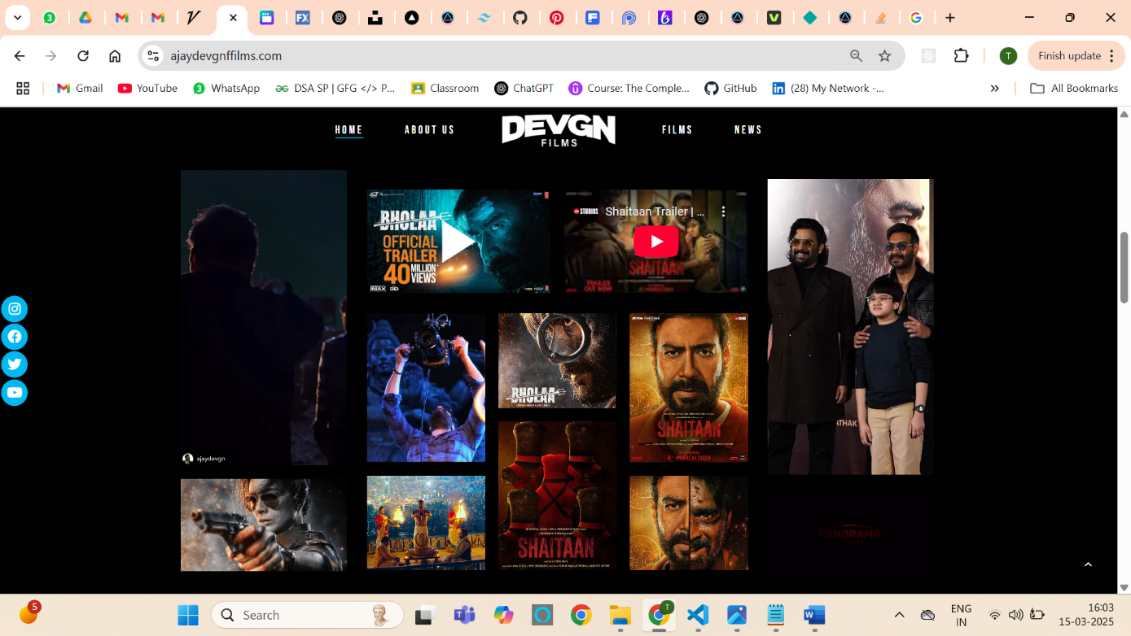

1. About us page: In the team section, I am not liking the background. Thinking of adding an image from the ones you gave and doing something like this:

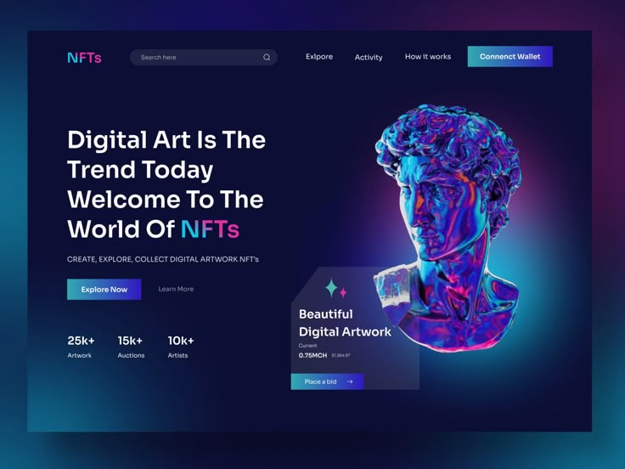

I mean a gradient background and a blur overlay box like this and then the team section’s content over it.

1. Contact page: In my past projects, I have used a service called as EmailJS (<https://www.emailjs.com/>) for contact forms. This allows 200 emails per month to be sent and if we want to extend it, there is an option to buy the premium versions depending on the needs. If you know any other service then do let me know.
2. Note: If you are watching it on a 14-inch laptop then the fonts might seem bigger and the margins a bit small. I am in the middle of adjusting them.

Do let me know the changes and I hope you guys like it so far