**CHAPTER 1**

**INTRODUCTION**

**1.1 INTRODUCTION**

Blind people are the ones who suffer from a severe reduction in vision that cannot be corrected with conventional means, such as refractive correction or any kind of medication. Visual impairment is the most common disability among mankind. According to the World health organization, there is about 285 million of the world’s population that suffers from visual impairment. Among them, 39 million are completely blind, and an estimated 246 million suffer from low vision.

In India itself, there are about 53 million visually impaired people, with 6.8 million with complete blindness. According to another survey, there are a large number of road accidents involving blind people. Such people are in need of the aiding devices for blindness. Due to lesser navigation facilities available and much less social awareness, blind people suffer the most. The electronic aiding devices are designed to solve such issue.

Presently, blind people use a white stick as a tool for direction, when they are moving or walking. The only navigation known to blind people is a blind stick that guides them from one place to another. For a few people, there are guide assistants, but they take a lot of time to train and can be used only by few people.

**1.2 BLIND STICK**

Normal Sticks cannot be helpful everywhere, like a crowded area, it might get collided with nearby objects without any prior knowledge.

Here we are developing a tool which can serve as a blind stick being more efficient and helpful than the conventional means.

The smart stick helps the blind person to navigate to his destination by providing proper aid of any obstacle in the path with classification of the object present, which helps the blind person in analysing the scene in front of him, and avoiding the accidents.

For the purpose of detection of obstacle on the road sensors can be used, so as to concerned with the accuracy for obstacle detection in this tool ultrasonic sensor is used.

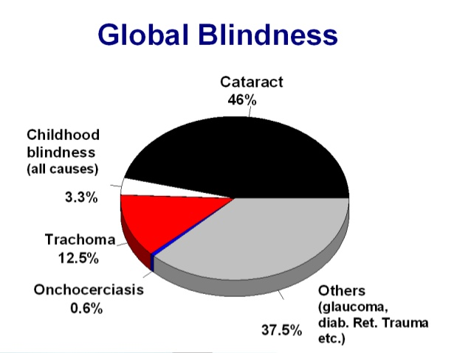

**Fig 1.2 Shows the percent of blindness**

**1.3 STATISTICS**

Artificial Vision is the most important part of human physiology as 83% of information human being gets from the environment is via sight. Mobility of visually impaired people is restricted by their incapability to recognize their surroundings.

Over 39 million people were totally blind out of which 19 million are children (below 15 years). Over 90 percent blind children obtain no schooling. Recent survey says, India has become the country with large number of blind people.

The population of India has reached 120 crore of those 8.90 crore people are visually impaired and among them 90% cannot travel independently

According to the procured data from World Health Organization (WHO) and National Federation of the Blind, there are around 253 million people who are visually impaired out of which 36 million people are blind worldwide.

According to the report by Times of India, India is now home to the world’s largest number of blind people. Of the 36 million people across the globe who are blind, over 15 million are from India .

On the other hand, while India needs 2.5 lakh donated eye every year, the country’s 109 eye banks (five in Delhi) manage to collect a maximum of just 25,000 eyes, 30% of which cannot be used.

According to a survey conducted by an NGO, 98% blind people have met with accidents while traveling. Also, there are no special facilities provided to blind people in local transports resulting in the high number of accidents involving blind people.

**1.4 INTRODUCTION TO IoT**

IoT (Internet of Things) is an advanced automation and analytics system which exploits networking, sensing, big data, and artificial intelligence technology to deliver complete system for a product or a service. (IoT) allow greater transparency, control, and performance when applied to any industry or system. It enhances the data collection, automation operations, and much more through smart devices and powerful enabling technology.

**1.4.1 Certain features of IoT are:**

**AI** – IoT makes virtually anything “smart”, meaning it enhances every aspect of life with power of data collection, artificial intelligence algorithms, and networks.

**Connectivity** – New enabling technologies for networking, and specifically IoT networking, mean networks are no longer exclusively tied to major providers. IoT creates small networks between its system devices.

**Sensors –** They act as defining instruments which transforms IoT from a standard passive network of devices into an active system which is capable of real-world integration**.**

**Small Devices –** Devices, as predicted, have become smaller, cheaper, and more powerful over time. IoT exploits purpose-built small devices to deliver its precision, scalability, and versatility.

**1.4.2 IoT- advantages:**

**Technology Optimization** – The technologies and data improve device use, and aid in more potent improvements to technology. IoT unlocks a world of critical functional and field data.

**Enhanced Data Collection** – Modern data collection suffers from its limitations and its design for passive use. IoT places it exactly where humans really want to go to analyze our world. It allows an accurate picture of everything.

**1.4.3 IoT - disadvantages**

**Security –** IoT creates an network of constantly connected devices communicating over networks. The system offers little control despite any security measures. This leaves users exposed to various kinds of attackers.

**Flexibility** – Flexibility is concerned in an IoT system to integrate easily with another. They worry about finding themselves with several conflicting or locked systems.

**1.5 INTRODUCTION TO API’S USED**

API refers for application (application program interface), which ties together the connected things of the ‘Internet of things’. These API’s are the points of interaction between the IoT device and the internet/or other elements within a network. API’s are the enabler IoT devices would be useless without them. API’s expose the data that enables multiple devices to be connected, they provide interface between the internet of things and the things to reveal previously unseen possibilities.

**1.5.1 DIRECTIONS API**

Directions API is a set of API developed by Google which allow communication with Google services and their integration to other services.

Directions API is a service that calculates distance between locations.

Directions API is a service that calculates directions between locations using an HTTP request.

This uses an API key, the API returns the most efficient routes when calculating directions.

We access the Directions API through an HTTP interface, with requests constructed as a URL string, using text strings or latitude/longitude coordinates to identify the locations, along with the API key.

The direction service can return multi-part directions using a series of waypoints.

**1.5.2 COMPUTER VISION API MICROSOFT AZURE CLOUD**

Azure provides several computer vision (CV) services. Which are wrapped to be different services.

CV API is a services offered by azure for extracting rich information from images to categorize and process visual-data and also performs machine assisted moderation of images to help curate services.

Main feature of vision API is that it returns the information about visual content found in an image captured.

Microsoft Azure is a cloud computing service created by Microsoft for building, testing, deploying, and managing applications and services through Microsoft managed data centres, where it offers several services and computer vision API is one among them.

It provides software as a service(SaaS), platform as a service(PaaS), infrastructure as a service(IaaS) and supports many different programming languages, tools and framework.

Certain services offered by Microsoft azure cloud:

**Compute**

(IaaS) allows users to launch general purpose Microsoft windows and linux virtual machines for popular software packages.

(PaaS) lets developers to easily publish and manage websites.

Web jobs application that can be deployed to an app service environment to implement background processing that can be invoked on a schedule, on demand, or continuously.

**Mobile services**

It provides real-time analytics that highlight user’s behaviour. It also provides push notifications to mobile devices.

HockeyApp from azure services can be used to develop, distribute, and beta-test mobile apps.

**Storage services**

Storage services provides REST and SDK API’s for storing and accessing data on the cloud.

Table service lets programs to store structured text in partitioned collections of entities that are accessed by partition key and prime key. It’s a NoSQL non-relational database.

Blob service allows programs to store unstructured text and binary data as blobs that can be accessed by a HTTP(S) path.

Queue service lets programs to communicate asynchronously by message using queues.

* 1. **COMPONENTS LIST**

Raspberry pi

Node MCU

Power adapter (5V , 2.5 A )

Neo 6M GPS module

Ultrasonic sensor

Web cam

Blynk App

Google directions API

Azure Computer Vision API

**1.6.1 RASPBERRY PI B 3**

Raspberry Pi is basically a credit card-sized single-board computer developed in the United Kingdom by the Raspberry Pi foundation. From time to time, several generations of Raspberry Pi are developed with more advanced features, such as memory capacity and peripheral device support. It is a microcontroller that can be used for making iot based systems. It takes input through GPIO pins. In proposed model it takes input through sensors.

**1.6.2 NODE MCU**

NodeMCU is an open source IoT platform. It include firmware which runs on the ESP8266 Wi-Fi SoC from espressif system and hardware which is based on the ESP-12 module.

**1.6.3 POWER SUPPLY (5V, 2.5 A)**

This is used to power on the raspberry pi board. Specifications required is 5V 2.5A

**1.6.4 Neo-6M GPS MODULE**

It is a gps receiver with a built-in ceramic antenna, which provides satellite search capability.

**1.6.5 ULTRASONIC SENSOR**

The ultrasonic sensors emit a short 40kHz ultrasonic burst signal. This burst signal moves through the air and hits the object and the rebounds to the sensor.

**1.6.6 WEB CAMERA**

Used to continuously capture images which is then sent to the cloud where object recognition is done.

**1.6.7 BLYNK APP**

Blynk app is used to indicate the location of the blind person, this is used for tracking the location.

**1.6.8 API’S**

Directions API is used for the navigation, used to reach the destination and Microsoft azure API is used for object recognition.

**CHAPTER 2**

**BACKGROUND AND PROBLEM STATEMENT**

**2.1 EXISTING SYSTEM**

Technology can help in minimizing many barriers that people with visual disabilities face. These technologies are known as assistive technology (AT). Many ATs have been proposed to help the visually challenged. The following section describes existing proposals or systems to be helpful for the blind.

The blind Cane is one of the assisting tools for the visually challenged and it is important. It was intended for testing the visually challenged to utilize their brain to memorize a set of objects. It aids its user to understand their surroundings but, if the user walks into a new environment, they will find it difficult to memorize the locations of the object or obstacles. The blind cane cannot detect any obstacle which is present in front of the person. There is no possibility of a practical application of this cane due to its requirement of extensive training.

The Guide Cane was designed to help the visually challenged people navigate safely and quickly among obstacles and other hazards, but it is considerably heavier than the white cane. It consists of wheels that are equipped with encoders to determine the relative motion. The servo motor, controlled by the built-in computer, can drive the wheels left and right relative to the cane. To detect obstacles, it is decked with ten ultrasonic sensors. A joystick fixed at the top handle allows the user to specify a desired direction of motion.

The Smart Cane consists of a sensor system. Ultrasonic sensors detect and avoid obstacles located in front of the user. A fuzzy controller is required to determine the instructions that will be executed. It uses purely ultrasonic sensors for its operation, which can detect very short distances, and there is no knowledge about the obstacle ahead. It cannot help the user in recognizing the object in front of him. Another Smart Cane using Radio Frequency Identification (RFID), was designed by students from Central Michigan University. RFID is used to detect objects or obstacles in front of the visually challenged person. This device is similar to a normal stick but it is equipped with a bag, worn by the person. This bag supplies electricity to the stick and informs the user through speakers inside the bag. However, this invention has several drawbacks and is only suitable for small areas. This is because it only detects the area with RFID tag otherwise this only works as a regular blind cane.

Navigation Assistance for Visually Impaired (NAVI) is also a technology for guiding the visually challenged people by use of sound and voice technology that helps them to find their way with the help of mobile systems.

Electronic Travel Aids (ETAs) are devices that warn the user with the help of some signals such as sound waves or by physical interaction with people such as vibratory patterns. This system provides an important measure to reduce accidents among blind people in common traffic areas and give away warning to them by creating a great tendency to detect objects and obstacles as blind death has become common due to their inability to see and manage situations in heavy traffic.

NAVBELT is a guidance system that uses a portable robot obstacle avoidance system. The prototype consists of ultrasonic range sensors, a computer and earphones. The disadvantage of this system is that it exclusively uses audio feedback and is very bulky for the users. Moreover, the users require extensive training to operate this system. Moreover, the end products that were created are difficult to wear, non-portable and are very costly, making them out of reach for common people.

**2.1.1 Obstacle-Detecting ETAs**

Although the white cane is inexpensive, it cannot detect obstacles accurately, and can only detect the obstacles by touch, so the user may get less time to react to situations, which is very dangerous for the user. Hence it is not dynamic in nature.

Ultrasonic sensors for obstacle avoidance, an Arduino microcontroller for processing the signal received by the sensors, and Raspberry Pi as a speech synthesizer to inform the VCP about detected obstacles. It can detect obstacles in the front, backside, left, and right directions of the user.

Mocanu et proposed a wearable device for efficient obstacle detection as well as recognition using sensors, computer vision, and machine learning techniques. The system uses four ultrasonic sensors, Bluetooth, an Arduino microcontroller, and a smartphone. The sensors and smartphone camera collect information about the obstacles and send it to the obstacle recognition module to understand the presence of obstacles in the surrounding scene. A STC15F2K60S2 microcontroller is used to control the whole system and processes the signal between the ultrasonic transmitting and receiving module to obtain distance information. Voice and vibration modules are used as feedback modules.

**2.1.2 HYBRID ETA’s**

These ETAs are designed with obstacle detection sensors along with either localization or communication technology. Thus, the systems provide information about the obstacles encountered and the VCP’s location, and also the VCP can contact parents or guardians. Dhod et al. proposed a prototype of a global position system (GPS) and global system for mobile communication (GSM)-based navigational aid called a “smart white cane” that helps visually impaired people in easy navigation.

**2.2 PROBLEM WITH PREVIOUS SYSTEM**

Blind sticks aids its user to understand their surroundings but, if the user walks into a new environment, they will find it difficult to memorize the locations of the object or obstacles.

It does not provide the navigation system on stick.

It does not provide the classification of the obstacle.

**2.3 COMPARISION WITH PREVIOUS AND PRESENT SYSTEM**

Existing blind sticks weremade of arduino, here we make use of raspberry pi which has several advantages over the arduino.

Raspberry pi is the fully functioned computer, a system on chip(SOC) device, which runs on a linux operating system specially designed, and is named as Raspbian.

As shown in the table raspberry pi has certain helpful features, it has micro SD card slot and internal memory of 512 MB RAM, whereas arduino offers lesser memory.

One major advantage of raspberry pi over arduino is that OS can be easily switched on the board.

Pi is capable of doing multiple tasks at a time like a computer.

Raspberry pi is much faster than arduino.

It has built in Ethernet port through which it can be directly connected to the networks. While in arduino it is difficult to connect to network.

**Table 2.1 Comparison Of Arduino And Raspberry Pi**

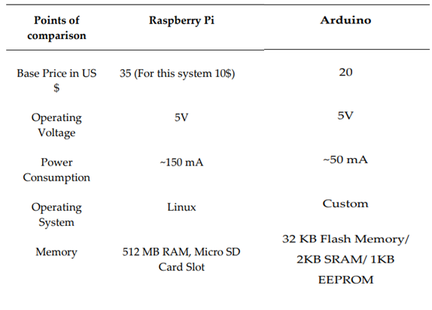

**2.4 SOLUTION**

Raspberry pi can be used in place of arduino which is much faster.

The proposed system automates the navigation for the disabled by using raspberry pi along with ultrasonic sensors and camera technology.

This system incorporates gTTS module for text to speech conversion of data, to help the blind user hear about the upcoming obstacle, which is much more advanced.

**2.5 LITERATURE SURVEY**

**2.5.1 PAPER-1 AUTONOMOUS WALKING STICK FOR THE BLIND USING ECHOLOCATION AND IMAGE PROCESSING**

1Akhilesh Krishnan, 2 Deepakraj G, 3 Nishanth N, 4 Dr.K.M.Anandkumar 1,2,3 U.G. Students, 4 Associate Professor Department of Computer Science and Engineering Easwari Engineering College, Chennai, Indiac 2016 IEEE

The Assistor is a smart walking stick that receives input from two types of sensors, namely: ultrasonic sensors and image sensors, which continuously feeds information to a smart phone.

The ultrasonic sensors, here, are used to detect how far the objects are from the person and the image sensor finds what those objects are with precision by taking a image and sending it to the smart phone.

The data from the sensors are transmitted to the Smartphone through Bluetooth communication.

A servomotor is used for the mobility of the stick. A microcontroller (ARDUINO UNO) is used to interface the hardware components with the smart phone.

The entire project is dependent on the Smartphone App and its reliability. It performs all the computation and calculations.

A separate database is designed, where the definition of the objects can be found. In the system level we could say that the novelty lies in the real-time application working on the Smartphone.

**2.5.2 PAPER-2 IOT BASED SMART WALKING CANE FOR TYPHLOTIC WITH VOICE ASSISTANCE,**

SathyaNarayanan E, GokulDeepan D, Nithin B P, Vidhyasagar P Department of Electronics and Communication Engineering PSG College of Technology Coimbatore, India 2016 Online International Conference on Green Engineering and Technologies (IC-GET)

The Ultrasonic Sensors are kept at five different heights to recognize obstacles at different positions.

First Ultrasonic Sensor facing downwards is to find the pit while walking. The Ultrasonic sensors are kept at heights of 10, 25, 40 and 75 cm to recognize the obstacles of different heights.

Specially programmed text to voice converter informs the obstacle information to the user through stereophonic headphone.

The frequency at which the buzzer buzzes alerts the visually challenged regarding the obstacle distance and make the people around the user of the Smart walking cane realize that visually challenged is around them.

Motion sensor senses the movement of any vehicle in the sensing region and informs the user of the same. The Vibratory circuit is used to assist deaf people in navigation.

The GPS Module senses the current location of the user and the Wi-Fi Module transmits the current location to the cloud, where the user navigation history can be tracked.

All the above mentioned functionalities acontrolled by a microcontroller that is programmed to continuously monitor the input from various sensors connected to it.

**2.5.3 PAPER-3 BLINDAR: AN INVISIBLE EYE FOR THE BLIND PEOPLE**

ZeeshanSaquib, ECE Dept, BNMIT, Bangalore, VishakhaMurari, ECE Dept, BNMIT, Bangalore, vish.rockstar96@gmail.com Suhas N Bhargav, ECE Dept, BNMIT, Bangalore, 2017 2nd IEEE International Conference On Recent Trends In Electronics Information & Communication Technology, May 19-20, 2017, India

The proposed system provides the following features:

Inexpensive navigation smart stick with total cost not exceeding more than 135$.

Fast response of the obstacle sensors in near range up to 4m.

Light weight components integrated on sticks which makes it user friendly with low power consumption.

Overall circuit is not complex and uses basics of C/C++/Java to program microcontroller.

There is a chance when the blind strolls in a noisy place and cannot hear the alert sound from the system. A Smart wrist band is introduced along with the stick. A vibrator is attached to it which alerts him of the obstacle by vibrating at different intensity.

RF Tx/Rx module is attached for finding the stick in close premises such as home. If the stick is misplaced, a key ison the wrist band which on pressing will activate the buzzer on the stick which helps the person to locate the stick depending on the intensity of sound.

A GPS module attached for location sharing to the cloud. Location is updated every 20ms.

MQ2 gas sensor for detecting fire in the path or at home.

**2.5.4 PAPER-4 SMART STICK FOR THE BLIND AND VISUALLY IMPAIRED PEOPLE ,**

Mukesh Prasad Agrawal,Department of Electrical Engineering,National Institute of Technology Kurukshetra Haryana, India 136 119, Atma Ram Gupta,Department of Electrical Engineering,National Institute of Technology Kurukshetra, Kurukshetra, Haryana, India 136 119, Proceedings of the 2nd International Conference on Inventive Communication and Computational Technologies (ICICCT 2018) IEEE Xplore Compliant - Part Number: CFP18BAC-ART; ISBN:978-1-5386-1974-2

The salient features of this paper are as follows:

Water sensor is used to detect the presence of water and will send the information to the microcontroller in digital form, the microcontroller will analyze this data/information and will send the command to the user notification setup i.e. buzzer and vibrator according to our program to alert the blind person.

Ultrasonic sensor will detect the nearby obstacles that can cause an accident of blind people and the blind person will get informed about the same in the same method as in case of water sensor.

In case the blind person forgot his/her stick by placing it somewhere else then he/she just have to press a button present in provided keypad.

The data will be sent to RF receiver present in the stick using RF transmitter, RF receiver will send this data to the microcontroller, microcontroller will activate the buzzer present in the stick so that blind person can search the stick easily.

One of the main features of our stick is to track the real-time location of blind people this is done using SIM808 GPS-GSM module. We have also provided a panic button to help the blind person in case of an emergency.

**CHAPTER 3**

**METHODOLOGY**

**3.1 OVERVIEW**

The development of IOT based smart cane for the visually challenged has two main design considerations to be taken into account namely,

Obstacle avoidance system with the help of ultrasonic sensors, camera, computer vision API.

GPS Tracking and navigation with the help of GPS sensor, directions api and BLYNK app.

The main assumptions of the environment and our system in which the tests have been carried out:

It is an open environment. The GPS sensor detects current location only when the user is outside. Navigation doesn’t work within buildings.

There is continuous access to the internet.

The distance between the source and the destination is small, because it is practically not possible for the blind person to walk large distances (say, between cities)

**3.2 PROPOSED METHOD**

The method proposed is that as soon as the blind stick gets powered on, any obstacle in the way is detected by the ultrasonic sensor. If an obstacle is detected, the user gets an “Alert” voice message, the web cam gets triggered to capture an image of the surroundings. The image is then sent to azure cloud by making a call to computer vision api. The analysis of the image is done, and result is being conveyed to the user in voice format by using gTTS.

The gps navigation system starts on pressing the push button which is connected to a GPIO pin of Raspberry pi. The blind stick asks the user where does he want to go. The user then feeds his destination which is sent to the speech recognition module. The geocoder gets the longitude and latitude of the destination. The gps sensor sends the current coordinates of the person to Node Mcu which communicates with Raspberry pi through MQTT protocol. The Node Mcu also continuously sends the current location of the user to the BLYNK app which is installed on the phone of a companion. This helps in live GPS tracking and remote monitoring. The current location and destination are sent to the directions api, which tells the user the next turn he has to take. Until the user doesn’t reach his destination, the navigation continues and the obstacle avoidance system also works simultaneously.

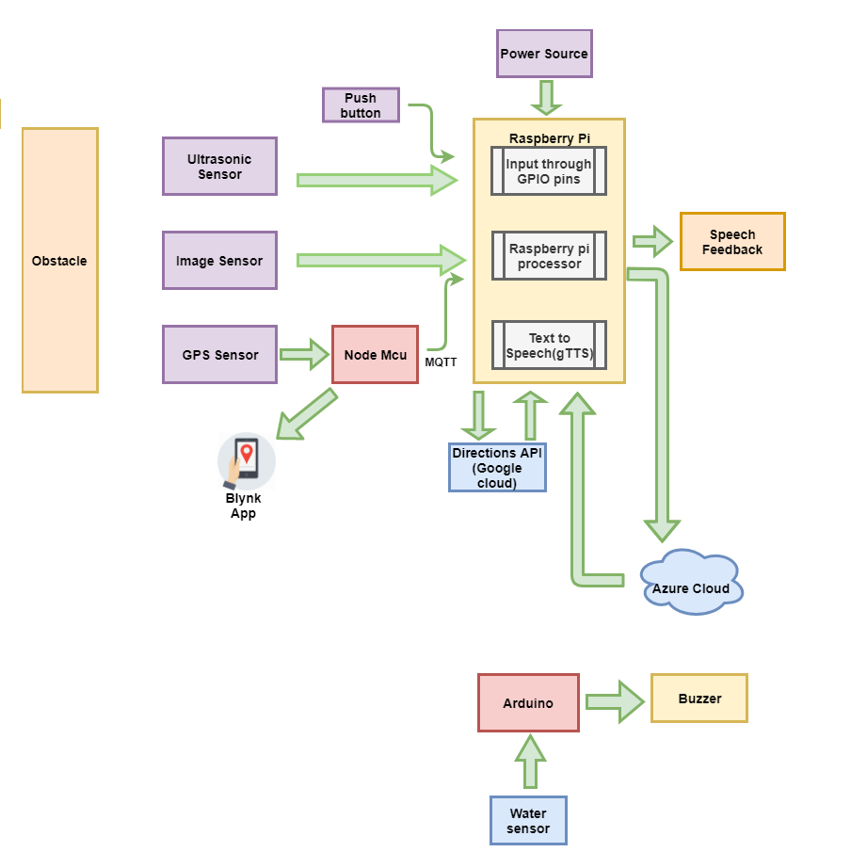**Fig. 3.2 Block diagram of the smart cane**

**3.2.1 Ultrasonic Sensor**

HC-SR04 is an ultrasonic ranging and sensing module that is used to provide 2 cm to 400 cm non-contact measurement. The ranging accuracy can reach up to 3mm and effective angle is < 60°. It emits an ultrasound at 40 kHz which travels through the air and if there is an obstacle in its path, it will bounce back to the module. Using the travel time and the speed of the sound you can calculate the distance.

The HC-SR04 Ultrasonic sensor Module has 4 pins, Ground, VCC, Trig and Echo. The Ground and the VCC pins of the sensor needs to be connected to the Ground and the 5 volts pins on the Raspberry Pi respectively and the trig and echo pins to GPIO pin 23 and 24 on the Raspberry piboard. In order to generate the ultrasound, you need to set the Trig of the sensor on a High State for 10 µs. That will send out an 8-cycle sonic burst which will travel at the speed of sound and it will be received by the Echo pin. The Echo pin will output the time in microseconds the sound waves travelled.

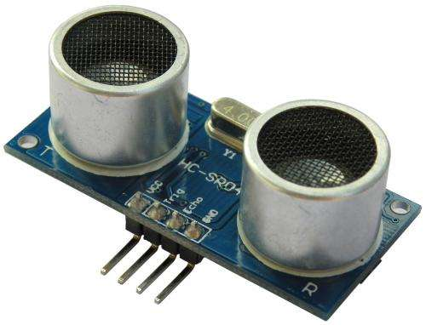

**Fig. 3.2.1.1 HC-SR04 Ultrasonic sensor**

For example, if the object is 20 cm away from the sensor, and the speed of the sound is 340 m/s or 0.034 cm/µs the sound wave will need to travel about 588 u seconds. But what you will get from the Echo pin will be double that number since the sound waves need to travel forward and bounce backward.

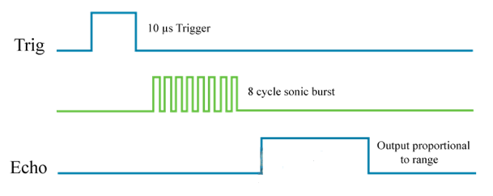[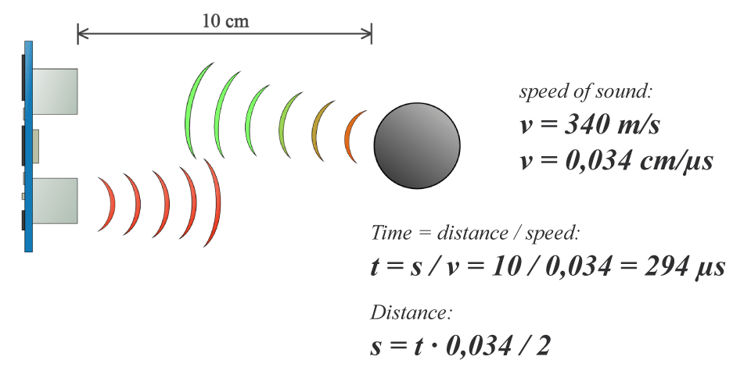](https://howtomechatronics.com/wp-content/uploads/2015/07/Ultrasonic-Sensor-Equasions.png?x57244)

**Fig. 3.2.1.2 Distance measurement Fig. 3.2.1.3 Trig and Echo signals**

**3.2.2 Raspberry Pi 3 B**

The Raspberry Pi is a low cost, credit card sized minicomputer that plugs into a monitor or TV, and uses a keyboard and mouse. This device enables people of all ages to explore computing, and to learn how to program in languages like Scratch and Python.

It is capable of doing everything you would expect a desktop computer to do, from browsing over the internet and playing HD videos, to making spreadsheets, word-processing, and playing games.

The GPIO (General Purpose Input/Output) pins of the Raspberry pi act as physical interface between the Raspberry Pi and the outside world. GPIO pins 23,24,18 are connected to the Trig, echo pins of ultrasonic sensor and push button respectively. The USB ports have been utilized to connect to headphones (with microphone) and the webcam.

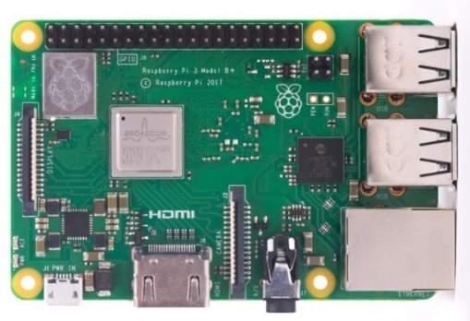

**Fig. 3.2.2 Raspberry pi**

**3.2.3 NodeMCU**

NodeMCU is an open source IoT platform with Wi-Fi capabilities. It is basically a development kit that consists of the ESP8266 Wi-Fi SoC (System on Chip) from Espressif Systems, and hardware which is based on the ESP-12 module.In our project, Node Mcu is used for getting the location of the stick in the form of latitude and longitude from the gps module.

The NodeMCU is connected to Wi-Fi and then to the MQTT server, where it publishes the latitude longitude values under the topic ‘esp8266’. This topic is subscribed by the client which is the python program. NodeMCU also sends the coordinates to the Blynk app. The WiFiEsp library allows Arduino board to connect to the internet. It serves as either a server accepting incoming connections or a client making outgoing connections. The WiFiEsp library is very similar to Arduino WiFi and Ethernet libraries, and many of the functional calls are the same.

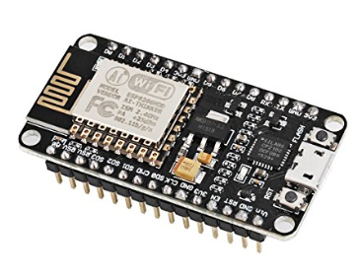

**Fig. 3.2.3 NodeMCU 12-E**

**3.2.4 Neo 6M GPS Module**

The NEO-6M GPS module is a complete GPS receiver with a built-in 25 x 25 x 4mm ceramic antenna, which provides a strong satellite search capability. With the power and signal indicators, you can monitor the status of this module. Because to the data backup battery, the module can save the data when the main power is shut down accidentally. The 3mm mounting holes on the module helps in fixing it easily on any surface.

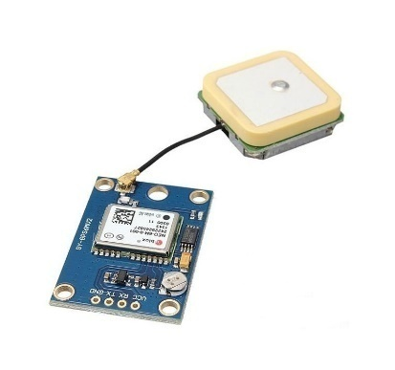

**3.2.4 Neo 6M GPS Module**

**3.2.5 Advantages of the proposed method**

Scalability – The ability to add more ultra-sonic sensors to the system so as to detect obstacles in other directions and also other sensors without the need for any fundamental changes

Robustness- The ability of the system to function efficiently and respond quickly to the changes in the environment.

Raspberry pi is being used unlike Arduino which is used in conventional smart sticks.Raspberry pi is more suitable for IOT applications as it easier to connect to the internet without the need of extra gsm/gprs module,

MQTT protocol is being used for the communication between raspberry pi and node mcu(esp8266), which is light weight, consumes low battery and network bandwidth.

The system provides a complete turn by turn navigation, by picking up the user’s current location through the gps sensor every 6 seconds.

The GPS tracker helps the companion of the blind person to keep a track of his current location. This can be useful in case the navigation fails and he is lost.

**3.3 DESIGN AND IMPLEMENTATION**

The smart cane consists of Raspberry pi B 3, Ultrasonic sensor HC-SR04, Image sensor Zebronics webcam, Node Mcu, Neo 6M GPS module, Arduino Uno, water sensor and buzzer. The overall structure of the smart cane is given is figure 3.3.

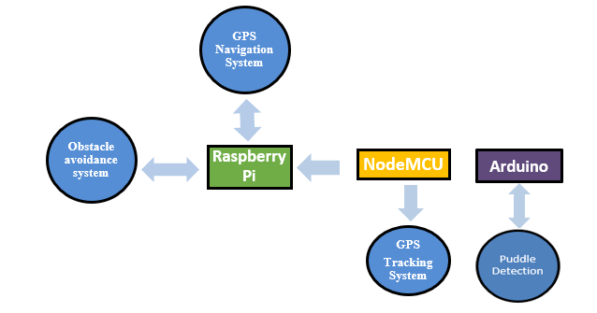

**Figure 3.3 Structure of the smart cane**

**3.3.1 Obstacle avoidance system**

This has been implemented with the help of raspberry pi, ultrasonic sensor and google text to speech (gTTS)module, webcam, Microsoft azure-computer vision API.

An Ultrasonic sensor measures distance by sending out a sound wave at a specific frequency and waiting for that sound wave to bounce back.

By recording the elapsed time between the sound wave being generated and the sound wave bouncing back, it is possible to calculate the distance between the sonar sensor and the object. Now, if the distance obtained is within 1m, then the message “Alert” in audio format is being conveyed to the user.

When the obstacle gets detected, the web cam gets triggered to capture a picture of surroundings. The cloud services of Microsoft Azure are used for the purpose of image recognition. The image is stored in a certain location on system, which is read into a byte array. Using the subscription key, we make a call to the computer vision api-a cloud based api. The image is analysed, and classification of the objects in the image is made. The result in text format is converted to voice in mp3 format with the help of gTTS. This mp3 file is converted to .wav format and played to the user.

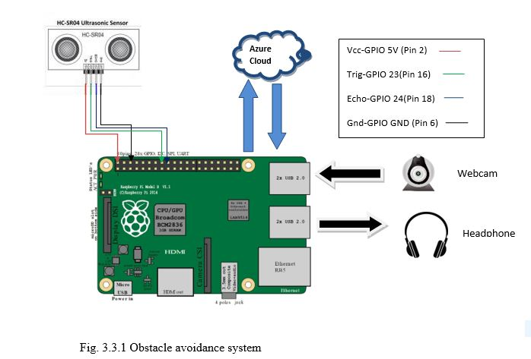

**3.3.1.1 Text to speech conversion**

For text to speech conversion we use the google Text To Speech (gTTS), it is a python library and CLI tool to interface with the google translate text-to-speech API. It is an easy tool which converts the text entered, into audio which can be saved in mp3 file, this supports several languages and works for any platform.

**3.3.2 GPS Navigation System**

We provide navigation aid with the help of raspberry pi, directions api, gTTS, speech recognition module, geocoder, nodemcu, Neo 6M gps module. The Neo 6M GPS sensor gets the user’s current location and sends it to Nodemcu.

Nodemcu consists of Wi-Fi module(esp8266) with the help of which we send the data to raspberry pi through mqtt protocol. The destination fed to the raspberry pi is converted to text form through speech recognition module. After knowing the current location and the destination with the help of **google direction api** we get the directions These directions are again read after every predetermined time. The results are in the form of voice commands with the help of gTTS.

The Geocoder converts the destination address in the form of coordinates (latitude and longitude). The Navigation continues till the person reaches his destination. Given in fig. 3.3.2 is the block diagram of gps navigation system.

**3.3.2.1 Speech To Text**

For speech recognition the speech must be converted from physical sound to an electrical signal with a microphone, as an input device which is connected to raspberry pi. For this we make use of speech recognition module.

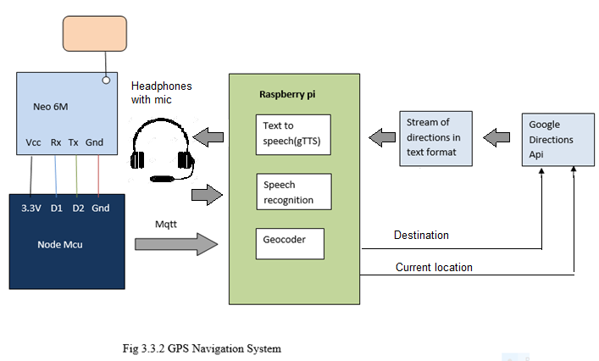

**3.3.2.2 Machine to machine connection**

In order to communicate between two machines, we use MQTT protocol, MQTT stands for message queuing telemetry transport. It is a publish-subscribe based messaging protocol.

**Publish-subscribe protocol**

In a publish-subscribe architecture, a central source called a broker which is also known as a server receives and distributes all data. The clients can publish data to the broker or subscribe to get data from it or both.

Clients which publish data send it only when the data is altered. Clients that subscribe to data automatically receive it from the broker but again, only when it changes. The broker does not store data, it simply moves it from publishers to subscribers. When data comes from a publisher, the broker sends it off to any client subscribed to that data.

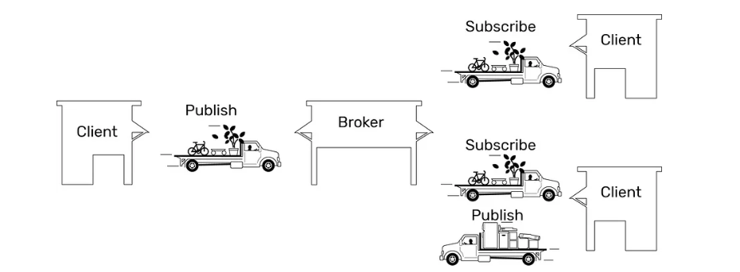

**Fig. 3.3.2.1 Publish-Subscribe protocol**

**MQTT**

MQTT is a well-known transport protocol that uses the publish subscribe architecture. MQTT is extremely lightweight hence it takes up almost no space in a device, so that even small devices with very little computing power can use it. MQTT can define the truck and the routes. But it doesn’t define how the load or the data is packed or unpacked. This protocol is used to transport data between the raspberry pi and the Nodemcu.

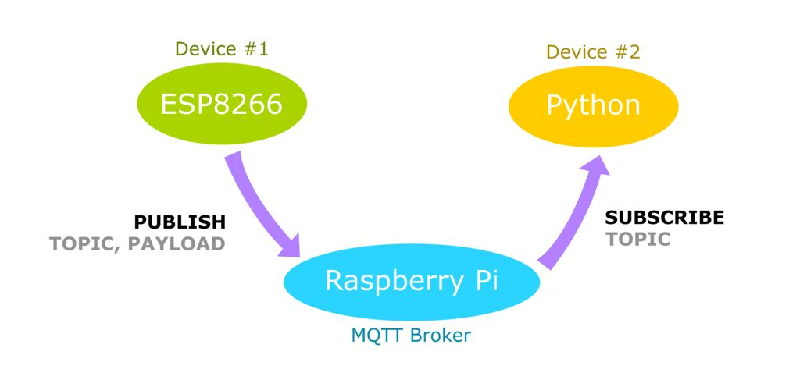

**Fig. 3.3.2.2 Illustration of MQTT protocol**

**3.3.3 GPS Tracking system**

This is used to find the location of the smart stick. We have used blynk app, node mcu(mc) and Neo 6M gps module. Node mcu is dumped with code and the following connections are made with gps module. We configure the app with different parameters such as -Latitude, longitude, speed, satellite, direction. After making all the configuration the tracker is ready to receive signals. We power the node mcu with a micro-usb. The app installed on a phone can detect the location of the cane. Hence the location can be detected.

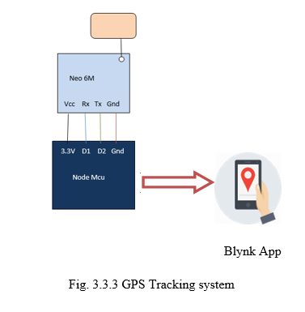

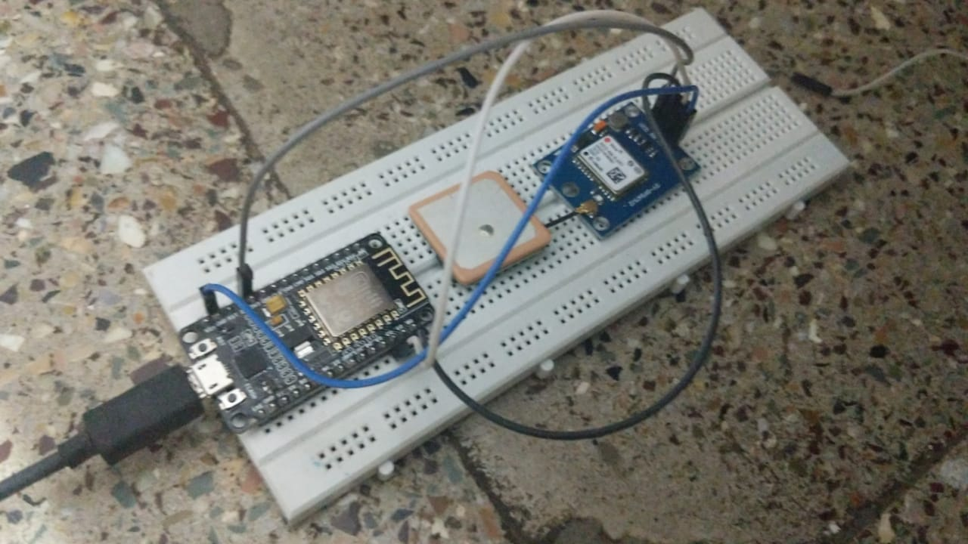

**Fig 3.3.3.1 Connections of neo-6m and nodemcu**

**3.4 SOFTWARE IMPLEMENTATION**

**3.4.1 Navigation system and GPS tracking**

On the subscriber side ,the raspberry pi has been coded using python.The following modules have been used:

**TABLE: 3.4.1 NAVIGATION SYSYTEM MODULES AND GPS TRACKING MODULE**

|  |  |
| --- | --- |
| **Module** | **Functionality** |
| os | This is used for running linux commands(os dependent functions) such as aplay,arecord. |
| RPI.GPIO | This package provides a class to control the GPIO on a Raspberry Pi. Used in configuring the GPIO pin 18 as input (Push button) |
| speech_recognition | This is used to convert the destination in speech to text form |
| geopy | This is used for geocoding and getting the latitude longitude values from the destination address |
| urllib | Used for making HTTP requests and getting the response. |
| gtts | The directions in text form is converted to speech using this module. |
| json | The directions are in the form of JSON(Javascript Object Notation).Used to load the response. |
| re | These are used to remove html headers from directions in our program. |
| pydub | This is used to convert mp3 file to wav format |
| time | This is used to give a delay. |
| paho | We use this for mqtt connection |

On the publisher side of the mqtt connection we have NodeMcu.The code is written in the arduino IDE.The following libraries were used:

**TABLE: 3.4.1.1 DESCRIPTION OF LIBRARY USED**

|  |  |
| --- | --- |
| **Library** | **Functionality** |
| TinyGps++ | TinyGPS++ is an Arduino library for parsing NMEA data streams provided by GPS modules. |
| SoftwareSerial | The SoftwareSerial library allows serial communication. |
| ESP8266WiFi | Connects ESP8266 module to Wi-Fi network to start sending and receiving data |
| BlynkSimpleEsp8266 | This library is used for connecting to blynk app |
| Adafruit_MQTT | This is used for MQTT connection |

**3.4.2 Object Recognition**

The Python code for object recognition uses the following modules:

**TABLE: 3.4.2 MODULES USED IN OBJECT RECOGNITION**

|  |  |
| --- | --- |
| **Module** | **Functionality** |
| Rpi.GPIO | This package provides a class to control the GPIO on a Raspberry Pi. The pins of ultrasonic sensor configured. |
| time | Used to introduce delay in capturing ultrasonic sensor readings. |
| os | This is used for running aplay command. |

**3.5 FLOWCHART OF THE COMPLETE PROCESS OF WORKING OF THE SMART CANE**

The overall flowchartinvolved in the implementation of smart cane is given in fig. 3.5.Here we have 3 separate processes running simultaneously,namely -Object recognition,GPS navigation,GPS tracking. On power up of the rasperry pi,node mcu and the sensors,these processes start. The Navigation system waits for the push button to be pressed and then executes the code.

Variables cc,dc stand for current coordinates and destination coordinates.So until the distance between the person’s present location and the destination is greater than 10 m ,the navigation continues.When the destination is reached,the user gets a voice message “Destination reached” .The other codes work just as explained earlier.

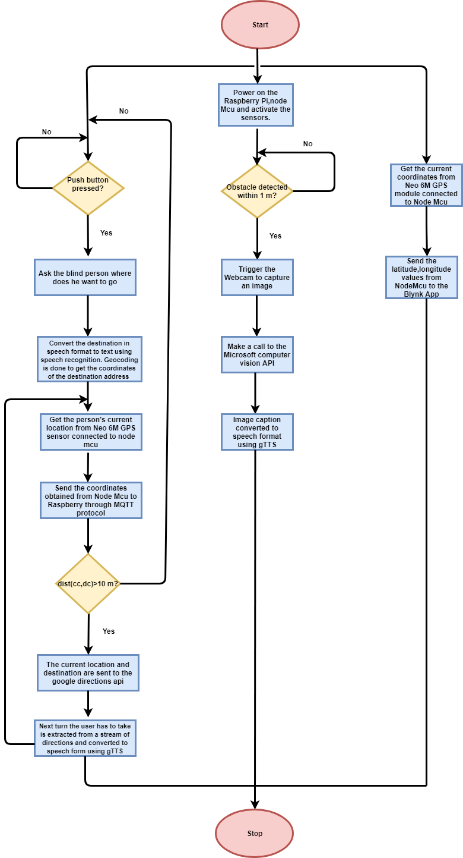

**Fig. 3.5 Flowchart of the complete process of working of the smart cane**

**CHAPTER 4**

**RESULTS AND DISCUSSION**

**4.1 STAGE-1**

**4.1.1 Stage 1 Test 1- Result Of Ultrasonic With Image Recognition, Using Vision API**

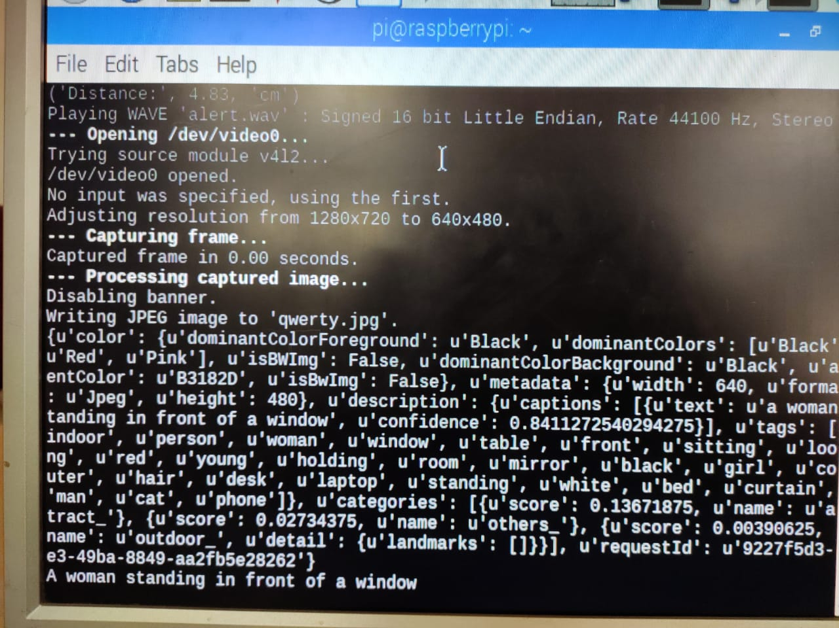

**Fig 4.1.1 Result­ of ultrasonic with image recognition, using vision api**

**Conclusion :**

The above image shows the output of the ultrasonic sensor with image recognition.

The distance of the image 4.83 cm.

The image captured is of a “woman standing in front of a window”.

The text is then converted into audio.

**4.1.2 Stage 1 Test 2 - Result Of Ultrasonic With Image Recognition,Using Vision API**

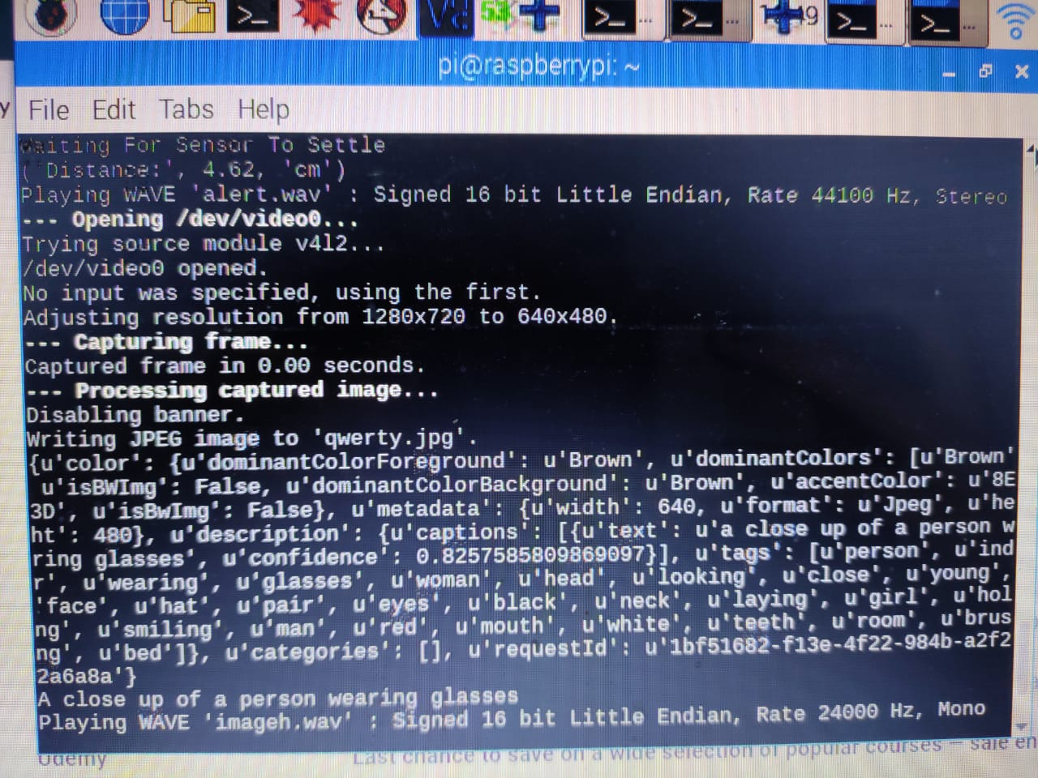

**Fig 4.1.2 Result Of Ultrasonic With Image Recognition,Using Vision Api**

**Conclusion:**

The above image shows the output of the ultrasonic sensor with image recognition.

The distance of the image 4.62 cm.

The image captured is of “A close up of a person wearing glasses”.

The text is then converted into audio.

**4.2 STAGE-2**

**4.2 .1 Stage 2 Test 1 - Result of message sent to raspberry pi from nodemcu**

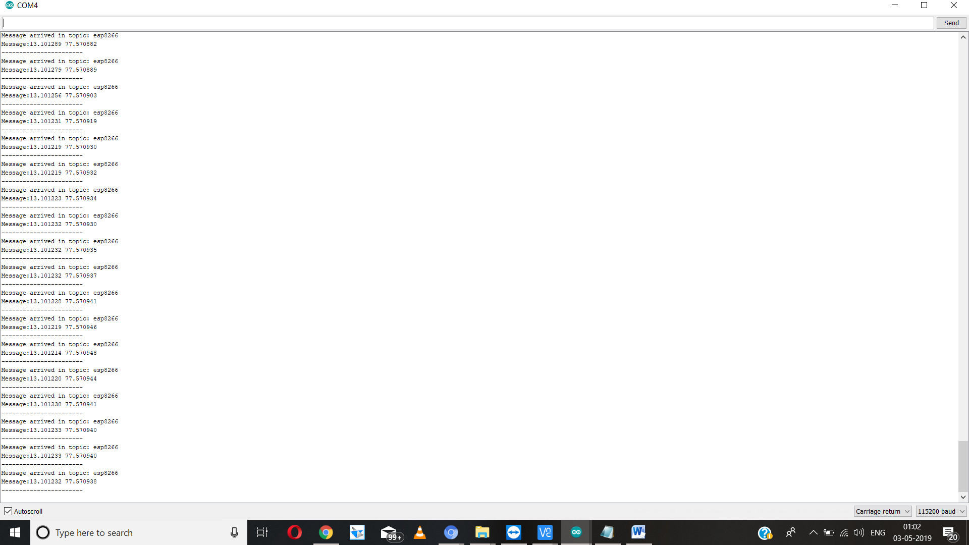

**Fig 4.2.1 Result of message sent to raspberry pi from nodemcu**

**Conclusion:**

The above image shows the result of message sent by nodemcu, connected to gps module, to raspberry pi.

The process for sending data is MQTT.

The message sent are latitude 13.101289 and longitude 77.570940.

The location is Yelahanka.

The topic name is esp8266.

**4.2 .2 Stage 2 Test 2 - Result of message sent to raspberry pi from nodemcu**

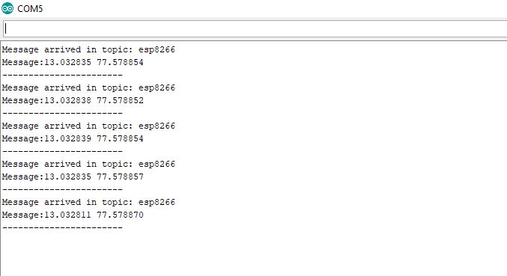

**Fig 4.2.2 Result of message sent to raspberry pi from nodemcu**

**Conclusion:**

The above image shows the result of message sent by nodemcu, connected to gps module, to raspberry pi.

The process for sending data is MQTT.

The message sent are latitude 13.032835 and longitude 77.578854.

The location is Sanjaynagar.

The topic name is esp8266.

**4.3 STAGE-3**

**4.3.1 Stage 3 Test 1- Result of navigation using direction API**

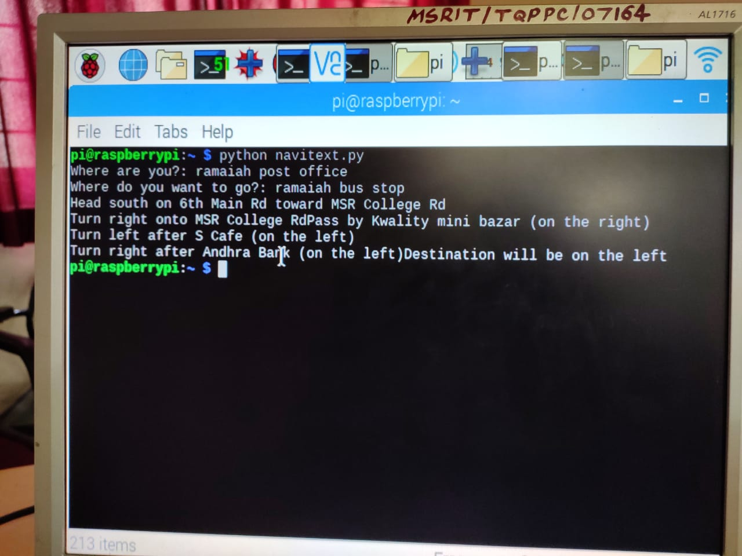

**Fig 4.3.1Result of navigation using direction api**

**Conclusion:**

The above image shows the result of directions using google direction api from “Ramaiah post office” to “ramaiah bus stop”.

The input are latitude and longitude from nodemcu as the current location and the voice input from the user as the destination which is converted to latitude and longitude using geocoding.

The output are the directions in text form.

**4.3.2 Stage 3 Test 2- Result of navigation using direction API**

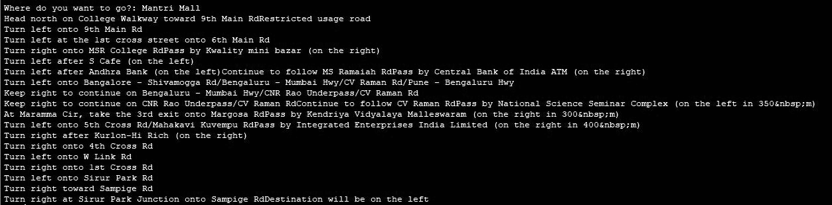

**Fig 4.3.2 Result of navigation using direction API**

**Conclusion:**

The above image shows the result of directions using google direction api from Yelahanka to Mantri Mall.

The input are latitude and longitude from nodemcu as current location and the voice input from the user as destination which is converted to latitude and longitude using geocoding.

The output are the directions in text form .

**4.4 STAGE-4**

**4.4.1 Stage 4 Test 1 - Results of geocoding**

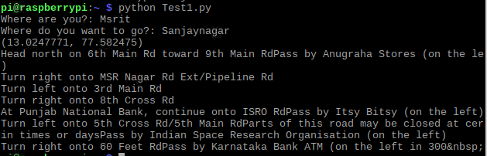

**Fig 4.4.1 Results of geocoding**

**Conclusion:**

The above image shows results of geocoding that is process of converting location to its coordinates.

The input is voice message from user converted to text using google speech to text i.e Sanjaynagar.

The outputs are the coordinates, latitude 13.0247771 and longitude 77.582475 .

This stage is used in stage 3 .

**4.4.2 Stage 4 Test 2- Results of geocoding**

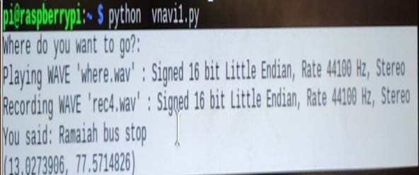

**Fig 4.4.2 Results of geocoding**

**Conclusion:**

The above image shows results of geocoding that is process of converting location to its coordinates.

The input is voice message from user converted to text using google speech to text i.e “Ramaiah bus stop”.

The outputs are the coordinates, latitude 13.0273906 and longitude 77.5714826.

This stage is used in stage 3 .

**4.5 STAGE-5**

**4.5.1 Stage 5 Test 1- Final output of navigation**

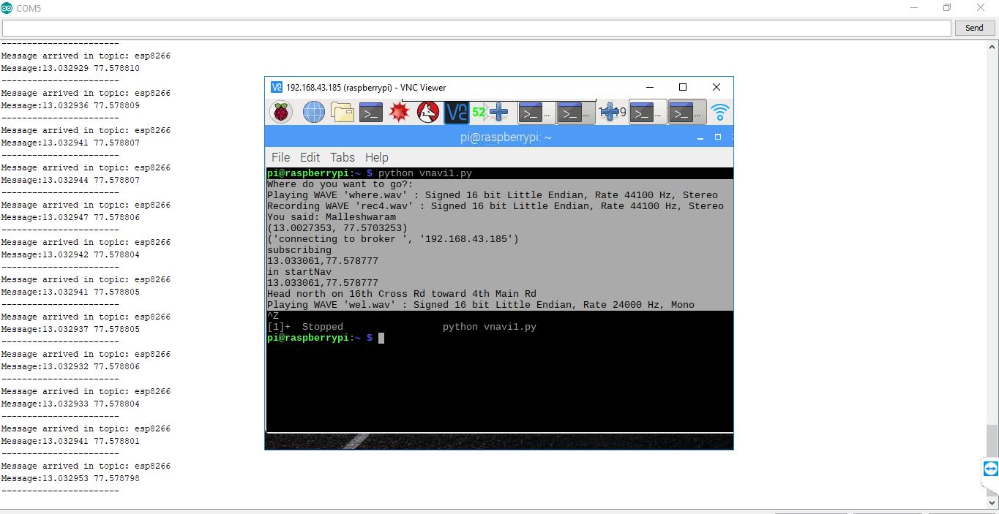

**Fig 4.5.1 Final output of navigation**

**Conclusion:**

The above result is the combination of the stage 2,3,4.

The text form of navigation output is converted to voice message.

The output is the voice message reading only the first sentence of direction output.

**4.5.2 Stage 5 Test 2- Final output of navigation**

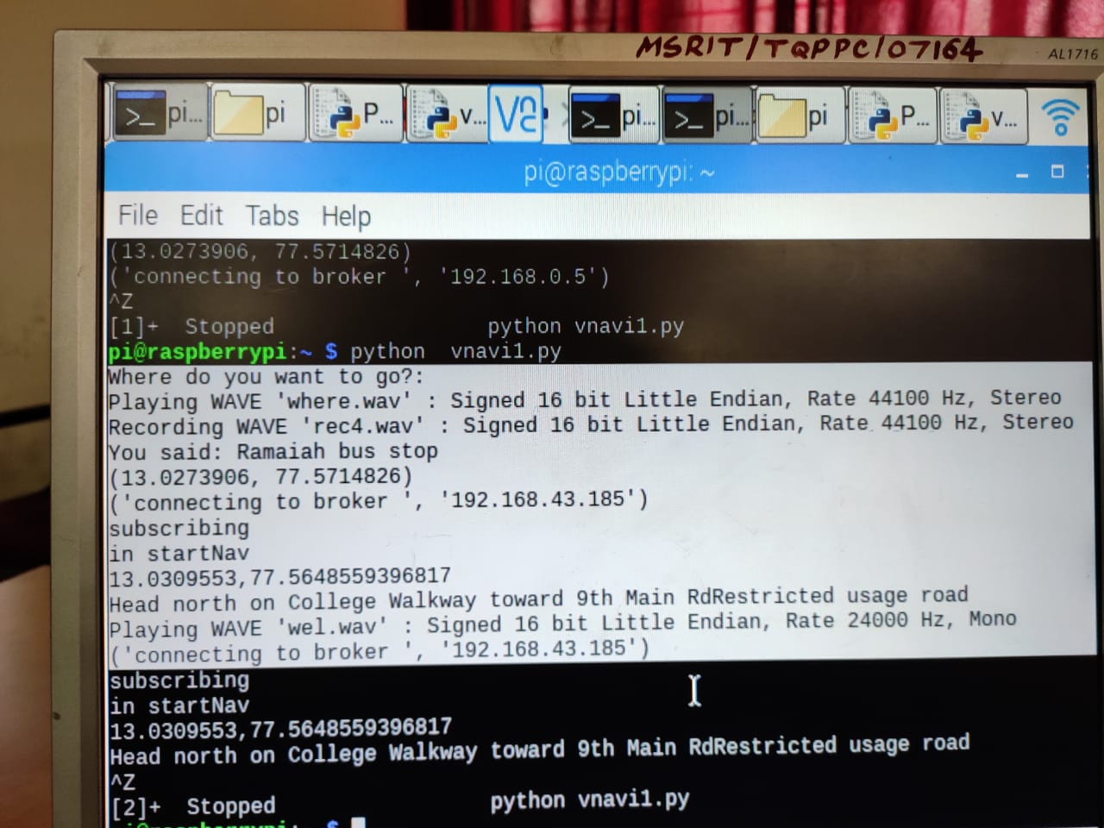

**Fig 4.5.2 Final output of navigation**

**Conclusion:**

The above result is the combination of the stages mentioned above.

The text form of navigation output is converted to voice message.

The output is the voice message reading only the first sentence of direction output.

**4.6 STAGE-6**

**4.6.1 Result of Tracker Test 1**

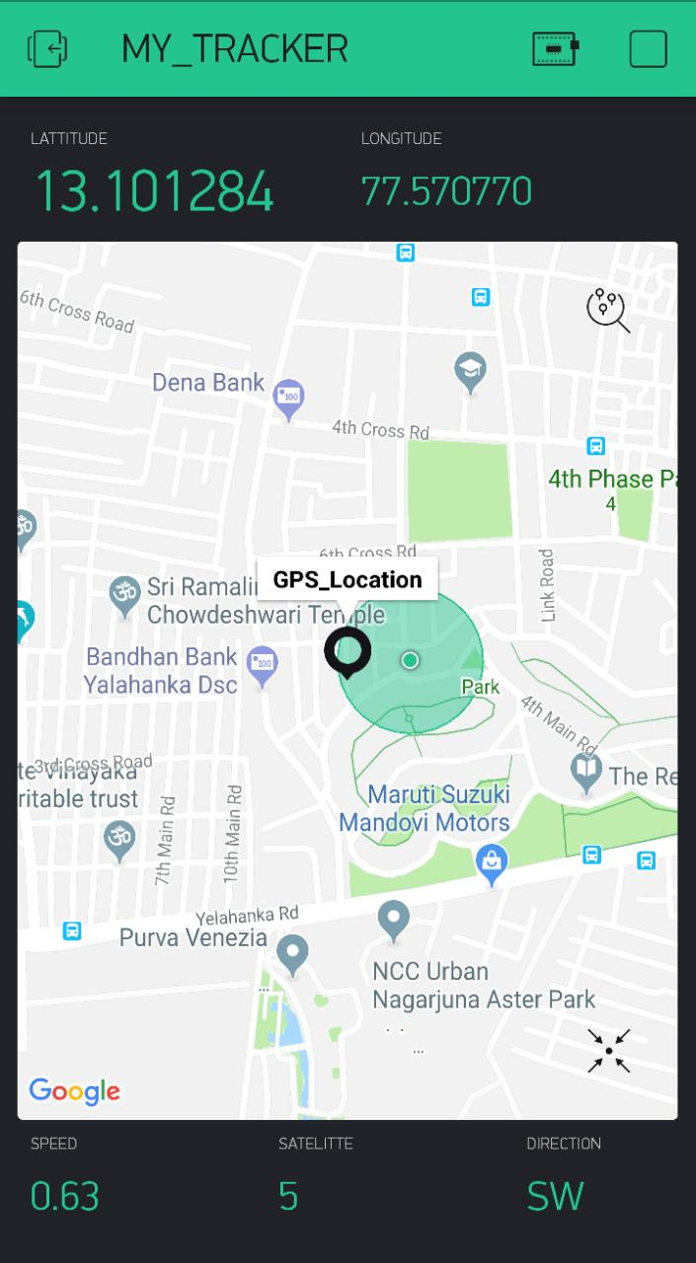

**Fig 4.6.1Result of Tracker**

**Conclusions:**

The above image shows the location of the person holding the smart cane.

The image shows latitude 13.101284 and longitude 77.570770.

The location is Yelahanka New Town.

Speed: 0.63

Satellite number: 5

Direction: SW(South West).

**4.6.2 Result of Tracker Test 2**

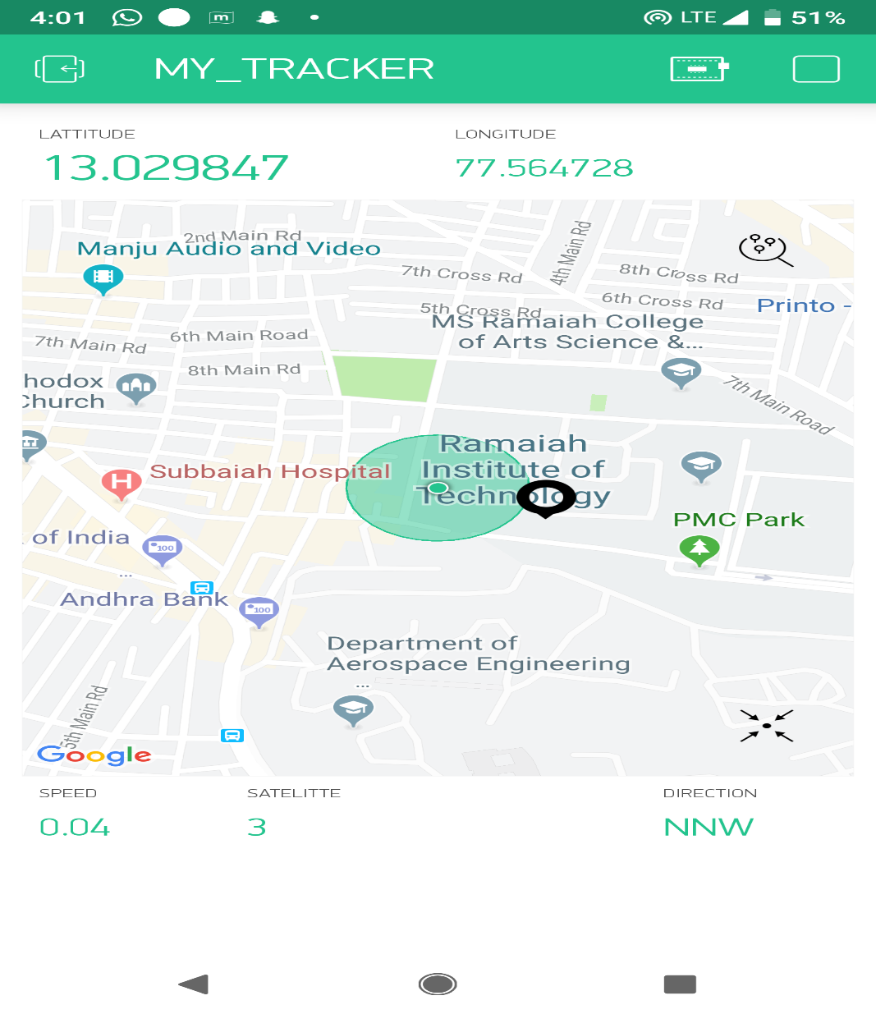

**Fig 4.6.2 Result of Tracker**

**Conclusion:**

The above image shows the location of the person holding the smart cane

The image shows latitude 13.029847 and longitude 77.564728.

The location is RIT

Speed: 0.04

Satellite number: 3

Direction: NNW

**4.7 The Final Product**

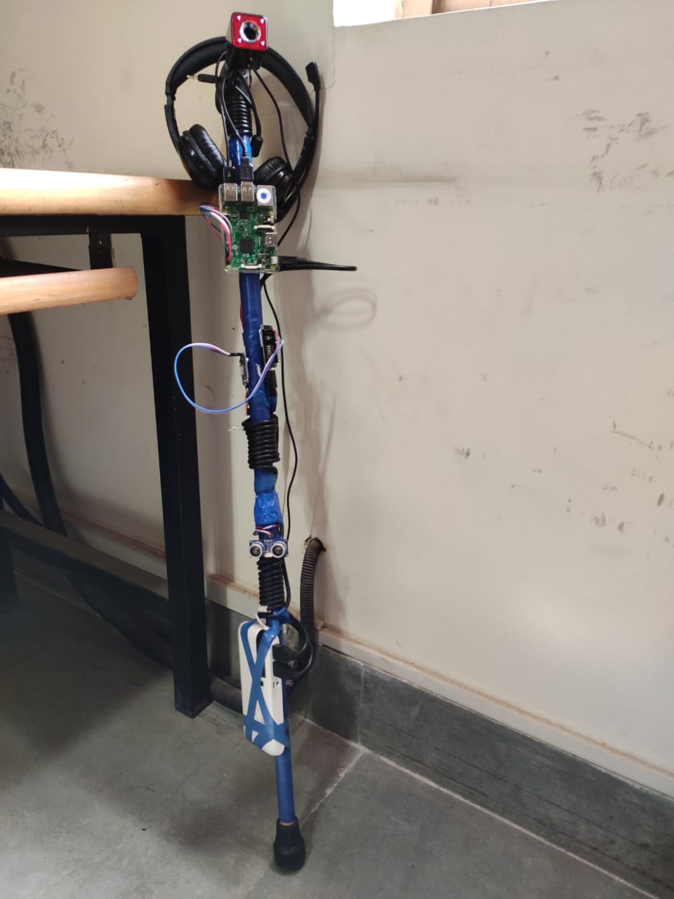

**Fig 4.7 Smart cane**

**Conclusion:**

This is the final prototype of our proposed system.

On boot up all the above mentioned stages are executed simultaneously.

**CHAPTER 5**

**CONCLUSION AND FUTURE WORK**

**5.1 CONCLUSIONS**

IOT (Internet of Things) is an advanced automation and analytics system which exploits networking, sensing, big data, and artificial intelligence technology to deliver complete system for a product or a service.

(IoT) allow greater transparency, control, and performance when applied to any industry or system. It enhances the data collection, automation operations, and much more through smart devices and powerful enabling technology.

In our proposed system we have included various api, direcrion api and vision api, for easier computation. Hence with the help of IoT we were enable to make navigation and analyses of components in the environment which helps the user move easily.

In the first part we are making use of ultrasonic sensor to detect the obstacle on the path which sends command to raspberry pi and camera is activated it takes the image of surrounding and the image is analysed and it gives the speech command about the obstacle.

Second part is the navigation where it helps the blind person to navigate to its destination. This is achieved by the use of directions API.

**5.2 FUTURE WORK**

Inclusions of add-ons like moisture sensor, for puddle detection.

The model can be improved to detect the caution sign put up which can avoid the accidents.

Processing time can be reduced, since the fast coming vehicle is detected but it takes necessary time to process it, which may lead to accidents.

Indication for power on and off can be done.

Multiple ultrasonic sensors can be included to improve the obstacle detection.

**REFERENCES**

1] Mrs. M. Deepthi 1, P. Sowmya 2, N. Naga Mounika 3, K. Pavani Sai 4, N. Sripriya 5, N. Balasaida 6 -1 Assistant Professor, 2,3,4,5,6U.G Students, Department of ECE Vasireddy Venkatadri Institute of Technology(VVIT), Andhra Pradesh, India “IOT Based Smart Stick with Voice Module”,International Journal for Research in Applied Science & Engineering Technology (IJRASET) Volume 6 Issue II, February 2018.

[2] P.Bhavishya 1, E.Pavithra 2 , V.Nivetha 3, R.Vidya Prakash 4 1, 2, 3 Student, Dept. of Computer Science and Engineering, R.M.K Engineering College, Tamil Nadu, India. 4 Asst. Professor, Dept. of Computer Science and Engineering, R.M.K Engineering College, Tamil Nadu, India “IoT based route assistance for visually challenged “,International Research Journal of Engineering and Technology (IRJET) Volume: 05 Issue: 03 , Mar-2018

[3] K.Swathi 1, E.Raja Ismitha 2, Dr.R.Subhashini 31,2U.G. Students,3 Professor Department of Information Technology ,Sathyabama University, Kancheepuram, India “Smart Walking Stick Using IOT” ,International Journal of Innovations & Advancement in Computer Science IJIACS Volume 6, Issue 11 November 2017

[4] Nadia Nowshin, Sakib Shadman, Saha Joy, Sarker Aninda, Islam Md Minhajul,American International University-Bangladesh (AIUB), Dhaka, Bangladesh “An Intelligent Walking Stick for the Visually-Impaired People” International Journal of Online and Biomedical Engineering (**iJOE**) Vol. 13, No. 11, 17 September 2017

[5] M.Vanitha 1, A. Rajiv 2, K. Elangovan 3, S.Vinoth Kumar 4 1 Associate Professor, Saveetha Engineering College, 2 ,3, 4 Assistant Professor, Sriram Engineering College “A Smart walking stick for visually impaired using Raspberry pi “ International Journal of Pure and Applied Mathematics ,Volume 119 ,No. 16 2018