Text Editor
Introduction
A console-based text editor in C which allows basic text editor functionalities like insertion, deletion, undo, redo and navigation. It uses doubly linked list where each node stores a single line and makes use of stack to implement undo-redo functionalities.

Data structures used
- Doubly linked list – Used to store lines of the text editor, where each node represents a line. Doubly linked list is used for forward and backward navigation between the lines. It also has O(1) time complexity for insertion at the cursor position.
- Stack – A dynamic array-based stack is used for undo and redo operations.
Files
- text_editor.c – contains functions to read an optional input text file, initialise text editor and stack, display text editor menu and handle the commands entered.
- text_ops.c - contains functions to insert text/new line, delete characters/entire line. Each operation records the resulting state onto the undo stack
- navigation.c – contains functions to move left, right, up, down, start of file, end of file, start of line, end of line.
- undo_redo.c – will undo/redo the insert/delete operations done to the file.
- save_and_exit.c – will save the unsaved changes to the file before exiting.
- save_to_file.c – takes input file name if not given through command line, prompts for overwriting file if file exists, saves the changes to the file.
- load_from_file.c – loads content to doubly linked list if input file exists
- display.c - display contents of file, cursor position and line number where the cursor is currently in

FEATURES
- insert data/newline
- delete characters/entire line
- navigation - up, down, left, right, start of file, end of file, start of line and end of line
- undo the changes made to file
- redo the changes made by undo
- display contents of file, cursor position and line number where the cursor is currently in
- load from file into doubly linked list
- save to file from doubly linked list
- optional save to file before exiting

Sample output

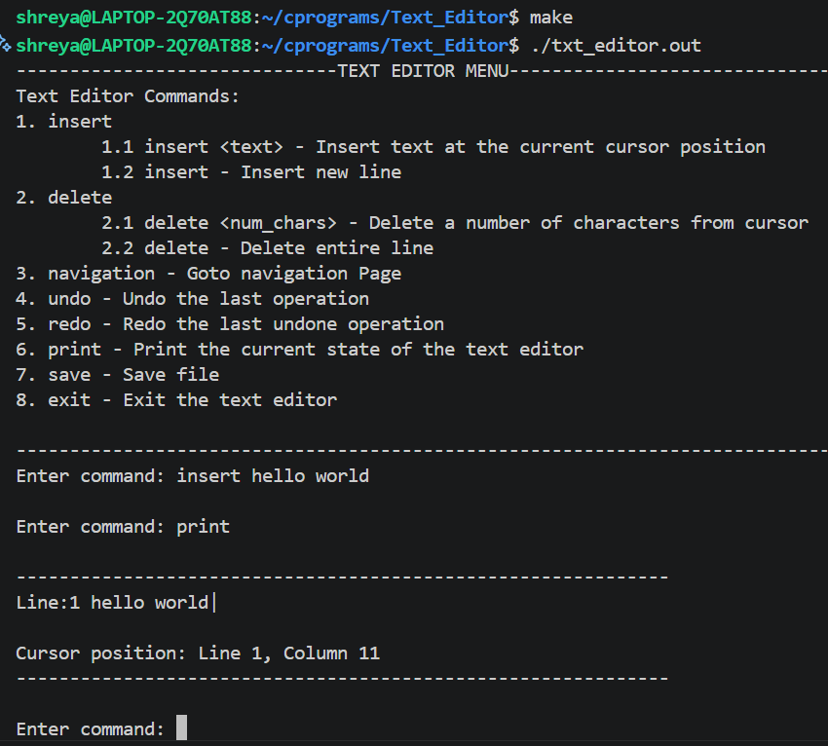
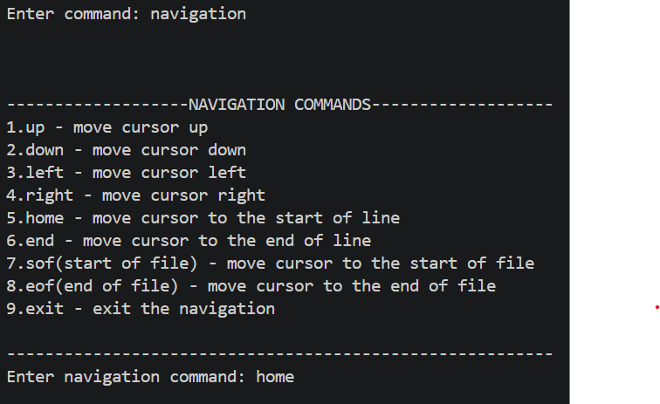
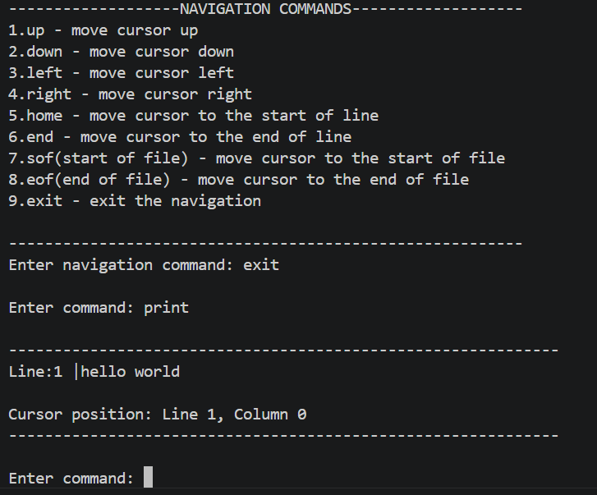
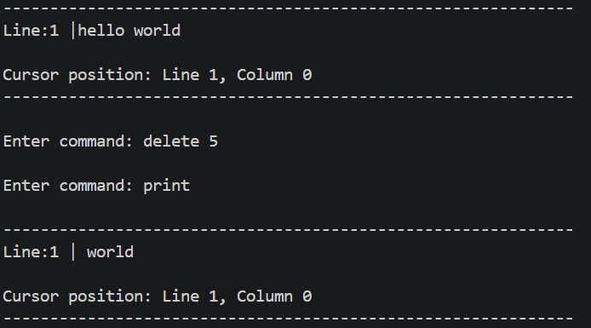
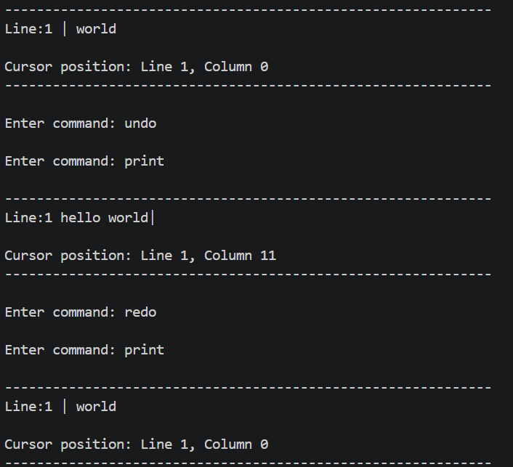
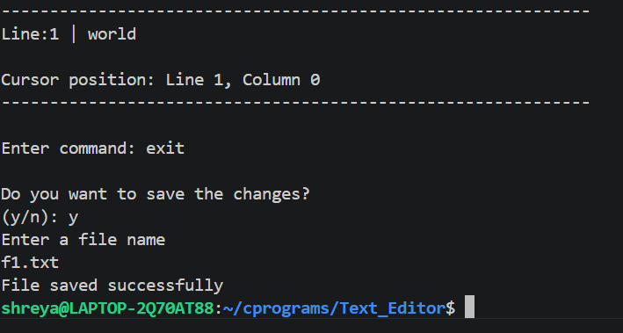

Output file
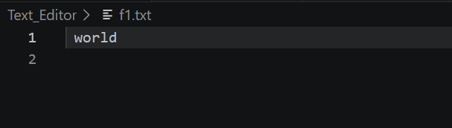
Conclusion
This project implements the core features of a text editor, such as line-by-line storage, navigation, and undo/redo, using a doubly linked list and a stack. Building it helped in understanding how these data structures work together to manage state and handle user input in C.

