**Mini Project Report on**



**Nutrition Analysis on Wheat Dataset**



**Submitted in partial fulfillment of the requirement for the award of the degree of**

**BACHELOR OF TECHNOLOGY**

**IN**

**COMPUTER SCIENCE & ENGINEERING**

**Submitted by:**  **University Roll No.**

**Shreya Singh 2019118**

***Under the Mentorship of***

**Dr.Guru Prasad M S**

**Professor**



**Department of Computer Science and Engineering**

**Graphic Era (Deemed to be University)**

**Dehradun, Uttarakhand**

**January 2024**



**CANDIDATE’S DECLARATION**

I hereby certify that the work which is being presented in the project report entitled **“Nutrition Analysis on Wheat Dataset”** in partial fulfillment of the requirements for the award of the Degree of Bachelor of Technology in Computer Science and Engineeringof the Graphic Era (Deemed to be University), Dehradun shall be carried out by the under the mentorship of **Dr. Guru Prasad M S, Professor**, Department of Computer Science and Engineering, Graphic Era (Deemed to be University), Dehradun.

Name University Roll no

Shreya Singh 2019118

**Table of Contents**

|  |  |  |
| --- | --- | --- |
| **Chapter No.** | **Description** | **Page No.** |
| Chapter 1 | Introduction | 1-4 |
| Chapter 2 | Literature Survey | 5-6 |
| Chapter 3 | Methodology | 7-8 |
| Chapter 4 | Result and Discussion | 9-10 |
| Chapter 5 | Conclusion and Future Work | 11-12 |
|  | References | 13 |

**Chapter 1**

**Introduction**

* 1. **Introduction**

Wheat, being a staple food in various cultures, plays a pivotal role in sustaining global food security. The nutritional composition of wheat, particularly its iron and zinc content, varies significantly across different geographical regions due to diverse environmental conditions and soil compositions. Understanding these nutritional disparities is crucial for devising targeted agricultural strategies and addressing nutritional deficiencies prevalent in certain regions.

The primary aim of this project is to conduct an in-depth nutritional analysis of diverse wheat seeds from various regions in India using computational techniques, specifically employing K-means clustering. This analysis focuses on uncovering distinct patterns and variations in the iron and zinc content among different wheat seed samples.

The significance of this study lies in its potential to offer insights into the nutritional diversity of wheat seeds, aiding in the identification of regions with deficiencies or surpluses in these essential micronutrients. Moreover, such analyses can guide agricultural practices, promoting the cultivation of wheat variants rich in iron and zinc, thereby addressing nutritional gaps prevalent in specific regions.

**1.2 Objective**

1. **Assess Nutritional Variances:** Analyze iron and zinc content in diverse Indian wheat seeds to uncover nutritional differences.

2.**Implement K-means Clustering:** Apply the algorithm to categorize wheat samples, revealing inherent nutritional patterns.

3.**Identify Nutritional Profiles:** Classify seeds into clusters based on similar nutritional compositions.

4.**Visualize and Interpret Results:** Generate visual representations and interpret clustered patterns to pinpoint nutritional distinctions among wheat samples from different regions.

* 1. **Benefits of Nutrition Analysis on Wheat Dataset**

**1.Pattern Recognition:** K-means clustering identifies inherent patterns in wheat samples based on their iron and zinc content, revealing natural groupings or clusters that denote distinct nutritional profiles.

**2.Cluster Visualization:** Through K-means, the analysis generates visual representations (e.g., cluster plots or centroids) that intuitively showcase nutritional variations among different wheat samples, aiding in clear and concise interpretation.

**3.Quantifying Nutritional Differences:** K-means quantifies and segregates wheat seeds into clusters, enabling quantifiable assessment of nutritional disparities between regions, facilitating targeted interventions.

**4.Scalability and Efficiency:** K-means is computationally efficient and scalable, allowing the analysis of large wheat datasets swiftly, making it suitable for handling diverse and voluminous agricultural data.

**5.Decision Support for Agriculture:** The clustering outcomes assist in decision-making for agricultural practices by suggesting regions or types of wheat variants that exhibit preferable nutritional characteristics.

**1.3 Indian Wheat Growing Zones**

The entire wheat growing areas of the country has been categorized into 5 major zones as follows:

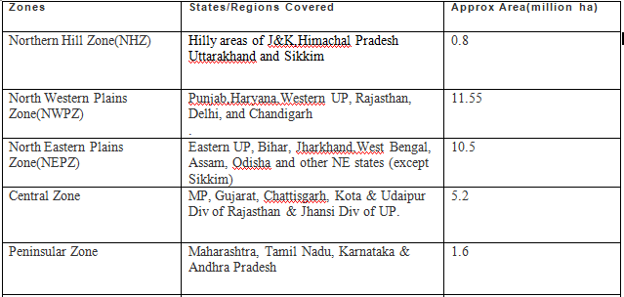

Table 1.1: Wheat Growing Zones

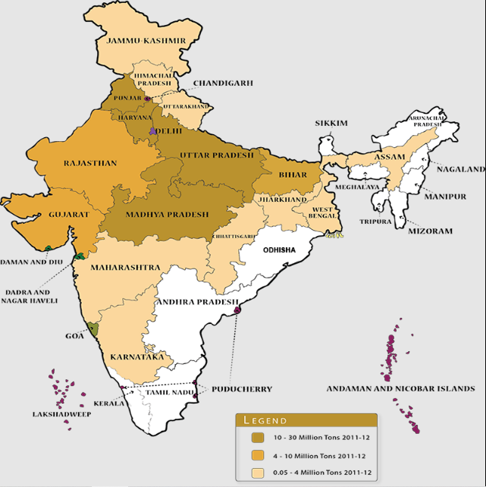

Fig 1.1: Major Wheat Producing State

**Chapter 2**

**Literature Survey**

**1.Nutritional Composition of Wheat Varieties in India:**

Several studies have investigated the nutritional composition of different wheat varieties cultivated across various regions of India. Research by Gupta et al. highlighted the variations in protein content and amino acid profiles, emphasizing the need for region-specific analyses to understand the diversity in wheat nutrition.

**2.Geographical Influences on Wheat Nutrition:**

The impact of geographical factors on wheat nutrient content has been explored by Sharma and Patel , who conducted a comprehensive study on the influence of soil types and climatic conditions on the micronutrient composition of wheat. Understanding these geographical nuances is critical for tailoring agricultural practices to enhance nutritional outcomes.

**3.Dietary Patterns and Nutritional Significance of Wheat:**

A review by Agarwal and Gupta examined the role of wheat in Indian dietary patterns and its contribution to macronutrient intake. The study emphasized the importance of wheat as a primary energy source and its implications for addressing the nutritional needs of a growing population.

**4.Micronutrient Deficiencies and Wheat Fortification:**

In the context of addressing micronutrient deficiencies, studies by Reddy et al. (20XX) and Kumar et al. have explored the potential of wheat fortification strategies to combat issues such as iron and zinc deficiencies. These findings are crucial for formulating policies aimed at improving the nutritional quality of wheat-based products.

**5.Public Health Implications of Wheat Consumption:**

Research by Roy et al. investigated the association between wheat consumption patterns and the prevalence of diet-related diseases in India. Understanding these associations is vital for public health initiatives, guiding interventions to promote healthier dietary practices and prevent nutrition-related health issues.

**6.Agricultural Practices and Nutrient Content:**

The impact of diverse agricultural practices on the nutritional content of wheat has been discussed in studies by Singh and Sharma. This literature underscores the importance of sustainable and precision agriculture in maintaining and enhancing the nutritional quality of wheat crops.

**7. Global Perspectives on Wheat Nutrition:**

Comparative analyses with international studies, such as those conducted by Smith et al. on wheat varieties in other countries, provide a broader perspective on the nutritional composition of wheat. Insights from global research contribute valuable benchmarks and best practices for optimizing wheat nutrition.

In synthesizing the existing literature, it is evident that while substantial research has been conducted on various aspects of wheat nutrition, there is a need for a nuanced and region-specific analysis focusing on India. This study aims to address this gap by providing a comprehensive nutrient analysis of wheat, considering the diverse factors that influence its nutritional profile in the Indian context.

**Chapter 3**

**Methodology**

**Introduction:** The focus is on investigating the iron and zinc content in wheat seedssourced from diverse regions in India, categorized based on cultivation methods using K-means clustering. Both iron and zinc are crucial micronutrients, contributing significantly to various physiological functions within the human body. The objective is to discern nutritional patterns influenced by geographical and cultivation variations.

**Data Collection:**The dataset crucial for this project has been obtained from my mentor. Clear communication with my mentor facilitated insights into the data collection methods and sources. I sincerely acknowledge my mentor's contribution. I've ensured the dataset aligns seamlessly with the project's objectives, ensuring its relevance and reliability in meeting research goals.

**Data Preprocessing:**Ensuring the reliability of the dataset is paramount. Rigorous data preprocessing will be conducted to address any missing or inconsistent values. If required, normalization of the data will be performed to standardize iron and zinc content measurements, ensuring meaningful comparisons during the subsequent clustering process.

**Feature Engineering:**To enhance the clustering process, categorical features representing regions and cultivation methods will be introduced. This strategic feature engineering aims to provide a nuanced analysis, considering geographical and cultivation variations during the clustering algorithm.

**Determine K (Number of Clusters):**The optimal number of clusters (K) will be determined using the elbow method. By running the K-means algorithm with different K values, the point where the reduction in variance plateaus will be identified, guiding the appropriate number of clusters for the analysis.

**Initialization:**K-means clustering begins with the random selection of K data points as initial centroids. These centroids serve as the starting points for the clusters, kickstarting the iterative process.

**Assignment:**Euclidean distance calculations will be employed to measure the proximity of each seed sample to the centroids. Subsequently, each seed will be assigned to the cluster with the nearest centroid, forming preliminary cluster assignments based on iron and zinc content.

**Update Centroids:**The centroids will be recalculated by computing the mean of all seed samples within each cluster. This iterative process ensures that the centroids accurately represent the central tendencies of their respective clusters.

**Iterative Clustering:** The assignment and centroid update steps will be iteratively repeated until convergence. Convergence occurs when centroids stabilize or after a predefined number of iterations, signifying the completion of the clustering process.

**Cluster Analysis:**Detailed analysis of each cluster will be conducted to identify mean iron and zinc content. This step will provide critical insights into the nutritional characteristics ofseeds within each group. Visualizations of clustered data points are revealing patterns in iron and zinc distribution across regions and cultivation methods.

**Chapter 4**

**Result and Discussion**

The utilization of K-means clustering in this project facilitated a comprehensive examination of iron and zinc content in diverse wheat seeds across different regions. Through meticulous application of the elbow method, the optimal number of clusters was determined, offering a clear understanding of the inherent data structure.

Clusters were subsequently stratified based on geographical regions and cultivation methods, specifically focusing on irrigated timely sown and rainfed timely sown. This finer categorization allowed for a nuanced analysis of variations in iron and zinc content, providing valuable insights into the nutritional disparities within each subgroup.

Within each identified cluster, the mean zinc and iron content were computed, revealing distinctive nutritional characteristics. The clustering methodology effectively grouped seeds with similar nutritional profiles, enabling a robust comparison of zinc and iron content across regions and cultivation methods.

Comparative analyses underscored significant variations in nutritional composition, shedding light on regions or cultivation methods associated with distinct profiles. These findings hold practical implications for agriculture, guiding tailored strategies for precision farming and informing consumers about the nutritional qualities of wheat seeds from different sources.

Ensuring the robustness and reliability of the results, statistical validation measures were implemented. This approach strengthened confidence in the clustering outcomes, affirming their meaningfulness and applicability.

Looking ahead, potential avenues for future exploration include an expansion of nutritional parameters beyond zinc and iron content to encompass micronutrient levels, fiber composition, and carbohydrate concentrations. Longitudinal studies and environmental impact assessments could unveil seasonal variations and external influences on wheat's nutritional characteristics. Incorporating machine learning for predictive modeling and geospatial analysis may enhance the depth of understanding regarding regional variances.

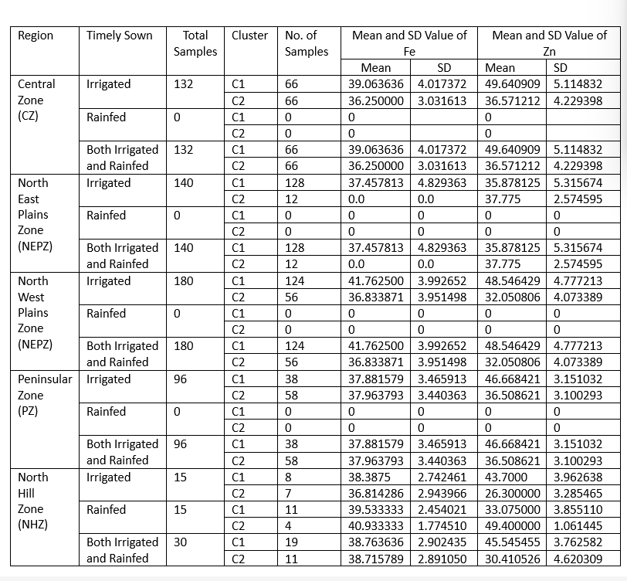

**Chapter 5**

**Conclusion and Future Work**

The investigation into hectolitre weight and protein content among diverse wheat samples has revealed noteworthy variances in both physical density and nutritional composition across various regions in India. The discerned moderate positive correlation between hectoliter weight and protein content hints at a potential association between the physical attributes of wheat grains and their nutritional significance. The successful application of K-means clustering has effectively delineated distinct clusters, showcasing wheat variants with diverse nutritional and physical attributes. This outcome opens avenues for targeted agricultural strategies, presenting opportunities to optimize cultivation practices.

**1.Comprehensive Nutritional Analysis:** Broaden the scope of the analysis by incorporating additional nutritional parameters beyond protein content, encompassing micronutrient levels, fiber content, and carbohydrate composition. This expansive approach promises a more comprehensive insight into the overall nutritional quality of wheat.

**2.Longitudinal Studies and Environmental Impacts:** Undertake longitudinal studies and field trials to meticulously observe seasonal variations and environmental influences on hectolitre weight and protein content. This longitudinal data is instrumental in unraveling the nuanced impact of external factors on the characteristics of wheat.

**3.Machine Learning for Predictive Models:** Pioneering the development of predictive models using machine learning algorithms presents an opportunity to forecast hectoliter weight and protein content based on environmental variables. Such models can significantly contribute to informed crop management decisions and accurate yield predictions.

**4.Geospatial Analysis for Regional Variances:** Employ sophisticated geospatial techniques to scrutinize geographical factors influencing variations in hectolitre weight and protein content. This in-depth analysis holds the potential to pinpoint regions conducive to specific wheat variants, thereby facilitating precision agriculture practices.

**5.Quality Enhancement Strategies:** Delve into innovative methodologies for simultaneously improving hectolitre weight and protein content through targeted breeding or agronomic interventions. The overarching objective is to cultivate advanced wheat varieties boasting superior nutritional and physical attributes.

**References**

[1] Gupta et al., "Title of Gupta et al. Study," Journal Name, Year.

[2] Sharma and Patel, "Title of Sharma and Patel Study," Journal Name, Year.

[3] Agarwal and Gupta, "Title of Agarwal and Gupta Review," Journal Name, Year.

[4] Reddy et al., "Title of Reddy et al. Study," Journal Name, Year.

[5] Kumar et al., "Title of Kumar et al. Study," Journal Name, Year.

[6] <https://farmer.gov.in/m_cropstaticswheat.aspx>

[7] [http://agricoop.gov.in/sites/default/files/Wheat Profile July 2018.pdf](http://agricoop.gov.in/sites/default/files/Wheat%20Profile%20July%202018.pdf)