**Industrial Internship Report on Embedded and IOT**

**Project Name:Object Detection**

**Prepared by:shreya singh**

|  |
| --- |
| *Executive Summary* |
| This report provides details of the Industrial Internship provided by upskill Campus and The IoT Academy in collaboration with Industrial Partner UniConverge Technologies Pvt Ltd (UCT).  This internship was focused on a project/problem statement provided by UCT. We had to finish the project including the report in 6 weeks’ time.  My project was about embedded systems and IoT, with a strong focus on object detection. The project's goal was to create a system capable of identifying things in real time utilizing embedded sensors and microcontrollers, then communicating the observed data to a cloud platform via IoT communication protocols for further analysis.  This internship gave me a very good opportunity to get exposure to Industrial problems and design/implement solution for that. It was an overall great experience to have this internship. |

**TABLE OF CONTENTS**

1 Preface 2

2 Introduction 2

2.1 About UniConverge Technologies Pvt Ltd 2

2.2 About upskill Campus 2

2.3 Objective 2

2.4 Reference 2

2.5 Glossary 2

3 Problem Statement 2

4 Existing and Proposed solution 2

5 Proposed Design/ Model 2

5.1 High Level Diagram (if applicable) 2

5.2 Low Level Diagram (if applicable) **Error! Bookmark not defined.**

5.3 Interfaces (if applicable) **Error! Bookmark not defined.**

6 Performance Test 2

6.1 Test Plan/ Test Cases 2

6.2 Test Procedure 2

6.3 Performance Outcome 2

7 My learnings 2

8 Future work scope 2

# Preface

**Summary of the whole 6 weeks’ work:** Developed an IoT-based object detection system, integrating embedded systems, sensors, and cloud communication, over 6 intensive weeks.

**About need of relevant Internship in career development:** In order to prepare for the workforce and develop one's skills, relevant internships combine academic knowledge with real-world experience.

**Brief about Your project/problem statement:** Created a system for real-time object detection using embedded sensors, microcontrollers, and IoT for data transmission.

**Opportunity given by USC/UCT:** USC/UCT provided hands-on experience in solving real-world industry challenges through innovative technology solutions.

**How Program was planned:** The program was structured into phases: research, design, development, testing, and final reporting, with weekly milestones.

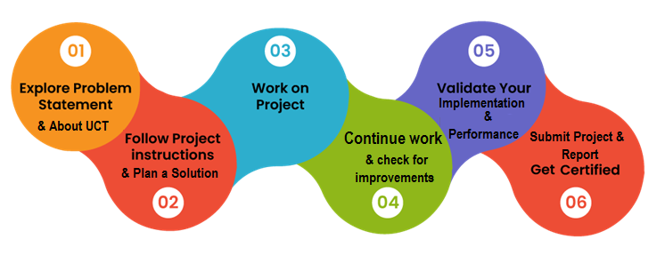

**Your Learnings and overall experience:** Gained expertise in embedded systems, IoT, and problem-solving; significantly improved technical and project management skills.

**Thank to all :** Special thanks to Nikhil Mandoli, Kunal Gupta ,Vishal Verma, Upskill Campus, The IoT Academy, and peers for their invaluable support.

**Your message to your juniors and peers:** Grab internship opportunities; they are essential for developing a solid career foundation, exposure to the sector, and hands-on learning.

# Introduction

## About UniConverge Technologies Pvt Ltd

A company established in 2013 and working in Digital Transformation domain and providing Industrial solutions with prime focus on sustainability and RoI.

For developing its products and solutions it is leveraging various**Cutting Edge Technologies e.g. Internet of Things (IoT), Cyber Security, Cloud computing (AWS, Azure), Machine Learning, Communication Technologies (4G/5G/LoRaWAN), Java Full Stack, Python, Front end**etc.



1. UCT IoT Platform **(****)**

**UCT Insight** is an IOT platform designed for quick deployment of IOT applications on the same time providing valuable “insight” for your process/business. It has been built in Java for backend and ReactJS for Front end. It has support for MySQL and various NoSql Databases.

* It enables device connectivity via industry standard IoT protocols - MQTT, CoAP, HTTP, Modbus TCP, OPC UA
* It supports both cloud and on-premises deployments.

It has features to  
• Build Your own dashboard  
• Analytics and Reporting  
• Alert and Notification  
• Integration with third party application(Power BI, SAP, ERP)  
• Rule Engine

 

1. **Smart Factory Platform (****)**

Factory watch is a platform for smart factory needs.

It provides Users/ Factory

* with a scalable solution for their Production and asset monitoring
* OEE and predictive maintenance solution scaling up to digital twin for your assets.
* to unleased the true potential of the data that their machines are generating and helps to identify the KPIs and also improve them.
* A modular architecture that allows users to choose the service that they what to start and then can scale to more complex solutions as per their demands.

Its unique SaaS model helps users to save time, cost and money.

 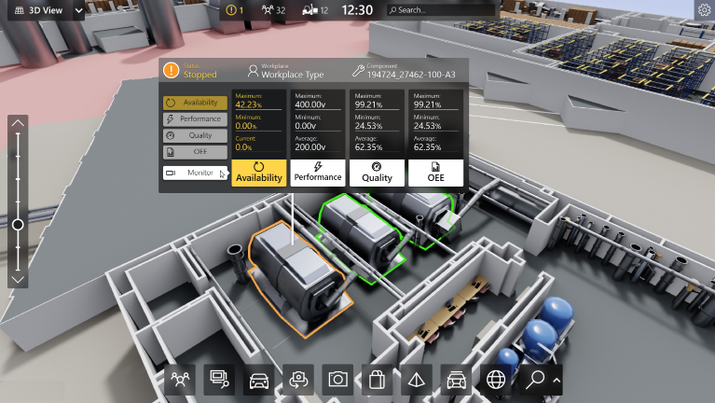

1. 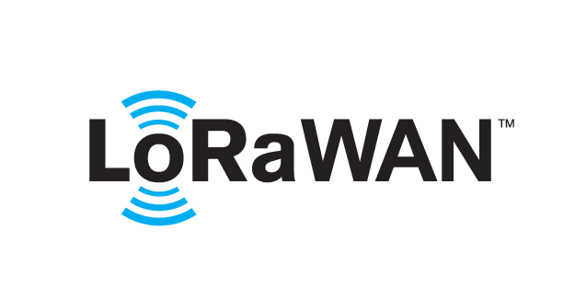 based Solution

UCT is one of the early adopters of LoRAWAN teschnology and providing solution in Agritech, Smart cities, Industrial Monitoring, Smart Street Light, Smart Water/ Gas/ Electricity metering solutions etc.

1. Predictive Maintenance

UCT is providing Industrial Machine health monitoring and Predictive maintenance solution leveraging Embedded system, Industrial IoT and Machine Learning Technologies by finding Remaining useful life time of various Machines used in production process.



## About upskill Campus (USC)

upskill Campus along with The IoT Academy and in association with Uniconverge technologies has facilitated the smooth execution of the complete internship process.

USC is a career development platform that delivers **personalized executive coaching** in a more affordable, scalable and measurable way.



Seeing need of upskilling in self paced manner along-with additional support services e.g. Internship, projects, interaction with Industry experts, Career growth Services

<https://www.upskillcampus.com/>

upSkill Campus aiming to upskill 1 million learners in next 5 year

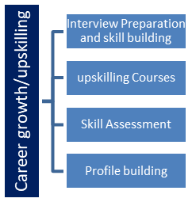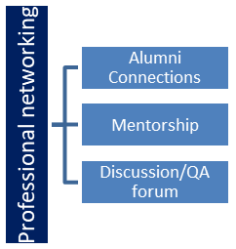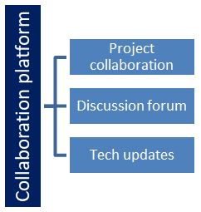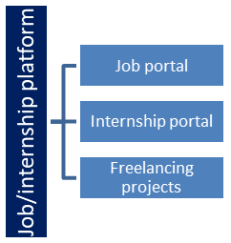

## The IoT Academy

The IoT academy is EdTech Division of UCT that is running long executive certification programs in collaboration with EICT Academy, IITK, IITR and IITG in multiple domains.

## Objectives of this Internship program

The objective for this internship program was to

 ☛ get practical experience of working in the industry.

 ☛ to solve real world problems.

 ☛ to have improved job prospects.

 ☛ to have Improved understanding of our field and its applications.

 ☛ to have Personal growth like better communication and problem solving.

## Reference

[1] R. M. Xian Wee, T. Connie and M. K. Ong Goh, "Integrating Object Detection and Optical Flow Analysis for Real-time Road Accident Detection," 2024 International Symposium on Intelligent Robotics and Systems (ISoIRS), Changsha, China, 2024

[2] Z. Li et al., "Aerial Image Object Detection Method Based on Adaptive ClusDet Network," 2021 IEEE 21st International Conference on Communication Technology (ICCT), Tianjin, China, 2021

[3] L. Lin, C. Shi, N. Wan, W. Lu and K. Gao, "Research and Implementation of Small Object Detection Algorithm for Power Embedded Devices," 2021 IEEE 2nd International Conference on Information Technology, Big Data and Artificial Intelligence (ICIBA), Chongqing, China, 2021

## Glossary

|  |  |
| --- | --- |
| Terms | Acronym |
| Embedded System | ES |
| **Internet of Things** | IoT |
| **Microcontroller** | MCU |
| **Ultrasonic Sensor** | US |
| **Cloud Platform** | CP |

# Problem Statement

This project's goal is to use Internet of Things (IoT) and embedded systems technologies to create and implement an object detecting system. Automated systems that can precisely identify an object's presence, movement, or absence inside a specific space are becoming more and more necessary in a wide range of industrial and consumer applications. Conventional object detection systems are generally restricted by fixed infrastructure or depend on manual monitoring, which results in inefficiencies and increased costs.  
  
Constructing a dependable, real-time system that can identify objects and transmit the resulting detection data to a centralized platform for additional processing and decision-making is the difficult part. The system needs to be scalable, low in false positives and negatives, and energy-efficient in order to function in a variety of situations.

To enable remote monitoring and data analysis, the system should also smoothly interact with current IoT frameworks.   
  
In order to overcome these obstacles, our project is creating a system that transmits data via Internet of Things communication protocols while detecting objects using embedded sensors and microcontrollers. The ultimate objective is to develop an object detection system that is affordable, dependable, and simple to implement. This system can be applied to a range of industrial applications, including automated manufacturing processes, inventory management, and security systems.

# Existing and Proposed solution

Typical object detection systems today use simple sensor arrays, like infrared or ultrasonic sensors, or more conventional techniques, like camera-based monitoring. These techniques have a number of drawbacks even though they might work well in some situations. More sophisticated camera-based systems are typically more expensive to install and maintain, which limits their applicability for mass usage. Conversely, basic sensor arrays sometimes have a restricted range and may have trouble correctly detecting things in settings that are complicated or varied. Furthermore, there is a chance of inaccuracy because a lot of these devices are quite sensitive to external variables like temperature and illumination.

Since many traditional systems do not interact with IoT frameworks, real-time data transfer is another major limitation that makes remote monitoring and data analysis difficult.   
  
On the other hand, my suggested remedy makes use of IoT technologies in conjunction with embedded sensors and microcontrollers to overcome these constraints. This technology combines infrared and ultrasonic sensors to identify objects more accurately, even in difficult-to-reach places. IoT protocols like MQTT are used to transfer the discovered data in real-time to a cloud platform, allowing for remote monitoring and immediate data analysis. This method not only increases detection accuracy and scalability but also provides a reasonably priced substitute for pricey camera-based systems.

## Code submission (Github link)

**Link:** https://github.com/msoni6620/upskillcampus/blob/main/blob/main/ObjectDetection.cpp.ino

## Report submission (Github link) :

**Link:** https://github.com/msoni6620/upskillcampus/blob/main/blob/main/ObjectDetection_Mayank_USC_UCT.pdf

# Proposed Design/ Model

The suggested object detection system, which makes use of embedded systems and the Internet of Things, is designed in a methodical manner to guarantee dependable performance and effective development. The first design phase, the middle development stages, and the final deployment and result comprise the three key stages of the process.  
  
1. The first stage of design  
Choosing the right components and designing the system architecture are the main priorities of the first phase. Selecting the sensors (such as infrared and ultrasonic) and microcontroller (MCU) that will process the sensor data falls under this category. Planning the communication protocol—like MQTT—to send the data to a cloud platform is another aspect of the design.

To visualize the system, a block diagram or flowchart is made, showing how data moves from the sensors to the microcontroller and then to the Internet of Things platform.   
  
2. Stages of Intermediate Development   
Parts of the system are constructed and tested in the development stages. In order to ensure precise object detection, the microcontroller must first be programmed to interpret sensor data in real-time. Subsequently, the integration of the IoT communication module facilitates the transmission of the discovered data to the cloud. This phase involves extensive testing in many settings to improve the accuracy and dependability of the system. Additionally, power optimization techniques are used to guarantee energy efficiency, which is vital for Internet of Things devices.

3. Final Results and Implementation  
The system is built in its whole and put through one more round of testing and validation in the final stage. Deployed in a real-world setting, the object detection system continuously identifies items and sends data to the cloud. The end result is a fully functional system that can be remotely observed using an Internet of Things platform, offering real-time data analysis and insights. To make sure all goals are achieved, the system's performance is assessed in comparison to the original problem description.

## High Level Diagram (if applicable)

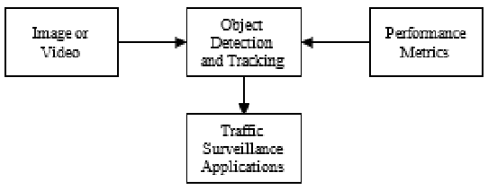

Figure 1: HIGH LEVEL DIAGRAM OF THE SYSTEM

# Performance Test

A focus on accuracy, power consumption, processing speed, and durability was part of the test plan to make sure the system would work well in industrial environments.

## Test Plan/ Test Cases

**Testing for Accuracy:**

Test Case 1: Confirm that the system recognizes items of different sizes and forms.

Test Case 2: Evaluate false positives and negatives in various environmental settings.

**Examination of Power Consumption:**

Test Case 3: To verify energy efficiency, measure power consumption while in operation and standby.

**Speed of Processing:**

Test Case 4: To guarantee real-time performance, measure the interval between object identification and data transfer.

**Examination of Durability:**

Test Case 5: Evaluate the system's dependability in high humidity and harsh temperature environments.

## Test Procedure

Record detection performance under various conditions while placing items within sensor range.

Testing for Power Consumption: Calculate and examine how much energy is used under various operating conditions.

Processing Speed: The amount of time it takes to detect an object and send data.

Durability Testing: Put the system in harsh environments and keep an eye on how it works.

## Performance Outcome

There were few false positives and negatives and a high accuracy rate from the system.

Power Consumption: Within reasonable power constraints, the system performed well.

Processing Speed: With very little delay, the system satisfied real-time processing requirements.

Durability: In high humidity and extremely cold temperatures, the system operated with dependability.

# My learnings

I learned a lot and got practical experience during this internship, which will help me advance in my profession. In order to create a workable object detection solution, I had to learn how to combine embedded systems with Internet of Things technologies. This improved my comprehension of real-time data processing and system architecture. I learned how to overcome obstacles like maximizing power usage, guaranteeing precise recognition, and efficiently handling data transfer from this experience.

In addition, by tackling and overcoming limitations in processing speed, accuracy, and durability, I strengthened my problem-solving abilities. My ability to apply theoretical knowledge in real-world circumstances has improved via working on a real-world project, which is essential for resolving challenging industrial problems.

All things considered, these knowledge and expertise will be extremely helpful as I grow in my work, especially in positions involving embedded systems, the Internet of Things, and industrial automation. They have equipped me with the skills I need to tackle technological difficulties, come up with creative solutions, and successfully participate in next initiatives and career prospects.

# Future work scope

Considering the project's time limits, a number of improvements were noted for further investigation. Improving object detection methods to get higher accuracy, especially in congested or complicated situations, is one possible area of focus. This might be accomplished by utilizing sophisticated machine learning techniques. To increase the system's detecting capabilities, adding other sensor types—like image-recognition cameras—is another way to make improvements. Future development might concentrate on scalability as well, which would enable the system to oversee numerous sensors or devices inside a bigger network for all-encompassing industrial monitoring. Improving power efficiency with cutting-edge methods may help decrease energy usage and prolong battery life. Furthermore, adding advanced data analytics to the cloud platform might help with improved decision-making and offer deeper insights.

Enhancing the IoT platform's user interface would also make it more accessible and useful. Finally, a thorough robustness test carried out in harsh circumstances would guarantee the system's dependability in a range of operational settings. Future improvements like these might greatly increase the system's usefulness and functionality.