Serper API
Serper API is an alternative to Google Custom Search API. Since Google Custom Search API was suffering from two major drawbacks - frequent timeouts and inability to extract URLs for all agencies. Also, we were not able to extract multiple URLs for each agency.
Serper API codes contain three .py files - step1_gsearch.py, step2_process_outputs.py, step3_extract_address.py
- step1_gsearch.py
For the 100 most flight-requested agencies documented in DBeaver-returned 100 most flight requested agencies csv
https://google.serper.dev/search and https://google.serper.dev/maps are the two endpoints we hit programmatically in this code.
JSON files for 100 most flight requested agencies save structured JSON files within agency_specific directories. Three JSON files are created for each agency - maps_xxx.json, search_address_xxx.json, search_website_xxx.json
The script supports batching, random delays between requests to avoid rate limits, and a resume feature to continue from a previous run. It uses a session with retry and exponential backoff to handle request failures, and prioritizes links that are most relevant for contact or location information.

- step2_process_outputs.py
This script aggregates and preprocesses previously saved JSON search results from JSON files for 100 most flight requested agencies, which contains folders named after individual agencies. For each agency, it extracts:
The agency’s website URL from web search snippet
The agency’s address from search answerbox
The agency’s address from Google Maps
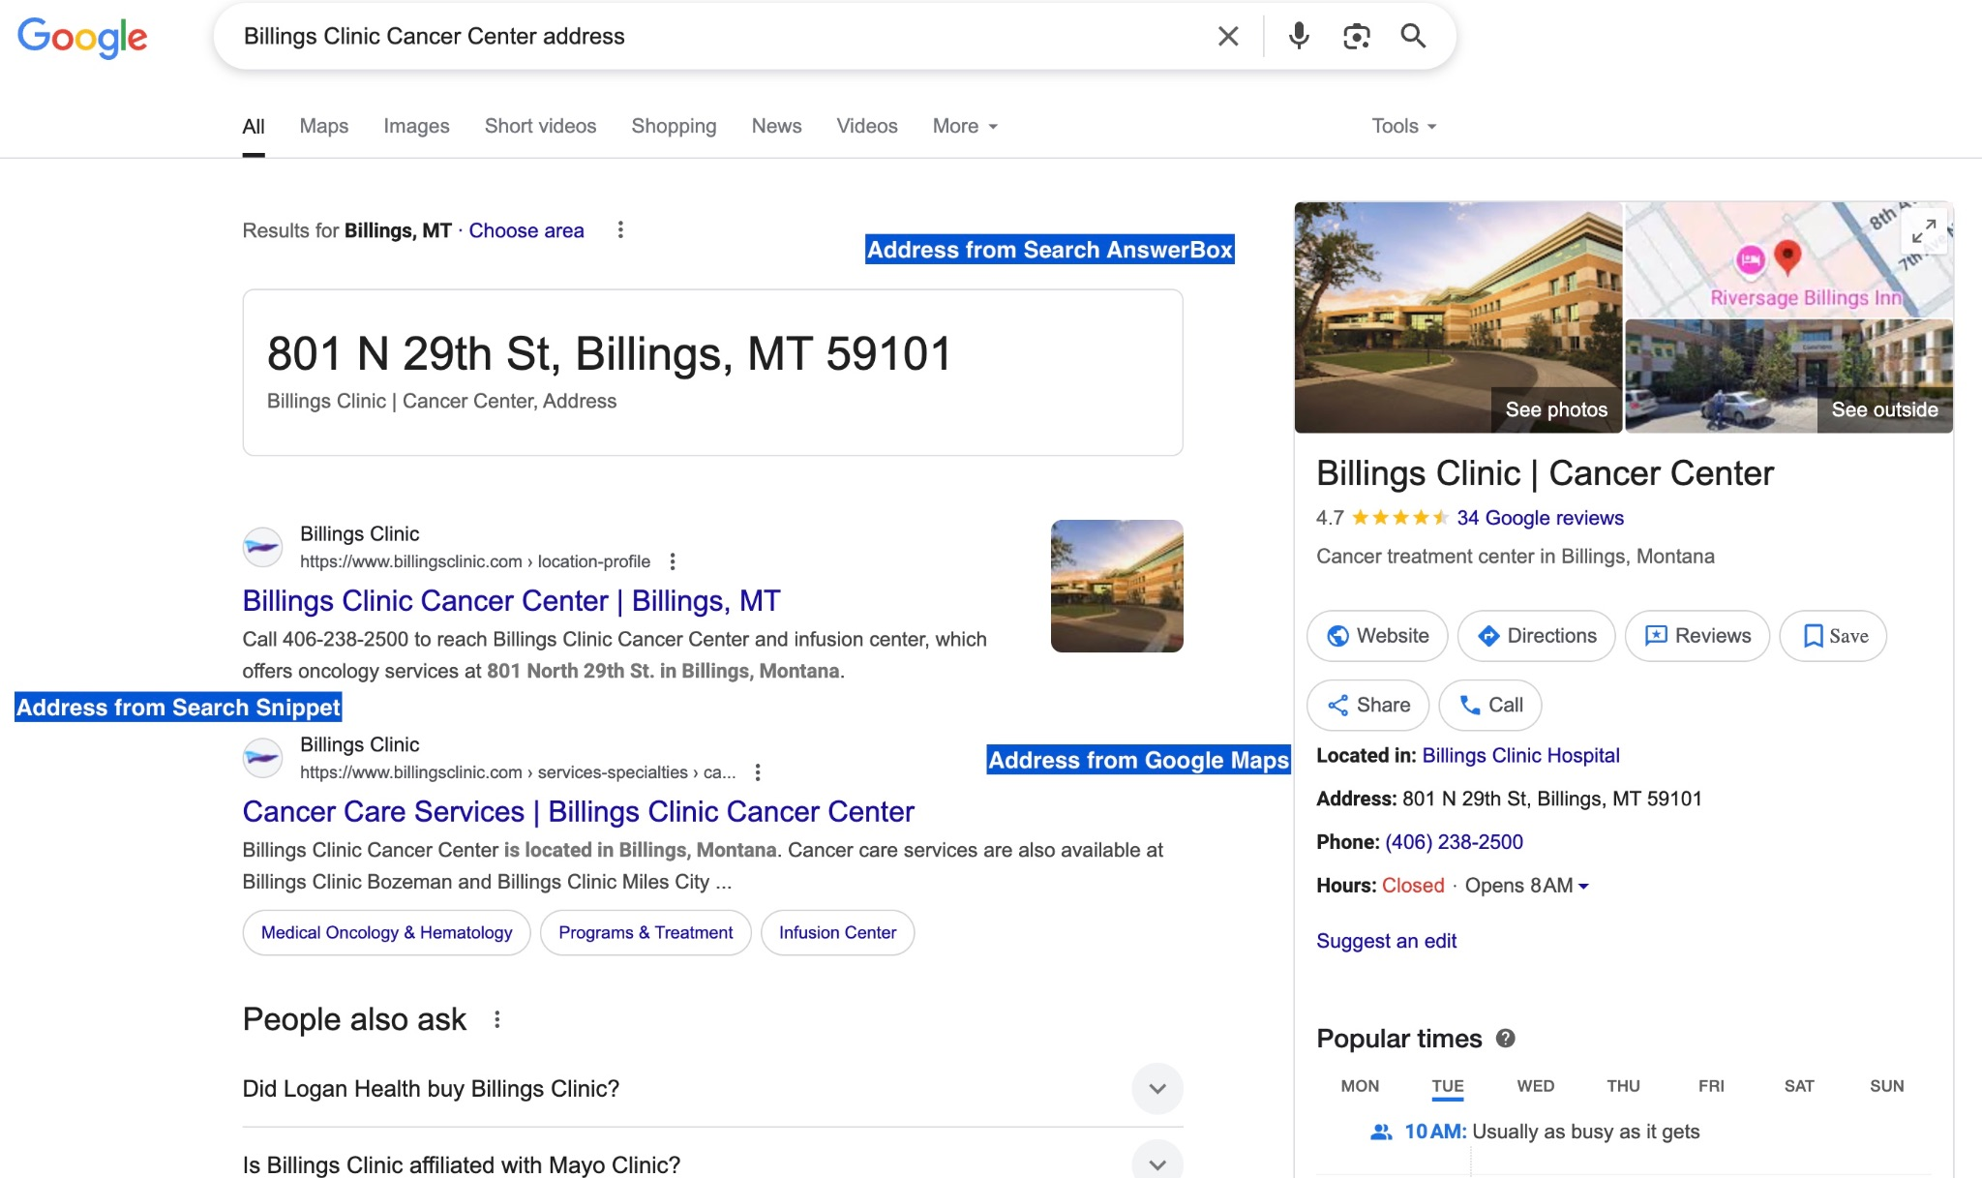
agency_data_preprocessedV2_Peilu.csv in Serper-output agency website URLs contains the full output from the Serper API code.
First 2 columns from above csv were retained to create below csv:
agency_data_preprocessedV2_Peilu_ToGiveToCharon-2.csv in Serper-output agency website URLs contains the website URLs for each agency.

3. Step3_extract_address.py
This Python script enhances agency address data by using the OpenAI API (gpt-4o) to analyze and standardize addresses. It reads agency data from a csv file (containing agency names and raw address information from different sources) and uses both synchronous and asynchronous methods to:
- Extract and clean address components (street address, city, state, zip code) from three sources (maps, search snippets, and answerbox)
- Determine confidence in the extracted address using a heuristic (high, medium, low) based on consistency and completeness of information.
- Use concurrency (via asyncio with a semaphore) to process multiple rows in parallel while respecting rate limits.
- Provide a fallback parser that tries to extract components using basic string splitting and regex if OpenAI fails.

Playwright
After the above webpage URL extraction with Serper API, agency_data_preprocessedV2_Peilu_ToGiveToCharon-2.csv in Serper-output agency website URLs was given to the web-scraping code using Playwright. I use the Crawl4AI library wrapper around Playwright in the code. Compared to Beautiful Soup, it increases address extraction rate from webpage URL from ~56% to ~90%. Some of the webpage URLs out of the remaining 10% did not contain any address.
test4.py in Playwright web-scraping code is the code which uses Playwright to extract address from the URL given for each agency. The column ‘website’ for each agency as picked up and address was extracted from the URL. Playwright_Output_for_Validation_Agencies contains the Playwright - extracted addresses as anew column address.
agency_data_preprocessedV2_Peilu.csv in Serper-output agency website URLs contains the additional columns - address_from_search_snippet, address_from_answerbox, address_from_maps created by the code - step2_process_outputs.py in Serper API codes. These serve as fallback address in case the codes - step2_process_outputs.py fails to extract website URL or + test.py fails to extract address from the URL. Additionally, the JSON maps_xxx.json, created by step1_gsearch.py returns a Google Places ID. This has the potential to serve as an agency identifier in future. The code Google PLaces ID extraction code achieves this.

Note: All of the current Playwright web-scraping is as per how the webpage is rendered in Chrome browser. The webpage sometimes is rendered very differently in Safari and Chrome.

Validation
We took 100 agencies with most requested flights. The business idea is that these agencies underwent the most scrutiny from AFW.
- Serper_API contains the three .py files - step1_gsearch.py, step2_process_outputs.py
This extracts web[age URLs for each agency.
- Playwright.py in https://drive.google.com/drive/folders/1SuoLngRR-HQD4gnnIof6nWoC2blZGSVs
was used to extract webpage URLs form above-extracted webpage URL.
The output was saved in agency_data_preprocessedV2_Peilu.csv Serper_Output_for_Validation_Agencies
- Returned_Addresses_Extract.ipynb Airport_Proximity was used to extract one address for agencies with multiple addresses returned by the web-scraping code. The resulting addresses(one address per agency) were saved
- Returned_address_Web_scraping_AFWAddressCombined.csv inValidation_Output_for_Validation_Agencies contain full_agency_address (address on AFW file), webscraped address (address returned by web-scraping pipeline code, Returned_Addresses_Extract.ipynb)
- MatchAddresses.ipynb in Address_Similarity was used to hit gpt-4o-mini model(LLM) and compare the address on AFW file and web-scraped address (The 2 columns - full_agency_address, web_scraped_address). And populate a new column - match_category in agency_address_compared_20250609_161342.csv in Validation_Output_for_Validation_Agencies

Note: The numbers in the EOQ presentation look different from what we got through the pipeline above as for above verification pipeline,
(i) agencies with multiple address on AFW file, eg-UCLA, UCD, UCSF were also kept. For one agency in this list, addresses returned by web-scraping code is only one. But for the same agency, multiple addresses are listed on the AFW file. Hence, it unnecessarily bloated up the category: No match.
(ii) Sometimes, the airport proximity logic did not return the address with a match against the address on the AFW file. But another address returned by web-scraping logic did. However, as discussed with Anne, this is a case of ambiguity and should not be attributed to the mismatch numbers.
(iii) The address returned by the Serper API from the three sources - web search snippet, search answerbox, maps should also be considered as fallback addresses.

Hence, for the numbers in the EOQ presentation, I manually did the matching of addresses on AFW file and web-scraping returned address. The results are saved in 100MostRequested_Manual_Address_Matching.csv here:Manual_Verification_of_address
I took care of the three shortcomings above.

Note:
Also, I processed all ~1600 agencies(agencies without requester attached, no year restriction for flight requested) through the entire above pipeline of Serper API. This, we hope, will serve as the basis for cleaning the existing database of AFW. Below is the location of all JSON files is as follows:
https://drive.google.com/drive/folders/1rbyKKcUnEcgahWQXf4Da_xR2Dv3S-HKW
The location of the csv file is as follows:
https://drive.google.com/drive/folders/1j8y8Zl4sxBTL0vm1X6SEKQhdh5D5ervK
The location of the code to obtain the list of agencies is:
https://docs.google.com/document/d/1dRHB_YwJZ6TOmxlOMcxkFw58xOSBpwbZPnmRDo6sh0M/edit?tab=t.0
We did not process this through Playwright code, as this was later deemed out of scope of our Practicum project.

Further Improvements to the entire workflow:
- Right now, the Serper API code sends only the website URL from the top organic search result to the Playwright/Beautiful Soup web-scraping code. However, this website may not always contain an address or contain the correct address. Serper API saves top-5 webpage URLs as part of the JSON files. We recommend sending all these to Playwright/Beautiful Soup web-scraping code, so that it can fetch more addresses.
- In case the web-scrapping code returns multiple addresses, the airport proximity code is utilized to return the accurate address. However, this is not always matching the address on the AFW file. Think of a more accurate logic to ensure correct selection of one address amongst the multiple addresses returned.
- For agencies like UCSF, UCD, UCLA, which have multiple addresses listed on AFW file, utilize site and department columns to send to Playwright web-scraping code. Since these are all valid agencies and addresses, there is some business reason why multiple addresses are listed against the same agency name. Confirmed this logic with Anne.
- The entire code can be put in Langchain. That will be a step towards Agentic systems.

Few considerations for the workflow proposed:
- Serper API is more expensive compared to Google Custom Search API, once the free tier is exhausted.
- The web-scraping code utilizing Playwright uses gpt-4o-mini LLM model. Hitting this API is paid. Though it is extremely cheap, if we scale this pipeline to org-level, a cost-benefit analysis will have to be done.

Note:
- I used a local Python environment inside Visual Code Studio throughout while coding.
Use following command to create a local Python environment:
python3 -m venv path/to/venv
Then install using pip install [library-name-required] inside Visual Code Studio.
Then use the below command to activate the local environment.
source path/to/venv/bin/activate

- I also used a .env file to save all my API keys, and concurrency settings used in step1_gsearch.py, step3_extract_address.py
Following are the concurrency settings:
# Concurrency Settings for step3_extract_address.py
MAX_CONCURRENT_REQUESTS=100
RATE_LIMIT_RPM=600

# Concurrency Settings for step1_gsearch.py
MAX_WORKERS=30
MIN_REQUEST_DELAY=0.1
MAX_REQUEST_DELAY=0.3
BATCH_SIZE=300
BATCH_PAUSE=1

Shreya Chandra
Phone: +919767902419
Email: shrchandra@ucdavis.edu
shreya.chandra.24@gmail.com
LinkedIn: https://www.linkedin.com/in/shreya-chandra-71486a63/

