VIT BHOPAL UNIVERSITY


PROJECT ASSIGNMENT BRIEF

Submitted By: Aarush Rahul Patel
Reg. No.:25BCY10047
Branch: B.Tech – Computer Science & Engineering
Course Code: CSE0001
Course Name: Digital Literacy
Submitted To: Dr. Kannan
Academic Year: 2025-26

Introduction –
This project focuses on developing a comprehensive understanding of digital literacy and responsible online behavior among college students. In today’s digital age, being digitally literate is not just about using technology, but also about understanding how to use it safely, effectively, and professionally. Through this project, various aspects were explored, including the meaning of digital literacy, useful digital tools for students, safe internet practices, professional online presence, and email etiquette.
The project also involved practical tasks such as creating an infographic, designing a digital literacy quiz using Google Forms, and exploring platforms like HackerRank, GitHub, Kaggle, and LinkedIn for academic and professional growth. Additionally, it included writing formal emails, analyzing cybercrime cases like UPI fraud, and preparing safety checklists for responsible social media and online usage.
Overall, this project helped in building awareness about digital risks and opportunities while enhancing communication, technical, and critical thinking skills necessary for students in the modern digital world.

Project Objectives –
- Create a Digital Literacy Awareness Infographic
- Build Your Student Digital Portfolio
- Explore Coding & Collaboration Platforms
- Draft a Professional Email & Etiquette Guide
- Cybercrime Awareness Case Study & Prevention Guide

TASK 1 –
I created my infographic using Canva, as it is a user-friendly and versatile design tool that offers a wide range of templates, icons, and customization options. My design focuses on three key aspects of digital literacy: understanding what digital literacy is, useful digital tools for students, and safe internet practices. I included brief definitions, examples of tools like online collaboration platforms and note-taking apps, and tips such as using strong passwords and avoiding suspicious links. The layout is visually organized with icons and color coding to make the information easy to read and engaging.
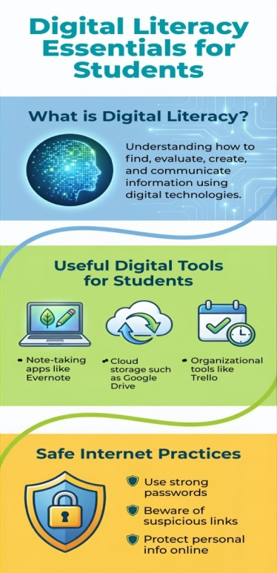
One thing I found particularly interesting while creating the design was how effectively visuals can simplify complex ideas and make them more appealing. However, I also found it slightly challenging to balance the amount of information with the available space. Ensuring that the info graphic was informative without looking overcrowded required careful selection of content and design elements. Overall, the experience helped me improve both my design skills and understanding of digital literacy concepts.
TASK 2 –
For building my professional online presence, I chose LinkedIn, GitHub, and Kaggle. Each of these platforms serves a unique and important purpose. LinkedIn is mainly used for professional networking, creating a digital resume, and connecting with industry professionals and recruiters. GitHub is a platform where I can upload, manage, and showcase my coding projects, which helps in demonstrating my technical skills. Kaggle is widely used for data science practice, competitions, and working with real-world datasets.
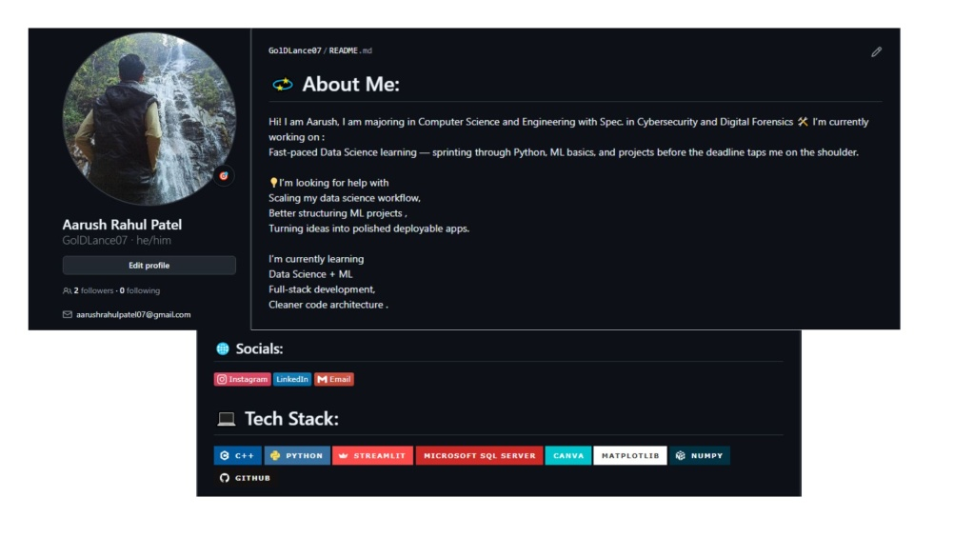
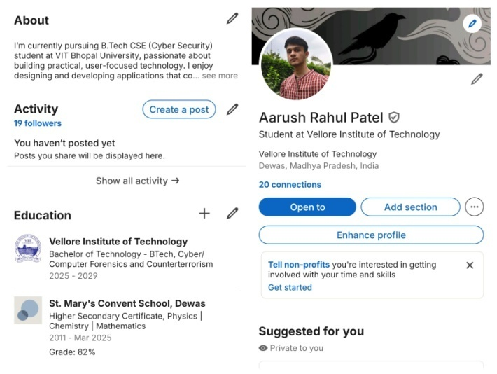
Over the next four years, I plan to actively use these platforms to build a strong professional profile. On LinkedIn, I will regularly update my achievements, certifications, and internships while expanding my network. On GitHub, I will consistently upload projects, collaborate with others, and improve my coding practices. On Kaggle, I aim to participate in competitions, learn new techniques, and build a portfolio in data analysis and machine learning. Together, these platforms will help me grow academically and professionally.
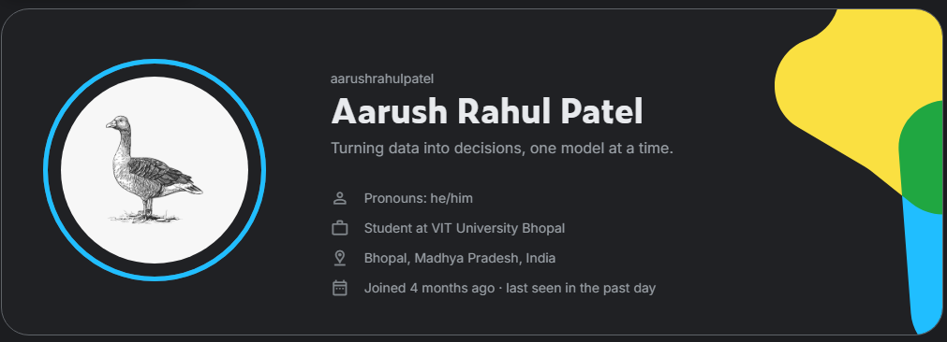

TASK 3 –
For this task, I used HackerRank and Google Forms. HackerRank is a platform designed for practicing coding and improving problem-solving skills, while Google Forms is used to create surveys, quizzes, and collect responses efficiently.
On HackerRank, I practiced solving coding problems, which helped me strengthen my logical thinking and programming skills. It provided structured challenges that improved my understanding of different concepts and techniques. Using Google Forms, I created a Digital Literacy Awareness Quiz, which allowed me to design questions, organize them properly, and understand how data collection works in a simple and effective way.
These tools will be very helpful for me academically over the coming years. HackerRank will support me in improving my coding proficiency, which is essential for my coursework, placements, and technical interviews. Google Forms will help me in conducting surveys, collecting feedback, and even creating quizzes for academic purposes. Overall, both tools contribute to enhancing my technical and practical skills.

TASK 4 –
A situation where poor digital communication caused a real problem could be a student emailing a professor about an assignment but writing a vague message like “I can’t submit it” without explaining the reason or mentioning the course details. As a result, the professor might ignore the request or misunderstand the situation, leading to the student losing marks due to late submission. This issue arises because the message lacks clarity, proper structure, and necessary information.
This problem could have been avoided by following proper email etiquette. The student should have written a clear subject line, explained the reason for the delay, mentioned the course name, and politely requested an extension. Using a professional tone and providing complete information would help the professor understand the situation and respond appropriately. Effective digital communication ensures that messages are clear, respectful, and actionable.

TASK 5 –
While researching this topic, what surprised me the most was how simple mistakes can lead to serious cybercrimes, especially in cases of UPI fraud. I realized that many scams do not rely on advanced hacking but instead exploit human error, such as clicking on unknown links or approving payment requests without verification. It was surprising to see how quickly money can be lost due to a small lapse in attention.
As a result, one habit I will personally change is being more cautious while handling digital payments and online messages. I will make it a rule to always verify payment requests before approving them and never click on suspicious links. I will also ensure that I do not share sensitive information like OTPs or PINs under any circumstances. This change will help me stay more secure and responsible in my digital activities.

Conclusion
This project provided a comprehensive understanding of digital literacy and its importance in today’s technology-driven world. Through various tasks, I explored essential areas such as creating awareness content, building a professional digital portfolio, practicing coding skills, and understanding cyber safety. The hands-on activities, including designing an infographic, using platforms like HackerRank and Google Forms, and drafting professional emails, helped me develop both technical and communication skills.
Additionally, researching cybercrime and creating prevention strategies increased my awareness of online risks and the importance of responsible digital behavior. Overall, this project has enhanced my confidence in using digital tools effectively and professionally. It has also prepared me to guide others as a Digital Ambassador and to use these skills for academic growth and future career opportunities.

References
- Google. (n.d.). Google Forms. https://forms.google.com
- HackerRank. (n.d.). Practice Coding Problems. https://www.hackerrank.com
- Canva. (n.d.). Design and Infographic Tool. https://www.canva.com
- LinkedIn. (n.d.). Professional Networking Platform. https://www.linkedin.com
- GitHub. (n.d.). Code Hosting Platform. https://github.com
- Kaggle. (n.d.). Data Science Platform. https://www.kaggle.com
- National Cyber Crime Portal, Government of India. https://cybercrime.gov.in
- Times of India. (2024). Fake LPG booking scam case

