BAND 1 – FOUNDATIONAL
Difficulty
Foundational: Direct use of one or two Java constructs with simple input/output.
For Band 1, you should not use complicated OOP, collections, packages, interfaces, JDBC, etc. The examiner mainly wants to see whether you understand basic Java programming.

Case Study: Student Marks and Grade
Problem Statement
Write a Java program to accept the marks of a student and calculate the total marks, percentage, and grade.

1. Aim
To develop a simple Java program that accepts student marks as input and calculates the total marks, percentage, and grade using basic Java constructs.

2. Theory
Java is a high-level, object-oriented programming language used to develop various types of applications.
A basic Java program consists of a class and a main() method. The execution of a Java program starts from the main() method.
In this case study, basic Java concepts such as:
- Variables
- Data types
- User input
- Arithmetic operators
- if-else statement
- Output using System.out.println()
are used.
Variables
A variable is a named memory location used to store data.
For example:
int marks;
Here, marks is an integer variable.
Data Types
Java provides different data types for storing different types of values.
Some common data types are:
Data Type | Use | Example
int | Integer values | 50
double | Decimal values | 85.5
char | Single character | 'A'
String | Text | "Shreya"
Scanner
The Scanner class is used to take input from the user through the keyboard.
Scanner sc = new Scanner(System.in);
For integer input:
int marks = sc.nextInt();
Arithmetic Operators
Arithmetic operators are used to perform mathematical calculations.
Operator | Meaning
+ | Addition
- | Subtraction
* | Multiplication
/ | Division
if-else Statement
The if-else statement is used to make decisions.
For example:
if(marks >= 40)
System.out.println("Pass");
else
System.out.println("Fail");
If the condition is true, the if block executes. Otherwise, the else block executes.

3. Algorithm
- Start the program.
- Create a Scanner object for taking input.
- Enter marks of three subjects.
- Calculate the total marks.
- Calculate the percentage.
- Check the percentage using if-else.
- Display the grade.
- Stop the program.

4.Screenshot:-
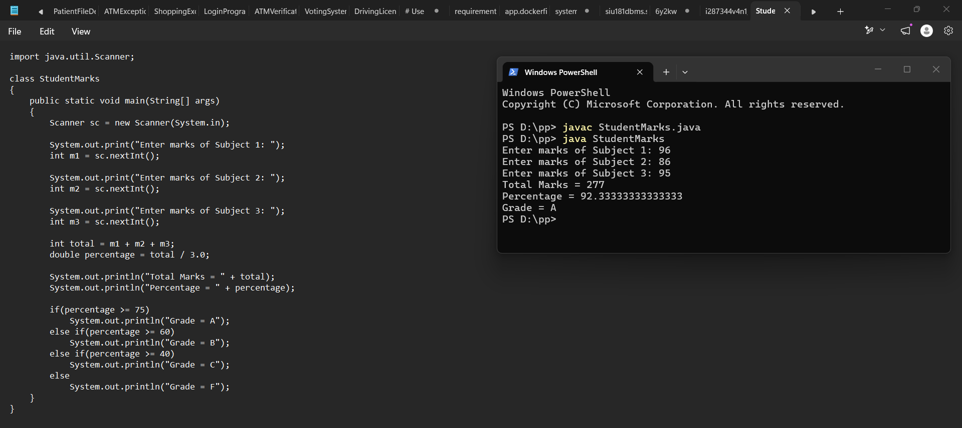

5. Simple Explanation of Code
Import Scanner
import java.util.Scanner;
This imports the Scanner class so that we can take input from the user.
Create Scanner
Scanner sc = new Scanner(System.in);
It creates a Scanner object named sc.
Take marks
int m1 = sc.nextInt();
It takes an integer value from the user and stores it in m1.
Calculate total
int total = m1 + m2 + m3;
It adds the marks of all three subjects.
Calculate percentage
double percentage = total / 3.0;
It divides the total marks by 3 to calculate the percentage.
Check grade
if(percentage >= 75)
If percentage is 75 or above, grade A is displayed.
else if(percentage >= 60)
If percentage is between 60 and 74.99, grade B is displayed.
else if(percentage >= 40)
If percentage is between 40 and 59.99, grade C is displayed.
Otherwise:
else
System.out.println("Grade = F");
Grade F is displayed.

6. Why This Is Band 1
This program fits Band 1 because it uses only basic Java constructs:
- Scanner
- Variables
- int and double
- Arithmetic operators
- if-else
- Simple input/output
There are no classes with objects, inheritance, interfaces, collections, exception handling, JDBC, or advanced concepts.

7. Conclusion
The program successfully accepts the marks of three subjects from the user and calculates the total marks and percentage. Based on the percentage, the appropriate grade is displayed. The program demonstrates the basic Java concepts of input/output, variables, arithmetic operations, and conditional statements.

BAND 2 – BASIC / INTERMEDIATE
Difficulty
Band 2 – Basic/Intermediate: Combines two or more core Java language features and introduces validation.
For Band 2, the program should be a little more advanced than Band 1. We can use:
- Scanner
- Variables and data types
- if-else
- Arithmetic operations
- Input validation
- while loop
The important new idea here is validation — checking whether the user's input is valid before processing it.

Case Study: ATM Withdrawal System
Problem Statement
Write a Java program to simulate a simple ATM withdrawal system. The program should accept a PIN and withdrawal amount, validate the input, and process the withdrawal if sufficient balance is available.

1. Aim
To develop a Java program that simulates a simple ATM withdrawal system using input, conditional statements, arithmetic operations, loops, and input validation.

2. Theory
An ATM system allows a user to perform banking operations such as checking balance and withdrawing money.
In this case study, the user enters a PIN and withdrawal amount. The program validates the entered information before allowing the transaction.
The following Java concepts are used:
1. Variables
Variables store values that are required during program execution.
Example:
int pin;
double balance;
double amount;
Here:
- pin stores the PIN entered by the user.
- balance stores the available bank balance.
- amount stores the withdrawal amount.

2. Scanner Class
The Scanner class is used to accept input from the keyboard.
Scanner sc = new Scanner(System.in);
For integer input:
pin = sc.nextInt();
For decimal input:
amount = sc.nextDouble();

3. Conditional Statements
The if-else statement is used to make decisions.
For example:
if(pin == 1234)
The program checks whether the entered PIN is correct.

4. Input Validation
Validation means checking whether the input provided by the user is correct and acceptable.
For example, a withdrawal amount should:
- Be greater than zero.
- Not be greater than the available balance.
We can check this using:
if(amount <= 0)
and:
if(amount > balance)

5. While Loop
A while loop repeatedly executes a block of code while a condition is true.
Example:
while(pin != 1234)
This can be used to allow the user to enter the PIN again if the PIN is incorrect.
For a simple practical program, we can limit the number of attempts.

6. Arithmetic Operation
After a successful withdrawal, the amount is subtracted from the balance.
balance = balance - amount;
This updates the remaining account balance.

3. Algorithm
- Start the program.
- Create a Scanner object.
- Store the initial account balance.
- Ask the user to enter the PIN.
- Validate the PIN.
- If the PIN is incorrect, display an error message.
- If the PIN is correct, ask for the withdrawal amount.
- Check whether the amount is greater than zero.
- Check whether sufficient balance is available.
- If all conditions are valid, subtract the amount from the balance.
- Display the remaining balance.
- Stop the program.

4. Java Code and output
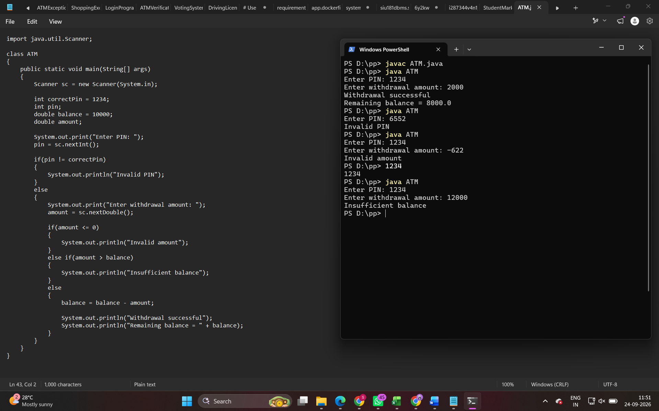

5. Explanation of Code
Import Scanner
import java.util.Scanner;
This imports the Scanner class for taking input.
Correct PIN
int correctPin = 1234;
This stores the correct PIN.
Initial Balance
double balance = 10000;
The account initially contains ₹10,000.
Take PIN
pin = sc.nextInt();
The user enters their PIN.
Validate PIN
if(pin != correctPin)
The program checks whether the entered PIN is different from the correct PIN.
If it is different:
System.out.println("Invalid PIN");
is displayed.
Take Withdrawal Amount
amount = sc.nextDouble();
The program accepts the amount the user wants to withdraw.
Validate Amount
if(amount <= 0)
This checks whether the withdrawal amount is zero or negative.
Check Balance
else if(amount > balance)
This checks whether the user is trying to withdraw more money than the available balance.
Update Balance
balance = balance - amount;
The withdrawal amount is subtracted from the current balance.

10. Why This Is Band 2
This is Band 2 because it combines multiple basic Java concepts rather than using only one or two simple constructs.
It uses:
Concept | Use
Scanner | User input
Variables | Store PIN, amount and balance
if-else | Decision making
Arithmetic | Calculate remaining balance
Validation | Check PIN and withdrawal amount
Nested conditions | Check multiple conditions
The key difference from Band 1 is that the program doesn't simply take input and calculate an answer. It checks whether the input is valid before performing the operation.

6. Conclusion
The ATM withdrawal program successfully demonstrates a simple banking transaction using Java. The program accepts a PIN and withdrawal amount, validates the entered information, checks the available balance, and processes the withdrawal only when all conditions are satisfied. This demonstrates the use of input handling, conditional statements, arithmetic operations, and input validation in Java.

BAND 3 – INTERMEDIATE
Case Study: Library Book Management System
Problem Statement
Develop a Java program for a library that stores book details and displays the available books. The program should use classes and an ArrayList to store multiple book objects. It should also handle invalid input using exception handling.

1. Aim
To develop a Java-based Library Management System using classes, objects, class relationships, collections, and exception handling.

2. Theory
A Library Management System is used to maintain information about books available in a library.
Instead of storing information about only one book, the program should be able to store details of multiple books. For this purpose, Java's Object-Oriented Programming concepts and the ArrayList collection can be used.
The main concepts used in this program are:
- Classes
- Objects
- Constructors
- Class relationships
- ArrayList
- Exception handling
- Methods

3. Class
A class is a blueprint or template used to create objects.
For example:
class Book
{
int id;
String name;
}
Here, Book is a class containing information about a book.

4. Object
An object is an instance of a class.
For example:
Book b = new Book();
Here, b is an object of the Book class.
A library can have many book objects:
Book 1
Book 2
Book 3

5. Constructor
A constructor is a special method used to initialize an object.
Example:
Book(int id, String name)
{
this.id = id;
this.name = name;
}
It assigns values when a new book object is created.

6. Class Relationship
In this program, the Library class contains book objects.
The relationship can be represented as:
Library
|
| contains
↓
Book
The Library class maintains a collection of Book objects.
This demonstrates a basic class relationship.

7. ArrayList
ArrayList is a collection in Java used to store multiple objects.
It is available in:
java.util.ArrayList
Example:
ArrayList<Book> books = new ArrayList<>();
This creates an ArrayList that can store multiple Book objects.
We can add a book using:
books.add(book);
We can display the books using a loop.

8. Exception Handling
Exception handling is used to handle errors that may occur while executing a program.
Java uses:
try
catch
For example:
try
{
int n = Integer.parseInt(input);
}
catch(Exception e)
{
System.out.println("Invalid input");
}
If an error occurs inside the try block, the catch block handles it.
This prevents the program from terminating suddenly because of invalid input.

9. Algorithm
- Start the program.
- Create a Book class.
- Create a Library class.
- Create an ArrayList to store books.
- Create book objects with ID and name.
- Add the book objects to the ArrayList.
- Display all books.
- Use exception handling to handle invalid input.
- Stop the program.

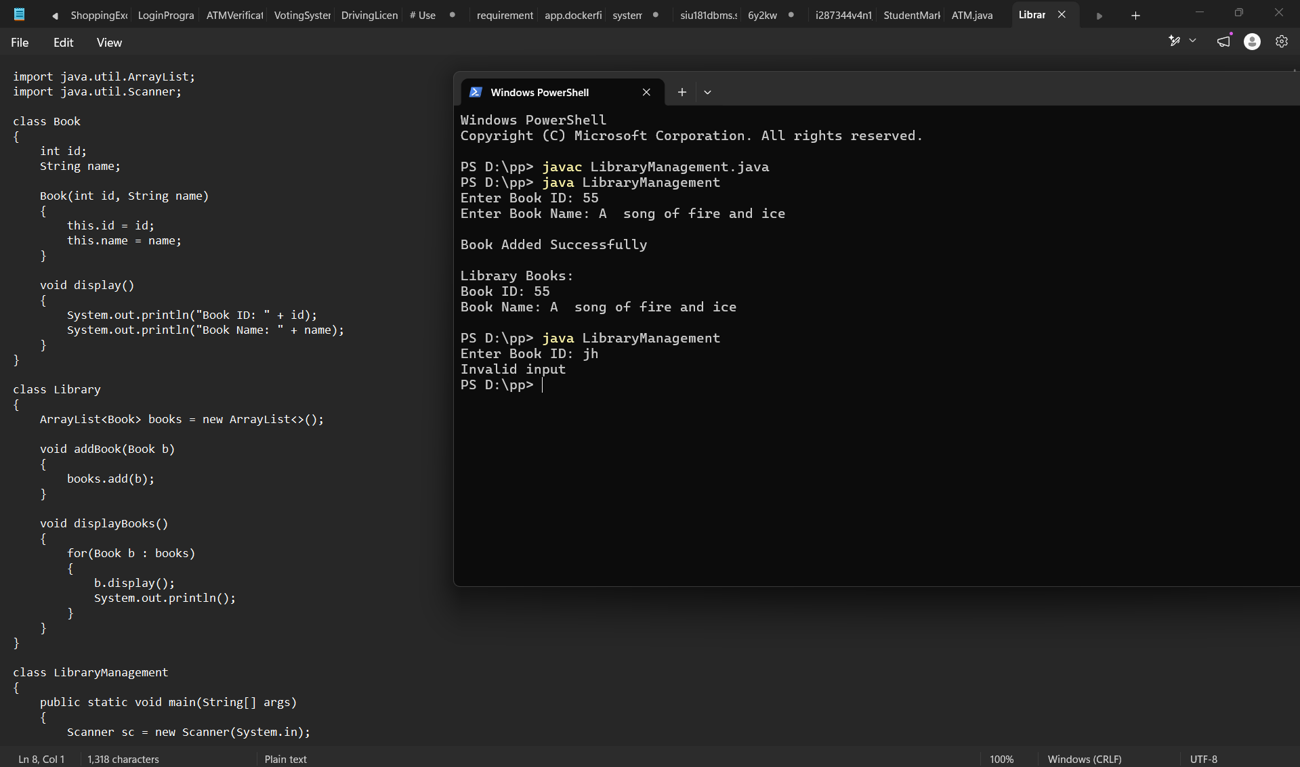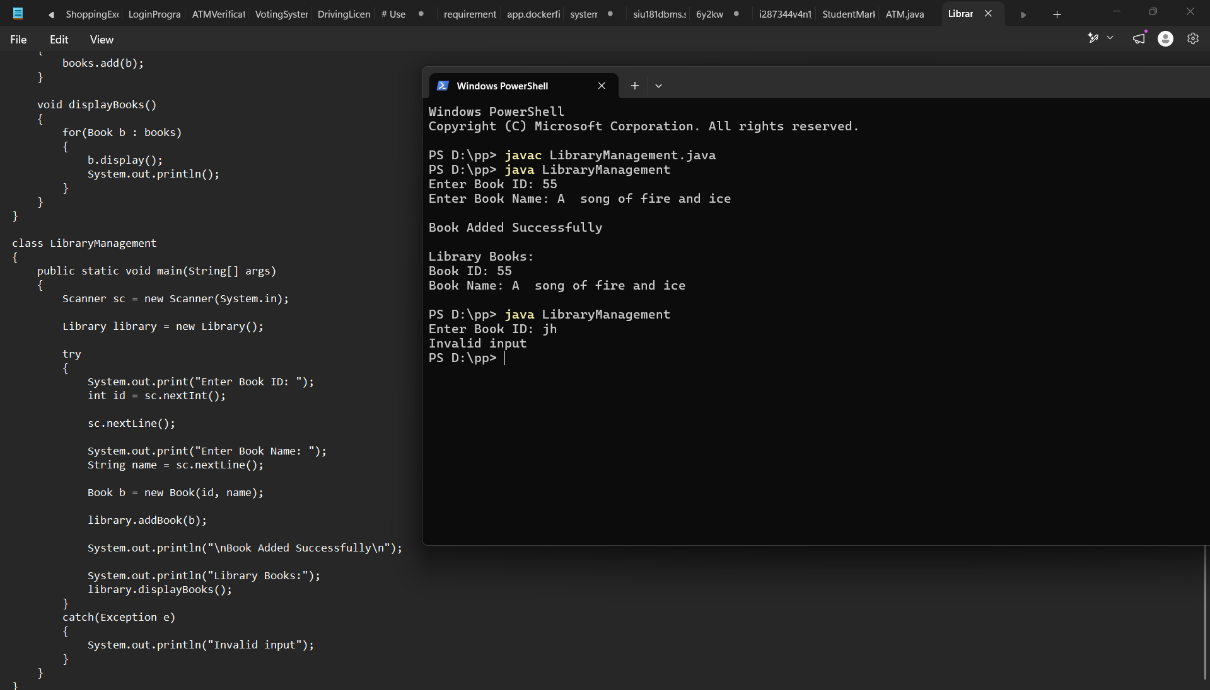

13. Explanation of Code
Import ArrayList
import java.util.ArrayList;
This imports the ArrayList class.

Book Class
class Book
This class represents a book.
It contains:
int id;
String name;
These store the book ID and book name.

Constructor
Book(int id, String name)
The constructor initializes the book details.
this.id = id;
this.name = name;
this refers to the current object.

Display Method
void display()
This method displays the details of a book.

Library Class
class Library
This class manages the books.
It contains:
ArrayList<Book> books = new ArrayList<>();
This means the library has an ArrayList that stores Book objects.

Add Book
void addBook(Book b)
{
books.add(b);
}
This method adds a book object to the ArrayList.

Display Books
for(Book b : books)
This loop goes through every book stored in the ArrayList.
Then:
b.display();
displays the details of each book.

Creating Library Object
Library library = new Library();
This creates an object of the Library class.

Creating Book Object
Book b = new Book(id, name);
This creates a new book object using the entered ID and name.

Adding Book
library.addBook(b);
The book is added to the library.

Exception Handling
try
{
...
}
catch(Exception e)
{
System.out.println("Invalid input");
}
The try block contains the code that may produce an error.
If an exception occurs, the catch block handles it.

15. Why This Is Band 3
This program is more advanced than Band 1 and Band 2.
Band 1
Basic:
Input → Calculation → Output
Band 2
Basic concepts + validation:
Input → Validation → Processing → Output
Band 3
Object-oriented structure:
Book Class
↓
Book Objects
↓
Library Class
↓
ArrayList
↓
Exception Handling
↓
Output
So this program demonstrates classes, objects, class relationships, collections, methods, constructors and structured exception handling, which makes it suitable for the Band 3 level.

16. Conclusion
The Library Management System successfully stores and displays book information using Java. The program demonstrates important intermediate Java concepts such as classes, objects, constructors, methods, class relationships, ArrayList collections, and exception handling. The use of try-catch allows the program to handle invalid input without terminating unexpectedly.

BAND 4 – INTERMEDIATE+
Difficulty
Band 4 – Intermediate+: Requires polymorphism, interfaces, event-driven programming or multi-step validation.
Now we move one step above Band 3. The main focus should be polymorphism and interfaces. I'll keep the program easy, but it should clearly demonstrate a Band 4 concept.

Case Study: Online Payment System
Problem Statement
Develop a Java program for an online payment system where a customer can make payment using different methods such as UPI and Credit Card. Use an interface and polymorphism to process the payments.

1. Aim
To develop a Java program that demonstrates interfaces and runtime polymorphism by implementing different payment methods in an online payment system.

2. Theory
An online payment system allows users to pay for products or services using different payment methods.
For example, a customer may use:
- UPI
- Credit Card
- Debit Card
- Net Banking
Although the payment methods are different, they all perform the common task of making a payment.
Java provides interfaces and polymorphism to implement this type of structure.

3. Interface
An interface is a blueprint that defines methods that a class must implement.
Example:
interface Payment
{
void pay(double amount);
}
Here, Payment is an interface and pay() is the method that payment classes must implement.

4. Implementing an Interface
A class can implement an interface using the implements keyword.
Example:
class UPI implements Payment
{
public void pay(double amount)
{
System.out.println("Payment through UPI");
}
}
The UPI class provides the implementation of the pay() method.
Similarly, we can create another payment method:
class Card implements Payment
{
public void pay(double amount)
{
System.out.println("Payment through Card");
}
}

5. Polymorphism
Polymorphism means "many forms."
In Java, polymorphism allows the same method or reference to behave differently depending on the object.
For example:
Payment p;
The same p reference can refer to different objects:
p = new UPI();
or:
p = new Card();
When:
p.pay(amount);
is called, Java executes the appropriate version of the pay() method.
This is called runtime polymorphism.

6. Why Interface and Polymorphism Are Useful
Suppose an online shopping application supports 10 payment methods.
Instead of writing completely separate payment-processing logic, we can define a common interface:
Payment
|
-------------------
| |
UPI Card
| |
pay() method pay() method
Every payment method follows the same basic structure but performs its own implementation.

7. Algorithm
- Start the program.
- Create a Payment interface.
- Define the pay() method inside the interface.
- Create a UPI class that implements Payment.
- Create a Card class that implements Payment.
- Accept the payment amount from the user.
- Ask the user to select a payment method.
- Create the appropriate payment object.
- Use the Payment reference to call pay().
- Display the payment status.
- Stop the program.

8. Easy Java Code
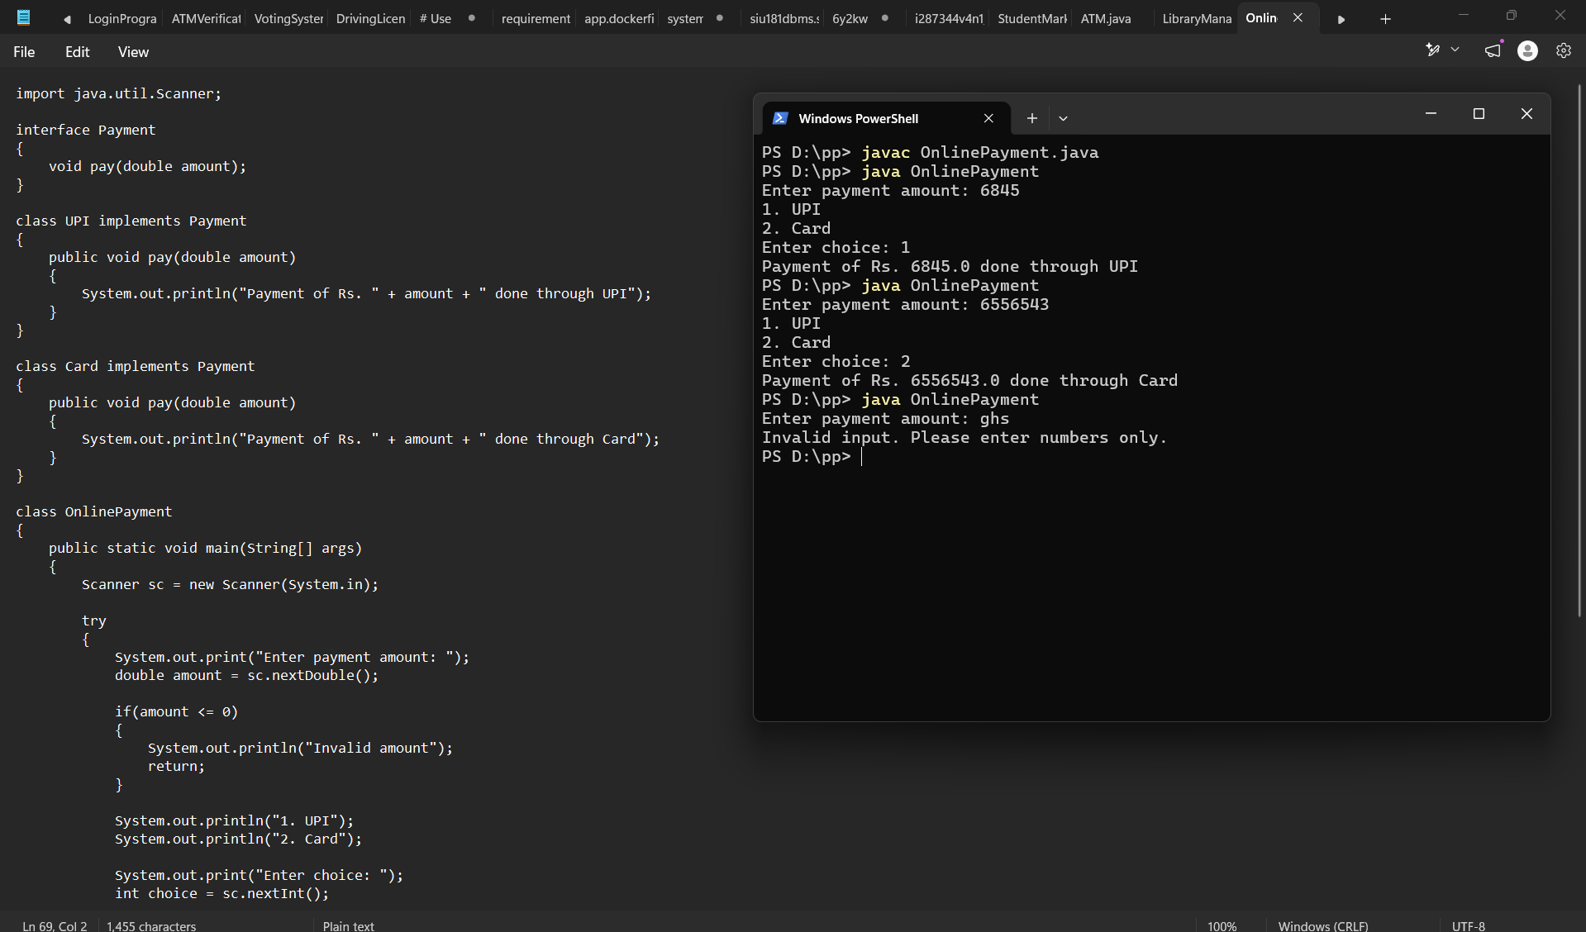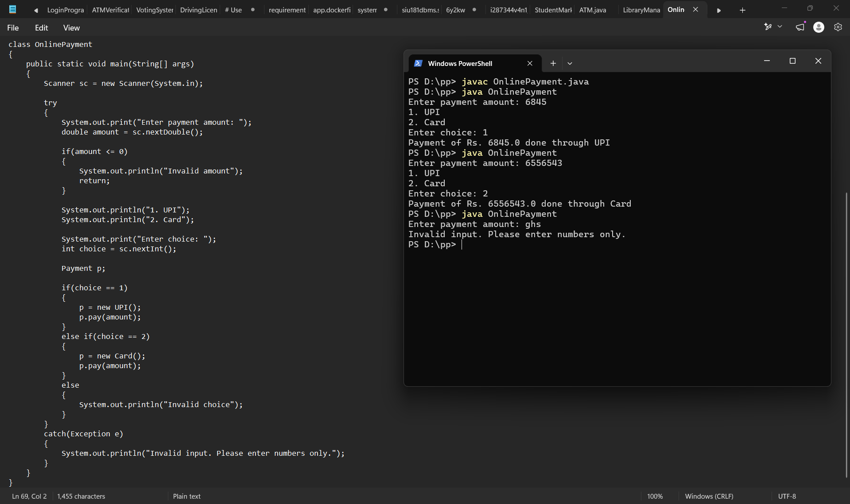

13. Explanation of Code
Interface
interface Payment
{
void pay(double amount);
}
Payment is an interface.
It defines a common pay() method.

UPI Class
class UPI implements Payment
The UPI class implements the Payment interface.
It provides its own implementation of:
public void pay(double amount)

Card Class
class Card implements Payment
The Card class also implements the same interface.
However, its implementation represents card payment.

Payment Reference
Payment p;
Here, p is a reference of the interface type.
It can refer to different objects.
For example:
p = new UPI();
or:
p = new Card();
This is where polymorphism is demonstrated.

Calling the Method
p.pay(amount);
The pay() method that gets executed depends on the object stored in p.
If:
p = new UPI();
UPI's pay() method executes.
If:
p = new Card();
Card's pay() method executes.

15. Why This Is Band 4
This program specifically demonstrates the Band 4 requirement of:
Polymorphism and interfaces
The structure is:
Payment Interface
|
---------------------
| |
UPI Card
| |
pay() pay()
\ /
\ /
Payment p
|
pay()
The same interface reference:
Payment p;
can refer to different objects.
Therefore, the behavior of:
p.pay(amount);
changes depending on the object.
That's runtime polymorphism.

16. Difference Between Band 3 and Band 4
This is important for your viva.
Band 3
Uses:
- Classes
- Objects
- Constructors
- Collections
- Exception handling
- Class relationships
Example:
Library → Book → ArrayList
Band 4
Adds more advanced OOP concepts:
- Interfaces
- Polymorphism
- Multiple implementations of the same operation
- Multi-step validation
Example:
Payment
↓
UPI / Card
↓
Different implementation of pay()
So Band 4 should demonstrate how the same common structure can produce different behavior.

17. Conclusion
The Online Payment System successfully demonstrates the use of interfaces and runtime polymorphism in Java. A common Payment interface is implemented by different payment classes such as UPI and Card. The same interface reference can be used to call different implementations of the pay() method. The program also performs basic validation of the payment amount and user choice.

BAND 5 – ADVANCED
Difficulty

Case Study: Student Database Management System
Problem Statement
Develop a Java program that connects to a MySQL database and allows the user to insert and display student records. The program should use JDBC for database connectivity and handle database-related exceptions.

1. Aim
To develop a Java application that connects with a MySQL database using JDBC and performs basic database operations such as inserting and displaying student records.

2. Theory
JDBC
JDBC stands for Java Database Connectivity.
It is a Java API that allows a Java program to communicate with a database.
Using JDBC, Java can:
- Connect to a database
- Insert data
- Update data
- Delete data
- Retrieve data
- Execute SQL queries
The basic flow is:
Java Program
↓
JDBC
↓
MySQL
↓
Database

3. Why JDBC is Used
Normally, Java variables exist only while the program is running.
For example:
int roll = 101;
Once the program ends, that data is lost.
A database provides persistent storage.
So:
Java variable
↓
temporary data
↓
program ends
↓
data lost
whereas:
Java Program
↓
JDBC
↓
MySQL Database
↓
data remains stored
This is called persistent storage.

4. Important JDBC Components
1. DriverManager
DriverManager is used to establish a connection with the database.
Connection con = DriverManager.getConnection(url, user, password);

2. Connection
The Connection object represents the connection between Java and MySQL.
Connection con;

3. PreparedStatement
PreparedStatement is used to execute SQL statements.
Example:
PreparedStatement ps =
con.prepareStatement("INSERT INTO student VALUES (?, ?)");
The ? symbols are placeholders for values.

4. ResultSet
ResultSet stores the data returned by a SELECT query.
Example:
ResultSet rs = ps.executeQuery();

5. Database Setup
Before running the Java program, create the database in MySQL.
Step 1: Create database
CREATE DATABASE college;
Step 2: Select database
USE college;
Step 3: Create table
CREATE TABLE student
(
roll INT PRIMARY KEY,
name VARCHAR(50)
);

6. Algorithm
- Start the program.
- Create a MySQL database.
- Create a student table.
- Import JDBC classes.
- Establish a connection between Java and MySQL.
- Accept student roll number and name.
- Insert the student details into the database.
- Execute a SELECT query.
- Display all student records.
- Handle database exceptions.
- Close the connection.
- Stop the program.

7. Easy Java Code
Important: You need the MySQL Connector/J .jar file in your Java classpath for this program.
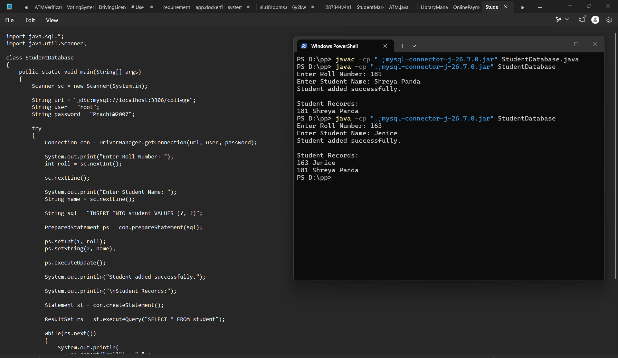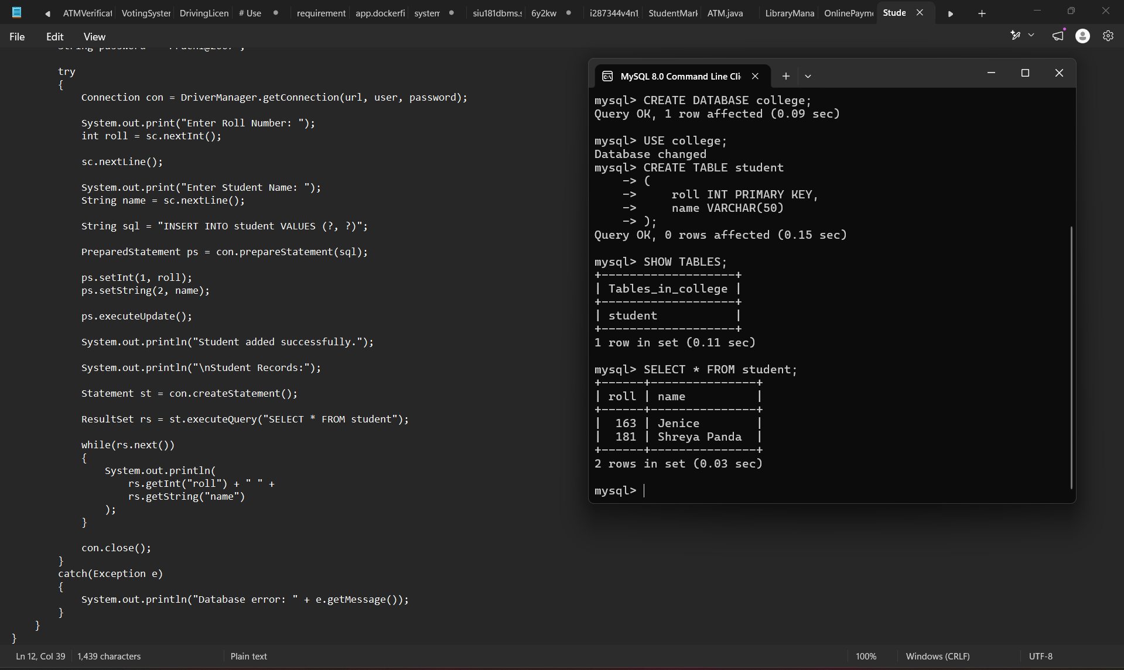

9. Explanation of Important Code
Import JDBC
import java.sql.*;
This imports JDBC classes such as:
- Connection
- DriverManager
- PreparedStatement
- Statement
- ResultSet

Database URL
String url = "jdbc:mysql://localhost:3306/college";
This tells Java where the MySQL database is located.
Breakdown:
jdbc:mysql://localhost:3306/college
↓ ↓ ↓ ↓
JDBC MySQL Port Database

Establish Connection
Connection con =
DriverManager.getConnection(url, user, password);
This establishes a connection between Java and MySQL.

SQL Query
String sql = "INSERT INTO student VALUES (?, ?)";
This SQL query inserts a student into the table.
The ? symbols are placeholders.

PreparedStatement
PreparedStatement ps = con.prepareStatement(sql);
It prepares the SQL query for execution.

Set Values
ps.setInt(1, roll);
ps.setString(2, name);
The first ? receives the roll number.
The second ? receives the student name.

Execute Insert
ps.executeUpdate();
This executes the INSERT query.

Retrieve Data
ResultSet rs = st.executeQuery("SELECT * FROM student");
This retrieves all student records from the database.

Display Records
while(rs.next())
The loop moves through each record.
Then:
rs.getInt("roll")
gets the roll number.
And:
rs.getString("name")
gets the student's name.

Exception Handling
catch(Exception e)
{
System.out.println("Database error: " + e.getMessage());
}
If a database or Java error occurs, the program displays an error message instead of abruptly stopping.

11. Why This Is Band 5
This program satisfies the Advanced Band 5 requirement because it uses:
Persistent Storage
Student data is stored in a MySQL database instead of temporary Java variables.
JDBC
Java communicates directly with MySQL using JDBC.
Exception Handling
Database errors are handled using try-catch.
The overall structure is:
User
↓
Java Program
↓
JDBC
↓
MySQL
↓
Student Table
This is significantly more advanced than the previous bands.

12. Difference Between All Five Bands
This is a very useful viva question.
Band | Main Concept
Band 1 | Basic input, output, variables, conditions
Band 2 | Basic concepts + validation
Band 3 | Classes, objects, collections, exceptions
Band 4 | Interfaces, polymorphism, multi-step validation
Band 5 | JDBC, persistent storage, advanced exception handling
You can remember it as:
B1 → Basics
B2 → Validation
B3 → OOP + Collections
B4 → Interface + Polymorphism
B5 → Database + Persistence

13. Conclusion
The Student Database Management System successfully connects a Java application with a MySQL database using JDBC. The program accepts student information, stores it permanently in the database, and retrieves the stored records using SQL queries. It demonstrates JDBC, persistent storage, database connectivity, SQL operations, and exception handling, making it suitable for the Advanced Band 5 level.

