1. Aim
To develop a Java program using a StudentResult class to accept student details and marks in three subjects, calculate the total and average marks, and determine the pass/fail status using separate methods.
2. Theory
Java is an object-oriented programming language that supports classes, objects, methods, variables, and conditional statements.
In this program, the StudentResult class stores the student's name, roll number, and marks in three subjects. An object of this class is created to access its data and methods.
- Variables: Store the student's details and subject marks.
- Methods: calculateTotal() calculates the sum of three subject marks, calculateAverage() calculates the average, and determineResult() checks whether the student has passed or failed.
- Conditional statements: The if-else statement checks whether the student has scored at least 40 marks in every subject.
- Scanner class: Accepts student details and marks from the user through the keyboard.
The program displays the student's name, roll number, total marks, average marks, and final result.
3. Algorithm
- Start the program.
- Import the Scanner class.
- Create a class named StudentResult.
- Declare variables for the student's name, roll number, and three subject marks.
- Define the calculateTotal() method to calculate the total marks.
- Define the calculateAverage() method to calculate the average marks.
- Define the determineResult() method to check whether all subject marks are at least 40.
- If all three subject marks are at least 40, return Pass; otherwise, return Fail.
- Accept the student's details and marks from the user.
- Display the student's details, total marks, average marks, and result.
- Stop the program.
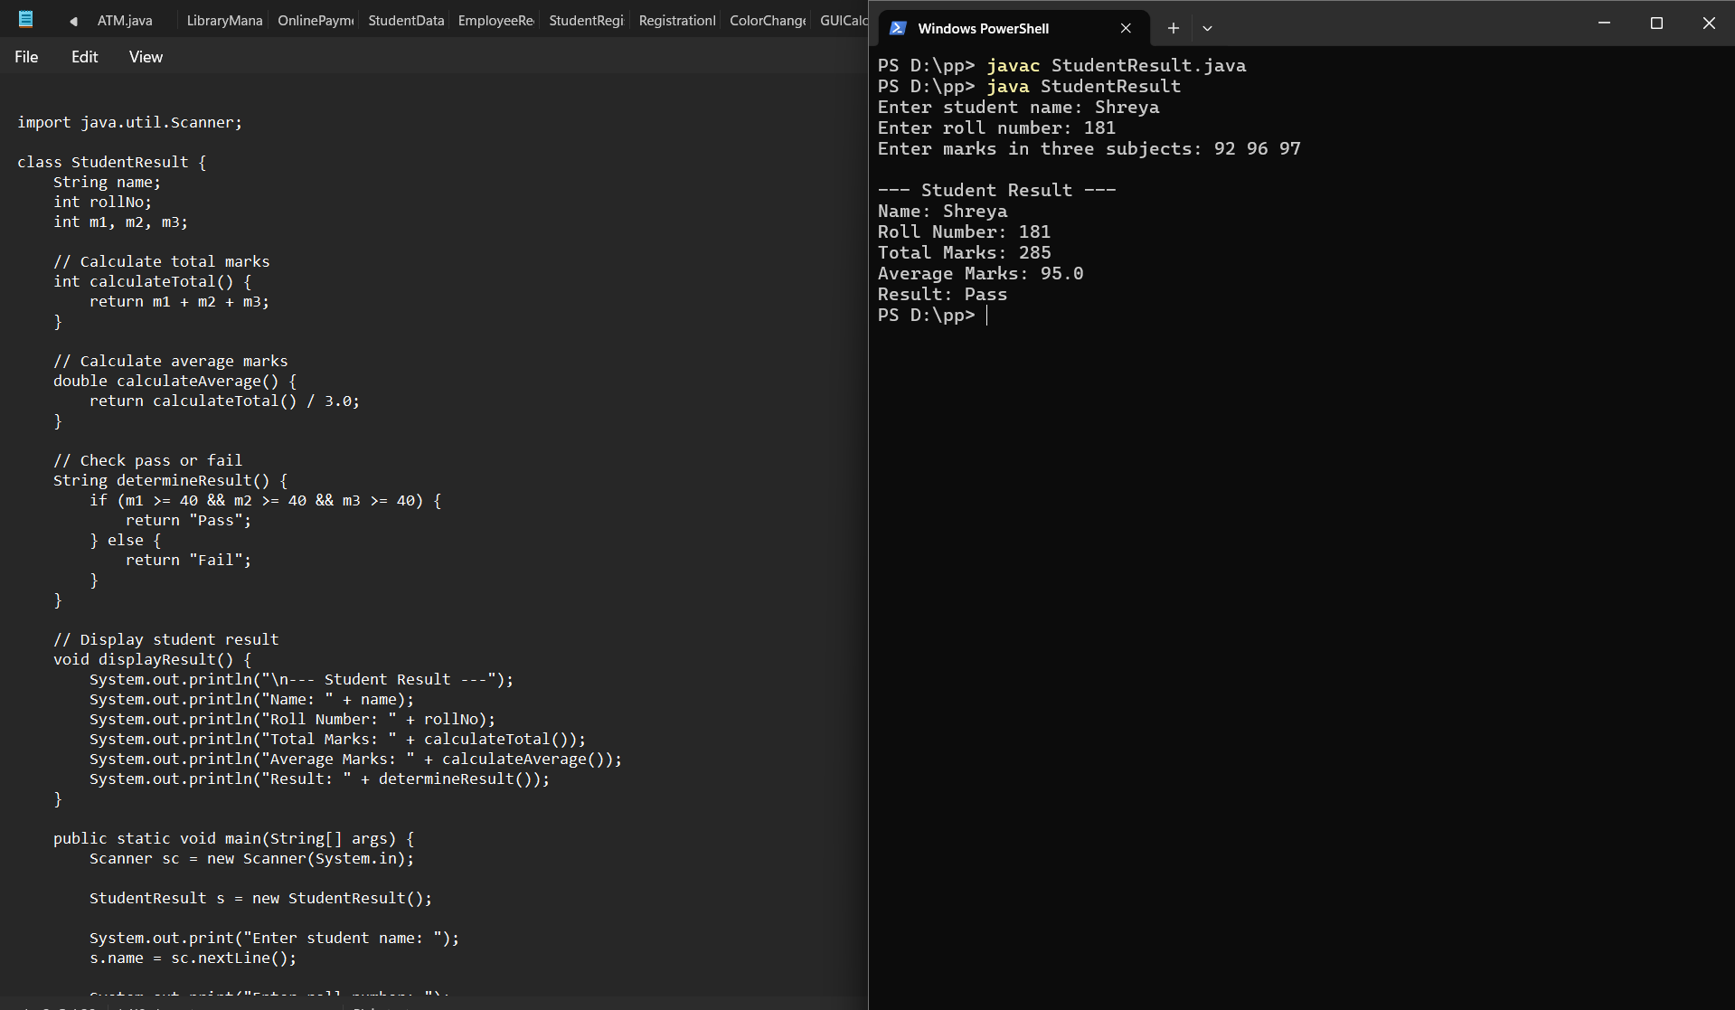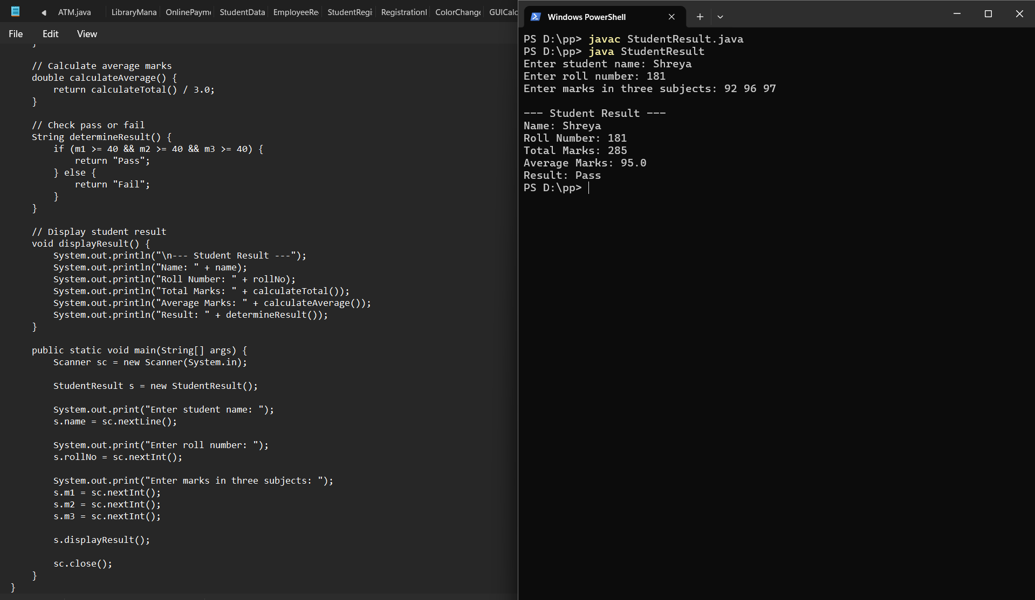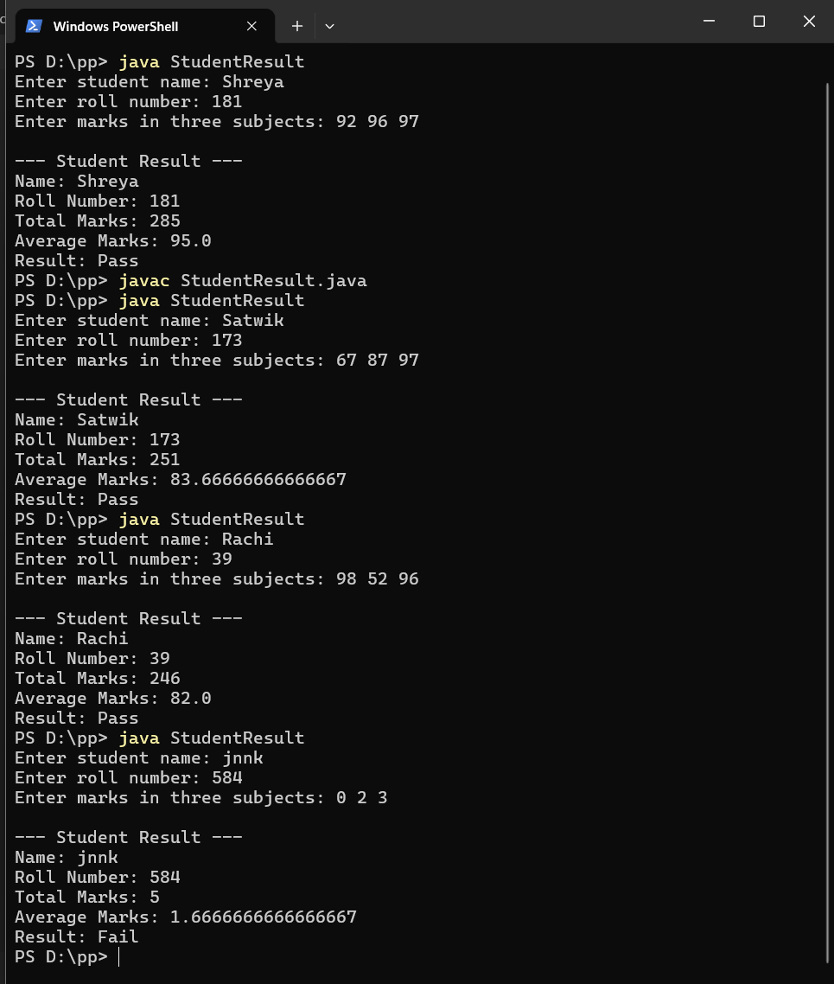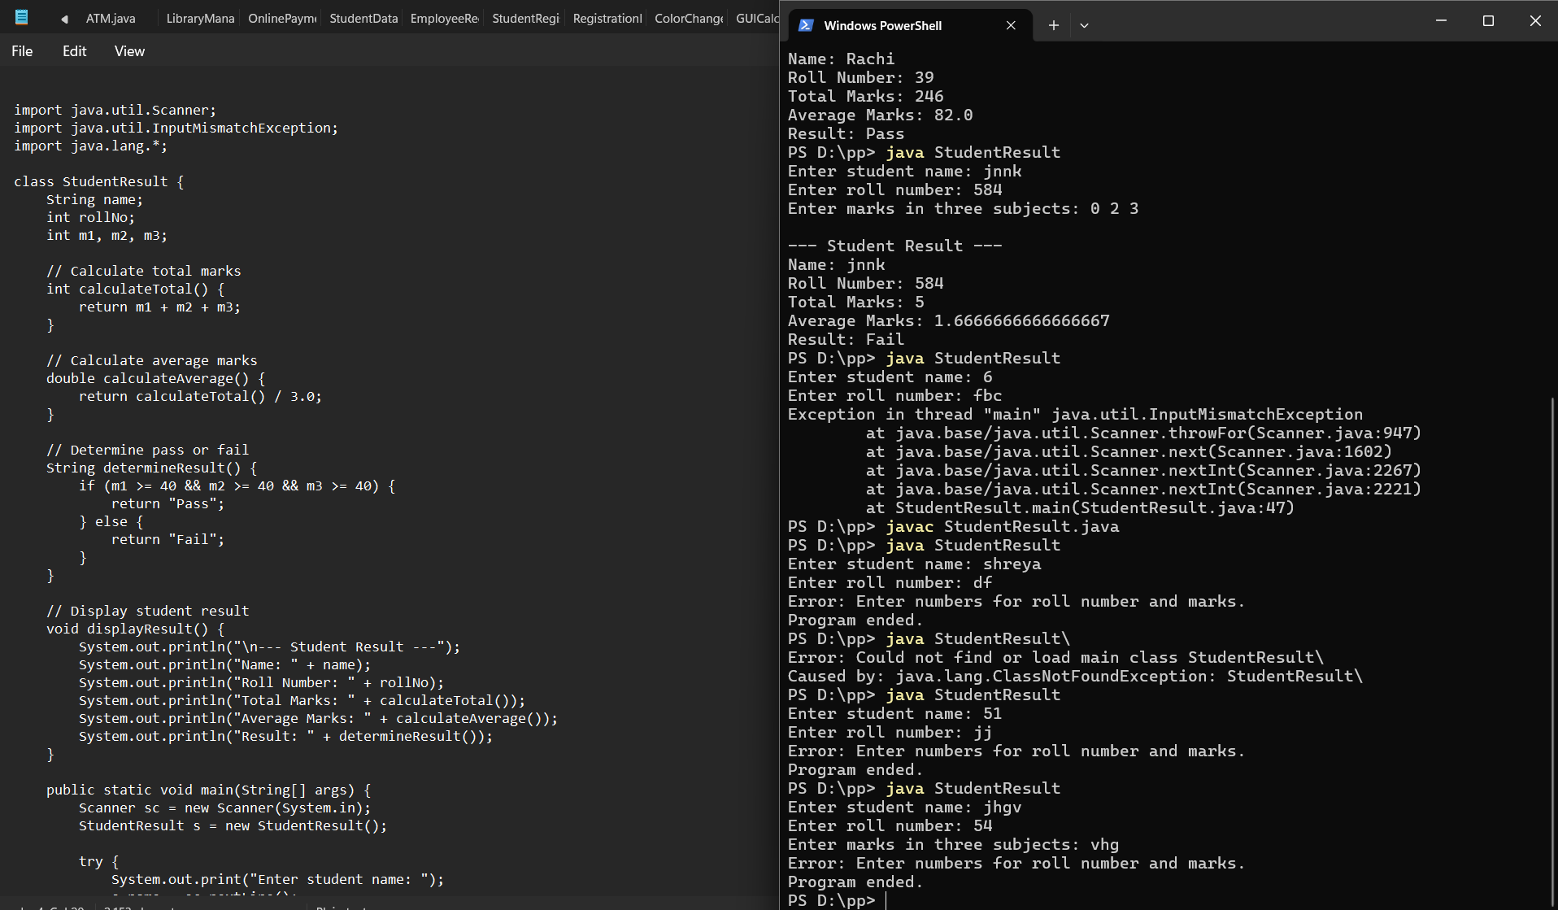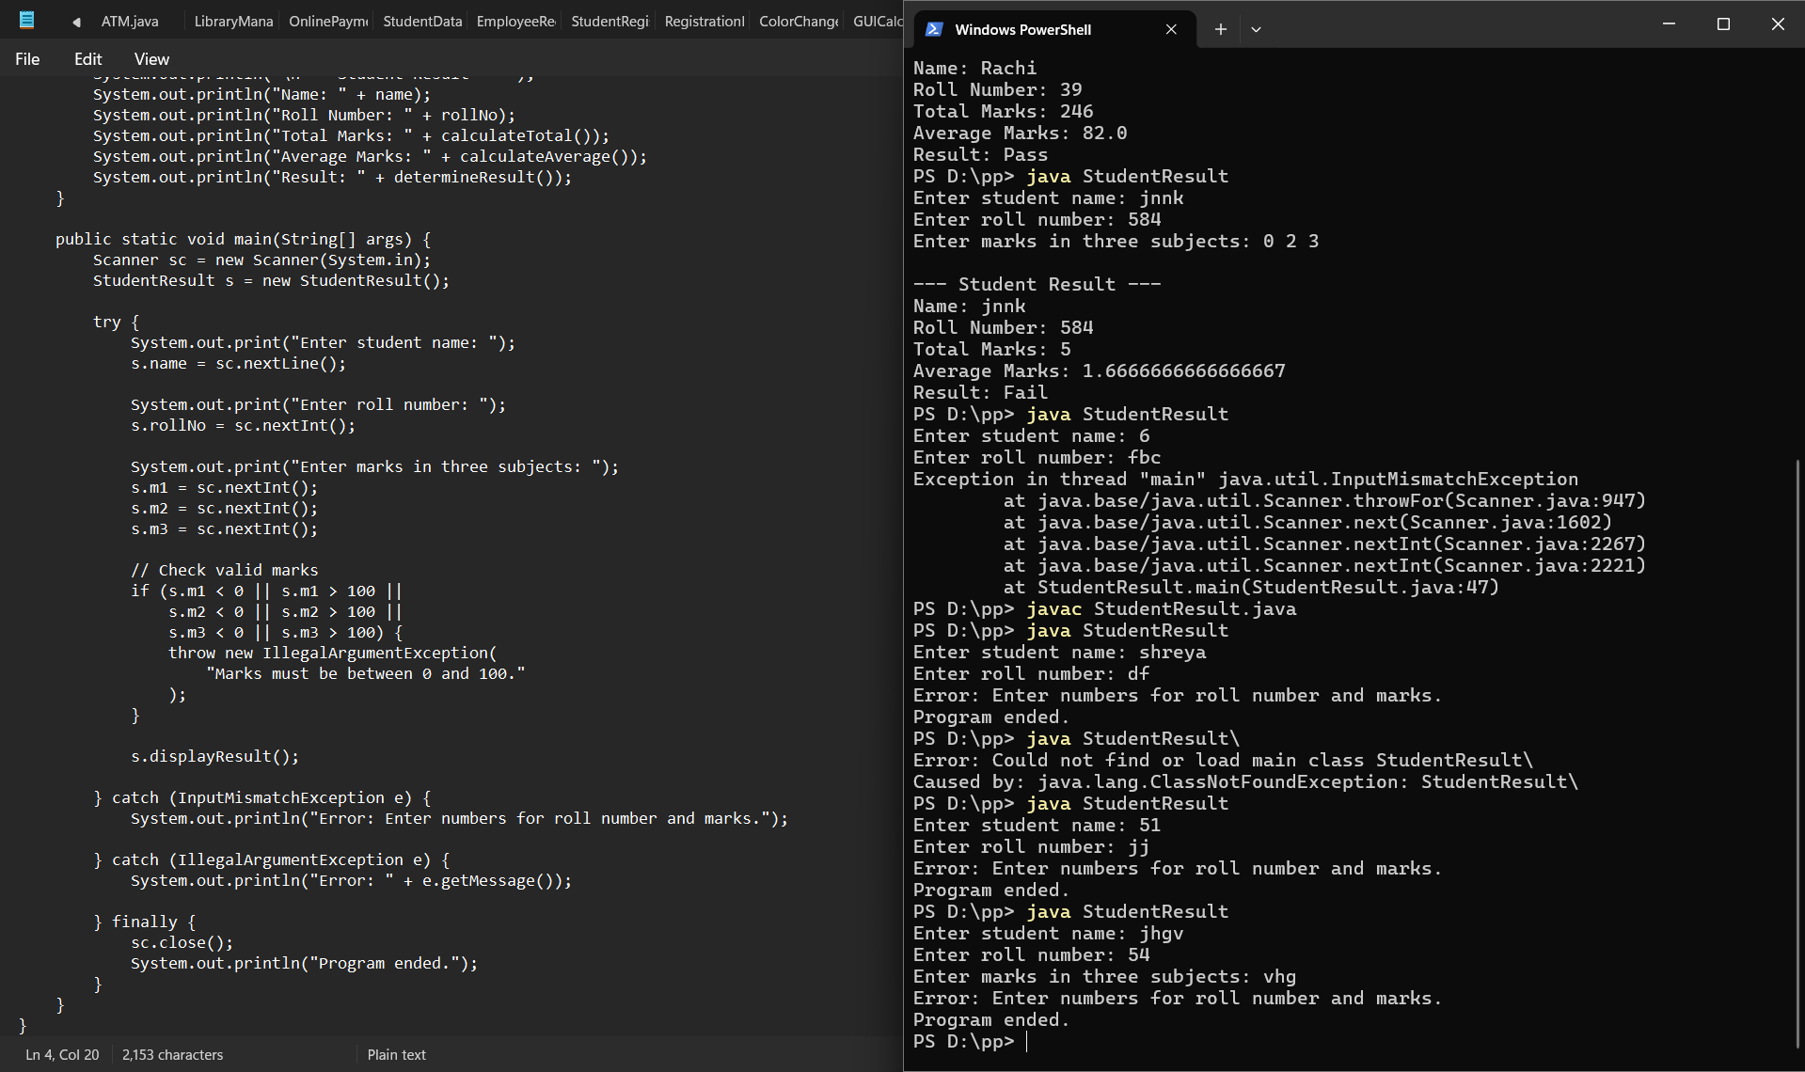4. Outcome
The Java program was successfully implemented to accept student details, calculate total and average marks, and determine the student's pass/fail status using separate methods and conditional statements.

5. Conclusion
This experiment helped in understanding the basic concepts of Java programming, including classes, objects, variables, methods, user input, arithmetic operations, and conditional statements. The program demonstrated how separate methods can be used to perform different calculations and determine a student's result. It also provided practical experience in accepting input through the Scanner class and displaying formatted output. Thus, the program successfully performs student marks calculation and pass/fail evaluation.

