Pragyan Edusec LLP

A Report on
“Overthewire Labs”

Bachelor of Engineering in
Computer Science and Engineering

Submitted By:
Shreya Singh Chauhan
USN: 3PD22CS102
College: PDA College of Engineering, Kalaburgi

INDEX

Sl. No | Content | Page No.
1 | Introduction to Overthewire | 3
2 | Introduction to SSH | 3
3 | Commands Used Every Level  And there learning & outcomes
 | Bandit level 0 – 1 | 4
 | Bandit level 1 – 2 | 4
 | Bandit level 2 – 3 | 5
 | Bandit level 3 – 4 | 6
 | Bandit level 4 – 5 | 6
 | Bandit level 5 – 6 | 7
 | Bandit level 6 – 7 | 7
 | Bandit level 7 – 8 | 8
 | Bandit level 8 – 9 | 9
 | Bandit level 9 – 10 | 10
 | Bandit level 10 – 11 | 11
 | Bandit level 11 – 12 | 12
4 | Conclusion | 13

INTRODUCTION
OverTheWire is a wargame platform designed to teach security concepts through hands-on practice. The "Bandit" series is specifically tailored for beginners to learn the Linux command line (CLI). The objective of each level is to find a hidden password on the server to log into the next level, utilizing various Linux tools, file permissions, and data manipulation techniques.
Secure Shell (SSH) is a cryptographic network protocol that provides a secure way to access a remote computer over an unsecured network. It encrypts the session, ensuring that passwords and data transmitted between the client (your Kali Linux machine) and the server (Bandit Labs) cannot be intercepted in plain text.
- Port: 2220 (Standard for Bandit Labs).
- Connection: Established via the terminal using the ssh command followed by the username and host address
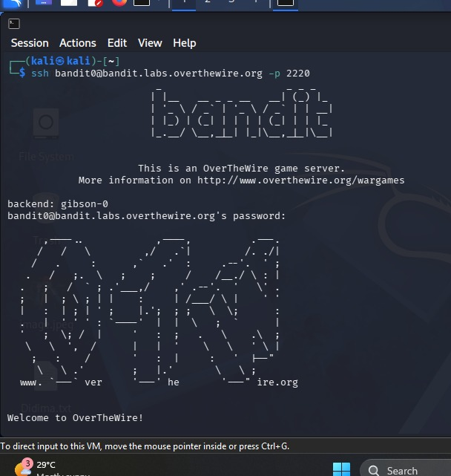
- The password is bandit0
COMMANDS & EXPLANATION

Bandit Level 0-1
- Introduction: The goal is to find the password stored in a file named readme located in the home directory.
- Command and Explanation: cat readme : The cat command reads the file and prints its content to the terminal.
- Learning & Outcomes: Learned the basic usage of the cat command to read file contents and familiarized myself with the standard home directory structure in Linux.

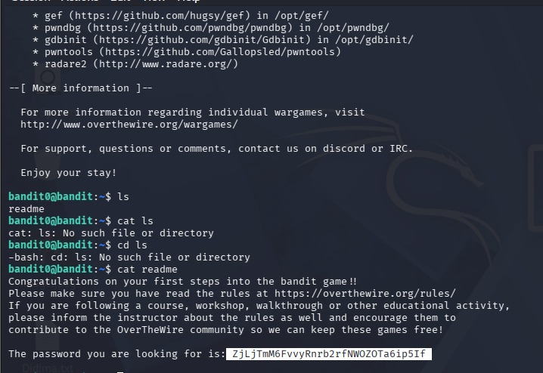
Bandit Level 1-2
- Introduction: The password is in a file named -, which is a special character in Linux.
- Command and Explanation: cat ./- Using ./- specifies the path, preventing the system from misinterpreting the hyphen as a command flag
- Learning & Outcomes: Understood how to reference files with special characters and learned that using absolute or relative paths can bypass shell misinterpretations of filenames.
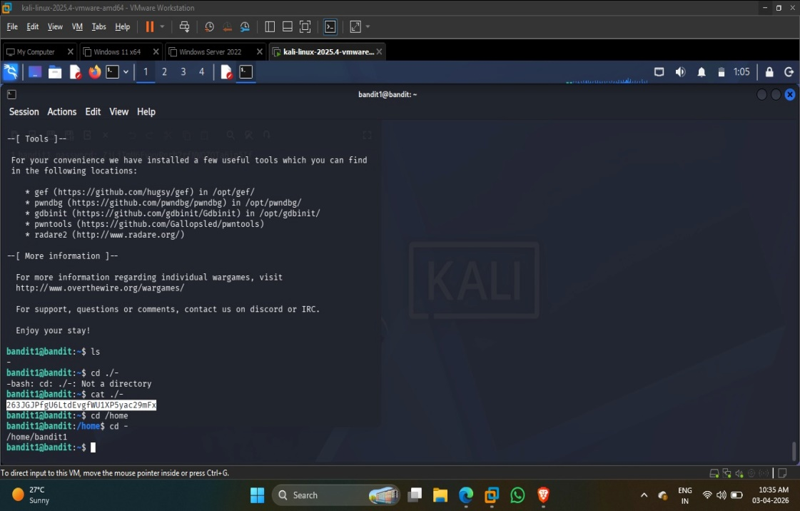
Bandit Level 2 -3
- Introduction: The goal is to retrieve the password from a file named spaces in this filename located in the home directory.
- Command & Explanation:
- ls: Lists the files to identify the target name.
- cat ./"spaces in this filename": Since the filename contains spaces, it must be enclosed in quotes or escaped. Using ./ explicitly points to the file in the current directory.
- Learning & Outcomes: Learned how to handle whitespace in filenames using quoting (or escaping with backslashes). This is a critical skill for managing non-standard file structures.

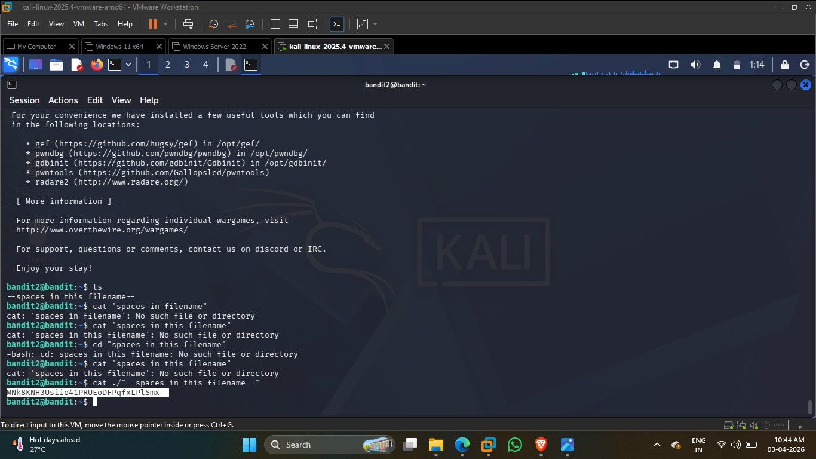

Bandit Level 3 - 4
- Introduction: The password is hidden in a file within the inhere directory.
- Command & Explanation:
  - cd inhere: Navigates into the target directory.
  - ls -la: Normal ls shows nothing; the -a flag is required to reveal hidden files (those starting with a dot).
  - cat ...Hiding-From-You: Reads the content of the hidden file discovered.
- learning & Outcomes: Mastered the identification of hidden system files and learned that standard ls commands do not show all directory contents by default
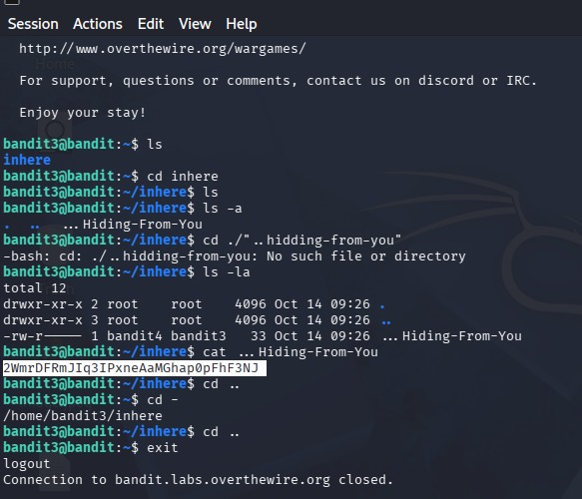

Bandit Level 4 - 5
- Introduction: The password is in the only human-readable file in the inhere directory.
- Command & Explanation:
  - file ./*: This command is used to determine the file type of every item in the directory.
  - cat ./-file07: After file identified -file07 as "ASCII text" (human-readable), I accessed it using this command.
- Learning & Outcomes: Learned to use the file command to distinguish between binary data and human-readable text, which is essential when filenames do not have extensions.
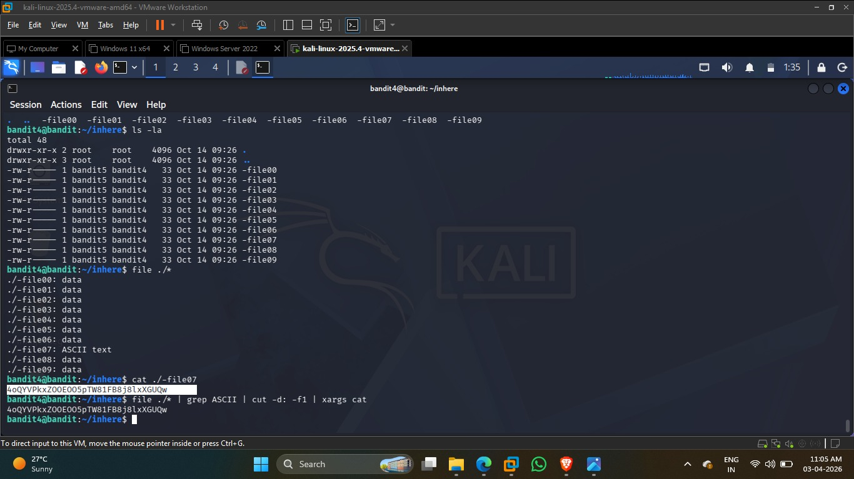

Bandit Level 5 -6
- Introduction: The password is in a file under the inhere directory that is human-readable, 1033 bytes in size, and not executable.
- Command & Explanation:
  - find inhere/ -type f -size 1033c ! -executable -exec cat {} +: Used the find command with specific flags (-size for 1033 bytes and ! -executable to exclude scripts/binaries) to isolate the one file that met all criteria.
- Learning & Outcomes: Mastered advanced file searching techniques. I learned how to filter the file system based on metadata rather than just filenames.
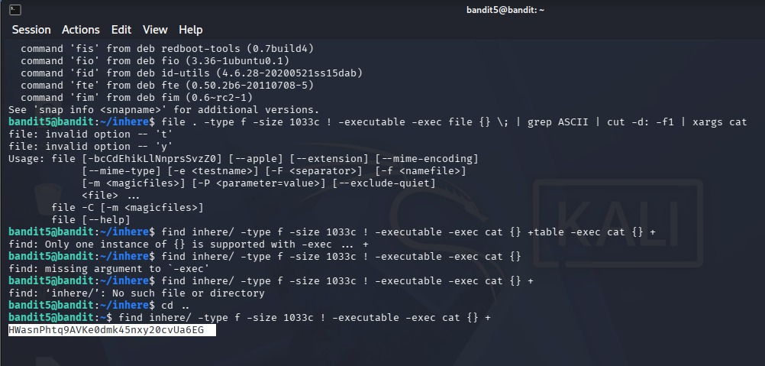

Bandit Level 6 – 7
- Introduction: The password is stored somewhere on the server and has specific properties: owned by user bandit7, owned by group bandit6, and is 33 bytes in size.
- Command & Explanation:
- cat /var/lib/dpkg/info/bandit7.password: Following a system-wide search for those specific ownership parameters, the file was located in the system package information directory.
- Learning & Outcomes: Understood how to search across the entire root file system. I learned that sensitive information can sometimes be found in system logs or package metadata files (/var/lib/...).
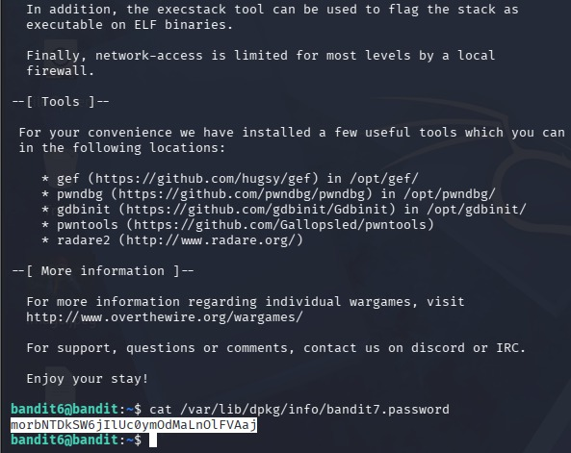

Bandit Level 7 - 8
- Introduction: The goal of this level is to find the password hidden within a large file named data.txt. The password is specifically located next to the word "millionth".
- Command & Explanation: du -b data.txt: Used this command to check the actual size of the file in bytes (4,184,396 bytes), confirming it is far too large to read manually.
  - cat data.txt | grep millionth: Piped the content of the file into the grep utility, which acts as a filter to extract only the line containing the specific string "millionth".
- learning & Outcomes: Understood the power of the grep (Global Regular Expression Print) command for pattern matching and information retrieval within high-volume log or data file
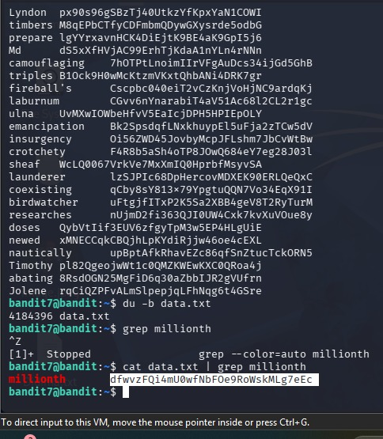

Bandit Level 8 - 9
- Introduction: The objective of this level is to find the password in a file named data.txt. The password is the only line of text that occurs exactly once within the file, while all other lines are repeated multiple times.
- Command & Explanation: ls -a: Used to list all files in the home directory, including hidden ones, to confirm the location of data.txt.
  - cat data.txt | sort | uniq -u:
  - cat data.txt reads the entire file.
  - sort organizes the lines alphabetically because the uniq command only identifies duplicate lines if they are adjacent (next to each other)
  - uniq -u filters the sorted output to display only the "unique" line that does not have any duplicates.
- learning & Outcomes: Learned how to use the strings utility to perform forensics on binary files that otherwise appear as "garbage" text in the terminal. Understood how to narrow down specific data within a noisy output using pattern matching.
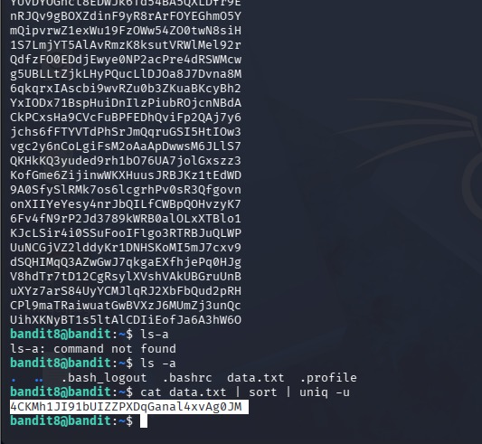
Bandit Level 9 – 10
Introduction: The password for this level is stored in a file named data.txt. However, the file is a binary file, making it unreadable with standard text commands. The password is hidden among several strings of text that start with multiple equal signs (=).
Command & Explanation: strings data.txt | grep ===: The strings command is used to extract human-readable sequences of characters from the binary file.
- This output was then piped into grep === to filter and display only the lines containing multiple equal signs, which led to the discovery of the password.
Learning & Outcomes: Learned how to use the strings utility to perform forensics on binary files that otherwise appear as "garbage" text in the terminal. Understood how to narrow down specific data within a noisy output using pattern matching
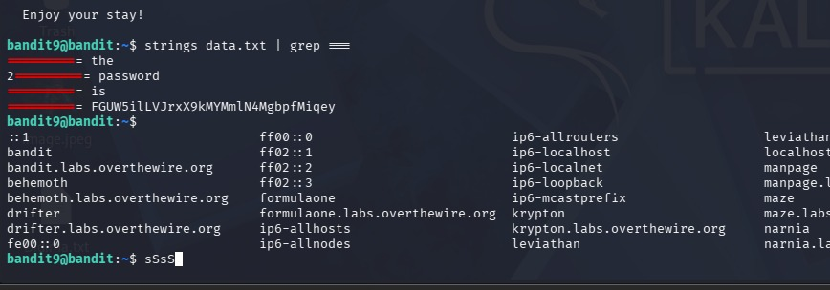

Bandit Level 10 - 11
- Introduction: The password for this level is stored in data.txt, which contains data that has been Base64 encoded. Base64 is a common encoding scheme used to represent binary data in an ASCII string format.
- Command & Explanation: The encoded string VGhlIHBhc3N3b3JkIGlzIG... was identified in the file.
  - A Base64 decoding tool was used to revert the encoded string back into human-readable plain text
- learning & Outcomes: Gained practical experience in identifying and decoding Base64 strings. Learned to distinguish between encryption (which hides information) and encoding (which simply changes the data format)
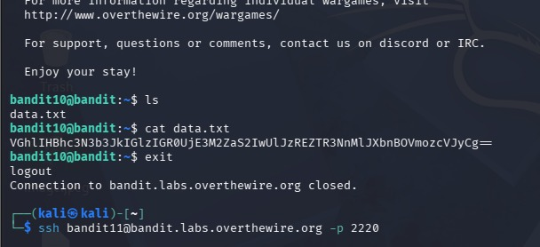

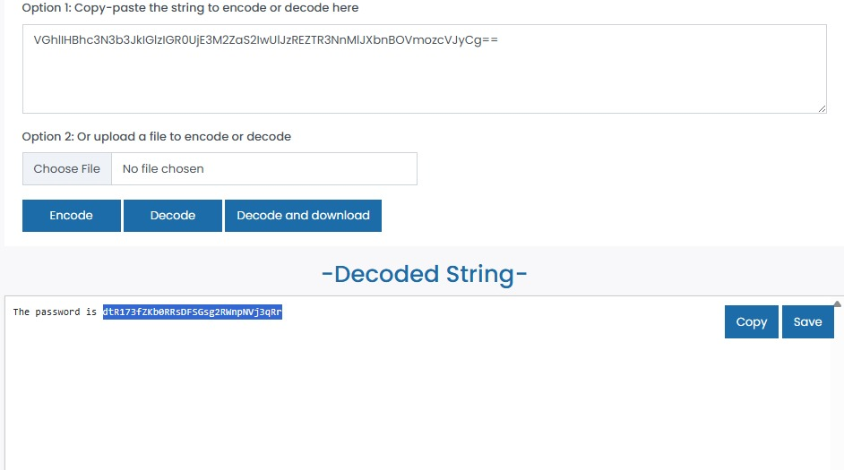

Bandit Level 11 - 12
- Introduction: The password for this level is stored in data.txt, where all lowercase (a-z) and uppercase (A-Z) letters have been rotated by 13 positions. This is a classic substitution cipher known as ROT13.
- Command & Explanation: cat data.txt: Displayed the obscured string "Gur cnffjbeq vf...".
  - To decrypt this, an external tool like CyberChef is used to shift the characters back by 13 places (e.g., A becomes N, B becomes O).
  - Exit: Logged out of the Bandit 11 session once the decoded password was obtained.
  - ssh bandit12@bandit.labs.overthewire.org -p 2220: Initiated the connection to the next level using the decrypted password
- Learning & Outcomes: Practiced identifying patterns that suggest ROT13 (e.g., "Gur" often translates to "The").
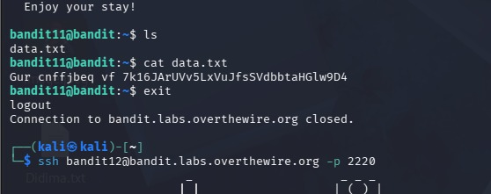

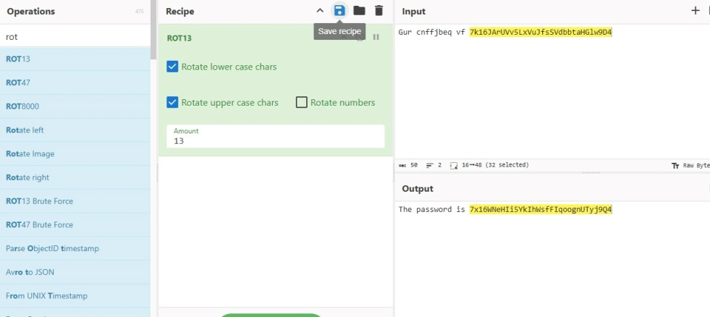

CONCLUSION
The completion of Bandit levels 0 through 11, as documented in the password log above, represents a significant milestone in my technical internship at Pragyan Edusec LLP. This project provided a practical, hands-on environment to apply theoretical concepts of Linux administration.
Throughout this lab series, I successfully transitioned from basic file system navigation to performing complex data extraction and cryptographic decoding. The key takeaways from this project include:
- Analytical Problem Solving: Developed a methodical approach to identifying hidden or obscured data by analyzing file metadata and system structures.
- Command-Line Efficiency: Mastered the use of advanced Linux utilities such as grep, find, strings, and uniq to manage high-volume data.
- Security Awareness: Gained exposure to common obfuscation methods, including Base64 encoding and ROT13 ciphers, reinforcing the importance of data integrity and protection.
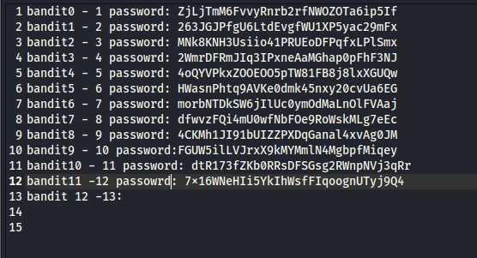

Bandit Level 12 → 13
- Introduction: The password is stored in a hex dump of a file that has been repeatedly compressed using different archival formats (gzip, bzip2, and tar).
- Command & Explanation:
  - mktemp -d: Created a temporary directory to work safely without affecting the root system.
  - xxd -r: Converted the original hex dump back into a binary file.
  - file: Used repeatedly to identify the compression type (e.g., "gzip compressed data" or "tar archive").
  - gzip -d, bzip2 -d, and tar -xf: Executed sequentially to peel back each layer of compression until the final plain-text file was revealed.
- Learnings & Outcomes:
  - Mastered the process of recursive decompression and hex-to-binary conversion.
  - Learned to rely on the file command rather than file extensions, as names can be misleading in a Linux environment.
- Conclusion: This level is a masterclass in data forensics. It demonstrates that information can be buried under multiple layers of obfuscation, requiring a disciplined, step-by-step approach to recover the original data.
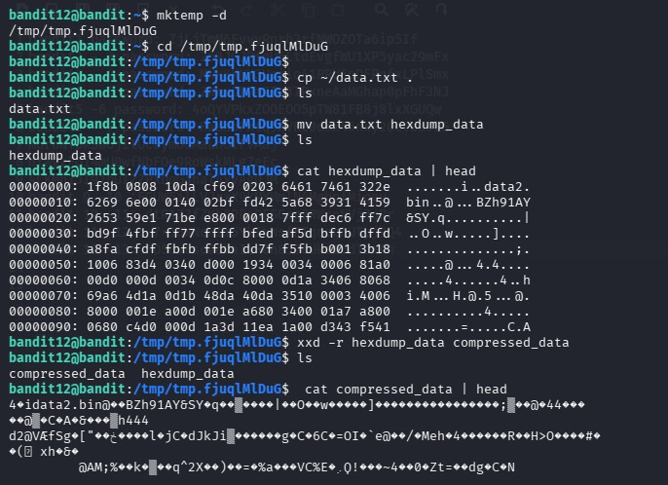
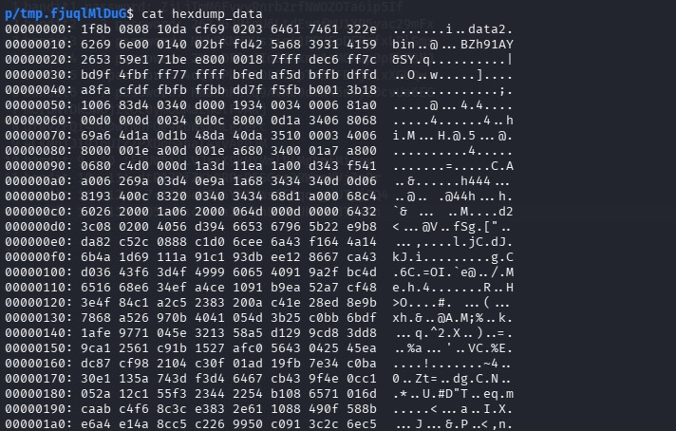

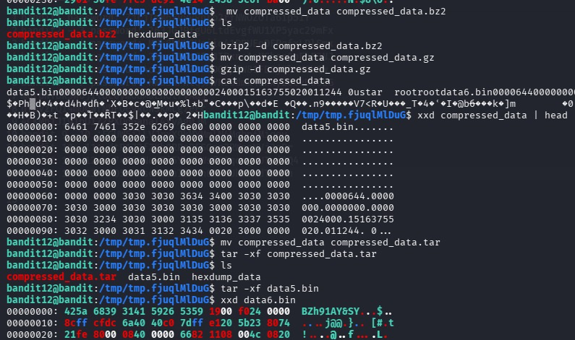

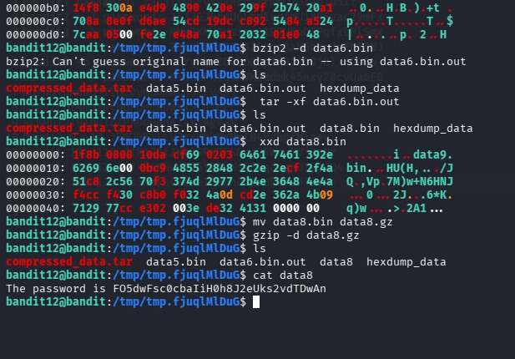

Bandit Level 13 → 14
- Introduction: The password for the next level is not in a file, but is obtainable by using a private SSH key stored in the home directory.
- Command & Explanation:
  - ssh -i sshkey.private bandit14@localhost -p 2220: Used the -i flag to specify the private key for authentication instead of a password.
  - chmod 600 sshkey.private: Adjusted file permissions to be "owner-read only." SSH clients will refuse to use a private key that is "too open" (readable by others) for security reasons.
- Learnings & Outcomes:
  - Understood Asymmetric Encryption basics and the role of private keys in automated or passwordless authentication.
  - Learned the critical importance of Linux file permissions (chmod) in protecting sensitive cryptographic assets

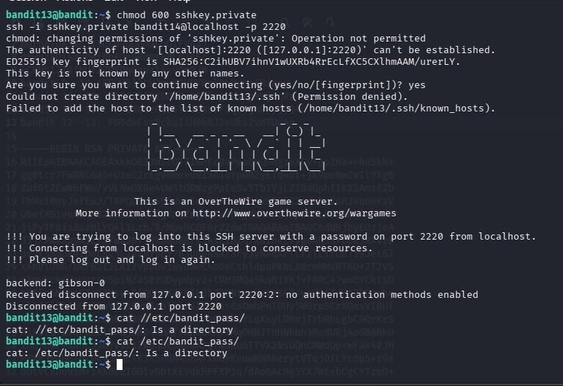

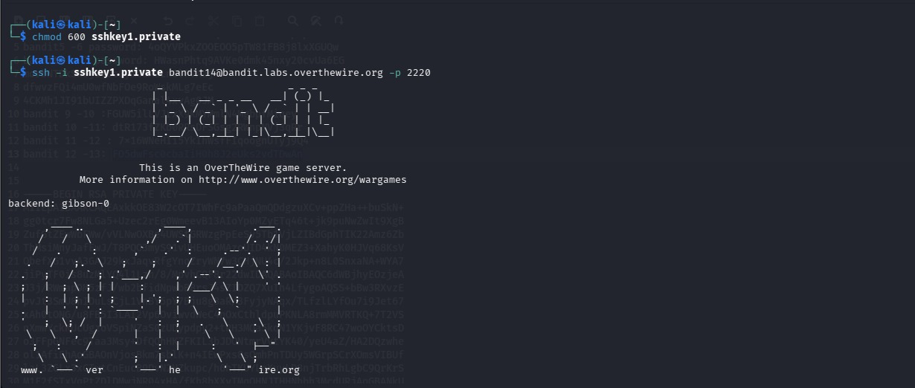

Bandit Level 14 → 15
- Introduction: The password for Level 15 is found by submitting the current level's password to a specific port on the local machine.
- Command & Explanation:
  - cat /etc/bandit_pass/bandit14: Retrieved the current password stored in a system directory.
  - nc localhost 30000: Used Netcat (or a similar tool) to connect to port 30000 and transmit the password string to receive the next level's credentials.
- Learnings & Outcomes:
  - Practiced Network Socket communication by connecting directly to a local service port.
  - Learned that services often use specific ports to listen for authenticated requests.

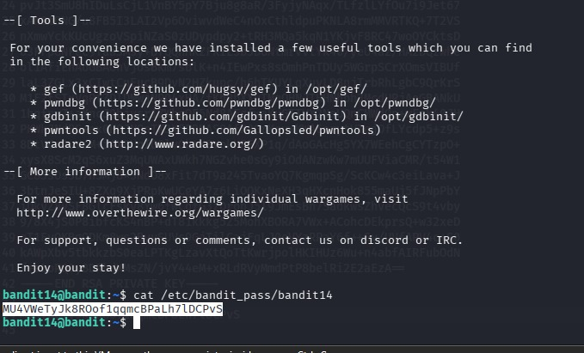

Bandit Level 15 → 16
- Introduction: Similar to the previous level, but the connection must be made using SSL/TLS encryption to a port that only accepts secure connections.
- Command & Explanation:
  - openssl s_client -connect localhost:30001 -quite: Used the OpenSSL client utility to establish a secure tunnel.
  - The -quite flag was used to suppress the detailed certificate information and focus on the data transmission.
  - The current password was submitted through this secure tunnel to unlock the next level.
- Learnings & Outcomes:
  - Learned the difference between plain-text connections and encrypted SSL/TLS sessions.
  - Practiced using openssl s_client for troubleshooting and interacting with secure services.
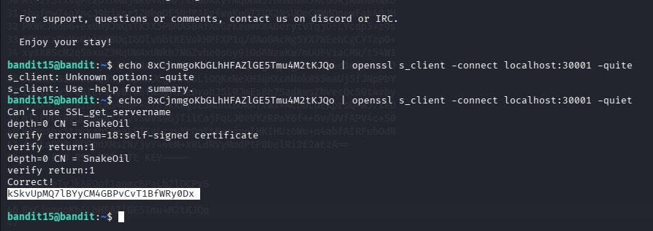

Bandit Level 16 → 17

Introduction
The goal of this level is to identify a specific service running on a range of ports (31000 to 32000). One of these ports is configured to listen for the current level's password and return a private SSH key that grants access to the next level. Unlike previous challenges, this level requires active network reconnaissance.

Command & Explanation
- nmap -p 31000-32000 localhost: Used the Network Mapper utility to scan for open ports. The scan identified several open services, including port 31790.
- openssl s_client -connect localhost:31790: Established a secure SSL/TLS connection to the target port. Upon submitting the current password, the server responded with an RSA Private Key.
- nano keeys: Copied the retrieved RSA key and saved it into a local file named keeys on the Kali Linux machine.
- chmod 400 keeys: Changed the file permissions to be readable only by the owner. This is a mandatory security requirement for SSH private keys; the SSH client will reject keys that are accessible by other users.
- ssh -i keeys bandit17@bandit.labs.overthewire.org -p 2220: Logged into the next level using the newly created identity file.

Learning & Outcomes
- Network Reconnaissance: Gained practical experience using nmap to discover active services and determine which ports are open for communication.
- Asymmetric Cryptography: Practiced handling RSA private keys and understanding their role in secure, passwordless authentication.
- Permission Hardening: Reinforced the critical importance of chmod settings when managing sensitive cryptographic assets in a Linux environment.
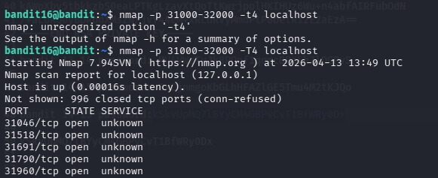

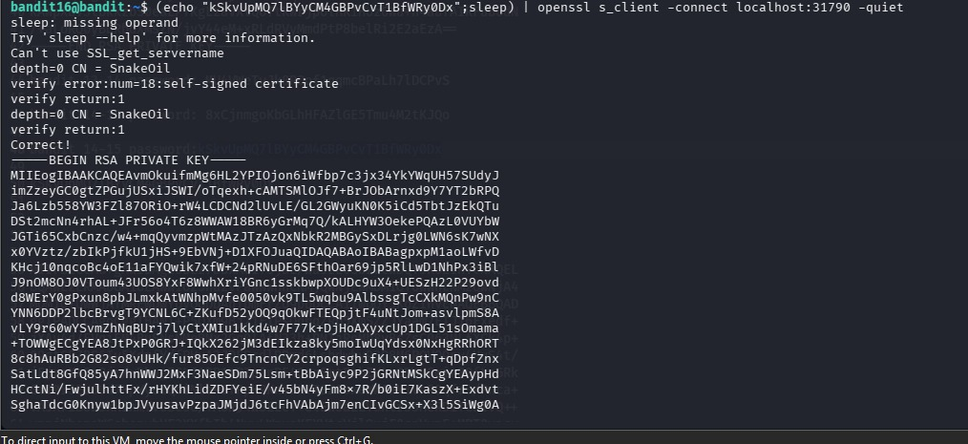

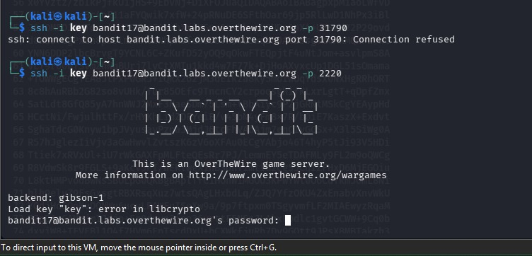
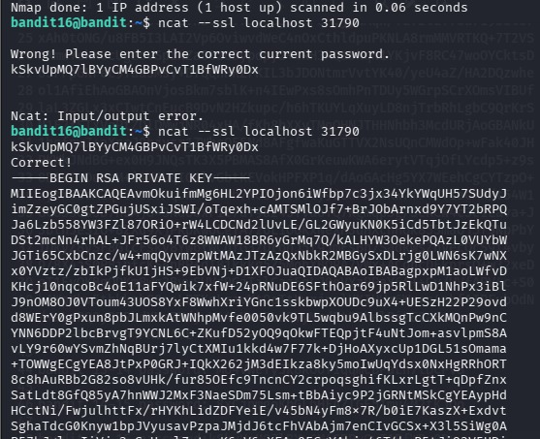

Bandit Level 17 → 18

Introduction
The objective of this level is to compare two files located in the home directory: passwords.old and passwords.new. The password for the next level is the only line that has been changed between these two versions. This task simulates a real-world scenario where a security analyst must identify unauthorized modifications or updates in configuration files.

Command & Explanation
- ls: Listed the directory contents to identify the two target files.
- diff passwords.new passwords.old: Used the diff utility to compare the files line by line. The output showed the specific differences between the new and old versions.
- diff passwords.old passwords.new | grep ">" | cut -d' ' -f2:
  - diff: Identified the change.
  - grep ">": Filtered for the line present in the new file (indicated by the > symbol).
  - cut -d' ' -f2: Cleaned the output to extract only the password string by removing the prefix symbols.

Learning & Outcomes
- File Comparison: Gained proficiency with the diff command, which is essential for identifying changes in code, logs, or system configurations.
- Data Parsing: Refined skills in chaining multiple text-processing tools (grep, cut) to isolate a specific piece of information from complex command output.
- Version Analysis: Understood the importance of maintaining "old" vs "new" records to track changes over time in a secure environment.
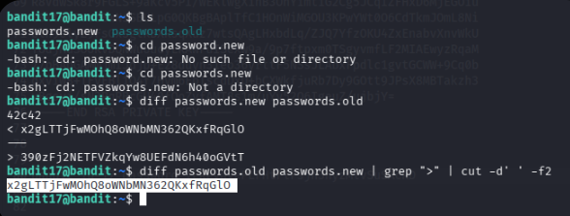

Bandit Level 18 → 19

Introduction
The objective of this level is to retrieve the password from a file named readme in the home directory of bandit18. However, the server has been configured to automatically log the user out as soon as an interactive SSH session is established. To solve this, a command must be executed directly through the SSH connection without entering the full interactive shell environment.

Command & Explanation
- ssh bandit18@bandit.labs.overthewire.org -p 2220 -t "bash --noprofile --norc":
  - -t: Forces pseudo-terminal allocation, which is necessary to execute interactive commands via SSH.
  - "bash --noprofile --norc": This command tells the server to start a bash shell while ignoring the initialization files (.profile or .bashrc) that contain the "logout" script.
- ls: Listed the files once the shell bypass was successful, confirming the presence of the readme file.
- cat readme: Displayed the content of the file to reveal the password for the next level.

Learning & Outcomes
- Shell Initialization Bypass: Learned how to bypass automated login/logout scripts by forcing the shell to ignore standard configuration files (--noprofile).
- Remote Command Execution: Practiced executing specific commands over SSH rather than relying on a standard interactive session.
- Terminal Allocation: Understood the use of the -t flag in SSH for handling interactive processes on remote hosts.
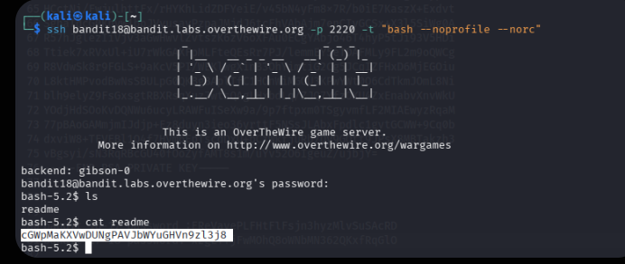

Bandit Level 19 → 20

Introduction
The goal of this level is to access the password for bandit20, which is stored in /etc/bandit_pass/bandit20. Ordinarily, a bandit19 user does not have permission to read this file. However, the home directory contains a special binary named bandit20-do. This binary has the SetUID bit enabled, allowing it to execute commands with the privileges of its owner (bandit20) rather than the user running it.

Command & Explanation
- ls -l: Used to examine the file permissions of bandit20-do. The output -rwsr-x--- is significant because of the 's' in the owner's execution field. This indicates the SetUID bit is set, and the file is owned by bandit20.
- ./bandit20-do whoami: A test command to verify the SetUID functionality. Although executed by bandit19, the output is bandit20, proving the binary successfully elevated privileges.
- ./bandit20-do cat /etc/bandit_pass/bandit20: This command uses the SetUID binary to execute cat on the protected password file. Because the binary runs with bandit20 privileges, it bypasses the standard permission restrictions and displays the password.

Learning & Outcomes
- SetUID Permissions: Learned how special Linux permissions can allow a user to temporarily assume the identity of another user to perform specific tasks.
- Privilege Escalation: Understood a legitimate method of privilege escalation provided by the system, as well as the security risks if such binaries are misconfigured.
- Binary Execution: Practiced passing arguments to a wrapper binary to perform restricted system actions.
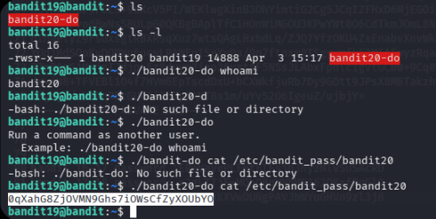

Bandit Level 20 → 21

Introduction
The objective of this level is to use a SetUID binary named suconnect to retrieve the password for Level 21. The binary works by connecting to a port specified by the user on the local machine. It expects to receive the password of the current level (bandit20) through that connection. If the password sent matches the server's record, it responds by sending back the password for the next level.

Command & Explanation
- nc -lvp 1234:
  - nc (Netcat): Initiated a listener on the local machine.
  - -l: Sets Netcat to "listen" mode.
  - -v: Enables verbose output to see connection details.
  - -p 1234: Specifies port 1234 as the listening port.
  - Once the listener was active, the current password for bandit20 was pasted into the terminal to be sent as soon as a connection was established.
- ./suconnect 1234: Executed in a separate terminal session (or sent to the background). This SetUID binary connected to the listener on port 1234.
- Verification: The suconnect binary read the password from the Netcat listener. Upon verifying it was "Correct," it transmitted the password for Level 21 back through the same connection.

Learning & Outcomes
- Network Listeners: Gained hands-on experience setting up local listeners using Netcat to intercept and transmit data between processes.
- Inter-Process Communication (IPC): Learned how different programs on the same system can communicate over network sockets.
- Binary Interaction: Practiced providing expected input to a binary through a network socket rather than direct standard input (stdin).
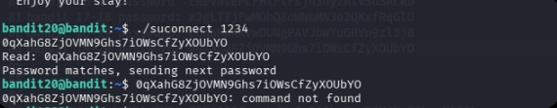

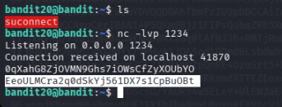

Bandit Level 21 → 22

Introduction
The objective of this level is to find the password for bandit22. The password is being generated or moved by a scheduled task known as a Cron job. These jobs run automatically at specified intervals or system events. To solve this, I had to investigate the configuration files for these scheduled tasks to understand where the password was being stored.

Command & Explanation
- ls /etc/cron.d: Listed the contents of the directory where system-wide cron jobs are defined. I identified a relevant configuration file named cronjob_bandit22.
- cat /etc/cron.d/cronjob_bandit22: Read the configuration file to see the scheduled command. It revealed that a script located at /usr/bin/cronjob_bandit22.sh runs every minute under the bandit22 user.
- cat /usr/bin/cronjob_bandit22.sh: Examined the actual shell script being executed. The script's logic showed that it copies the password from /etc/bandit_pass/bandit22 into a temporary file in the /tmp/ directory.
- cat /tmp/t706lds9S0Rqqh9aMcz6ShpAoZKF7fgv: Accessed the temporary file identified in the script to retrieve the password for the next level.

Learning & Outcomes
- Task Automation (Cron): Gained practical knowledge of the Linux Cron system, including how to read cron tables (crontab) and locate script files.
- Script Analysis: Practiced reading and interpreting bash scripts to follow the flow of data across the filesystem.
- Permission Logic: Observed how a script running with higher privileges can move protected data into a location accessible by a regular user.

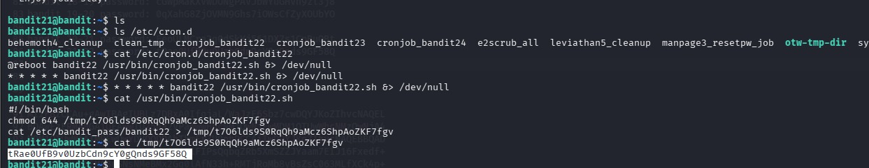

Bandit Level 22 → 23

Introduction
The objective of this level is to retrieve the password for bandit23. Like the previous level, a scheduled Cron job is responsible for moving the password, but this time the destination filename is generated dynamically based on the user's name. I had to reverse-engineer the script's logic to calculate the exact filename where bandit23’s password was being stored.

Command & Explanation
- ls /etc/cron.d: Confirmed the existence of a cron configuration for the next level: cronjob_bandit23.
- cat /etc/cron.d/cronjob_bandit23: Identified the script being executed: /usr/bin/cronjob_bandit23.sh.
- cat /usr/bin/cronjob_bandit23.sh: Analyzed the script logic. The script creates a target filename by taking the MD5 hash of a specific string: "I am user bandit23".
  - The core command in the script is: echo I am user $myname | md5sum | cut -d ' ' -f 1.
- echo "I am user bandit23" | md5sum: Replicated the script's logic manually to find the target filename. This resulted in the hash: 8ca319486bfbbc3663ea0fbe81326349.
- cat /tmp/8ca319486bfbbc3663ea0fbe81326349: Accessed the generated path in the /tmp directory to find the password.

Learning & Outcomes
- Dynamic Path Resolution: Learned how scripts can use variables and hashing algorithms to create dynamic or "hidden" file paths.
- MD5 Hashing: Gained experience using the md5sum utility to generate unique identifiers from text strings.
- Environmental Variables: Observed how the $myname variable (derived from whoami) controls the flow of a shared script.

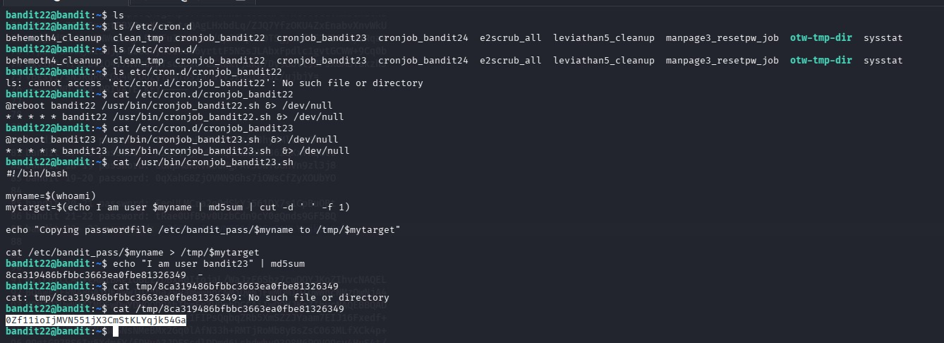

Bandit Level 23 → 24

Introduction
The objective of this level is to retrieve the password for bandit24. Investigation reveals a Cron job that executes all scripts found in the directory /var/spool/bandit24/foo. The system runs these scripts as the bandit24 user and deletes them immediately after execution. To solve this, I had to create a custom shell script that would use bandit24's privileges to copy the protected password file into a location where I could read it.

Command & Explanation
- cat /etc/cron.d/cronjob_bandit24: Identified the cron configuration, which points to a shell script at /usr/bin/cronjob_bandit24.sh.
- cat /usr/bin/cronjob_bandit24.sh: Analyzed the script logic. It uses a for loop to execute every file in /var/spool/bandit24/foo that is owned by the user who uploaded it.
- mkdir /tmp/ban_ & chmod 777 /tmp/ban_: Created a temporary workspace with full read/write/execute permissions so the automated process could write the output file there.
- nano /tmp/ban_/myscript.sh: Authored a malicious "payload" script. The script contained a simple command: cat /etc/bandit_pass/bandit24 > /tmp/ban_/password.txt.
- chmod +x /tmp/ban_/myscript.sh: Made the script executable.
- cp /tmp/ban_/myscript.sh /var/spool/bandit24/foo/: Copied the script into the "spool" directory. I then waited for the cron job to trigger (which happens every minute).
- cat /tmp/ban_/password.txt: Once the automated task executed my script, the password was written to my temporary file, allowing me to retrieve it.

Learning & Outcomes
- Automated Task Exploitation: Learned how to leverage system automation to perform tasks with higher-level privileges.
- Shell Scripting: Practiced writing functional bash scripts to automate the retrieval of protected data.
- Linux Permission Manipulation: Reinforced the importance of directory permissions (chmod 777) when coordinating data transfer between different user accounts.
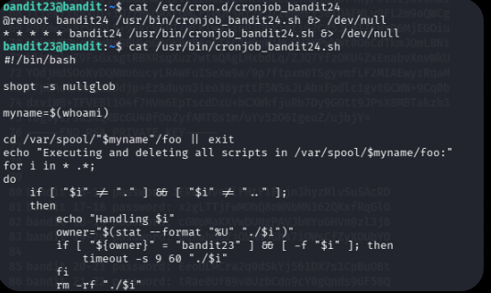
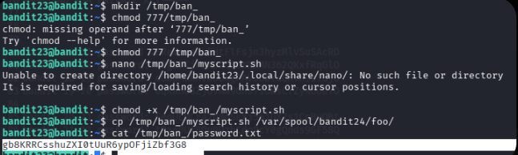

Bandit Level 24 → 25

Introduction
The objective of this level is to retrieve the password for bandit25. A service is running on port 30002 that requires the current level's password (bandit24) followed by a secret 4-digit PIN (0000-9999). Since the PIN is unknown, the only way to retrieve the password is to systematically try every possible combination from 0000 to 9999 until the correct one is accepted.

Command & Explanation
- mkdir /tmp/b_ans & chmod 777 /tmp/b_ans: Created a temporary directory to store the brute-force script.
- nano myscript.sh: Developed a bash script to automate the brute-force attack.
  - Script Logic: The script uses a for loop combined with seq -w 0000 9999 to generate all 10,000 possible PIN combinations.
  - Execution: For each PIN, it sends the string "bandit24_password PIN" to localhost on port 30002 using Netcat (nc).
  - Filtering: The output is piped through grep -v "Wrong" to hide all failed attempts and only display the successful response.
- chmod +x myscript.sh: Granted execution permissions to the script.
- ./myscript.sh: Executed the attack. The script cycled through the combinations until the service returned "Correct!" along with the password for the next level.

Learning & Outcomes
- Brute-Force Automation: Gained experience in automating repetitive security tasks using shell scripting to perform thousands of operations in seconds.
- Network Service Stress Testing: Observed how a network service handles a high volume of rapid connection requests.
- Sequencing and Padding: Learned to use the seq -w command to ensure the PINs were properly formatted with leading zeros (e.g., 0001 instead of 1).
