Iris Flower Species Classification Using Machine Learning and Flask

**Name**: Shreya Singh Chauhan  
**Internship**: Unified Mentor

**Date**: 26-07-2025

# Abstract

* This project focuses on classifying iris flowers into three species using machine learning.
* It uses sepal and petal features to predict species with high accuracy.
* A web interface built with Flask allows users to input values and get predictions instantly.

# Objective

* To build a machine learning model that classifies iris flowers into Setosa, Versicolor, or Virginica, and deploy it using a web application built with Flask.

# Tools and Technologies Used

- Python  
- Google Colab / Jupyter Notebook  
- scikit-learn  
- Flask  
- HTML, CSS, JavaScript  
- VS Code

# Dataset Description

The Iris dataset contains 150 samples of iris flowers with the following features:  
- SepalLengthCm  
- SepalWidthCm  
- PetalLengthCm  
- PetalWidthCm  
- Species (Setosa, Versicolor, Virginica)  
Source: UCI Machine Learning Repository

# Methodology and Implementation

## Data Exploration

Explored dataset using pair plots, box plots, and scatter plots. Petal features were most discriminative.

## Data Preprocessing

Encoded species labels, scaled features, and split data into training and testing sets.

## Model Training

Used K-Nearest Neighbors (KNN) classifier and achieved high accuracy.

## Web Deployment Using Flask

Developed a user-friendly web app with progressive input animation using Flask and HTML/CSS.

## Folder Structure

iris_flask_app/  
├── app.py  
├── model/  
├── templates/  
├── requirements.txt

# Results

* The model achieved high accuracy on test data.
* The web interface allows interactive predictions.
* Confusion matrix and classification report show the performance.
* Screenshots of the Web interface and predictions are included.

# Conclusion

The project successfully classified iris species with high accuracy using the KNN algorithm. It demonstrates the ability to integrate machine learning models into web applications using Flask.

# Future Scope

- Add user authentication to the web app  
- Use more advanced ML models  
- Deploy the app online (e.g., Render)  
- Collect real-time user input data

# References

- <https://scikit-learn.org/>  
- <https://flask.palletsprojects.com/>  
[- https://archive.ics.uci.edu/ml/datasets/iris](https://www.kaggle.com/datasets/himanshunakrani/iris-dataset)  
- <https://github.com/shreya293/internship-projects>

**Screenshots of Web App**

1. Initial View of the Web Application

The web app loads with a background image and a clean UI prompting the user to enter Sepal Length.

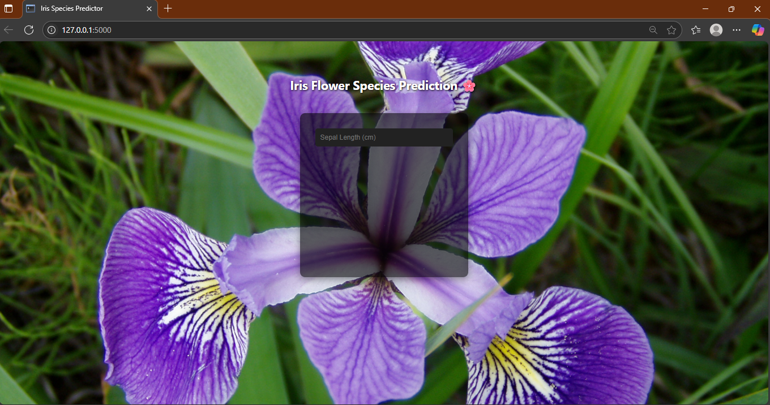

1. Inputs Entered by User

The user enters all required parameters — Sepal Length, Sepal Width, Petal Length, and Petal Width — before clicking on "Predict".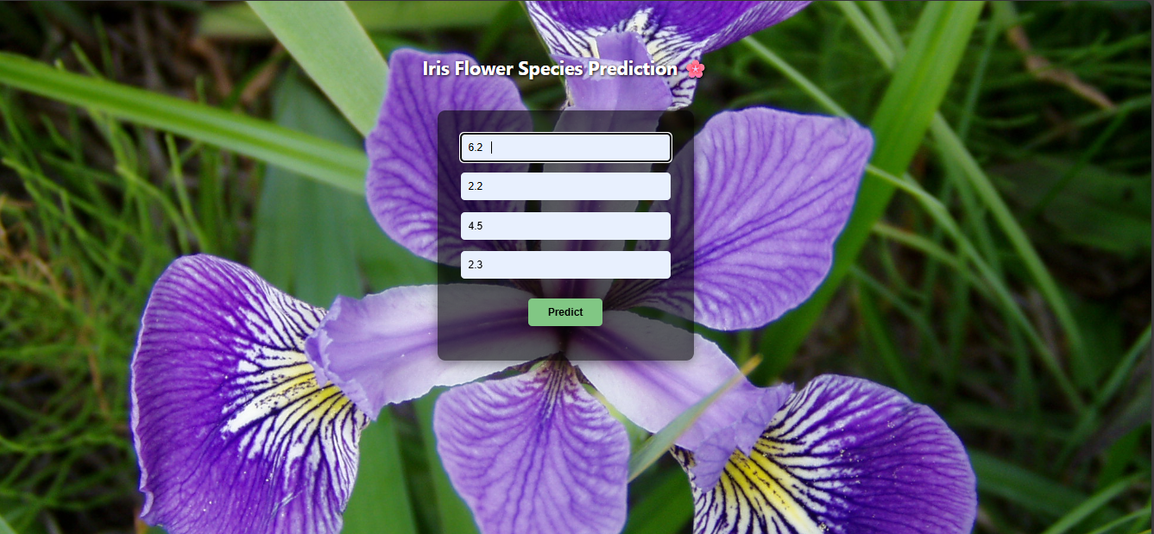

1. Predicted Output Displayed

The model predicts the species as "Iris-versicolor" and displays it below the input form.

