PRACTICAL-6

1)Task 1:Categorize the following prompts into types (Instructional, Conversational, Visual, etc.) and
explain your reasoning:
- 'Generate a logo for a tech startup using neon colors.'
- 'Explain blockchain to a 5-year-old.'
- 'You are a UX designer. Suggest improvements to this app layout.'

1."Generate a logo for a tech startup using neon colors."
Type: Visual (Creative/Design)
Reasoning: This prompt asks for a graphic or visual output—a logo—with specific style instructions (neon colors). It focuses on creation in the visual/design domain rather than purely text-based or conversational content.
2."Explain blockchain to a 5-year-old."
Type: Instructional / Educational
Reasoning: The prompt requires breaking down a complex concept (blockchain) into simple, understandable terms suitable for a young child. It’s about teaching/explaining, so it falls under instructional or educational content.
3."You are a UX designer. Suggest improvements to this app layout."
Type: Instructional / Analytical / Professional Advice
Reasoning: This prompt requests expert analysis and recommendations based on a professional role (UX designer). It involves critique and instruction on improving a design, blending analytical and advisory elements

2)TASK 2:Given vague prompts, refine them to be more effective. Example:
Original: 'Make a poster.' → Refined: 'Create a poster for a school science fair with a blue
background, cartoon robots, and bold text saying SCIENCE EXPO 2025.'

Original:
“Write a story.”
Refined:
“Write a short story for kids aged 8-10 about a brave squirrel who goes on an adventure to find a magical acorn in an enchanted forest.”

TASK 3: Prompt Design Exercise
Design 5 original prompts for different domains:
1. ChatGPT (text-based)
Prompt:
"Write a heartfelt letter from the perspective of a time traveler who has just returned to the present after 100 years in the future, describing what has changed and what stayed the same."

2. DALL·E (image-based)
Prompt:
"Create a surreal landscape showing a floating island made of giant, colorful crystals with waterfalls flowing into a starry night sky."
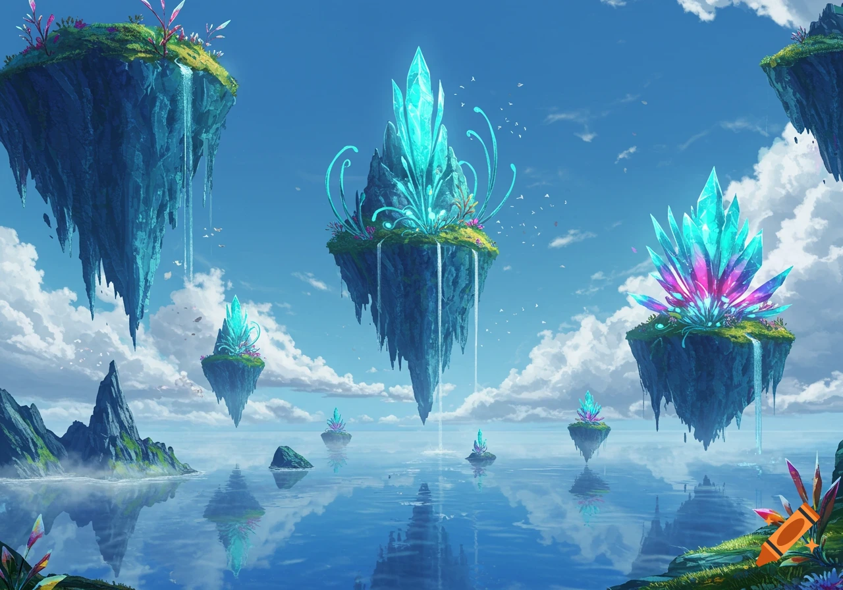

3. SORA (video-based)
Prompt:
"Produce a 30-second animated video showing the lifecycle of a butterfly, from egg to caterpillar, chrysalis, and finally a butterfly taking flight, with soothing background music."

4. Coding or Logic
Prompt:
"Write a Python function that takes a list of integers and returns the longest subsequence of consecutive numbers in ascending order."

5. Education or Training
Prompt:
"Develop an interactive lesson plan for middle school students explaining the water cycle, including a hands-on experiment, diagrams, and quiz questions to test understanding."

