# ****Apartment Management PHP Project with MySQL****

**Abstract**

Apartment Management system is web based PHP project which provides a way for Owners to register tenants in modern way rather than registering in registers. This project Apartment Management system is solution for Apartment Owners to manage the tenants in an easier and more convenient way. The administrator/Developer, is able to view all the owners of there building's apartment as well as their details. The basic structure of the system is as follows. This project manages the tenants and keeps the rent payment records. This system also maintains the tenants details.

**Introduction**

The main purpose of this project is to automate apartment management to manage the owners and tenants. It provides the way for tenants to make payment of Rent easily. and stores the tranaction records in a secure dataBase.

Existing system

* Filling of forms by tenants which Is not desirable as incorrect data can be entered by tenant.
* Payment records are managed by owner’s manually.
* Tracking is difficult with regards to due payment.

Proposed System

In the proposed system the developer who has created the apartments can allot the apartment to owner’s, which solves the problem of dual ownership as our system checks if owner is already allocated or not.

Owners can issue the apartment to tenant and can set the rent for it.

The Tenant can check the rent status and pay.

Advantages of proposed system:

The system proposed has many advantages.

1. The proposed system is highly secured, because for login the system it requires the username and password which is different for each.

2. It maintains records for all the apartments.

3. Manages rent of apartment.

4. Tracking the payment due is made easy.

System Modules:

The proposed project contains mainly three modules they are

* **Admin module**
* **Owner's Module**
* **Tenant Module**

1)Admin/Developer Module features:

* can add new buiding
* can add new apartment
* can add new owner
* can manage owners
* can manage apartment
* can View owners list respect to there apartments.
* can Update owners data
* can Delete owner
* can update the contact details dynamically
* can update password
* Apply for the Courier Service.
* View the current status His couriers.

**2)Owner's Module Features:**

* Owner Login
* Owner can Add Tenants
* Owner can update tenants details
* Owner can delete Tenants
* Owner can view Tenants

**3)Tenant Module Features::**

* Tenant Login.
* Can make payment.
* Can view previous Payments.

System Design :

**ER Diagram**

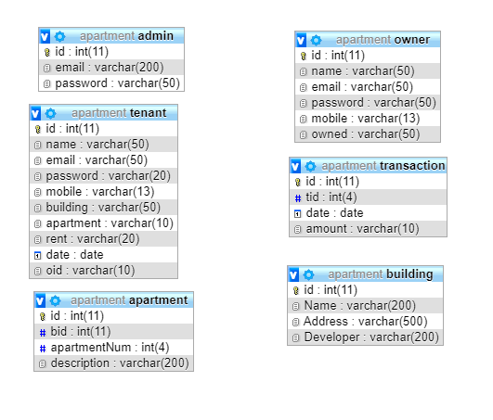

**System Requirements**

**Software Requirements:**

* Windows XP/7/8/10
* Browsers Chrome/Firefox/EDGE (For best view preferred browser is Chrome)
* Netbeans IDE 8.2(frontend)
* XAMPP for Apache and MySQL(backend)
* Internet Connectivity(must required)

**Hardware Requirements:**

* Hard Disk Drive(HDD) 10GB
* RAM 1GB
* Processor 1.2GHz

**Language Used**

HTML,CSS,Javascript,PHP(main functionality),MYSQL.

**NOTE:**

* In PhpMyAdmin create a database by name "apartment" then import database contents by clicking on Import- browse-local and select the .sql file provided with project.
* Internet connectivity is required to run this project.