Industry Clusters

Final Project for CS 591

Shreya Ramesh and Jia Yao

12/14/2016

Abstract

Within general industries, there are further details and specializations, which are crucial to candidates’ job searches. For example, within the all-encompassing title of “Software Development/IT,” there are details such as programming languages, frameworks, etc. which will highly influence a candidate’s employability and eligibility as well as the position’s attractiveness to a candidate. Using document clustering and analysis, this project will identify clusters within each industry, in the ten cities with the most job listings for that industry, based on job descriptions available on indeed.com.

Introduction

The motivation behind this project is to delineate areas within industries of high demand, in the cities that have the greatest demand for each industry. The results of this project will likely have applications in several areas including candidates’ decision-making to pursue certain specializations or certifications, analysis of which cities have a demand for certain sub-industries, and perhaps even identifying trends within industries to further understand the job-market.

The approach at a high level is to cluster each industry using TfidfVecotrizer, which is a tool provided by the Python library sklearn. This generates the top terms or clusters per industry, revealing the information initially desired through this project.

At a high level, the results show concrete areas of focus which definitely can be deemed useful and appropriate. For example, within the main industry title of “Accounting/Finance,” we found categories of “financial reporting analysis management monthly business finance budget internal annual” which is a specific area within this industry.

Techniques

The TfidfVectorizer which is used is based on term frequency, in conjunction with inverse document-frequency. This technique essentially transforms the document or text into a vector, and based on the vector clusters the words. The code used can be seen in the ipython notebook file Dataset-Analysis.ipynb, where the first component generates the Singular Value Decomposition (SVD) graphs for each of the industries. Through the SVD graphs, the number of principal components for each cluster is determined.

The second component of the analysis runs the k-means algorithms on the text vector. At a high level, the k-means algorithm moves the means of points until the given number of means (k) converge. The error graphs generated were used to determine the optimal number of clusters; the value chosen for this project should have an error of less than 70 on the graph.

For the final component, seen in the ipython notebook file Cluster-Analysis.ipynb, the principal components for each dataset are generated along with a visualization of a pie-char showing how the clusters make up the industry as a whole. These results can be viewed in the appendix.

Datasets

The dataset is generated as a result of information from Glassdoor’s API, and also includes more detailed content from indeed.com. In order to determine which cities’ data to scrape, the Glassdoor API provides the ability to pull the cities with the most jobs per industry. This information, of the top ten cities per industry, was stored in a CSV (comma separated values) file. For example, the top ten cities with job openings in the field of Software Development are New York, San Francisco, Washington DC, Chicago, Atlanta, Austin, San Jose, San Diego, Boston, and Santa Clara. A CSV file of all the industries’ top ten cities can be found in the appendix. The Python script, entitled cities.py, used to generate these CSV files can also be found in the appendix.

For each city in each industry, a search was run in indeed.com, and using web-scraping techniques, job descriptions from each city and industry combination were generated. These were also stored in CSV files. The Python script used to generate these files is entitled indeed-scraper.py.

Results and Discussion

The SVD graphs generated determine the number of principal components per cluster. The value of k for each industry is determined based on the error and silhouette score. For standardization, the number of clusters has to have an error less than 70. Below is an example of the error graphs used for the determination of k-values.

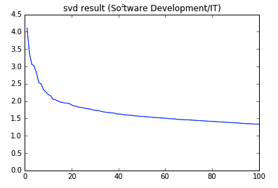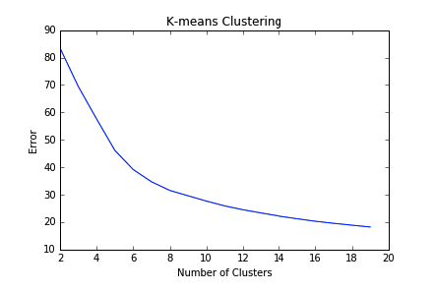

Based on this analysis, below are the values for number of principal components and number of clusters.

|  |  |  |
| --- | --- | --- |
| Industry | Number of Clusters | Number of Principal Components |
| Accounting/Finance | 18 | 15 |
| Administrative | 18 | 20 |
| Analyst | 9 | 5 |
| Architecture/Drafting | 13 | 15 |
| Art/Design/Entertainment | 18 | 10 |
| Banking/Loan/Insurance | 12 | 10 |
| Beauty/Wellness | 10 | 13 |
| Business Development/Consulting | 18 | 7 |
| Education | 18 | 5 |
| Facilities/General Labor | 10 | 5 |
| Hospitality | 18 | 10 |
| Human Resources | 18 | 7 |
| Installation/Maintenance Repairs | 18 | 5 |
| Legal | 14 | 5 |
| Manufacturing/Production/Construction | 18 | 10 |
| Marketing/Advertising/PR | 18 | 10 |
| Medical/Healthcare | 13 | 10 |
| Product/Project Management | 18 | 10 |
| Real Estate | 16 | 20 |
| Restaurant/Food Services | 18 | 15 |
| Retail | 18 | 10 |
| Science/Research | 10 | 15 |
| Security/Law Enforcement | 6 | 10 |
| Senior Management | 2 | 7 |
| Skilled Trade | 2 | 7 |
| Software Development | 5 | 10 |
| Sports/Fitness | 7 | 7 |
| Travel/Transportation | 6 | 7 |
| Writing/Editing/Publishing | 6 | 7 |

Using the sklearn.cluster library, KMeans analysis is used to generate the principal components for each industry, and a corresponding pie chart using the matplotlib.pyplot library. The pie charts indicate that for each percentage, that percentage of jobs belong to a cluster that is dominated by jobs with that label. Below are a few examples of results.

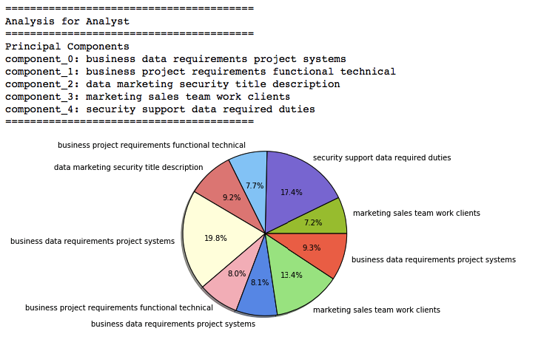

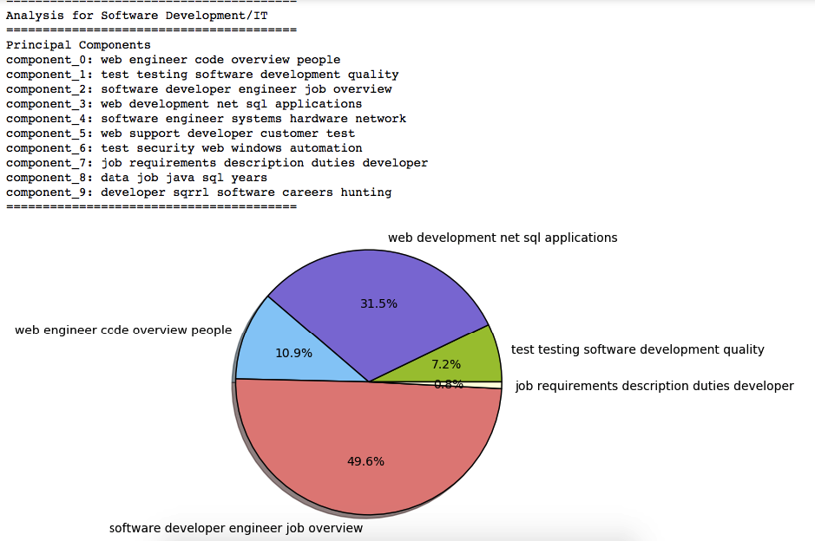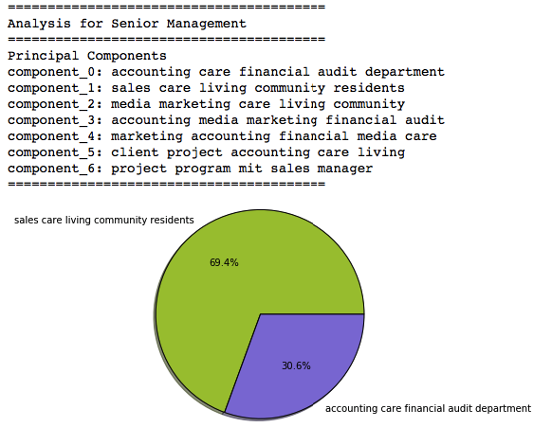

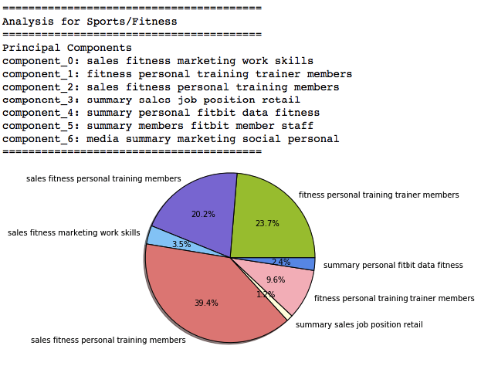

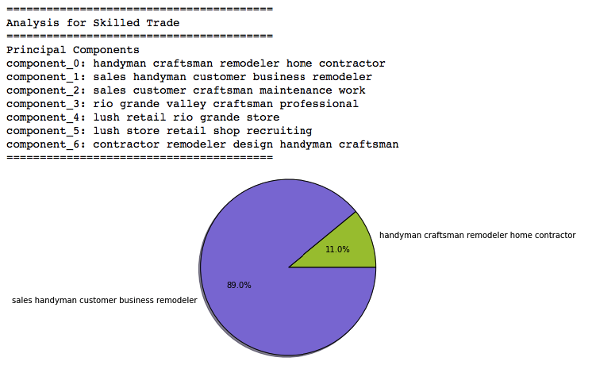

========================================

Analysis for Medical/Healthcare

========================================

Principal Components

component_0: business sales management client development

component_1: looking license 00 time brookdale

component_2: care brookdale health home clinical

component_3: billing coding claims summary collections

component_4: brookdale billing residents insurance associates

component_5: care health billing home healthcare

component_6: summary patient patients position equipment

component_7: brookdale clinical patient patients practice

component_8: laboratory patient clinical patients research

component_9: office clinical data research study

========================================

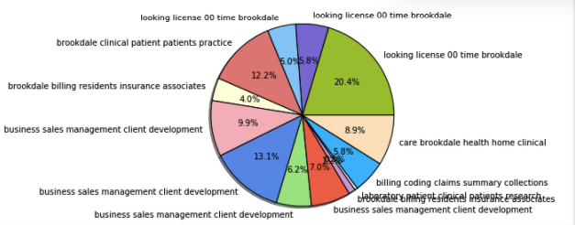

Conclusion

Most of the industries generated useful principal components, which seems to relevantly describe the industry as a whole. However, some of the industries (such as Medical/Healthcare, pictured above) center on certain streets or locations, which may not be particularly useful for the objective of this project.