Class: SYMCA Div: A  Semester: III | Course Code: MCA10602  Course Name: Laboratory Practice-III |  | Batch: S2
Name: Shreya Ganesh Joshi |  | Roll No: 52025
CO No: CO607B.4 |  | Assignment No: 08

Practical Write-Up A.Y. 2025-26

Title:
Prepare Test Plan, Test Case, Defect Report for Online Banking Application.

Test Plan – Online Banking Application

Test Plan Identifier

OB_TestPlan_V1.0 – Dated 12-Aug-2025

Introduction

This test plan covers the testing of the Online Banking Application, which allows customers to log in securely, view account details, transfer funds, pay bills, and download statements. The objective is to ensure all features work correctly, securely, and meet the bank’s requirements.

Test Items

  - Login and authentication module
  - Account summary and transaction history
  - Fund transfer module
  - Bill payment module
  - Statement download feature

Features to be Tested

  - User login with valid credentials
  - Secure fund transfer between accounts
  - Accurate account balance display
  - Bill payment processing
  - PDF/CSV statement download

Features Not to be Tested

  - Core banking backend processing system
  - Third-party payment gateway internal logic
  - Mobile app (if scope is only web version)

Approach

  - Unit Testing: Individual module verification
  - Integration Testing: Ensure modules work together (e.g., login → fund transfer)
  - System Testing: End-to-end flow testing
  - Security Testing: Check encryption, session management, SQL injection protection
  - Regression Testing: After fixes, ensure no new issues introduced
  - User Acceptance Testing (UAT): Validate against bank requirements

Item Pass/Fail Criteria

  - Pass: Test case produces expected result without critical defects.
  - Fail: Critical/high-severity defects found or output mismatches requirement.

Suspension/Resumption Criteria

  - Suspend: Server downtime, major security breach, or >20% critical test cases fail.
  - Resume: Environment restored, critical bugs fixed, retesting completed.

Test Deliverables

  - Approved Test Plan
  - Test Cases & Test Data
  - Daily Execution Report
  - Defect Reports
  - Final Test Summary Report

Testing Tasks

  - Prepare test cases and data
  - Execute test cases
  - Report and track defects
  - Retest after fixes
  - Prepare final test closure report

Environmental Needs

  - Test server with latest build
  - Browsers: Chrome, Firefox, Edge
  - Database: MySQL test instance
  - Test accounts with sample data

Staffing and Training Needs

  - 1 Test Lead – Manage activities
  - 2 Testers – Execute and log results
  - Training: Testers trained in online banking workflows and security protocols

- Scheduling

Activity | Start Date | End Date
Test Planning | 13-Aug-2025 | 14-Aug-2025
Test Case Writing | 15-Aug-2025 | 17-Aug-2025
Test Execution | 18-Aug-2025 | 22-Aug-2025
Test Closure | 23-Aug-2025 | 24-Aug-2025

- Risks and Contingencies

Risk | Contingency
Server downtime | Have backup server ready
Delay in test build delivery | Adjust schedule or prioritize modules
Security vulnerability found | Immediate fix and re-test

- Approval

Name | Designation | Signature | Date
QA Manager | — | — | —
Project Manager | — | — | —
Bank IT Manager | — | — | —

Test Cases – Online Banking Application
 | TC ID | Objective | Procedure | Expected Result | Actual Result | Pass/Fail | Bug ID
 | TC001 | Verify login with valid credentials | Enter valid username & password, click Login | User is redirected to dashboard | As expected | Pass | —
 | TC002 | Verify login with invalid password | Enter valid username & wrong password, click Login | Error message: “Invalid username or  password” | As expected | Pass | —
 | TC003 | Verify fund transfer between own accounts | Select source & destination account, enter valid amount, click Transfer | Transfer successful, balance updated | As expected | Pass | —
 | TC004 | Verify fund transfer with insufficient balance | Select account with low balance, enter large amount, click Transfer | Error message: “Insufficient balance” | Shows wrong error text | Fail | BUG001
 | TC005 | Verify bill payment to registered biller | Select biller, enter amount, confirm payment | Payment successful, confirmation shown | Payment processed twice | Fail | BUG002
 | TC006 | Verify statement download in PDF | Click “Download Statement” for last month | PDF file downloads successfully | As expected | Pass | —
 | TC007 | Verify session timeout after inactivity | Log in, stay idle for 10 minutes | User is logged out automatically | As expected | Pass | —

Defect Report – Online Banking Application
 | Field | Details
 | Bug ID | BUG001
 | Summary | Incorrect error message on insufficient balance
 | Description | When transferring an amount greater than the account balance, the system displays “Transaction failed” instead of “Insufficient balance”.
 | Severity & Priority | Severity: High, Priority: High
 | Status | Open
 | Reported By | QA Tester 1
 | Assigned To | Developer 2
 | Steps to Reproduce | 1. Log in with valid credentials.2. Navigate to Fund Transfer.3. Select account with ₹500 balance.4. Enter ₹2000 as transfer amount.5. Click Transfer.
 | Environment | Test Server v2.5, Chrome v116, MySQL Test DB
 | Attachments | Screenshot: BUG001.png
 | Release Name | OB_Release_v2.5
 | Release Date | 10-Aug-2025
 | TC ID & Name | TC004 – Verify fund transfer with insufficient balance
 | Expected Result | Error message should be “Insufficient balance”
 | Actual Result | Error message shown is “Transaction failed”

Field | Details
Bug ID | BUG002
Summary | Bill payment processed twice

 | Description | When paying a bill to a registered biller, the payment request is sent twice, resulting in double deduction.
 | Severity & Priority | Severity: Critical, Priority: High
 | Status | Open
 | Reported By | QA Tester 2
 | Assigned To | Developer 1
 | Steps to Reproduce | 1. Log in with valid credentials.2. Navigate to Bill Payments.3. Select a registered biller.4. Enter ₹500 as amount.5. Click Confirm.6. Check transaction history – payment appears twice.
 | Environment | Test Server v2.5, Chrome v116, MySQL Test DB
 | Attachments | Screenshot: BUG002.png
 | Release Name | OB_Release_v2.5
 | Release Date | 10-Aug-2025
 | TC ID & Name | TC005 – Verify bill payment to registered biller
 | Expected Result | Payment should be processed only once
 | Actual Result | Payment processed twice

AIM: Write black box test cases using ECP & BVA to test the requirementBank has different charges depending on the transaction done
- 5% of the amount for transaction less than or equal to 1000.
- 6% of the amount for transaction more than 1000 and less than or equal to 2000.
- 7% of the amount for transaction more than 2000.

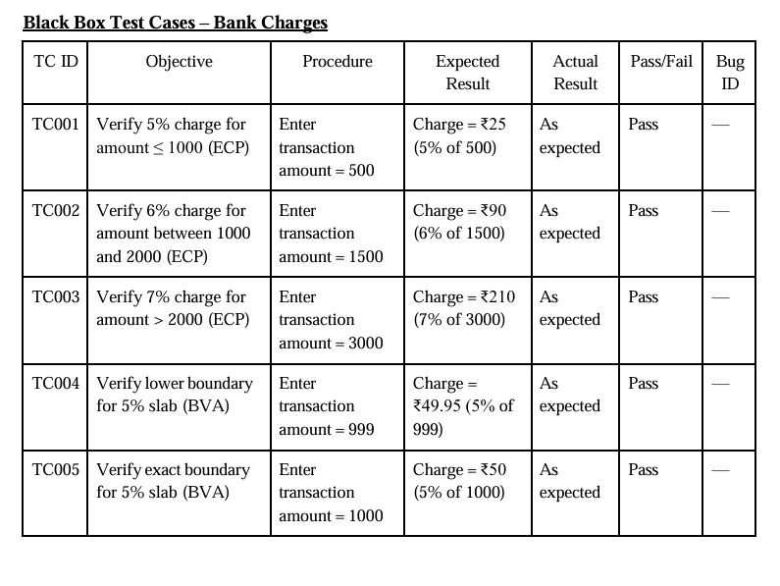
OUTPUT:

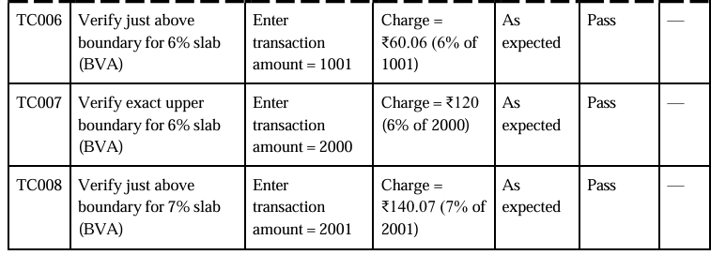
Title: Install Selenium IDE in Mozilaa Firefox/Google Chrome Test following scenario in Selenium IDE using record and replay Invoke Google Chrome browser.
Open URL: www.google.com
Click on the Google Search text box.
Type the value “java tutorials”
Click on any java tutorial link

1) Objective
Create and execute a Selenium IDE test on Mozilla Firefox that:
Opens Google (https://www.google.com)
Clicks the Search text box
Types "java tutorials"
Presses Enter to search
Clicks any Java tutorial link from the results

2) Prerequisites
OS: Windows 10/11 (or macOS/Linux)
Browser: Mozilla Firefox (latest)
Extension: Selenium IDE (enabled)
Stable internet connection

Note: If Google shows a cookie/consent page, accept it before recording.

3) Evidence of Setup (Screenshots)
Paste your screenshots under each caption.

Figure 1: Selenium IDE extension enabled in Firefox Add- ons

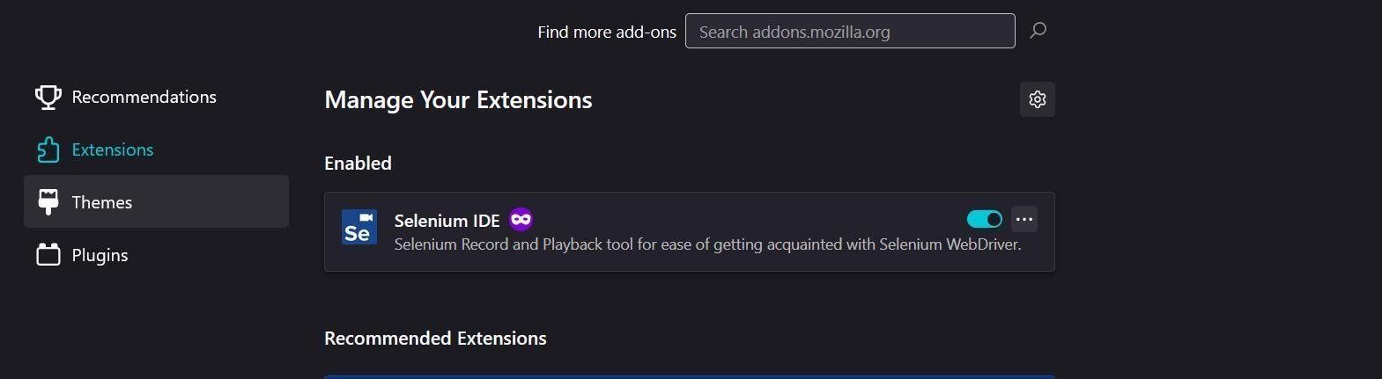

Figure 2: Selenium IDE – Name your new project dialog
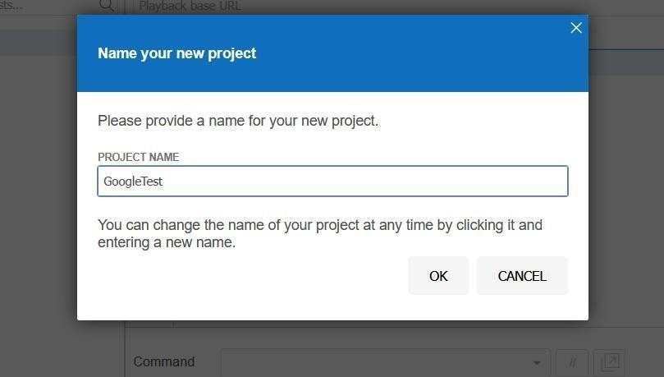
Figure 3: All Test Cases have been Executed
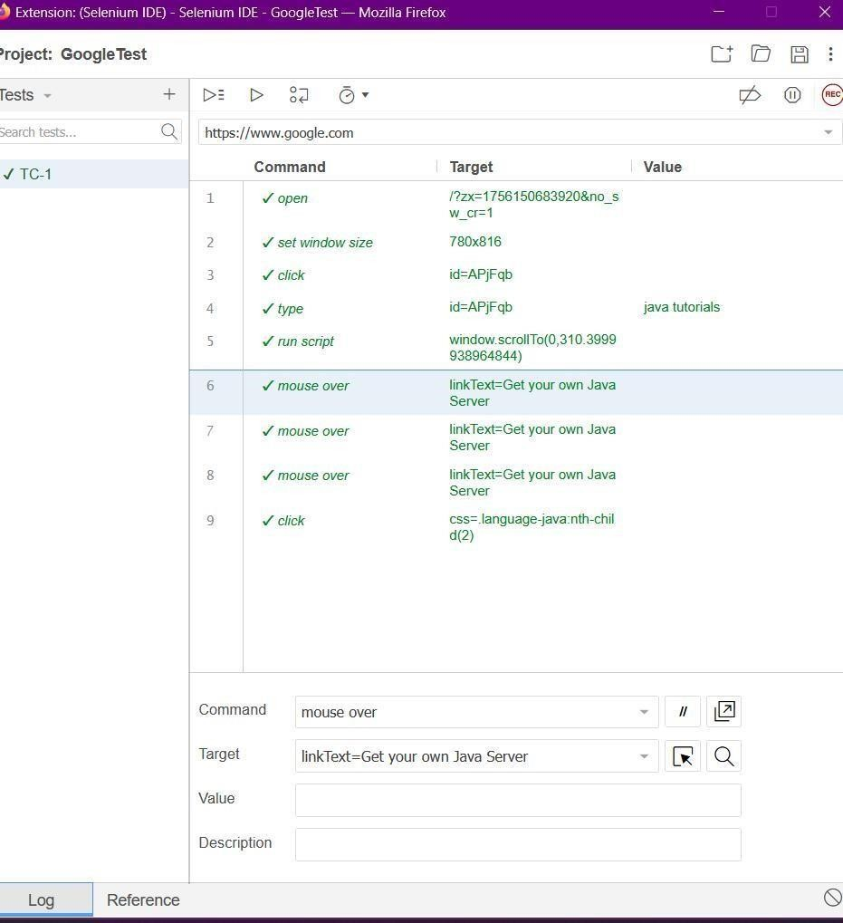

4) Step- by- Step Procedure

A. Install & Enable Selenium IDE
Open Firefox → Menu (≡) → Add- ons and themes.
Search for Selenium IDE → Add to Firefox → Add.
Ensure the extension is Enabled.
Reference: See Figure 1.

B. Launch Selenium IDE
Click the Selenium IDE icon in the Firefox toolbar (top- right).
Tip: If a blank dark window appears, maximize/resize it or reopen from the icon.

C. Create a New Project
In Selenium IDE, choose Record a new test in a new project.

When prompted, enter Project Name: _{GoogleTest} → OK. Reference: See Figure 2.

Enter Playback base URL: https://www.google.com → Start Recording.

D. Record the Test Steps
In the Google page that opens (recording is ON):
Click the search box.
Type java tutorials.

Press Enter to submit the search.

After results load, click any Java tutorial link (first result is fine).

E. Stop, Save & Name the Test
Return to the Selenium IDE window → click Stop recording.

Name the test case (e.g., GoogleJavaTutorialTest) → Save the project (.side).

F. Replay the Test
Click Play current test case.

Observe Firefox automatically performing all steps.

Confirm the test passes (green) in the IDE Logs/Results panel.

5) Selenium IDE Command Table (for reference)
Use this as a checklist; your recorded selectors may differ slightly.

# Command Target Value
- open /
- type name=q java tutorials
- send keys name=q ${KEY_ENTER}
- wait for element visible css=h3
- click css=h3

Alternatives:
Instead of step 3 you can click the Google Search button after type.
For step 5, you can target a specific result using css=div#search h3 or a linkText locator.

6) Expected Result
Selenium IDE opens Google, searches for java tutorials, and navigates to a Java tutorial page from the results.

The test case completes with Pass status.

7) Observations / Output
Insert a brief note on what happened during playback.

8) Troubleshooting
Blank IDE window: Resize/maximize or reopen from the toolbar icon; restart Firefox if needed.

Recording didn’t start: Ensure the IDE shows the red recording indicator; re- enter the base URL and try again.

Selectors failing on Google: Use wait for element visible before click; prefer stable locators like name=q and css=h3.

Consent page appears: Accept cookies/consent, stop, and re- record from the search step.

9) Conclusion
Successfully recorded and replayed a Google search flow using Selenium IDE on Firefox, demonstrating basic record- and- playback automat
Title: Automation of Gmail, Rediffmail, and Hotmail Login Flow using Selenium WebDriver
Code:
import time, os, getpass
from selenium import webdriver
from selenium.webdriver.common.by import By
from selenium.webdriver.chrome.service import Service as ChromeService
from selenium.webdriver.common.keys import Keys
from selenium.webdriver.support.ui import WebDriverWait
from selenium.webdriver.support import expected_conditions as EC
from webdriver_manager.chrome import ChromeDriverManager

# ----------------------- DRIVER SETUP -----------------------
def make_driver(headless=False):
"""Create and return a Chrome WebDriver with reasonable defaults."""
options = webdriver.ChromeOptions()
options.add_argument("--start-maximized")
options.add_argument("--disable-notifications")
options.add_argument("--disable-blink-features=AutomationControlled")
options.add_argument("user-agent=Mozilla/5.0 (Windows NT 10.0; Win64; x64) "
"AppleWebKit/537.36 (KHTML, like Gecko) Chrome/130 Safari/537.36")
options.add_experimental_option("excludeSwitches", ["enable-automation"])
options.add_experimental_option('useAutomationExtension', False)

if headless:
options.add_argument("--headless=new")
options.add_argument("--disable-gpu")

driver = webdriver.Chrome(
service=ChromeService(ChromeDriverManager().install()),
options=options
)
driver.set_page_load_timeout(40)
time.sleep(2) # Add slight delay
return driver

# ----------------------- CREDENTIAL INPUT -----------------------
def get_credentials(service_name):
"""Prompt user for credentials."""
print(f"\nEnter credentials for {service_name} (leave blank to cancel):")
username = input("Username / Email: ").strip()
if not username:
print("Cancelled.")
return None, None
password = getpass.getpass("Password (input hidden): ")
return username, password

# ----------------------- GMAIL LOGIN -----------------------
def login_gmail(username, password, headless=False):
"""Automate Gmail login."""
driver = make_driver(headless=headless)
try:
driver.get("https://accounts.google.com/signin/v2/identifier")
wait = WebDriverWait(driver, 20)

email_el = wait.until(EC.visibility_of_element_located((By.XPATH, "//input[@type='email']")))
email_el.clear()
email_el.send_keys(username)
email_el.send_keys(Keys.ENTER)

pwd_el = wait.until(EC.visibility_of_element_located((By.XPATH, "//input[@type='password']")))
time.sleep(0.5)
pwd_el.clear()
pwd_el.send_keys(password)
pwd_el.send_keys(Keys.ENTER)

time.sleep(5)
current = driver.current_url
success = "mail.google.com" in current or "myaccount.google.com" in current
print("\nGmail login attempt complete. Current URL:", current)

if not success:
print("Note: Gmail may block automated logins or require extra verification (2FA/CAPTCHA).")
return success

except Exception as e:
print("Gmail login error:", e)
return False
finally:
driver.quit()

# ----------------------- REDIFFMAIL LOGIN -----------------------
def login_rediffmail(username, password, headless=False):
"""Automate Rediffmail login."""
driver = make_driver(headless=headless)
try:
driver.get("https://mail.rediff.com/cgi-bin/login.cgi")
wait = WebDriverWait(driver, 15)

user_el = wait.until(EC.visibility_of_element_located((By.NAME, "login")))
user_el.clear()
user_el.send_keys(username)

pwd_el = driver.find_element(By.NAME, "passwd")
pwd_el.clear()
pwd_el.send_keys(password)

signbtn = driver.find_element(By.NAME, "proceed")
signbtn.click()

time.sleep(4)
current = driver.current_url
success = "mail.rediff" in current or "accounts.rediff" not in current
print("\nRediffmail login attempt complete. Current URL:", current)

return success

except Exception as e:
print("Rediffmail login error:", e)
return False
finally:
driver.quit()

# ----------------------- HOTMAIL / OUTLOOK LOGIN -----------------------
def login_hotmail(username, password, headless=False):
"""Automate Outlook/Hotmail login."""
driver = make_driver(headless=headless)
try:
driver.get("https://login.live.com/")
wait = WebDriverWait(driver, 20)

email_el = wait.until(EC.visibility_of_element_located((By.NAME, "loginfmt")))
email_el.clear()
email_el.send_keys(username)
driver.find_element(By.ID, "idSIButton9").click() # Next

pwd_el = wait.until(EC.visibility_of_element_located((By.NAME, "passwd")))
pwd_el.clear()
pwd_el.send_keys(password)
driver.find_element(By.ID, "idSIButton9").click() # Sign in

time.sleep(4)
try:
stay_btn = WebDriverWait(driver, 5).until(EC.element_to_be_clickable((By.ID, "idSIButton9")))
stay_btn.click()
except Exception:
pass

current = driver.current_url
success = any(sub in current for sub in ["outlook.live.com", "mail.live.com", "inbox"])
print("\nHotmail/Outlook login attempt complete. Current URL:", current)

if not success:
print("Note: Microsoft may require additional verification or block automation.")
return success

except Exception as e:
print("Hotmail login error:", e)
return False
finally:
driver.quit()

# ----------------------- MAIN EXECUTION -----------------------
if __name__ == "__main__":
u, p = get_credentials("Gmail")
if u and p:
login_gmail(u, p, headless=False)

u, p = get_credentials("Rediffmail")
if u and p:
login_rediffmail(u, p, headless=False)

u, p = get_credentials("Hotmail/Outlook")
if u and p:
login_hotmail(u, p, headless=False)

print("\n⚠️ Important: If you see 2FA, CAPTCHA, or 'verify it's you' messages, "
"automation cannot complete that step automatically.")

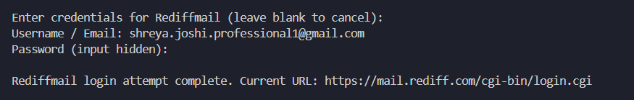

AIM: Host a Static Website on Cloud Storage - Test accessing the site via public URL.

Steps to Host Static Website on GitHub
1. Create a GitHub Account
• Go to https://github.com
• Sign up / log in.
2. Create a New Repository
1. Click + (New repository).
2. Give it a name (example: my-website).
3. Choose Public.
4. Check “Add a README file”. (Optional)
5. Click Create repository.
3. Upload Your Website Files
1. On your repo page, click Add file → Upload files.
2. Upload your index.html, style.css, script.js, images, etc.
3. Click Commit changes.
4. Enable GitHub Pages
1. Go to your repo → Settings.
2. Scroll to Pages (left sidebar).
3. Under Source, select Deploy from a branch.
4. Choose main branch → / (root) folder.
5. Click Save.

5. Get Your Website Link
• After a few minutes, your site will be live at:
• https://your-username.github.io/repository-name
Example:
If username = shreya949 and repo = my-website,
then link = shreya949/Codes: C Language Commits at Academics

Output:
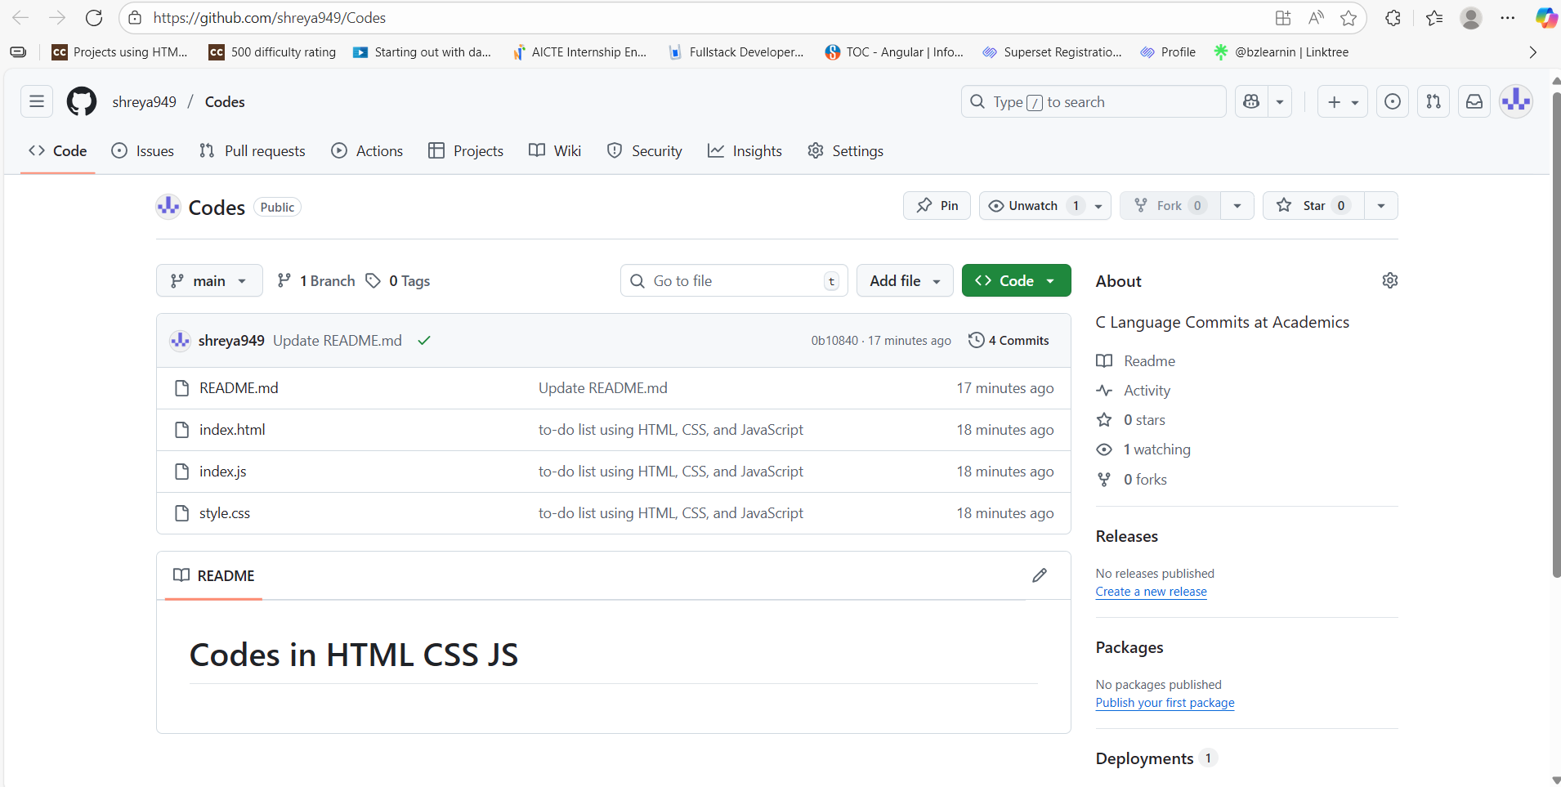
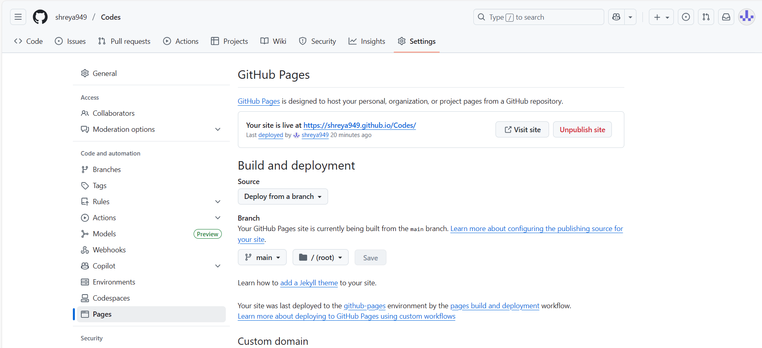
LINK: https://shreya949.github.io/Codes/
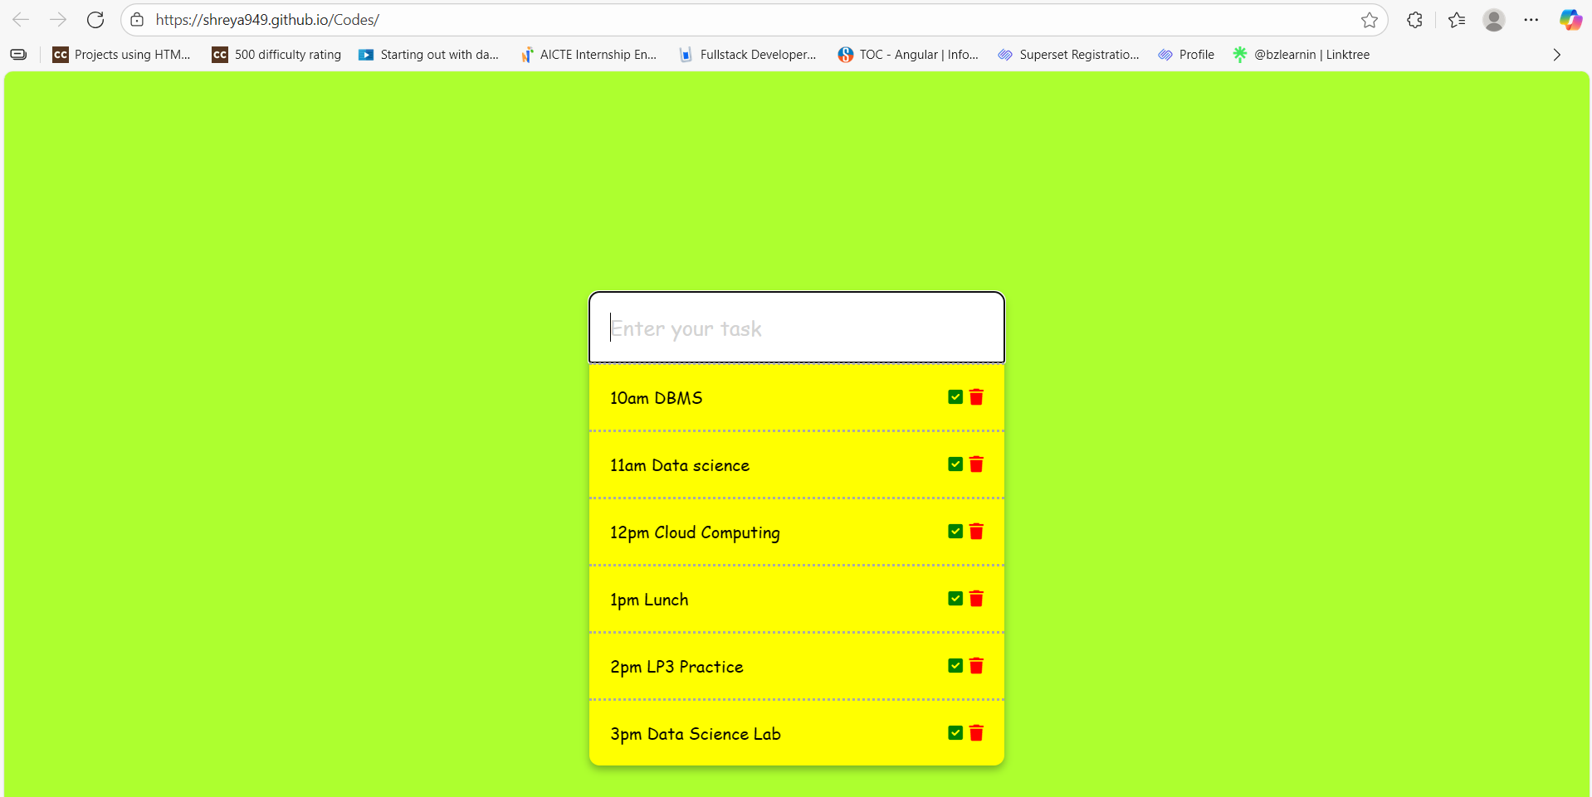

Q. Deploy a Simple Cloud Network - Deploy VMs in different subnets.

Code and Output:
Subnet Creation
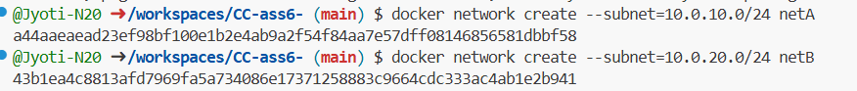

Virtual Machine Creation
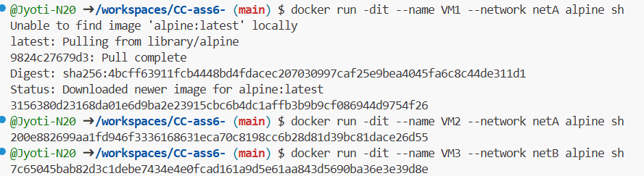

Test Ping Within Same Subnet (VM->VM2)
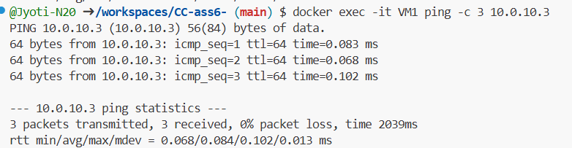


Progressive Education Society’s
MODERN COLLEGE OF ENGINEERING, Pune -05.
(An Autonomous Institute Affiliated to Savitribai Phule Pune University)
MCA DEPARTMENT
Install Ping Utility
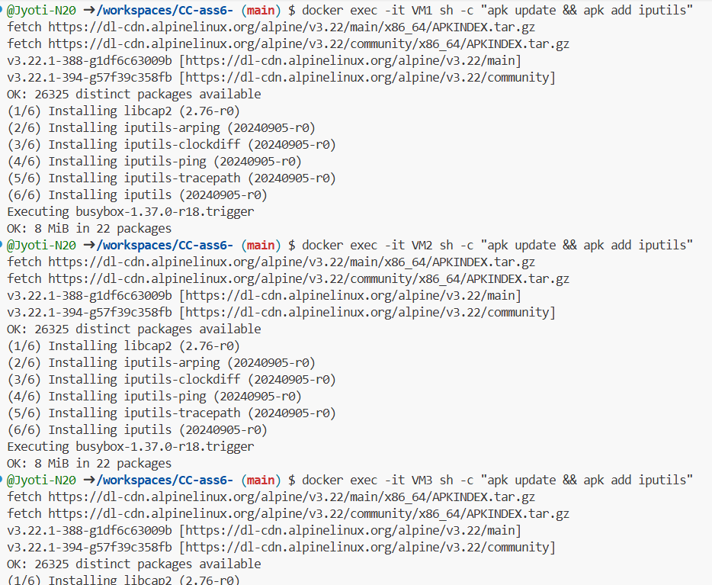

Test Ping Across Subnets(VM1->VM3)(Failed)
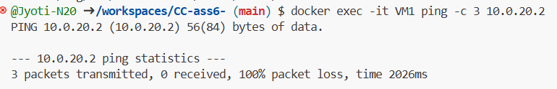

Communication from VM1 to VM3
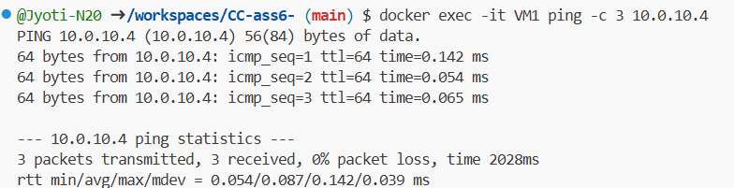


Progressive Education Society’s
MODERN COLLEGE OF ENGINEERING, Pune -05.
(An Autonomous Institute Affiliated to Savitribai Phule Pune University)
MCA DEPARTMENT

Communication from VM3 to VM1
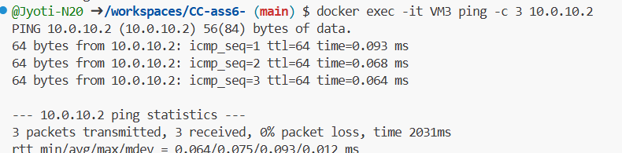

Title: Create a cloud database – create tables, insert records, and run queries.
Solution :
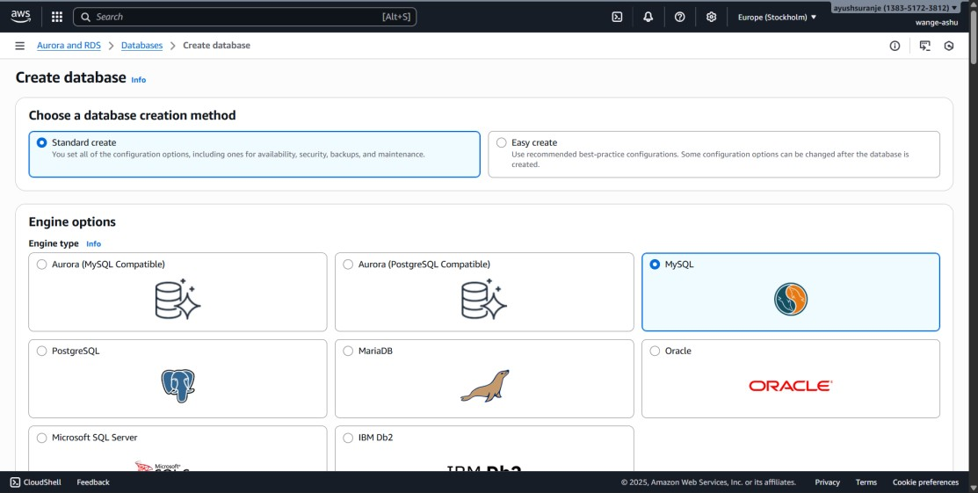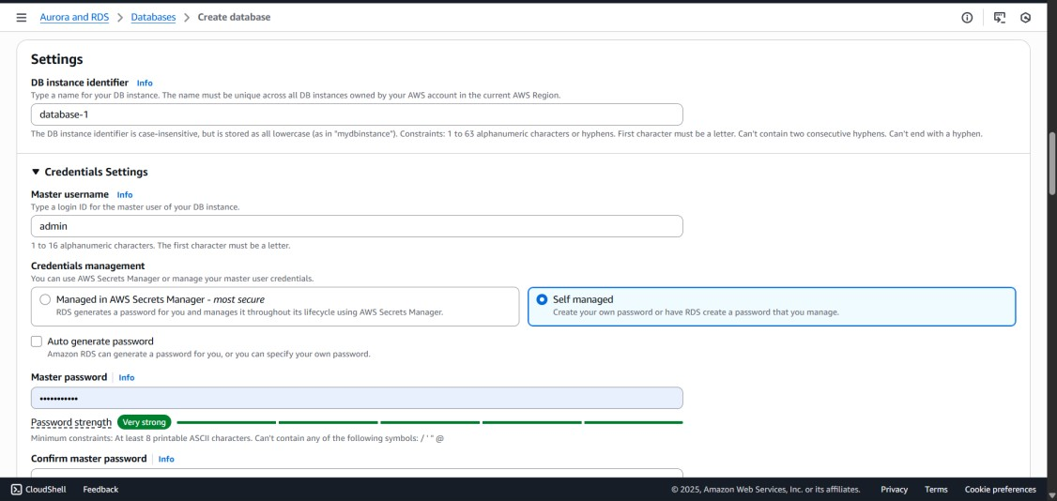

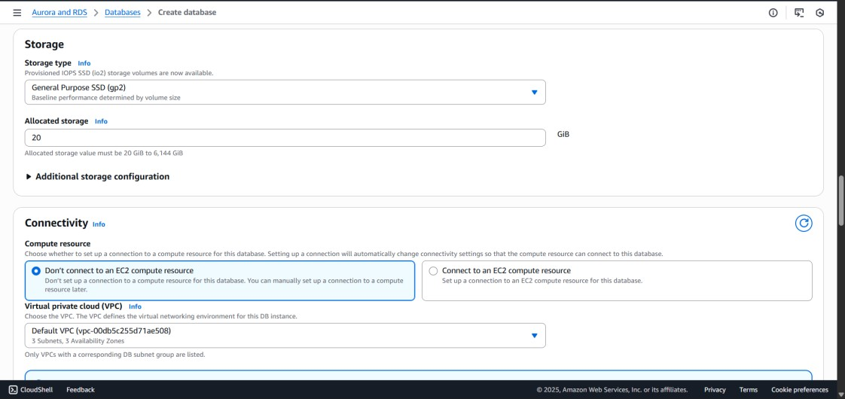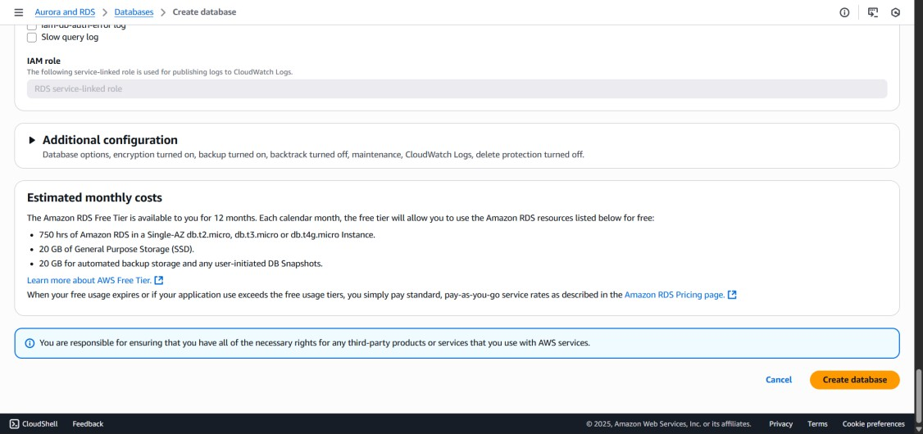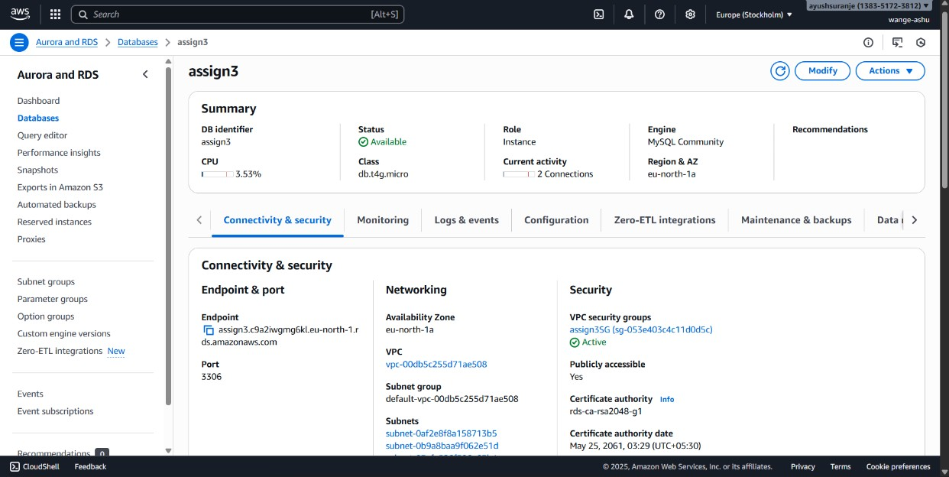

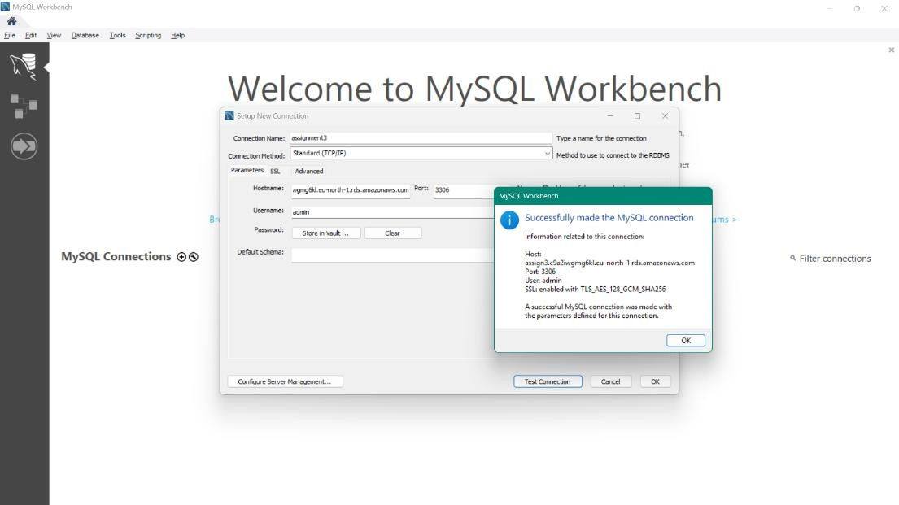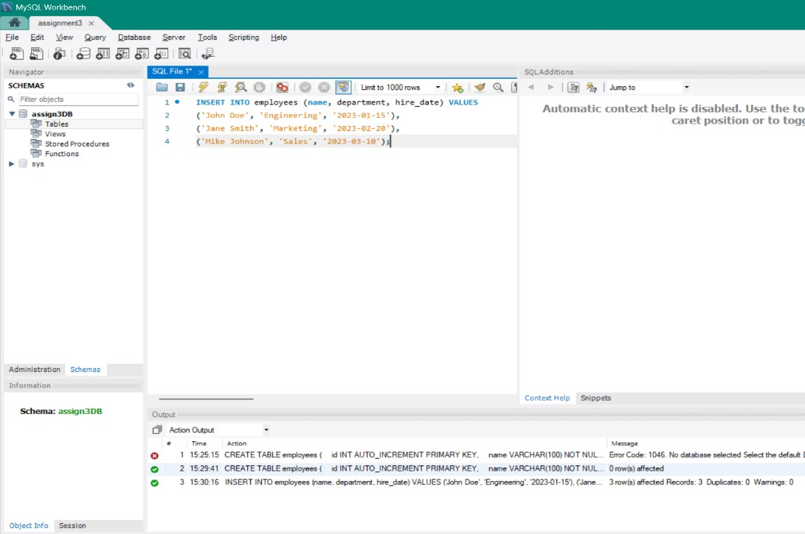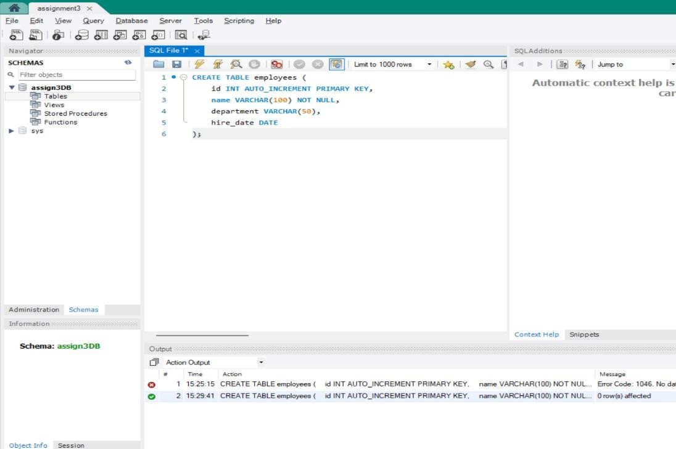
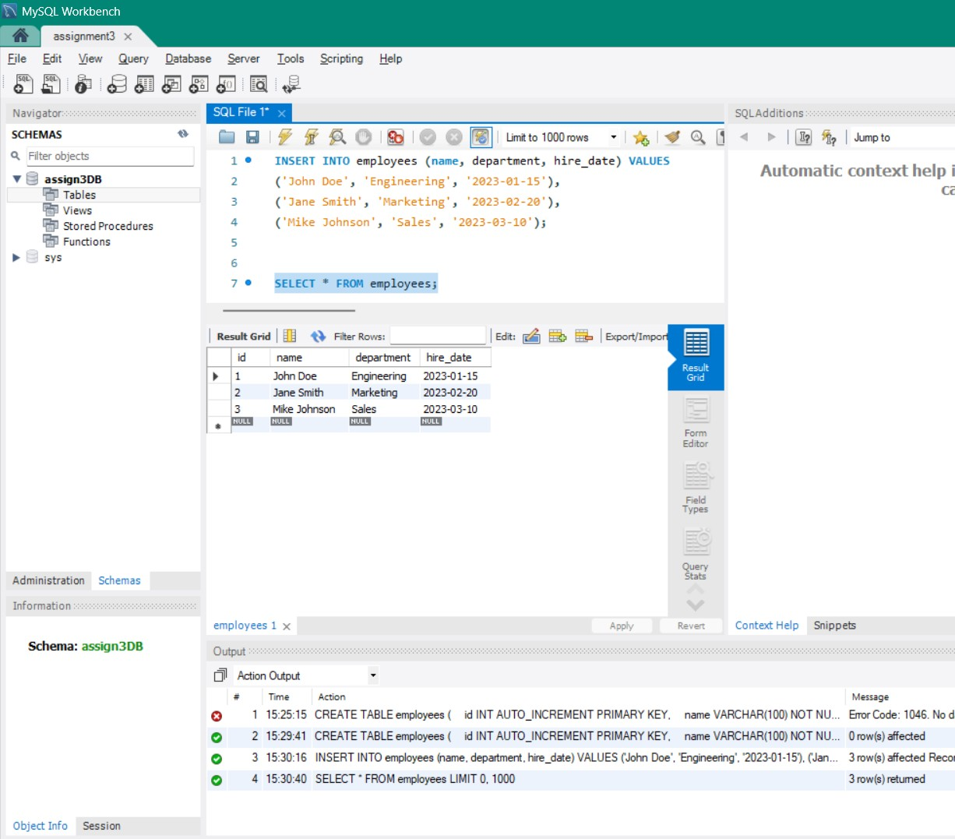

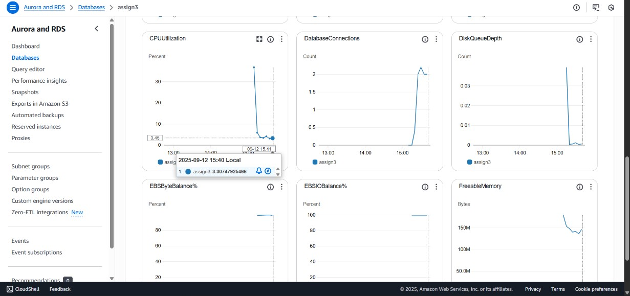

Title: Set up a load balancer, Test traffic distribution by accessing the public IP of the Load balancer. Solution :

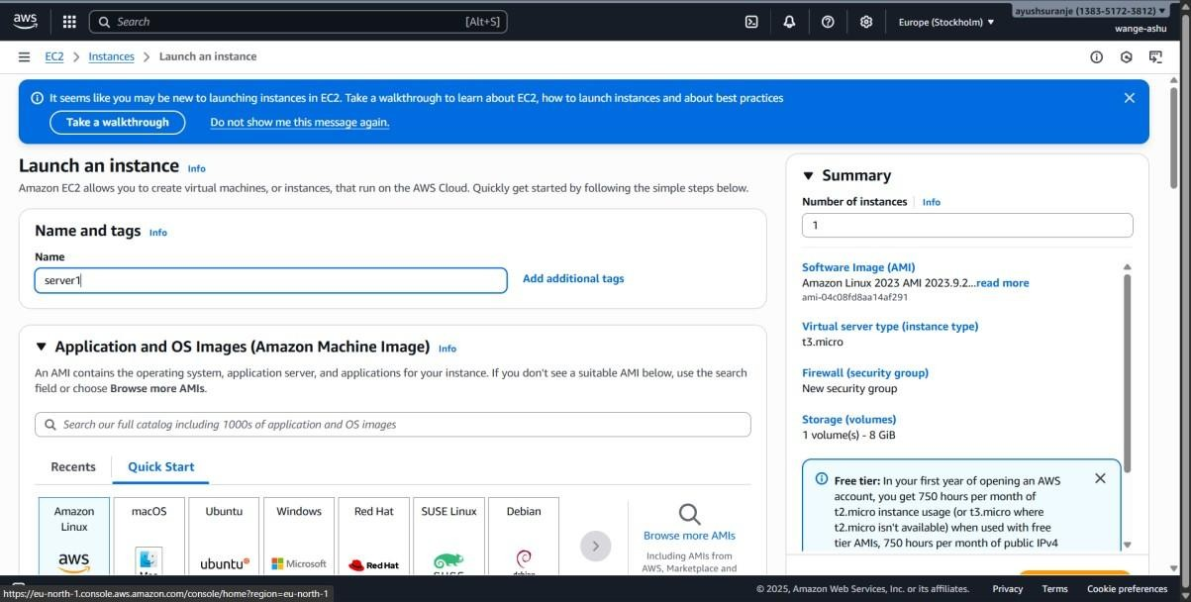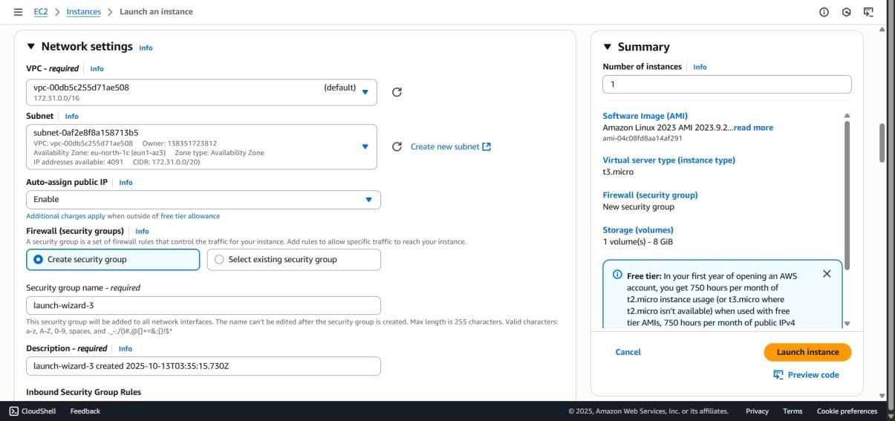
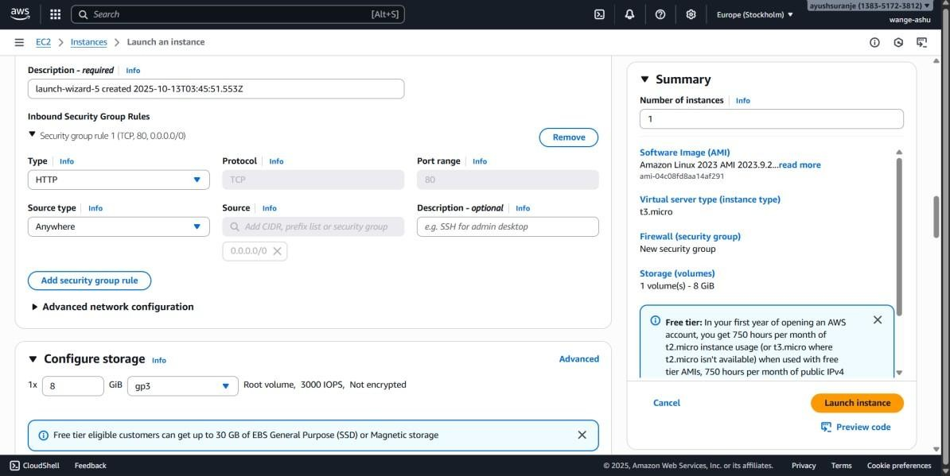

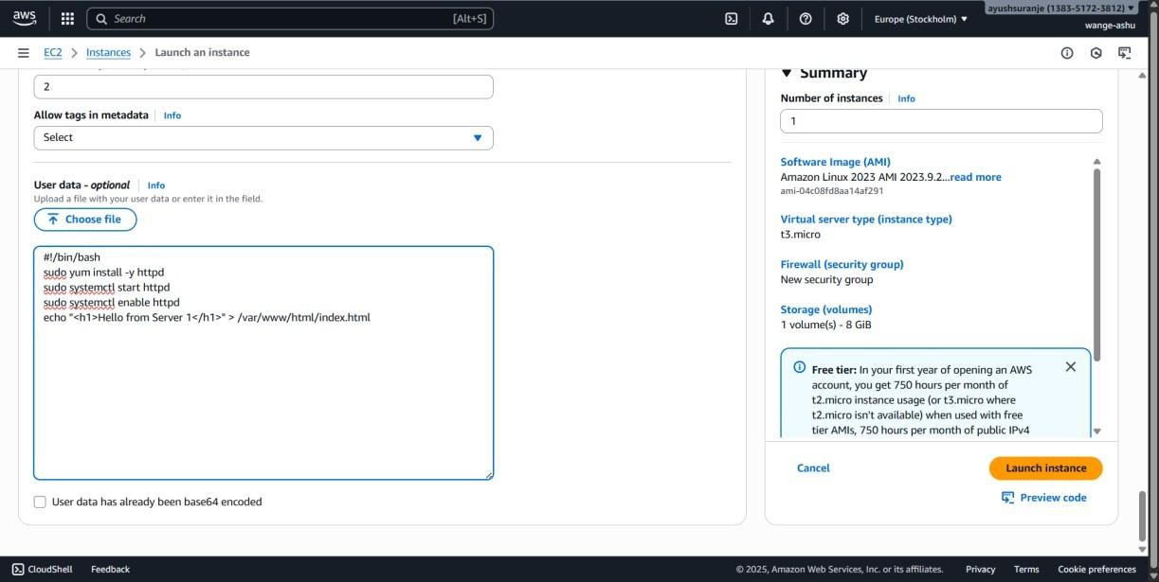
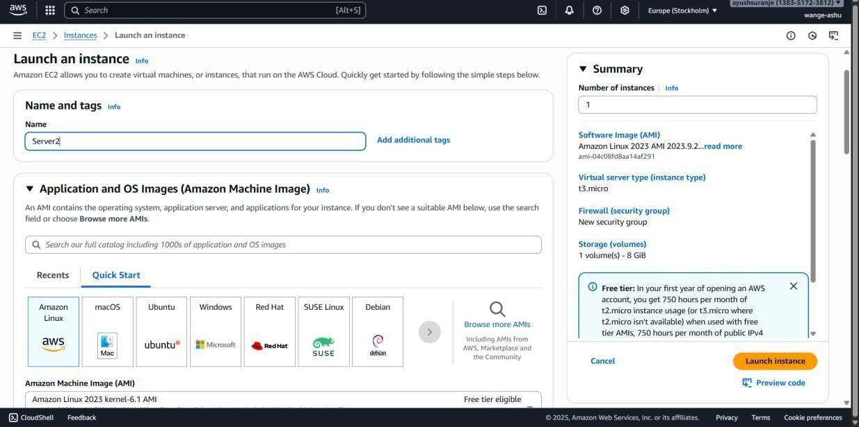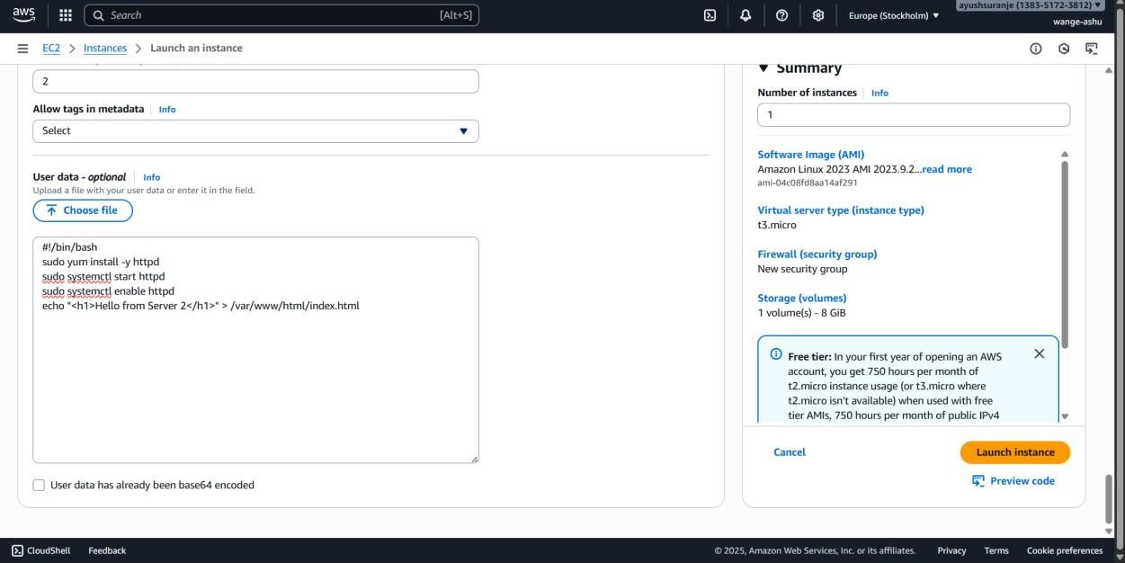

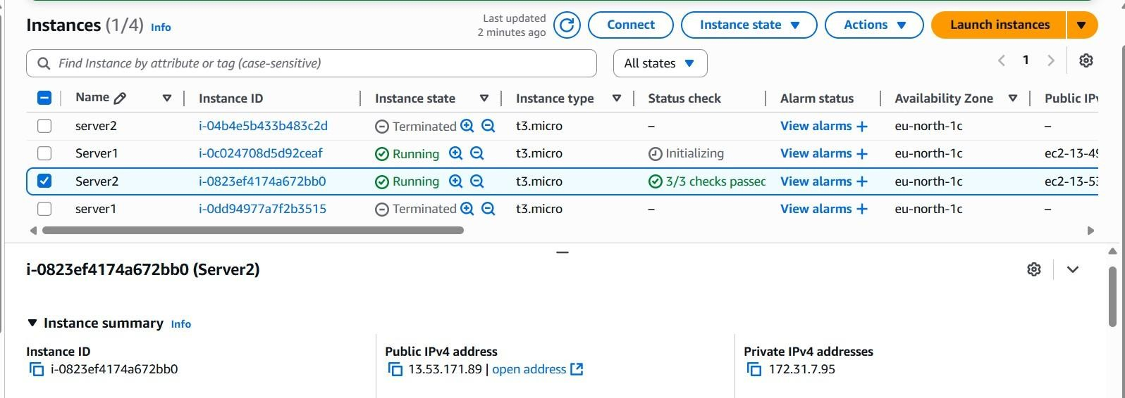
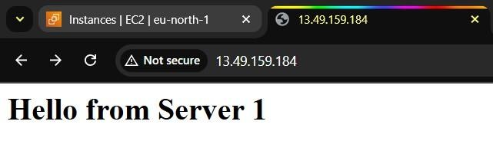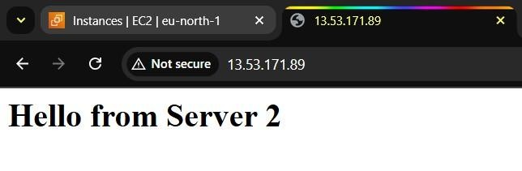

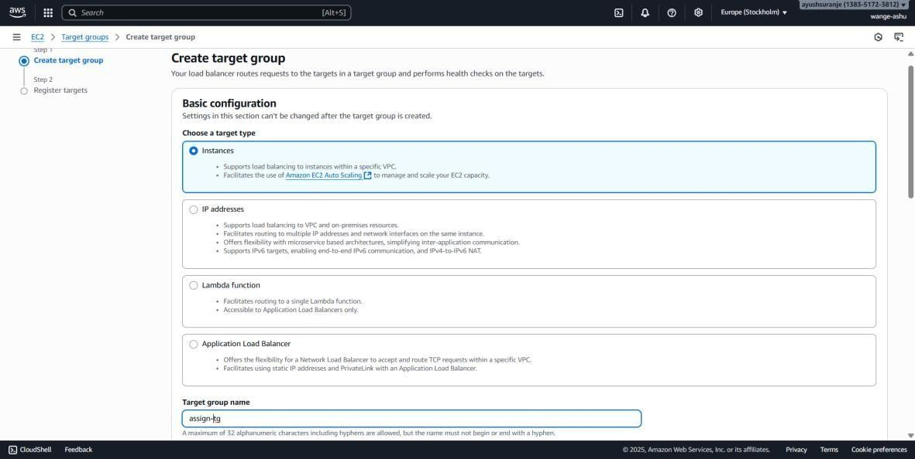
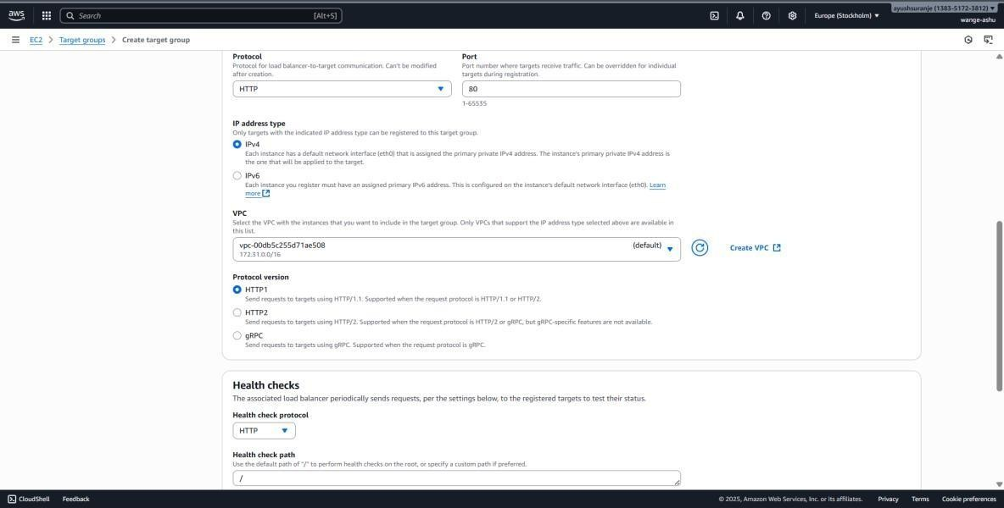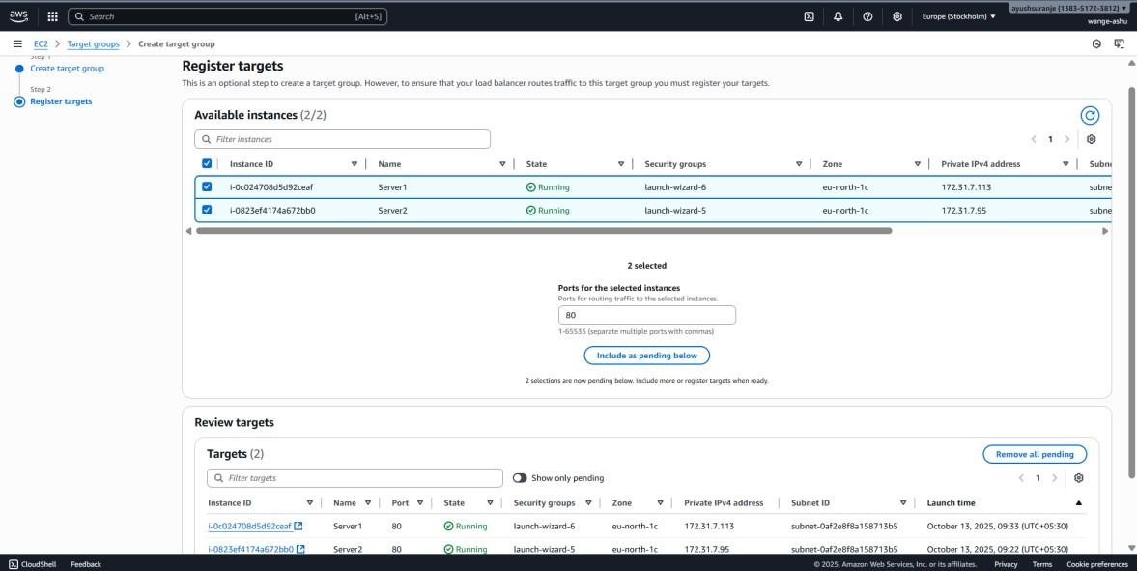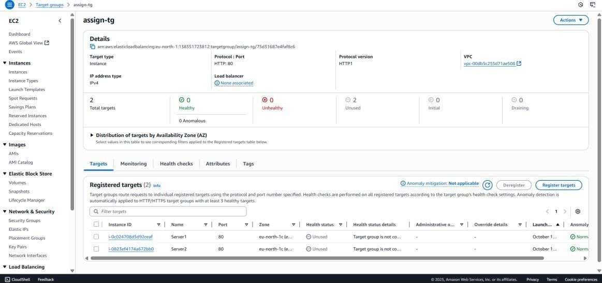

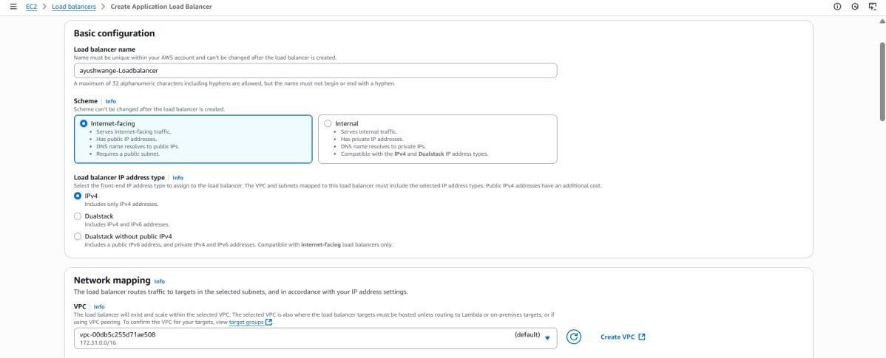

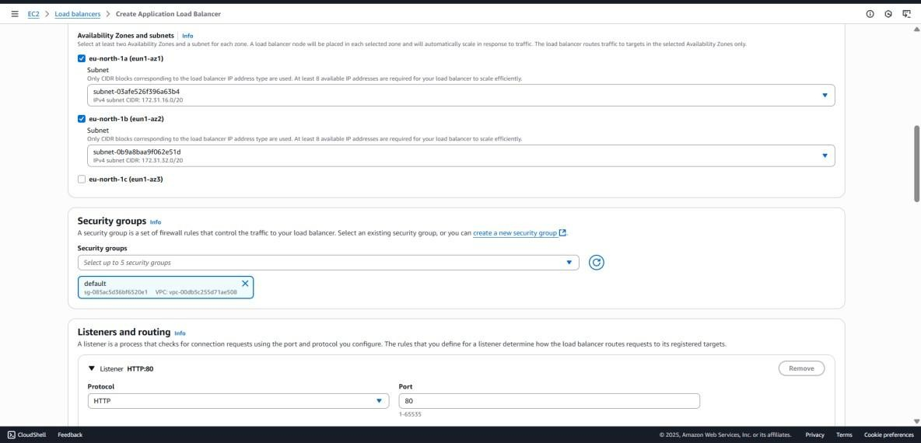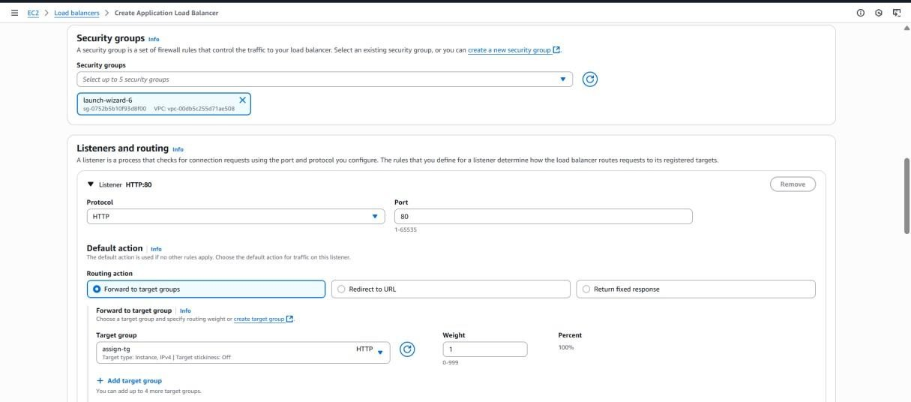

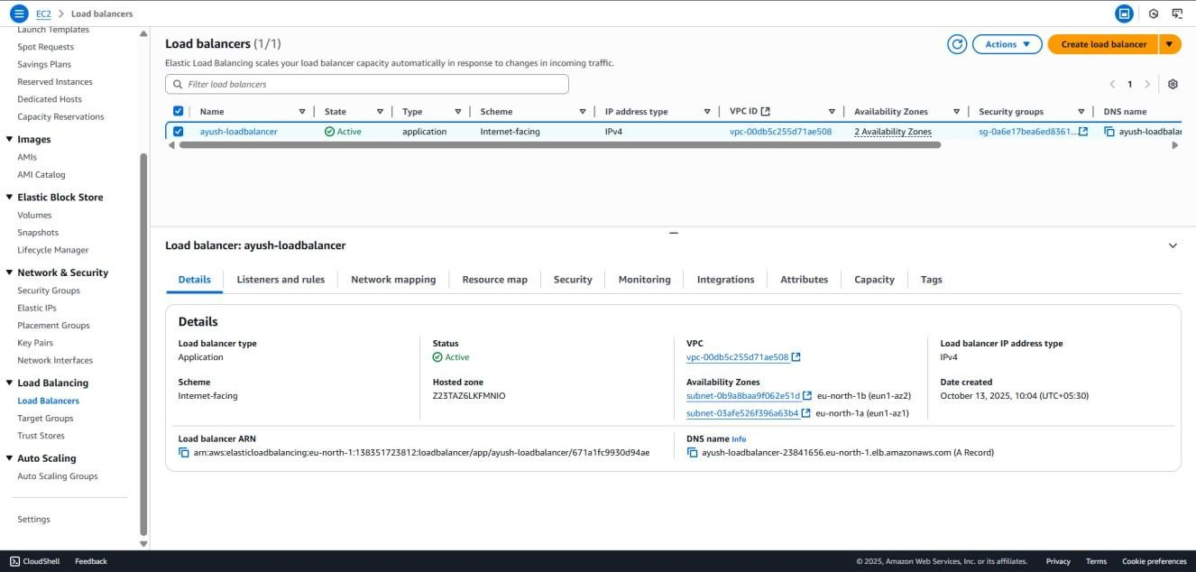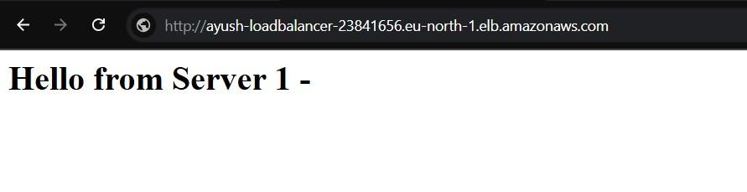

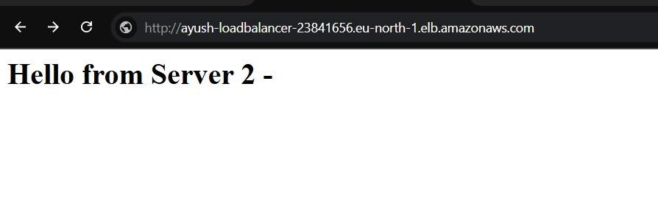

Progressive Education Society’s
MODERN COLLEGE OF ENGINEERING, Pune - 05.
(An Autonomous Institute Affiliated to Savitribai Phule Pune University )

MCA Department

