|  |  |
| --- | --- |
| **Shreya Das**  29, KdnGhRd, Nimta, Kolkata - 49, West Bengal  (+91)8017448289  [dasshreya140@gmail.com](mailto:dasshreya140@gmail.com)  [shreya-das-7a728b229](https://www.linkedin.com/in/shreya-das-7a728b229)  [shreyaGituser-90](https://github.com/shreyaGituser-90)  Gender - Female DOB - October 27, 2002 |  |
| **EDUCATION**  * **B. P. Poddar Institute of Management and Technology**   2020 – 2024 | Kolkata  Computer Science and Engineering | MAKAUT | Current CGPA : 9.61   * **Belgharia Mahakali Girls’ High School**   2020 | Kolkata | WBCHSE | 94.6%   * **R. K. S. M. Sister Nivedita Girls’ School**   2018 | Bagbazaar, Kolkata  WBBSE | 90.7% **PROJECTS**  * **My Portfolio Website**   Technologies used: HTML, CSS, JS   * [**Progressive Weather App**](https://github.com/shreyaGituser-90/project_weather_pwa)   Technologies used: HTML, CSS, ReactJS   * [**E-Commerce FrontEnd**](https://github.com/shreyaGituser-90/mern-e-commerce-frontend)   Technologies used: HTML, CSS, ReactJS   * [**YouTube Clone**](https://github.com/shreyaGituser-90/project_youtube_video_player)   Technologies used: HTML, CSS, ReactJS   * [**Spacewar Game**](https://github.com/shreyaGituser-90/Spacewar)   Technologies used: Python, Pygame  **EXTRACURRICULAR ACTIVITIES**   * Worked as a Freelancer in **Transtutors** and **Dudor** by giving students programming solutions and more. | **SKILLS**  * **Technical** * Languages: HTML, CSS, JS, React, Python, Java, C * Relational Database: SQL * OOPs Concept * Data Structure and Algorithm * GitHub * **Professional** * Disciplined and Goal driven * Ability to work and grow as a team * Self-motivated and adaptable learner   **CODING PROFILES :**   * GitHub - [shreyaGituser-90](https://github.com/shreyaGituser-90) * Hackerrank - [shreyaofficial54](https://www.hackerrank.com/profile/shreyaofficial54)  **ACHIEVEMENTS** 4* Problem Solving | Python in *Hackerrank*  **LANGUAGES**  English | Hindi | Bengali  **INTERESTS**  Music, Photography, Reading |

**DECLARATION**

I hereby declare that all the information given above is true and correct to the best of my knowledge.

Date: 09-01-2024

Place: Kolkata

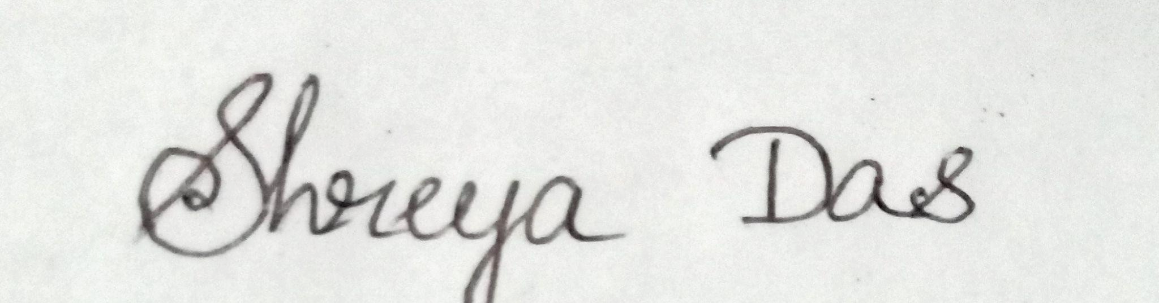

**______________________**

**Signature**

**(Shreya Das)**