# Operational Concept Description (OCD)

**Cash Doctor 3.0**

**Team 12**

**Steven Helferich: Project Manager**

**Kenneth Anguka: IIV&V**

**Xichao Wang: Operational Concept Engineer**

**Alisha Parvez: Life Cycle Planner**

**Ekasit Jarussinvichai: Requirements Engineer**

**Kshama Krishnan: Prototyper**

**Le Zhuang: Feasibility Analyst**

**Shreya Sharma: Software Architect**

**October 11, 2014**

# Version History

| Date | Author | Version | Changes made | Rationale |
| --- | --- | --- | --- | --- |
| 09/19/14 | XW | 1.0 | * Original template for use with CS577a * Added 1.1 1.2 | * Initial draft for use with CS577a |
| 09/19/14 | XW | 1.1 | * Added section 3.1 * Added section 3.2 | * Section 3.2 was added to provide traceability for the outcome in the Benefits Chain |
| 09/25/14 | SH | 1.2 | * Added section 2.1 | * Initial information from current system |
| 09/27/14 | SH | 1.3 | * Added section 2.2 2.3 | * Initial information from current system |
| 09/28/14 | XW | 1.4 | * Updated section 3.1.3 | * Fix the current workflow |
| 10/01/14 | SS, KK | 1.5 | * Added section 3.3 | * Initial draft of new system |
| 10/10/14 | XW | 1.6 | * Updated section 1.2 * Added section 3.4 | * Updated the status of OCD * Initial the transformation condition |

# Table of Contents

Operational Concept Description (OCD) i

Version History ii

Table of Contents iii

Table of Tables iv

Table of Figures v

1. Introduction 1

1.1 Purpose of the OCD 1

1.2 Status of the OCD 1

2. Shared Vision 2

2.1 Benefits Chain 3

2.2 System Capability Description 3

2.3 System Boundary and Environment 4

3. System Transformation 5

3.1 Information on Current System 5

3.2 System Objectives, Constraints and Priorities 8

3.3 Proposed New Operational Concept 10

3.4 Organizational and Operational Implications 11

# Table of Tables

Table 1 The Program Model 2

Table 2 The hardware 5

Table 3 Artifacts 6

Table 4 Capability Goals 8

Table 5 Level of Service 8

Table 6 Relation to Current System 9

# Table of Figures

Figure 1 Benefits Chain of Cash Doctor 3.0 3

Figure 2 System Boundary and Environment Diagram of Cash Doctor 3.0 4

Figure 3 Current Business Workflow of Cash Doctor 2.0 7

Figure 4 Element Relationship Diagram of Cash Doctor 3.0 10

Figure 5 Business Workflow Diagram of Cash Doctor 3.0 11

### Introduction

#### Purpose of the OCD

This document provide a operational concept of Cash Doctor 3.0, which includes the success-critical stakeholders’ shared vision, expected benefits of the system, objectives, constraints, current and new workflows, new operational concepts, goals and organizational and operational transformations. Clients and developers reached this mutual understanding together.

The success-critical stakeholders of this project include:

* Consumers: the individuals who are going to use this app.
* Corporations: the corporations or organizations that going to encourage their employee to use this app.
* Cash Doctor: the service provider and maintainer.
* Student team: developers
* Healthcare Providers: provide healthcare information for Cash Doctor 3.0

#### Status of the OCD

All sections of OCD have already been completed at this point. This vision of OCR will be a core document of Foundations Commitment Package. Future it will works as a guideline during development and it will be periodically updated to reflect the latest state of project.

### Shared Vision

Table 1 The Program Model

|  |  |  |  |
| --- | --- | --- | --- |
| **ASSUMPTIONS**   * Users will share info and provide reviews. * Corporations will push their employees to use it via incentives. * People will move away from insurance providers if it saves them money. * Providers will benefit from using cash. * Providers will use the system. | | | |
| **Stakeholders**  **(Who?)** | **Initiatives**  **(What?)** | **Value Proposition**  **(Why?)** | **Beneficiaries**  **(For Whom?)** |
| * Developers * Cash doctor | * Develop the system (for price & review/rating). * Market the app/system   + Corporate marketing strategy.   + Individual marketing strategy.   + Provider marketing strategy. | * Increase price transparency of health care costs. * Increased time and dollar savings for patients and healthcare consumers in general. * Empowering the consumer to make a more educated choice about healthcare expenditures * Enable consumers/patients to evaluate or provide feedback on healthcare services for community benefit. * Revolutionize the industry and profit. | * Healthcare consumers - individual and corporate. * Health care providers. * Cash doctor (includes student team) |
| **Cost** | | **Benefits** | |
| * Development time (in person-hours) * Hardware * Software * Network * Maintenance * Miscellaneous | | * Consumers and corporations save money * Consumers have access to healthcare, information, and networks (intangible) * Doctors make more money * Usage   + Registered users   + Downloads   + Rate of access   + Rate of sharing * Time saved in finding coverage | |

#### Benefits Chain

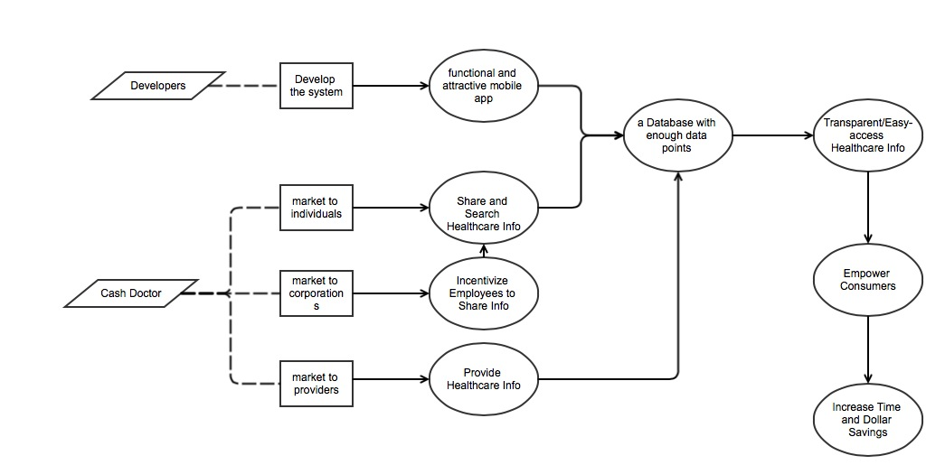

Figure 1 Benefits Chain of Cash Doctor 3.0

#### System Capability Description

* A mobile application that allows users to search and share healthcare information about location, code, price and specialty.
* Individual consumers who are looking for or sharing healthcare information are the target users of this application.
* Consumers will find a more efficient way to find cheaper healthcare services by using this application. Besides, corporations would reduce their cost by encouraging their employees to use this application. Healthcare providers would also benefit form this application by attracting more customers.
* The telephone doctor services are the closet competitor of cash Doctor.
* Cash Doctor could help consumers to search and compare healthcare price, and keep updated from healthcare provider, which would makes it more competitive than telephone doctor.

#### System Boundary and Environment

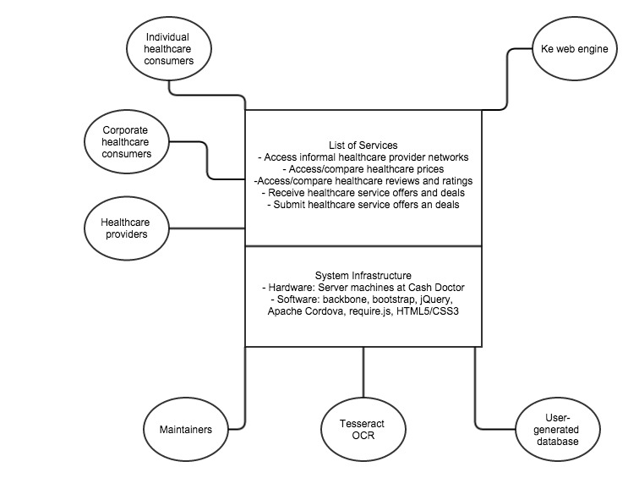

Figure 2 System Boundary and Environment Diagram of Cash Doctor 3.0

### System Transformation

#### Information on Current System

##### Infrastructure

**Software:**

Web Engine: Ke

Proprietary CMS

Technologies: HTML5, CSS3, Backbone.js, Require.js, jQuery, jQuery Mobile, Bootstrap

Integration Architecture: Apache Cordova

Database: SQL Server

Table 2 The hardware

|  |  |  |
| --- | --- | --- |
| Component | Minimum | Recommended |
| Processor | 2.9 gigahertz (GHz) or faster x86- or x64-bit dual core processor with SSE2 instruction set | 3.3 gigahertz (GHz) or faster 64-bit dual core processor with SSE2 instruction set and 3 MB or more L3 cache |
| Memory | 2-GB RAM | 4-GB RAM or more |
| Display | Super VGA with a resolution of 1024 x 768 | Super VGA with a resolution of 1024 x 768 |

**Network:**

* Bandwidth greater than 50 KBps
* Latency under 150 ms

##### Artifacts

Table 3 Artifacts

|  |  |  |  |
| --- | --- | --- | --- |
| Artifact | Description | Status | Planned delivery date |
| Overall Project Description | Brief analysis about the healthcare industry and the opportunity and challenge about Cash Doctor. | Received from client | N/A |
| Overall Requirement Description | Brief Description about target functions about this app. | Received from client | N/A |
| Technique Description | Description about database structure, development environment, etc. | Received from client | N/A |

##### Current Business Workflow

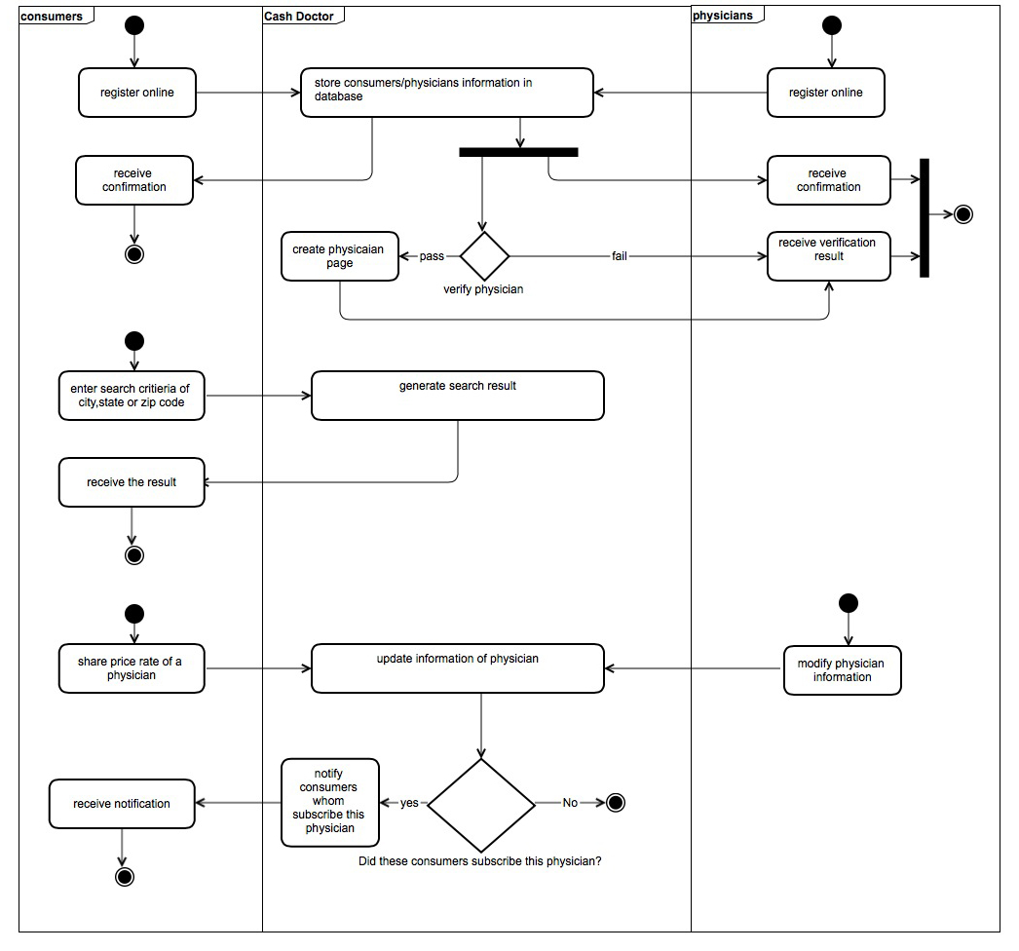

Figure 3 Current Business Workflow of Cash Doctor 2.0

#### System Objectives, Constraints and Priorities

##### Capability Goals

Table 4 Capability Goals

|  |  |
| --- | --- |
| **Capability Goals** | **Priority Level** |
| **OC-1 Manual Information Search: The application should enable consumers to search healthcare information by imputing location, code, price and specialty.** | **Must have** |
| **OC-2 Geo-Location Search: The application should be able to find consumers’ location and show relevant providers around.** | **Must have** |
| **OC-3 Price Comparison: The application should enable consumers to compare price between different providers.** | **Must have** |
| **OC-4 User Registration: The application should enable consumers to register as a user.** | **Must have** |
| **OC-5 Price Sharing: The application should enable users to share healthcare services price by manually imputing or capturing invoice.** | **Must have** |
| **OC-6 Provider Rating: The application should enable users to rate providers and create a review.** | **Must have** |
| **OC-7 Networking: The application should enable users to create a private network and join existing networks.** | **Must have** |
| **OC-7 Profile Management: The application should enable users to create and manage a health profile.** | **Must have** |
| **OC-8 Notification Management: The application should enable users to subscribe form providers to get update notifications. And it also allows users to filter notifications.** | **Must have** |

##### Level of Service Goals

Table 5 Level of Service

|  |  |  |
| --- | --- | --- |
| **Level of Service Goals** | **Priority Level** | **Referred WinWin Agreements** |
| **LOS-1 Number of users: System should be able to support at least 1000 simultaneous users.** | **Must have** | **WC_3080** |

##### Organizational Goals

OC-1: Increase the price transparency for all healthcare services consumers.

OC-2: Increase sales for Healthcare provider.

OC-3: Reduce costs for corporations who pay healthcare bills for their employees.

##### Constraints

**OC-1 Operating System:** the new application must be able to run on IOS, Android and windows phone.

**OC-2 Deliver time:** the application must be delivered at the end of next semester (spring 2015).

##### Relation to Current System

Table 6 Relation to Current System

|  |  |  |
| --- | --- | --- |
| **Capabilities** | **Current System** | **New System** |
| Roles and Responsibilities | Corporations do not involve in current system. | Corporations encourage their employees to use cash doc and they benefit from it by reducing costs |
| User Interactions | Web based system | Mobile app based system |
| Infrastructure | N/A | N/A |
| Stakeholder Essentials and Amenities | -Users have to search on website and manually input to share price.  -Providers could only update their webpage to promote and advertise. | -It is much easier for users to search on smart phones.  -Implementing OCR makes it much easier for users to share price.  -Notifications make providers easier to advertise themselves. |
| Future Capabilities | N/A | Providers can push notifications to users. And users can subscribe from providers to keep updating. And users could filter notification. |

#### Proposed New Operational Concept

##### Element Relationship Diagram

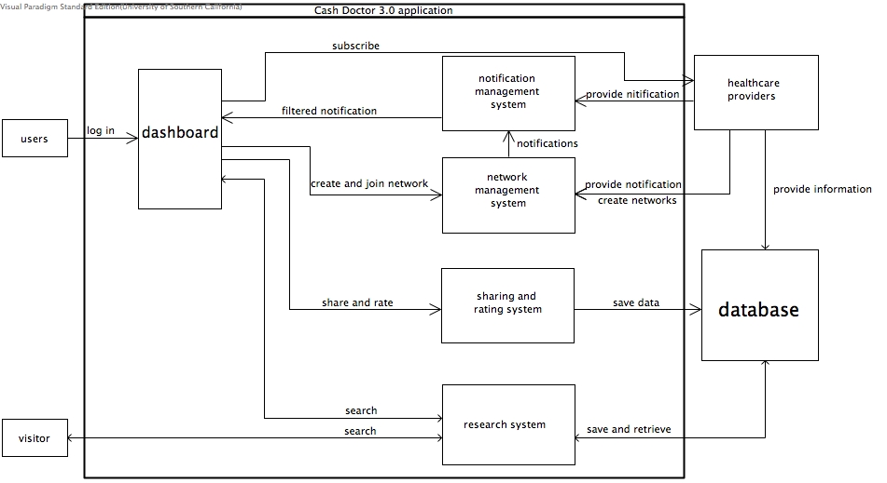

Figure 4 Element Relationship Diagram of Cash Doctor 3.0

##### Business Workflows

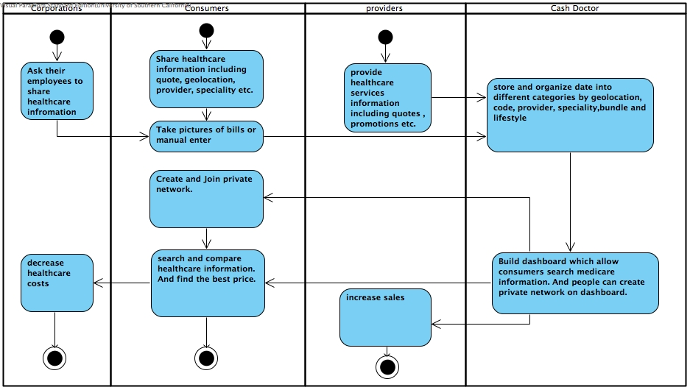

Figure 5 Business Workflow Diagram of Cash Doctor 3.0

#### Organizational and Operational Implications

##### Organizational Transformations

* The need to hire a maintainer to maintain the mobile system.
* The need to market target on corporations.

##### Operational Transformations

* An option is available for healthcare providers to create networks to attract and stay connect with consumers.
* An option is available for corporations to save costs by encouraging their employees to use cash doctor.