Feasibility Evidence Description (FED)

Cash Doctor 3.0

12

Steven Helferich: Project Manager
Kenneth Anguka: IIV&V
Xichao Wang: Operational Concept Engineer
Alisha Parvez: Life Cycle Planner
Ekasit Jarussinvichai: Requirements Engineer
Kshama Krishnan: Prototyper
Le Zhuang: Feasibility Analyst
Shreya Sharma: Software Architect

<Date>

Version History
Date | Author | Version | Changes made | Rationale
08/20/05 | PP | 1.0 | - Original template for use with LeanMBASE v1.0 | - Initial draft for use with LeanMBASE v1.0
08/30/06 | SK, RT | 1.6 | - Add template table  - Remove Section 3. Requirement Traceability | - Consistent format  - Move to Supporting Information Document
10/06/06 | SK | 1.61 | - Removed Section 1.6 | - Section 1.6 was duplicated with section 1.7 due to Format error
09/14/07 | SK | 1.9 | - Updated Section 2 | - Consistent with LeanMBASE1.9
08/25/08 | IC | 2.0 | - Moved Section 1.1 to 1.2  - Add Section 1.2  - Updated Section 3 and add 3.1-3.3  - Updated Section 6, 6.3 | - Consistent with IICM-Sw
08/14/09 | SK | 2.1 | - Embedded description in each Table  - Removed Section 6.1.1 Definition | - To be consistent with ICM EPG template set standard V2.1  - To leanify the artifact
08/17/12 | TK | 2.2 | - Updated Section 2, 3, and 6 | - To be consistent with IICSM-Sw

Table of Contents
Feasibility Evidence Description (FED) i
Version History iii
Table of Contents iv
Table of Tables v
Table of Figures vi
1. Introduction 1
1.1 Purpose of the FED Document 1
1.2 Status of the FED Document 1
2. Business Case Analysis 2
2.1 Cost Analysis 3
2.2 Benefit Analysis 3
2.3 ROI Analysis 4
3. Architecture Feasibility 5
3.1 Level of Service Feasibility 5
3.2 Capability Feasibility 5
3.3 Evolutionary Feasibility 6
4. Process Feasibility 7
5. Risk Assessment 8
6. NDI/NCS Interoperability Analysis 9
6.1 Introduction 9
6.2 Evaluation Summary 9

Table of Tables
Table 1: Personnel Costs 3
Table 2: Hardware and Software Costs 3
Table 3: Benefits of xxx System 3
Table 4: ROI Analysis 4
Table 5: Level of Service Feasibility 5
Table 6: Capability Requirements and Their Feasibility Evidence 5
Table 7: Evolutionary Requirements and Their Feasibility Evidence 6
Table 8: Rationales for Selecting Architected Agile Model 7
Table 9: Risk Assessment 8
Table 10: NDI Products Listing 9
Table 11: NDI Evaluation 9

Table of Figures
Figure 1: ROI Analysis Graph 4

Introduction

Purpose of the FED Document
<< Discuss the purpose of the FED>>

Status of the FED Document
<< Discuss the status of the FED especially key differences from the previous version, for example
- The risk of possible components mismatch has been removed
- The client postponed the hardware acquisition to next fiscal year and business case analysis is updated accordingly. >>

Business Case Analysis
<< The program model created during the operational concept description is to be augmented by cost and benefit drivers that will help ascertain the worth of the program. Two boxes of Cost and Benefits are added to the program model:

Assumptions (Under what Business assumptions will this ‘model’ be true)

Stakeholders  (Who is accountable for the initiatives) | Initiatives  (What to do to realize benefits) | Value Propositions  (Benefits i.e Why) | Beneficiaries  (Who derives value)
- Who/what resources are required for ‘executing’ the initiatives  - Do you need to ‘partner’ with another department or organization?  - Do you need to hire anyone? | - What are the key activities that must be done to for delivering/realizing the value propositions? | - Why undertake this project/program?  - What are the value propositions you seek to satisfy/serve? | - Usually the customers or end users  - Can also be project sponsors
Cost (Cost factors)  - What are the costs involved in executing this program?  Ex.: Personnel Costs, Hardware/Software Costs, Office Rental, Equipment/infrastructure etc. |  | Benefits (Key performance indicators – KPIs)  - Against what metrics will you track the benefits delivered?  MEDIC (Maintain, Eliminate, Decrease, Increase or Create)

Cost: List all the costs drivers for executing the program.
Benefits: Explicitly list metrics against which the Benefits will be measured i.e. tracking towards completion. To help identify the metrics whether its hours saved or availability increased, it is important to capture the value propositions in a MEDIC form. That is explicitly framing the value propositions to be of the form “Maintain current level of service” or “Increase system availability” or “Decrease effort overhead” etc. Once they are framed in this manner, it would be easier to identify the corresponding metrics to help track the benefits. For example, customers served per hour (maintained) or hourly system availability (increase) or “number of jobs processed (decreased effort) etc.

These are then elaborated further and used for ROI Analysis as detailed in the following sections. The program model is augment with costs/benefit drivers to provide an easy overview and facilitated discussions during face to face meetings due to its ease of use. >>

Cost Analysis
<< Identify all possible cost either in monetary term or non-monetary term, such as hours spent, qualitative benefits for the project. Please note that you do not include the effort cost spent by development team, include only cost spent by clients. >>

Personnel Costs
<< Identify all personnel-related cost from exploration phase to operation phase. Example can be found at ICSM EPG>Task: Analyze Business Case >>
Table 1: Personnel Costs
Activities | Time Spent (Hours)

Hardware and Software Costs
<< Identify all hardware and software-related cost from exploration phase to operation phase. Example can be found at ICSM EPG>Task: Analyze Business Case >>
Table 2: Hardware and Software Costs
Type | Cost | Rationale

Benefit Analysis
<< Analyze benefits from this project. Benefits could be in the quantitative form such as more revenue, saved effort, and qualitative form such as increase of reliability. Example can be found at ICSM EPG>Task: Analyze Business Case >>

Table 3: Benefits of xxx System
Current activities & resources used | % Reduce | Time Saved (Hours/Year)
Total

ROI Analysis
<< Calculate Return on Investment by using your cost and benefit analysis results and identify the breakeven point. Note, if you have hardware and software cost, it must be included in ROI calculation. For effort cost, if you use a salary as your calculation base, assume 10% annually increase. Example can be found at ICSM EPG>Task: Analyze Business Case>>
Table 4: ROI Analysis
Year | Cost | Benefit  (Effort Saved) | Cumulative Cost | Cumulative Benefit | ROI
Figure 1: ROI Analysis Graph
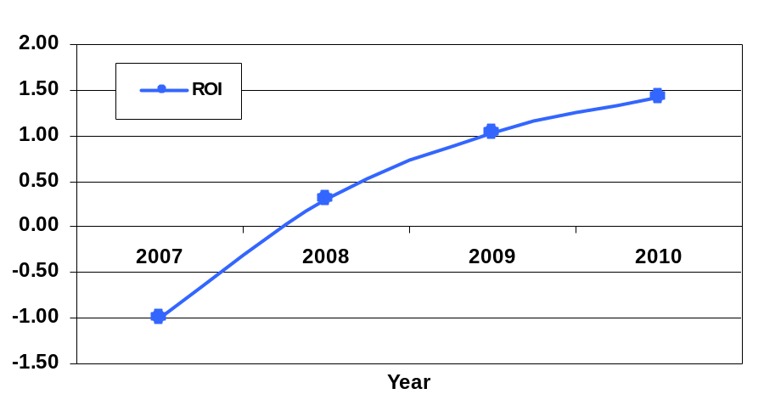

Architecture Feasibility
<< Provide evidence or rationale of why do you think the following LOS, capability, and evolutionary requirements are satisfiable. Example of product and process strategies can be found in ICSM EPG> Task: Provide Feasibility Evidence for Architecture Agile project >>

Level of Service Feasibility

Table 5: Level of Service Feasibility
Level of Service Requirement | Product Satisfaction
LOS-1: << LOS name >> | Product Strategies: <<Identify product-related strategies that can make you achieve this requirement. >>
LOS-1: << LOS name >> | Process Strategies: <<Identify process-related strategies that can make you achieve this requirement. >>
LOS-1: << LOS name >> | Analysis: << Provide rationale to support your strategies>>
 | Product Strategies:
 | Process Strategies:
 | Analysis:
 | Product Strategies:
 | Process Strategies:
 | Analysis:

Capability Feasibility

Table 6: Capability Requirements and Their Feasibility Evidence
Capability Requirement | Product Satisfaction
CR-1: << CR name >> | Software/Technology used: <<identify the software/technology that is/are used to develop this capability requirement>>
CR-1: << CR name >> | Feasibility Evidence: << briefly provide rationale of how this capability could be developed to satisfy the requirements. >>
CR-1: << CR name >> | Referred use case diagram: << identify related use case diagram >>
 | Software/Technology used:
 | Feasibility Evidence:
 | Referred use case diagram:
 | Software/Technology used:
 | Feasibility Evidence:
 | Referred use case diagram:

Evolutionary Feasibility

Table 7: Evolutionary Requirements and Their Feasibility Evidence
Evolutionary Requirement | Product Satisfaction
ER-1: << ER name >> | Software/Technology used: <<identify the software/technology that is/are used to develop this capability requirement>>
ER-1: << ER name >> | Feasibility Evidence: << briefly provide rationale of how this capability could be developed to satisfy the requirements. >>
ER-1: << ER name >> | Referred use case diagram: << identify related use case diagram >>
 | Software/Technology used:
 | Feasibility Evidence:
 | Referred use case diagram:
 | Software/Technology used:
 | Feasibility Evidence:
 | Referred use case diagram:

Process Feasibility
<< Based on process decision table provided in ICSM EPG> Concept: Process Decision Selection Guidelines, Identify which process model you are following and provide rationale why that model would fit your development project. Note: Development team discusses with stakeholders on important drivers and project status
Decision Criteria Rating Scale; 0:Very Low; 1:Low; 2: Medium; 3:High; 4:Very High
Importance Rating Scale: 1:Low; 2: Medium; 3:High
>>
Table 8: Rationales for Selecting Architected Agile Model
Criteria | Importance | Project Status | Rationales
30 % of NDI/NCS features
Single NDI/NCS
Unique/ inflexible business process
Need control over upgrade / maintenance
Rapid deployment
Critical on compatibility
Internet connection independence
Need high level of services / performance
Need high security
Asynchronous communication
Be accessed from anywhere
Critical on mass schedule constraints
Lack of personnel capability
Require little upfront costs
Require low total cost of ownership
Not-so-powerful local machines

Risk Assessment
<< Identify our project risk, its exposure and its mitigation plan. Please note risk is a threat or probability that something will happen and possibly create loss or injury. So, if your threat or your incident is already happened, then it is a problem, not a risk. More example of risks can be found at ICSM EPG> Task: Assess and Plans to Mitigate Risks>>
Table 9: Risk Assessment
Risks | Risk Exposure |  |  | Risk Mitigations
Risks | Potential Magnitude | Probability Loss | Risk Exposure | Risk Mitigations
We have no experience in implementing Optical Character Recognition and it is a critical feature for the Price Posting win condition | 9 | 3 | 27 | By prototyping we can buy information about this risk and understand early on the challenges involved in implementing it.
Component integration of Apache Cordova, Twiiter Bootstrap, The “Ke” web engine, and the open source OCR | 6 | 3 | 18 | Prototyping will most likely help us to solve this issue early on as well.
Win condition prioritization poses a risk as we currently have 24 and some may need to be consolidated or prioritized | 4 | 2 | 8 | Stakeholder meetings and discussions can help to consolidate these early on without later lose to project integrity
OCR open source does not produce high-accuracy results. In addition, it can recognize text well only from printed materials. Handwriting receipts will be the limitation. | 2 | 7 | 14 | Negotitate with Acquirer about the limitation of OCR technology. Allow users to edit what OCR recognizes before posting the price.

NDI/NCS Interoperability Analysis

Introduction
<< Identify the Non-Developmental Item (NDI) and Net-Centric Services (NCS) including open source software or libraries that you are using/ plan to use in your project and analyze their interoperability. >>

COTS / GOTS / ROTS / Open Source / NCS
<< Identify all candidate commercial off-the-shelf, government-off-the-shelf, research-off-the-shelf, open source software, libraries, and net-centric services component that you are using/ plan to use. Also identify the purpose of each component. >>
Table 10: NDI Products Listing
NDI/NCS Products | Purposes

Connectors
<< Identify the connector, for example
- “In this project, we use PHP/MySQL Connector to enable the PHP web application to retrieve and query data from the database”. >>

Legacy System
<< Identify the connector, for example
- “In this project, the development system has to be able to interoperate and works well with “BusinessWorks” version 5.2, which is a software system that the client is currently using.” >>

Evaluation Summary
<< Summarize the final selection of your interoperable NDI/NCS, its usage and its comment. Example can be found in ICSM EPG> Task: Analyze NDI Interoperability for NDI / NCS project. >>
Table 11: NDI Evaluation
NDI | Usages | Comments

