System and Software Architecture Description (SSAD)

Cash Doctor 3.0 Mobile APP
Team 12

Name Primary Role
Alisha Parvez Life Cycle Planner
Ekasit Jarussinvichai Requirements Engineer
Kenneth Anguka Requirements Engineer
Kshama Krishnan Prototyper
Le Zhuang Feasibility Analyst
Shreya Sharma System/Software Architect
Steven Helferich Project Manager
Xichao Wang Operational Concept Engineer

October 13,2014

Version History
Date | Author | Version | Changes made | Rationale
10/13/14 | Kshama  Shreya | 1.0 | Using the SSAD template, determined the purpose and the status of the current architecture of the project and system analysis using use cases, artifacts and system context diagrams | - To depict different non-technical architectural overview of the project

Table of Contents
System and Software Architecture Description (SSAD)
Version History 1
Table of Contents 2
Table of Tables 3
Table of Figures 4
1. Introduction 5
1.1 Purpose of the SSAD 5
1.2 Status of the SSAD 5
2. System Analysis 6
2.1 System Analysis Overview 6

Table of Tables

Table 1:Actors Summary……………………………………………………………………………………7

Table 2:Artifacts and Information Summary…………………………………………………………….8

Table 3:Process Description……………………………………………………………………………….9

Table of Figures
Figure 1:System Context Diagram………………………………………………………………………6

Figure 2:Artifacts and Information Diagram………………………………………………………….8

Figure 3:Process Diagram………………………………………………………………………………9

Introduction

Purpose of the SSAD

This document provides a comprehensive architectural overview of the system, using a number of different architectural views to depict different aspects of the Cash Doctor Mobile Application 3.0. It is intended to capture and convey the significant architectural decisions which have been made on the system.

Status of the SSAD

This current status of the document provides the non-technical comprehensive architectural overview of the system, not using the different technical details as of now of Cash Doctor Mobile Application 3.0.

System Analysis

System Analysis Overview
The primary purpose of the Cash Doctor Mobile Application 3.0 is empowering consumers
with the cost and quality of care by sharing pricing and review information of healthcare costs.
Through the development of a free mobile app, we will allow consumers, globally, to share
the cost of care, thus driving down the cost of medical services while improving the health
of consumers. This project constitutes of three sections; section 1 will allow the consumer to
capture a picture of a health care receipt via the smart phone’s camera, define the charges on the
bill while attaching to a provider in a geo location (resembles the current bank mobile deposit
app) Section 2 will allow the consumer to lock on to providers creating a private user network
with updates and comparison features and section 3 will allow users to search data posted by
other users - geolocation, provider, other users, specialty, lifestyle.

System Context

Cash Doctor 3.0 Mobile APP System Context Diagram

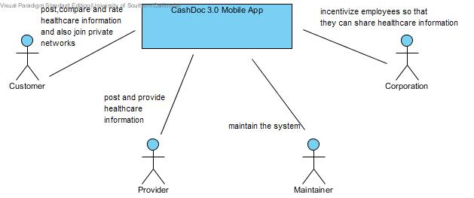

Figure 1: System Context Diagram

Table 1: Actors Summary

Table 1:Actor diagram

Actor | Description | Responsibilities
Customer | A customer can post, compare, rate the healthcare services.He can also join a private network. | 1.Can create an account  2.Can create and edit profile  3.Can share the prices by uploading his medical bills.  4.Can search healthcare services based on location,price,services offered etc.  5.Can form a network and become part of an existing network  6.Can rate and review providers.
Provider | Provide healthcare information like price posted, videos, photos and blogs. | 1.Can share prices based on the service offered.  2.Can upload pictures, videos, and blogs.
Corporation | Incentivize employees so that employees can share healthcare information | 1.Encourage employees to share more healthcare information on Cashdoc so that employees gain incentives from corporations.
Maintainer | Maintain the website by approving newly registered users. | 1.Approve newly registered users.  2.Filter invalid or bad content.

Artifacts & Information
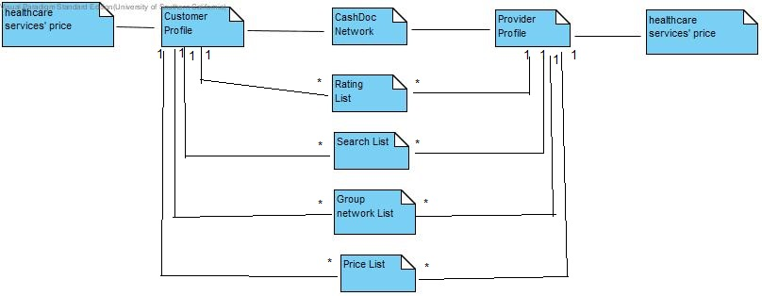

Figure 2: Artifacts and Information Diagram
Table 2: Artifacts and Information Summary
Artifact | Purpose
ATF-1:Customer Profile | Contains information about the prices the customer has shared, the networks he is part of and the providers that he has rated.
ATF-2:Provider Profile | Contains prices for each of the services they provide.They also contain blogs, videos and photos related to the healthcare services which are being offered.
ATF-3:Price List | Contains information about the price of the medical bills.
ATF-4:Rating List | Contains the rating and the reviews written by the customers about the healthcare providers
ATF-5:Search List | Contains information about the search made by the customer based on location, price, services etc.
ATF-6:Group List | Contains information about the customer or provider who is part of the network.

Behavior

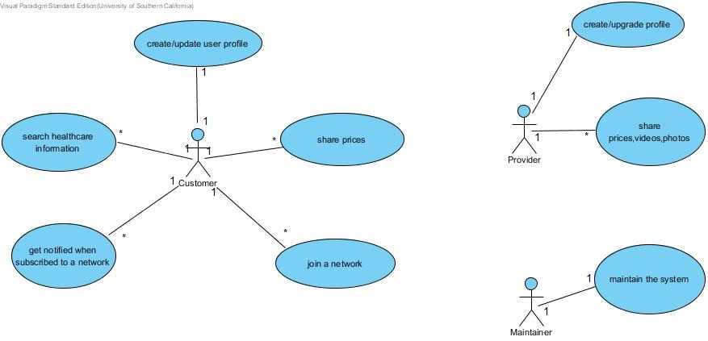

Figure 3: Process Diagram

USE-CASE GRID

ID | NAME | PRIMARY ACTORS
UC1 | Create/Login customer profile | Customer
UC2 | Update customer Profile | Customer
UC3 | Prices shared by the customers | Customer
UC4 | Search healthcare information | Customer
UC5 | Create a network | Customer
UC6 | Join an existing network | Customer
UC7 | Get notified based on the network subscribed for | Customer
UC8 | Create/Login Provider profile | Provider
UC9 | Provider shares Healthcare Information | Provider
UC10 | Maintain the system | Maintainer
UC11 | Customer can rate/review a provider | Customer
UC12 | Customer can compare medical price information | Customer

Capability

Create/Login customer profile, Create/Login Provider profile
Identifier | UC1,UC8:Login
Purpose | Determines if a person logging in to the system can be authenticated, and, if so, what the person's privileges are as a user of the system, i.e., what the person is authorized to do when using the system
Requirements | Authorization and Authentication
Development Risks | None
Pre-conditions | CMS database should be initialized
Post-conditions | If customer is authorized s/he is given access to “My accounts” page; otherwise, s/he is denied access to the system.

Typical Course of Action:Login-Successful
Seq# | Actor’s Action | System’s Response
1 | [Customer] Enters a user name and password
2 | [Customer] Clicks Login button
3 |  | Sends username and password to the CMS server
4 |  | [valid] Redirects the actor to “My Accounts” Page

Alternate Course of Action:Login-New Account
Seq# | Actor’s Action | System’s Response
1 | User click “Register New Account” link
2 |  | Directs to the “New Account” Page
3 | Customer inputs all the fields and clicks register
4 |  | [valid]Directs to the “My Account” Page
 |  | [invalid]Displays error messages

Alternate Course of Action:Login-Failure
Seq# | Actor’s Action | System’s Response
1-3 | Refer to Typical Course of Action
4 |  | Displays An error message: “username or password is wrong” in a dialog box
5 | Click OK button
6 |  | Redirects the user to the login page

Alternate Course of Action:Login:Forgotten Password
Seq# | Actor’s Action | System’s Response
1 | User click “Forgotten username or password” link
2 |  | Sends An email message, providing the details of the customer’s credentials to his email id.
3 | User opens the email and inputs the username and password again
4 |  | Refer to Typical Course of Action

Create/Login Provider profile
Identifier | UC2
Purpose | To provide a homepage for the user wherein the user gets to know all the features available to him like price posting, viewing different networks where he can join,searching various healthcare services.
Requirements | None
Development Risks | None
Pre-conditions | The user should be logged in
Post-conditions | The user can explore all the features available to him in his account

Typical Course of Action
Seq# | Actor’s Action | System’s Response
1 | User clicks on any feature that he wants to explore
2 |  | System directs him to the required page
3 | User modifies information in his dashboard
4 |  | [valid]Modified information is updated in the server  [invalid]Error message is displayed.

Prices shared by the customers
Identifier | UC3
Purpose | Uploading medical bills so that the cost of that particular healthcare service is known.The uploading can be done manually or through an OCR capture
Requirements | None
Development Risks | OCR is not accurate and will not recongnize handwritten medical bills
Pre-conditions | UC1,UC2
Post-conditions | If the price and other fields are valid, the information is updated in the database.

Typical Course of Action: Share Price manually
Seq# | Actor’s Action | System’s Response
1 | Clicks share price manually
2 |  | The doctor’s name,the service offered and the price field is displayed on screen
3 | The user input all the fields
4 |  | [valid]stores information into the database  [invalid]Displays error message
Alternate Course of Action:Share Price through OCR capture
Seq# | Actor’s Action | System’s Response
1 | Clicks share price through photo capture
2 |  | The photo option is enabled
3 | User clicks the photo and uploads to server
4 |  | If OCR reads the medical service and corresponding medical price correctly,updates in database  Else,makes the user to try again.

Search healthcare information
Identifier | UC4
Purpose | Users can search doctors based on multiple conditions like locality,price,service etc
Requirements | None
Development Risks | None
Pre-conditions | UC1,UC2
Post-conditions | The user will be able to view a list of all the doctors and their price based on multiple conditions specified.

Typical Course of Action
Seq# | Actor’s Action | System’s Response
1 | Inputs the fields-locality,service and price and click search
2 |  | [valid]retrieves all the records matching the condition  [invalid]Displays an error message

Alternate Course of Action
Seq# | Actor’s Action | System’s Response
1-1 | Refer to typical course of action
2 |  | If no records found, then displays “No records found”

Create a network
Identifier | UC5
Purpose | The user can create his own network which basically contains all the doctors he would want to subscribe to.the user can also join an existing network where he would want to receive updates from.
Requirements | None
Development Risks | None
Pre-conditions | UC1,UC2
Post-conditions | The user creates a new network

Typical Course of Action
Seq# | Actor’s Action | System’s Response
1 | Clicks “Create new network”
2 |  | The name of the network is displayed
3 | The user inputs a name and other information such as healthcare speciality
4 |  | A new network is created by creating a new entry in the database.

Join an existing network
Identifier | UC6
Purpose | The user can join any network that he would want to get notifications from
Requirements | None
Development Risks | None
Pre-conditions | UC1,UC2
Post-conditions | The user is part of the network which he selected.

Typical Course of Action
Seq# | Actor’s Action | System’s Response
1 | User searches the network which he want to be part of
2 |  | Displays all information based on his search criteria
3 | Based on the user’s preference, he selects the network that he would want to be a part of
4 |  | The information about the network that the user wants too join is updated in the database

Get notified based on the network subscribed for
Identifier | UC7
Purpose | The
Requirements | None
Development Risks | None
Pre-conditions | UC4,UC6
Post-conditions | The user will be able to get up to date information about all the notification posted by their providers

Typical Course of Action
Seq# | Actor’s Action | System’s Response
1 | User searches for the providers
2 |  | Retrieves list of doctors based on the conditions supplied
3 | The user selected a doctor and click “notify me”
4 |  | The user will be notified about the doctor henceforth.
Alternate Course of Action
Seq# | Actor’s Action | System’s Response
1-2
4 | The user click unnotify me
5 |  | The user will be innotifies about the provider henceforth

Provider shares Healthcare Information
Identifier | UC9
Purpose | The provider will be able to share all the healthcare services that he offers in the form of blogs,videos,pictures etc.
Requirements | None
Development Risks | None
Pre-conditions | UC8
Post-conditions | The updated information is sent out to every customer who has subscribed to this provider.

Typical Course of Action
Seq# | Actor’s Action | System’s Response
1 | Provider uploads content in his homepage
2 |  | [successful]the data is stored in the database  [unsuccessful]error message indicating uploading was unsuccessful

Maintain the system
Identifier | UC10
Purpose | The maintainer is responsible for approving the new creation requests
Requirements | None
Development Risks | None
Pre-conditions | UC1
Post-conditions | The new users are approved by the maintainer

Typical Course of Action
Seq# | Actor’s Action | System’s Response
1 | Checks for new requests
2 |  | List of new requests are retrieved
3 | Maintainer approves the requests that are valid and unapproves the invalid ones
4 |  | The information is updated into the database

Customer can rate/review a provider
Identifier | UC11
Purpose | The user has the ability to rate or review a provider
Requirements | None
Development Risks | None
Pre-conditions | UC4
Post-conditions | None

Typical Course of Action
Seq# | Actor’s Action | System’s Response
1 | Searches for the provider to whom the review/rating needs to be written
2 |  | Retrieves the provider details
3 | Writes the rating/review
4 |  | The information is updated in the database.

Customer can compare medical price information
Identifier | UC12
Purpose | The user has the ability to compare medical price information
Requirements | None
Development Risks | None
Pre-conditions | UC4
Post-conditions | None

Typical Course of Action
Seq# | Actor’s Action | System’s Response
1 | Searches for the provider based on his search criteria like location,price
2 |  | Retrieves the provider details
3 | Compares the result

