Task 1: Process Creation Utility

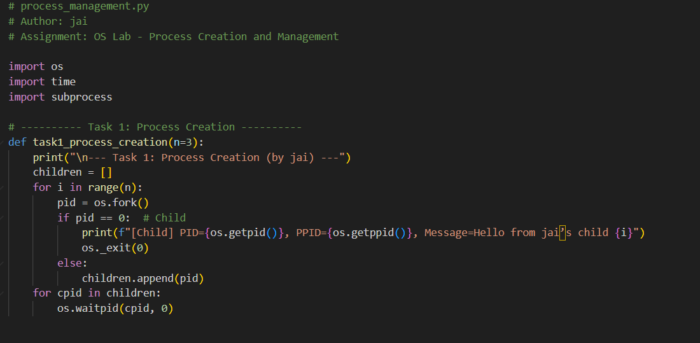

Task 2: Command Execution Using exec()
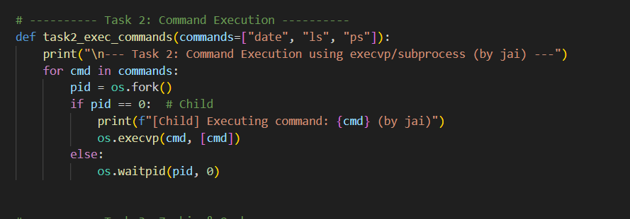

Task 3: Zombie & Orphan Processes

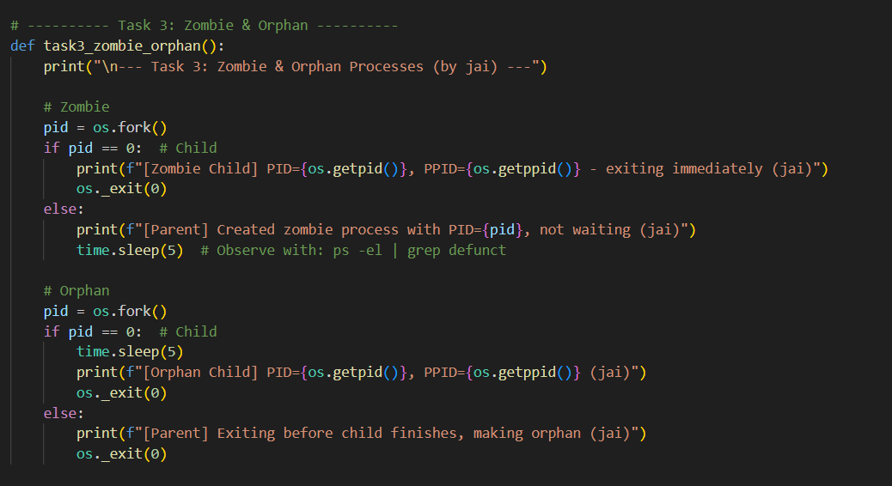

Task 4: Inspecting Process Info from /proc
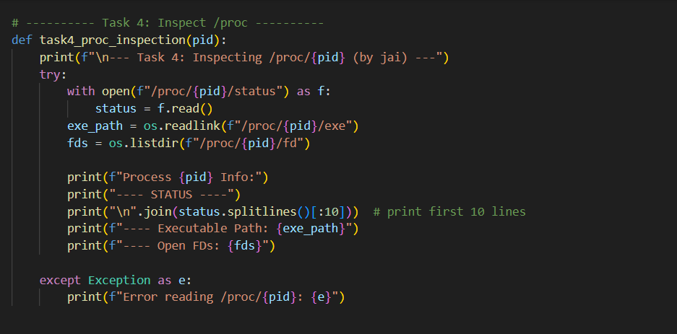

Task 5: Process Prioritization
