CASE STUDY: MVP OF AN APP

SHREYAA CHOUDHURY

+91-8334917889  
shreyaa.choudhury@gmail.com

The MVP is for a superapp which is a one-stop shop for all freelance consultants and digital consumers.

**LordsApp: One app to bind them all, in darkness find them!**

|  |  |  |
| --- | --- | --- |
| **MAIN PROBLEMS** | **SUB PROBLEMS** | **FEATURES & SUCCESS METRICS** |
| Accessibility | Expand to new markets | End Users-Search Bar, listing of the type of consultants like physicians, dieticians, CA, astrologers, etc. Consultants - Register/Sign up page.  **Success metrics** - Traffic can be measured by number of app downloads, registrations, number of active users, uninstallations. |
| Real time consultations | End Users - Service Listing Cards for each profile with ratings, credentials, green dots to show active consultants and action buttons like Call/Chat/Book an Appointment buttons. Consultants - Toggle button to switch to online/offline mode for either/both call and chat services.  **Success metrics** - Number of clicks, click to action rate, Load time for notification window after clicks on action or toggle buttons. |
| Ease to onboard & operate | The interface must be easy and flexible | End Users -   1. Home Page with the Search bar. 2. Listing on the basis of type of consultants opens to show organic lists of all active then inactive individual consultants. 3. Triple bar or Options: This button opens to show further recourses. 4. Book Now Window to book an appointment for desired time and date.   Consultants-   1. Sign up/ login page. 2. Home Page opens to Chats, Calls and tri-bar (options). 3. Chats page: Shows all ongoing and past chats with users with toggle to go online. 4. Calls page: Shows all past calls, with duration and review section with toggle to go online. 5. Triple bar or Options: This button opens to show further recourses.   **Success Metrics**- Engagement rate, bounce rate, time spent, number of keyword searches, number of clicks. |
| Payment | Secure collection of payment from users and timely transfers to the stakeholders i.e., the consultants. | End Users -   1. Confirm & Pay button after action to call/chat/book an appointment that leads you to the Choose Payment Method page. 2. The Choose Payment Method page shows various online payment methods like credit/debit cards, UPI, etc. Select one and proceed or cancel to go back to the last page. 3. Order History shows one all the past consultations with details like name, date, time, duration, fee paid, invoices, ratings/review given.   Consultants-   1. Invoices option to show and download previous invoices. 2. Order History shows past consultation details like name, date, time, duration, total fee and rating/review of the customer. 3. Bank details show the details like full name, account number, IFSC code and address and an option to update the bank details.   **Success Metrics** - Number of orders and repeat orders, retention rate, spend rate, revenue generated per unit. |
| Updates | In-app | End Users-   1. Notification pop-up window after action to show calling, waiting, or confirmation of appointments. 2. Notification bell icon to list all recent updates on the app and necessary updates required by the user. 3. Appointments show list of upcoming consultation appointments with edit/cancel consultation with * terms & conditions applied on cancellation in the next 7 days. It also shows cancelled appointments. Cancellations before 6 hours of appointments will reduce cancellation charges.   Consultations-   1. Notification pop-up window to show end user requesting real-time consultations with buttons to accept/reject and/or confirmation of an appointment. 2. Notification bell icon to list all recent updates on the app and necessary updates required by the consultant. 3. Reminder pop-up for upcoming appointments in the next 6 hours. 4. Appointments show list of upcoming consultation appointments and edit/cancel consultation with * terms & conditions applied on cancellation in the next 7 days. It also shows cancelled appointments.   **Success metrics** - Open rate, View rate, Conversion rate, cancellation charges, revenues from appointments, number of orders. |
| Out of app | End Users-   1. Generic Push and/or email notifications about the latest updates, festive greetings, ratings/review requests. 2. Personalized Push and/or notifications alerting users about their desired consultant being online.   Consultants-   1. Generic Push and/or email notifications about the latest updates, festive greetings, ratings/review requests. 2. Personalized Push and/or email notifications with reminders of upcoming appointments, recently booked appointments, profile review/rating update by users.   **Success metrics**- Time spent, re-engagement rate, view rate and open rate. |

**BASIC LAYOUT**

**FOR END USER**

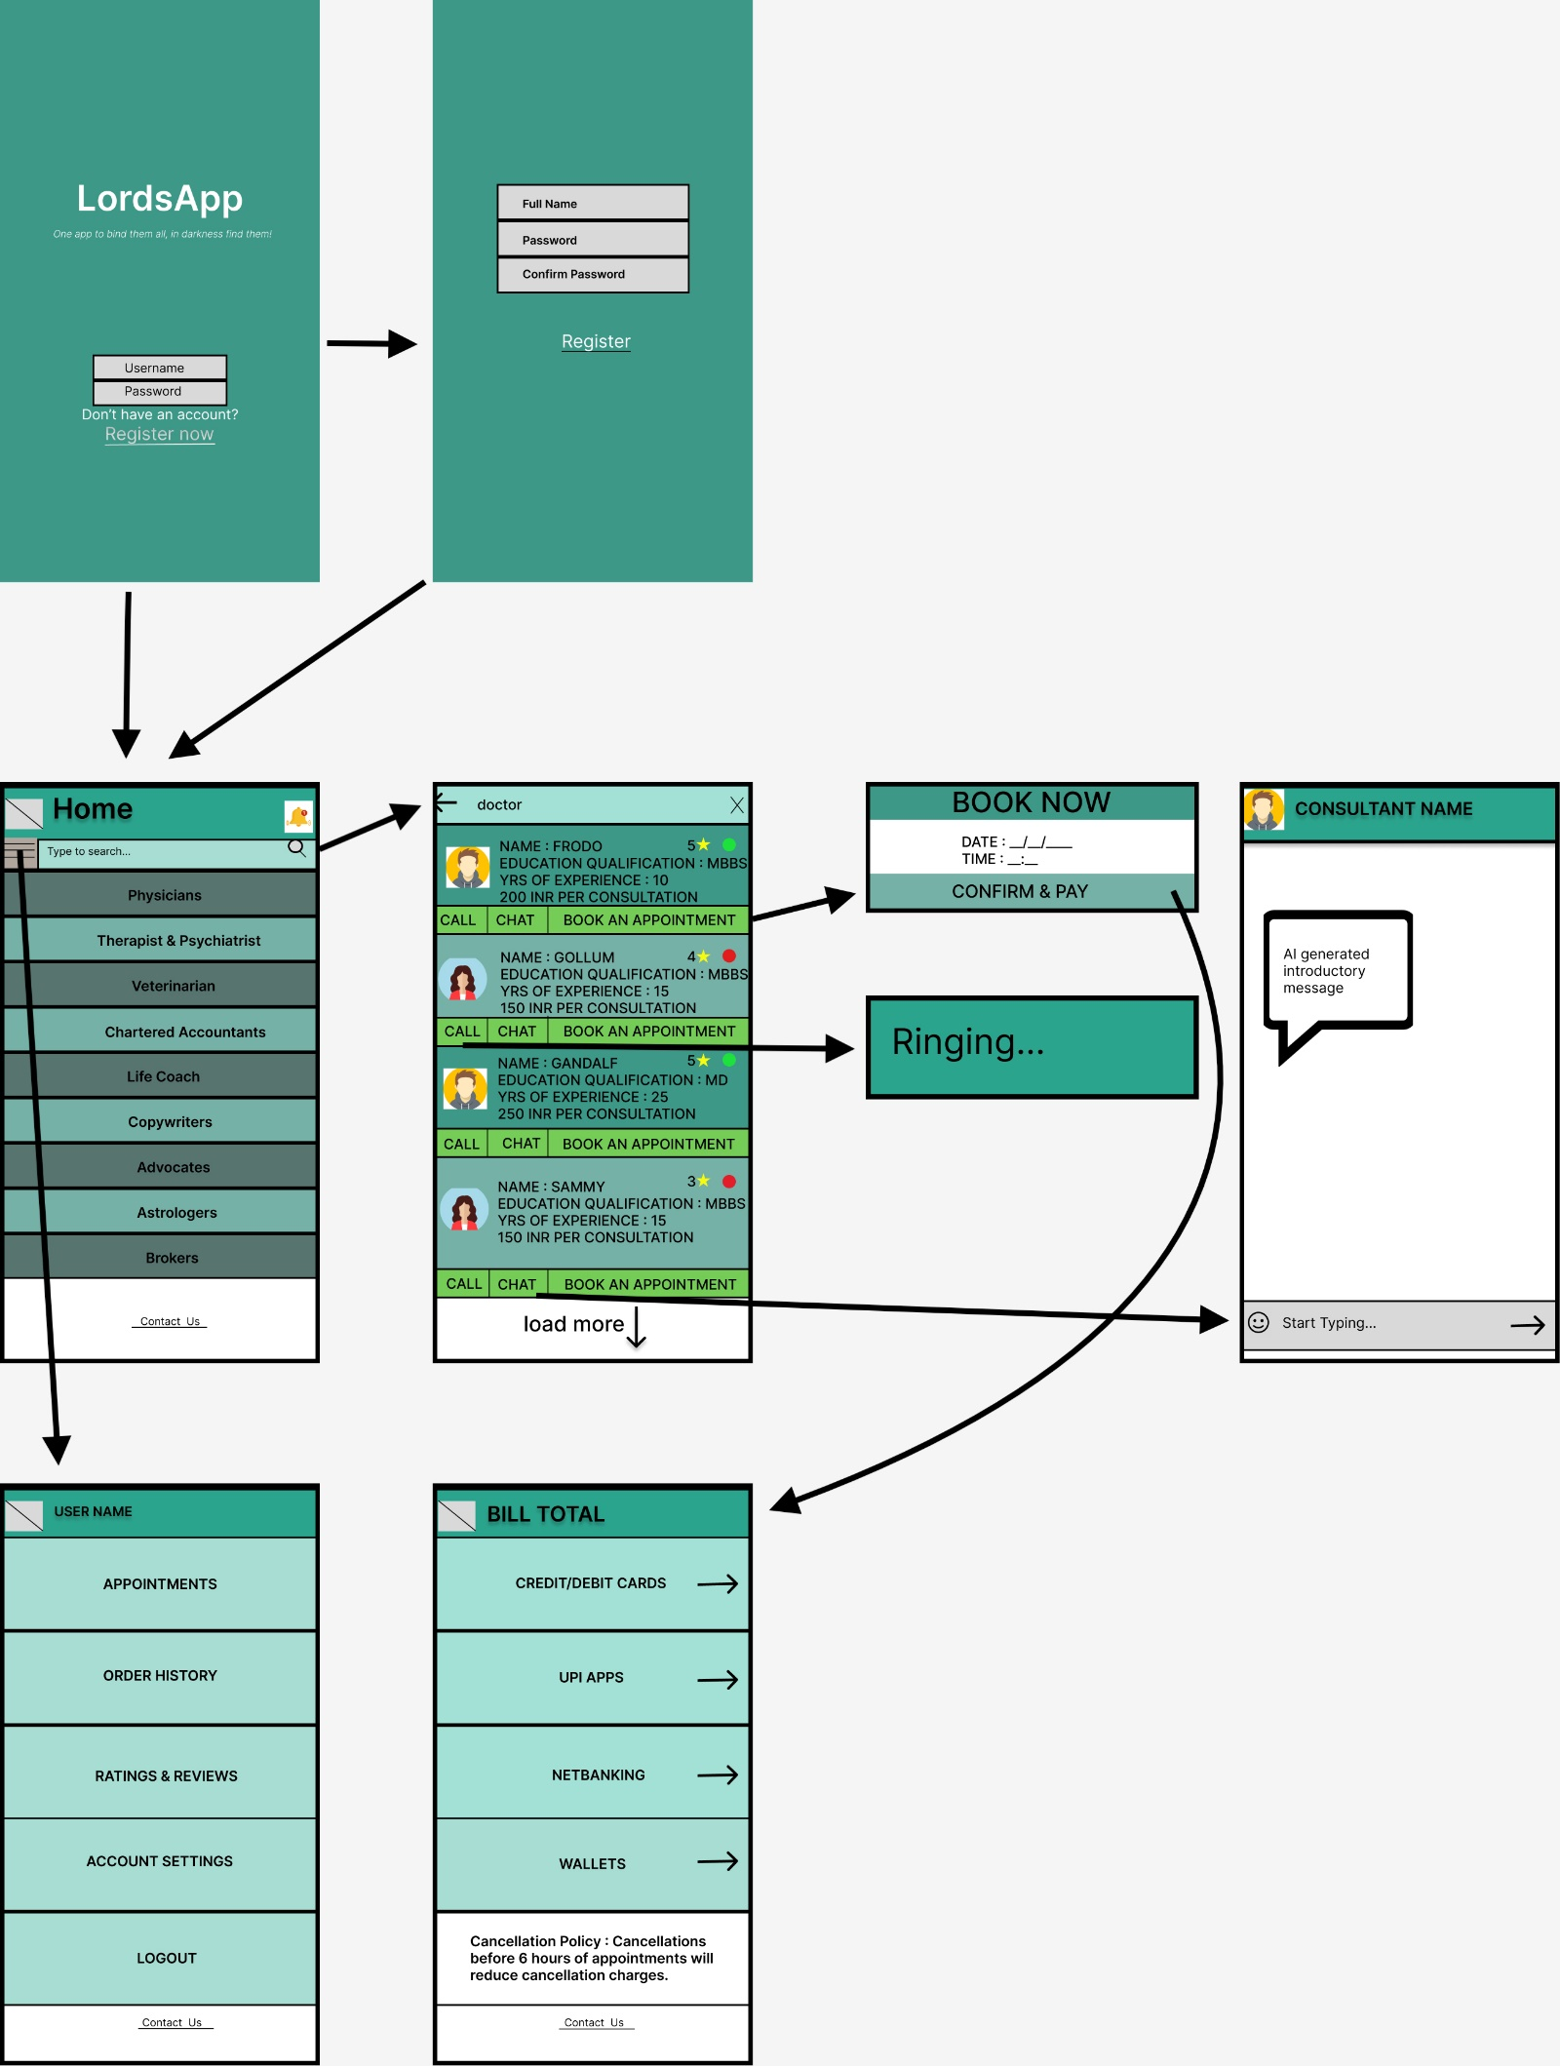

**FOR CONSULTANTS**

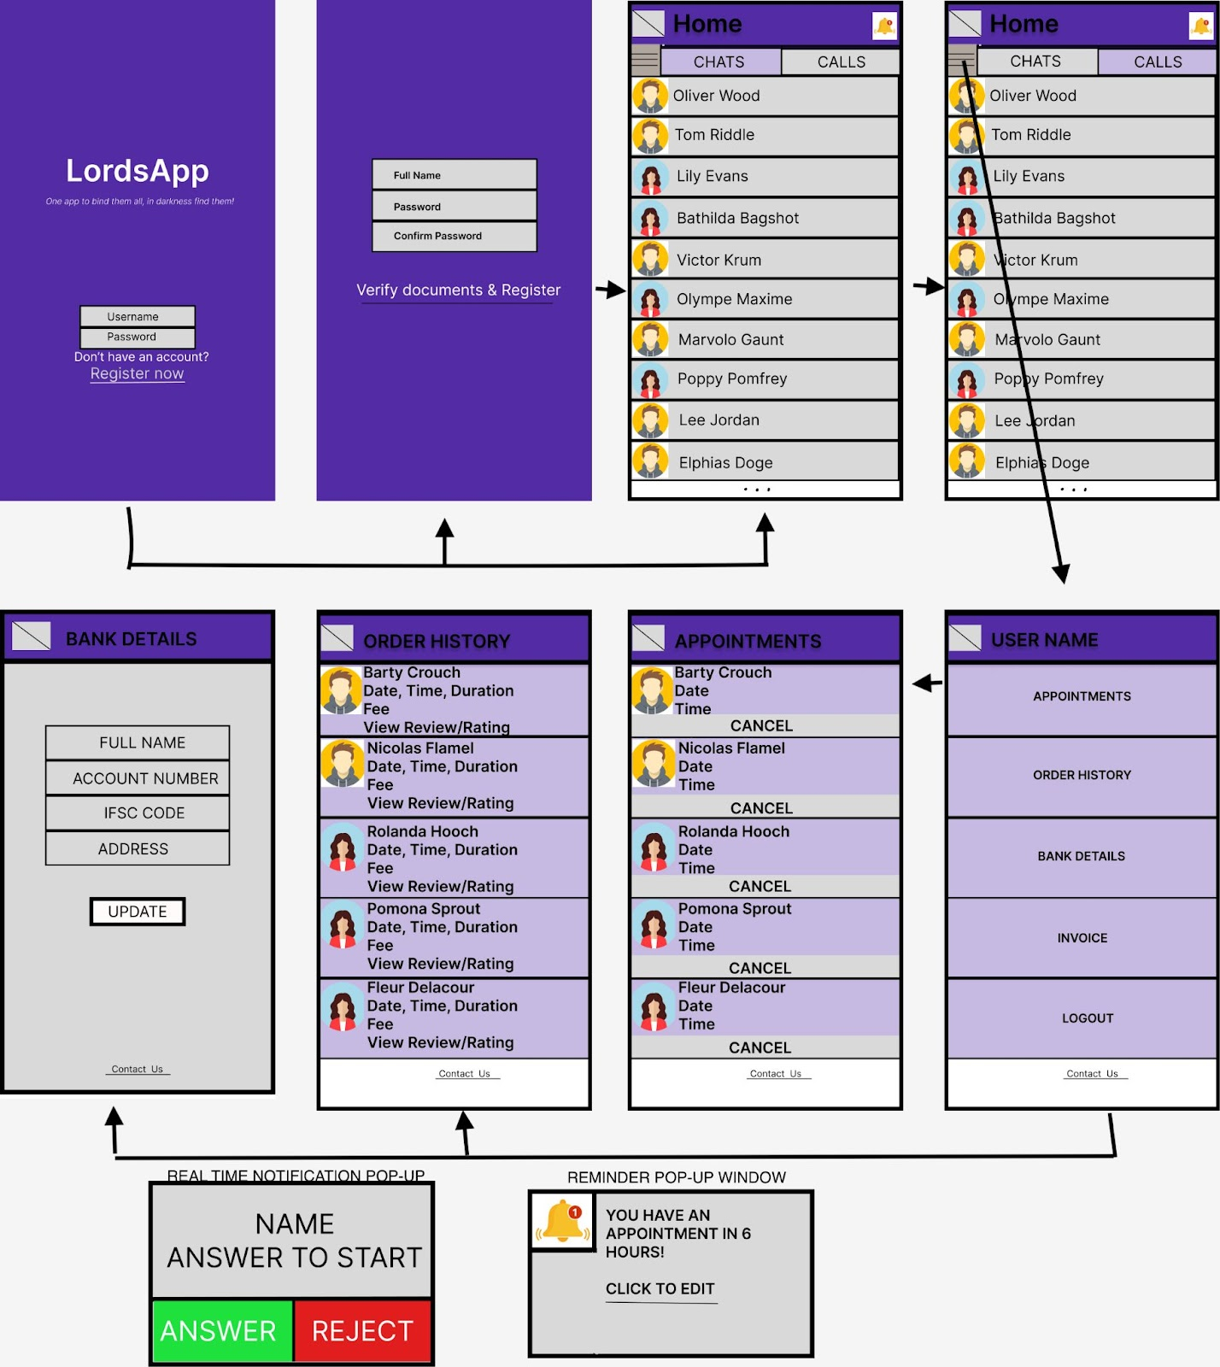

**COMPETITIVE LANDSCAPE**

Porter’s Five Forces have been used as a framework to determine the competitive forces in the market.

|  |  |
| --- | --- |
| **Competition in Industry** | **Low**; There are a few super-apps currently in India like Tata Neu, Paytm, MyJio, however their offering is different than Lordsapp. |
| **Threat of new entrants** | **High**; Barrier to entry is extremely low with cost & time to enter the market. |
| **Power of buyers** | **High**; Switching cost is low, high volume of users with extreme price sensitivity and high ability to substitute. |
| **Power of suppliers** | **Low**; The app serves as the digital yellow pages for all kinds of consultants which is a rare offering by a player. |
| **Threat of substitutes** | **High**; Numerous individual types of consultants’ digital apps like Practo for physicians, Indiafilings for Chartered Accountants, etc. Apart from that, buyers will find countless options offline. |

**HOOK FRAMEWORK**

**FOR END USERS**

|  |  |
| --- | --- |
| TRIGGER  Internal: Any online consumer would be delighted to have all types of consultants under one roof.  External: Could be paid ads, celebrity marketing, influencer marketing, referrals, email & pop-up notifications. | ACTION  Open and register on the app. Try to search keywords on the Search bar and browse through the pre-existing listing on the basis of types of consultants. |
| INVESTMENT  Users may subscribe to a premium membership.  This may increase user referrals and word of mouths which in turn helps in the brand placement and growth. | VARIABLE REWARDS  1 superapp for all types of consultant services. No more clutter of multiple apps on mobile phones.  Try multiple & new consultants for confirmations. |

**FOR CONSULTANTS**

|  |  |
| --- | --- |
| TRIGGER  External: Pop-up notifications with new offers on the commission, Email notifications with detailed profile metrics like number of orders, number of clicks, accepted/rejected orders, open rate, profile conversion rate.  Internal: Freelance consultants want to expand their user base and want flexibility in work hours, online platforms provide both in just one click! | ACTION  Open the app, increase consultation time which increases the visibility of the user, attracts customers, increases the number of orders, hence the revenue of the company increases. |
| INVESTMENT  Consultants may invest in sponsored services like Ad Clicks. The more consultants act to open the app, they invest their time and effort, which helps create investments in the form of content, data, followers and reputation. | VARIABLE REWARDS  Consultants’ ratings increase with visibility and help garner more orders and increase income via the app.  Referrals from existing users may help strengthen one’s credibility and customer base.  Flexibility to work at one’s own time makes it more attractive. |

**RESOURCES & BUDGET**

The resources required would be 1 front-end engineer, 1 back-end engineer and a data analyst.

To allocate a budget, criteria like salaries, development time, cost of maintenance should be estimated.

Ideally, a generally accepted formula to calculate the cost of developing an app in India is = development time *salary

As per Google,

Average salary of a front-end developer is 4.5 LPA

Average salary of a back-end developer is 5.5 LPA

Average salary of a data analyst is 4.3 LPA

Total salary of the team is 14.3 LPA

To allocate a budget, criteria like salaries, development time, cost of maintenance should be estimated.

For a standard app development in India, development time ranges from 4-9 months.

Total salary of the team is 14.3 LPA

Approx. cost of developing an app = (14.3/12) *9 = ₹10.72 Lacs

Approx. cost of maintenance is 20% of the initial development cost = 10.72 * 20%= ₹2.15 L

Total budget to execute the plan and develop app is = 10.72 + 2.15 = ₹ 12.87 L

**BUSINESS MODEL**

Consultants: We would opt for a commission-based revenue model wherein the cost is related to the value of the business achieved rather than just a fixed amount. As per www.enginethemes.com commission of 15% per transaction is considered a good rate. For partners who want to be exclusive with our platform can work with us at a lower commission for a certain time period.

Users: We would opt for a fixed fee model, wherein end users pay for individual consultations.

As per market experts, the cost of consultation on superapps ranges from ₹50 -₹2000. Avg is ₹1025.

**Unit economics** is calculation of revenues and costs in relation to an individual unit.

It depends on:

1. The amount of business spent to acquire the profile = customer acquisition cost.
2. Revenue each profile generates for the business.

Let there be 10 super apps which are active.

* Avg price is ₹1025
* Let the active paid service users per day be 100 M and 10M per app.

Net revenue = Users * ARPU * (1- commission)

ARPU = Avg price * Conversion * Lifetime

Conversion = Percentage of consultants who have opted for paid services like Ad clicks, let it be 2%.

Lifetime = Let it be 6 months.

Therefore,   
                 ARPU per unit= 1025 * 2% * 6 = 123

Net Revenue= 123 * (1-15%) = 1045.5M

Revenue per unit = ₹104.55

Cost per user = (CPM/1000)/CTR/CTI

As per adcostly.com, digipuush.com and wordstream.com;

Avg CPM in India = 60

Avg CTR in India = 2%

Avg CTI in India = 4%

Therefore,

Cost per user = (60/1000) / 2% / 4% = ₹75

Profit = Revenue per unit - Cost per unit = 104.55-75 = ₹29.55

**RECOMMENDATIONS**

Initially our goal is to acquire users and gain market share, instead of making high profits off the bat. This aligns with the assumption in the problem statement, the primary market goal is gaining market share.

Eventually the revenue could be increased by introducing:

* In-app advertising for third parties and commercial ad networks.
* Sponsored Ads / Ad Clicks for consultants.
* Transaction fees which would be a nominal amount charged for making digital payments available for the users.
* Exclusivity option for the finest consultants in the market whereby there will be a discount on the commission charged granted they are exclusively available on our app only. The contract would be time-bound which would organically grow our user base and revenue from consultation fees.
* Increase the commission percentage eventually to market standards for all users after the early adopters.