**Manasi Jadhav | Neha Kolambe | Shreya Jain**

**2018140025 | 2018140030 | 2018140027**

**CN-ISE2 Mini Project**

**Aim:** To Create a LUDO GAME Using SOCKET PROGRAMMING.

Ludo is a strategy board game for two to four players, in which the players race their four tokens from start to finish according to the rolls of a single die.

Two, three, or four can play, without partnerships. At the beginning of the game, each player's four tokens are out of play and staged in the player's yard (one of the large corner areas of the board in the player's colour). When able to, the players will enter their tokens one per time on their respective starting squares, and proceed to race them clockwise around the board along the game track (the path of squares not part of any player's home column). When reaching the square below his home column, a player continues by moving tokens up the column to the finishing square. The rolls of a single die control the swiftness of the tokens, and entry to the finishing square requires a precise roll from the player. The first to bring all their tokens to the finish wins the game.

**Code:**

File is attached with this document.

**Output:**

Start Page

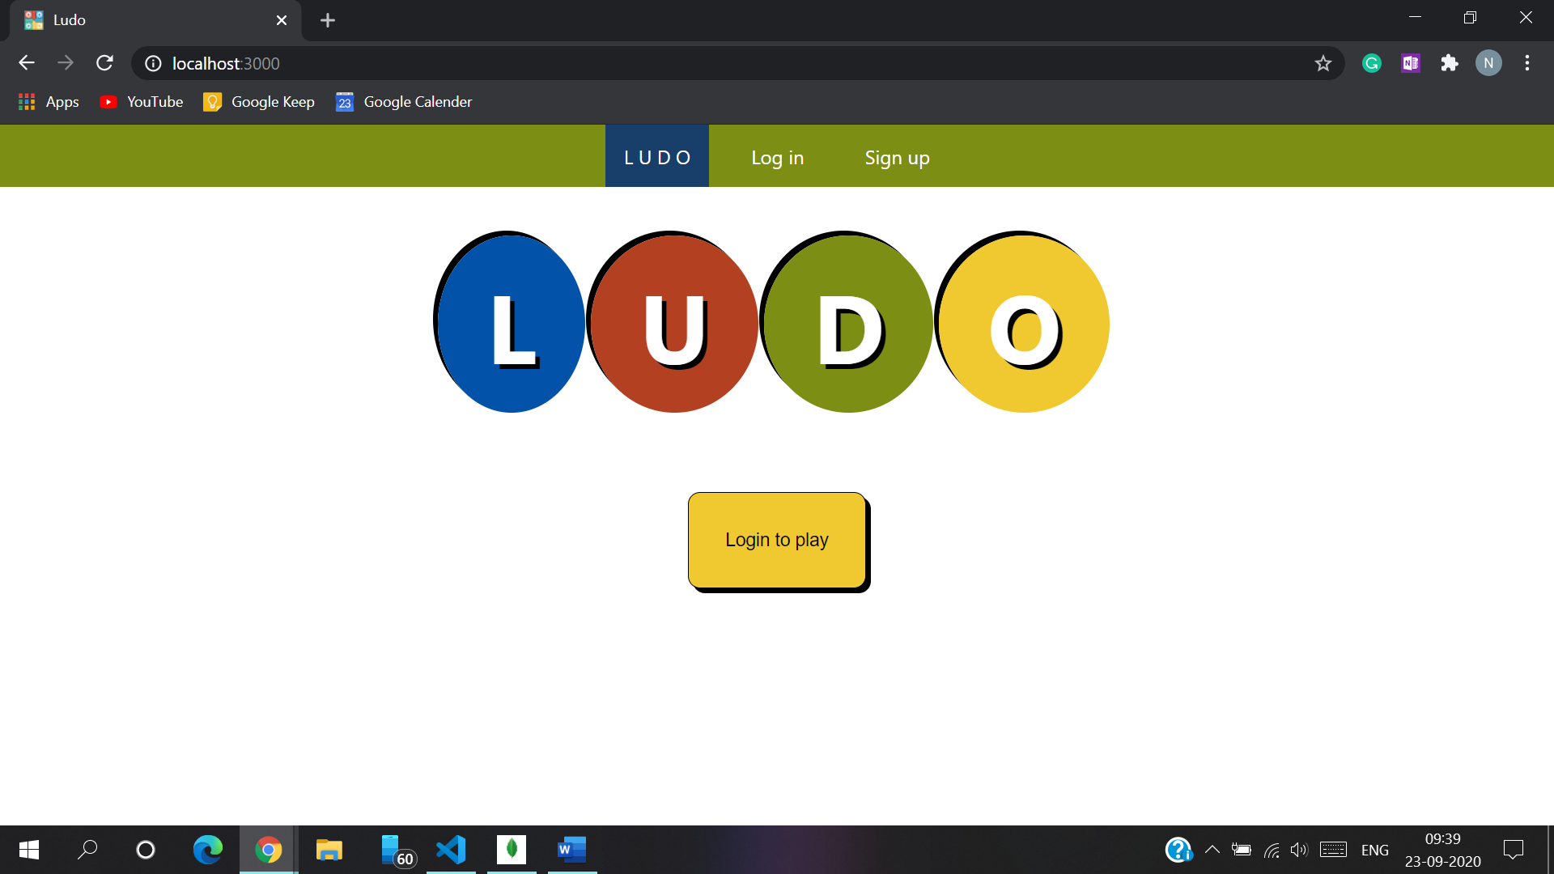

Structure of Table named “users” in myapp Database

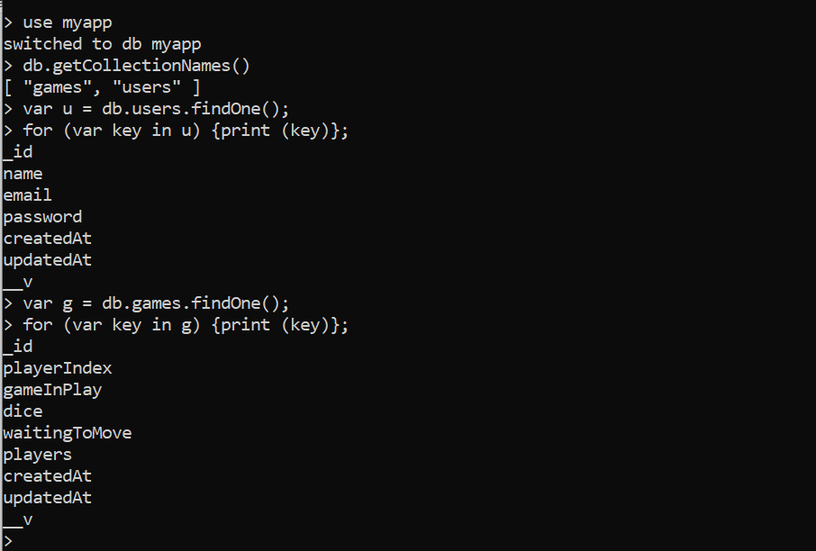

Sign Up Page:

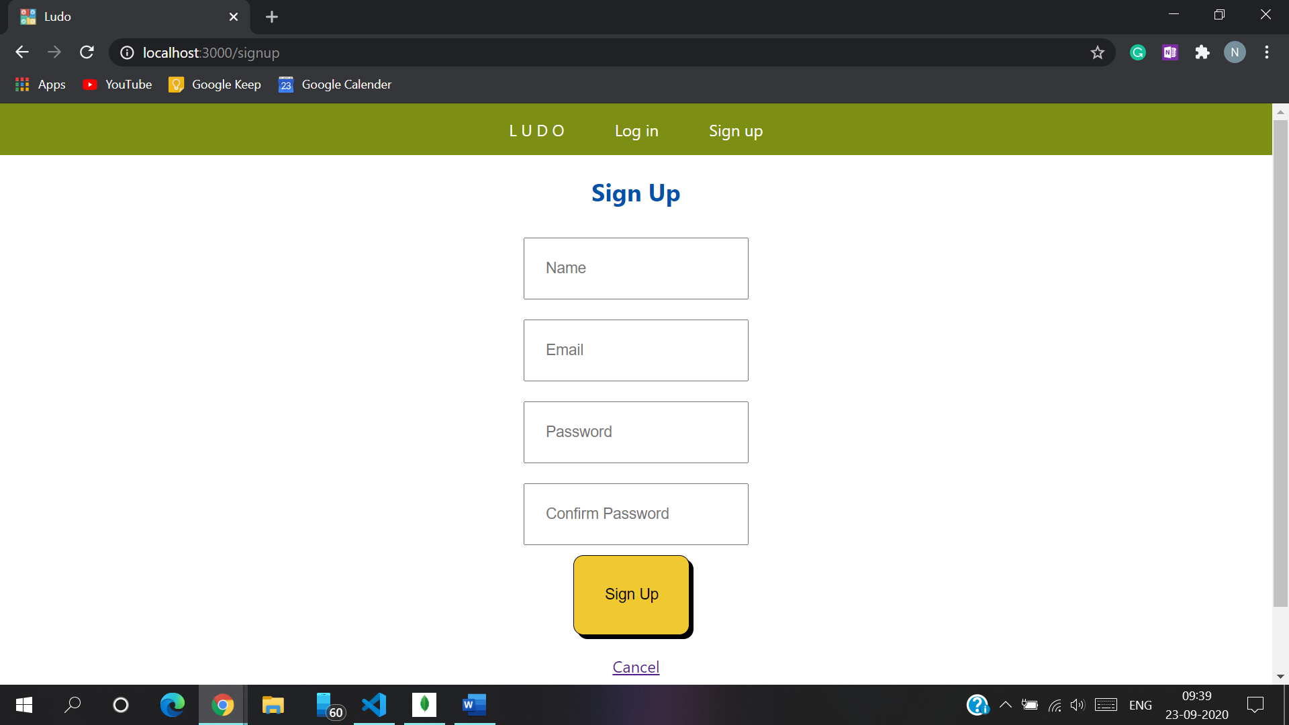

Login Page:

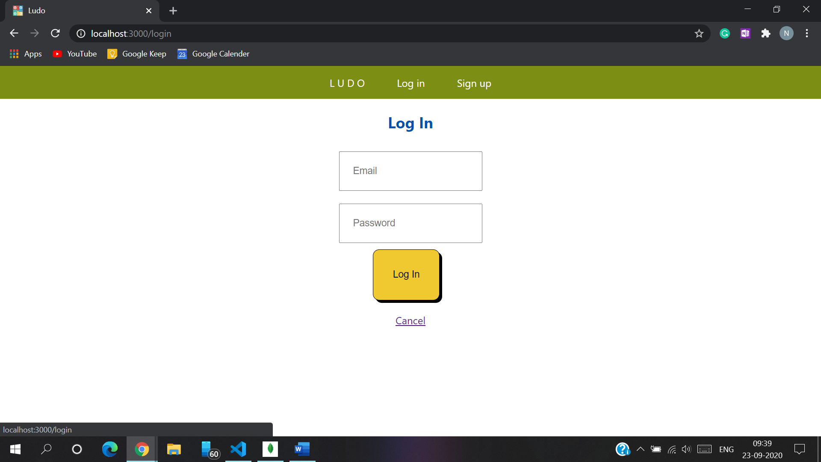

This is the current records in the users table

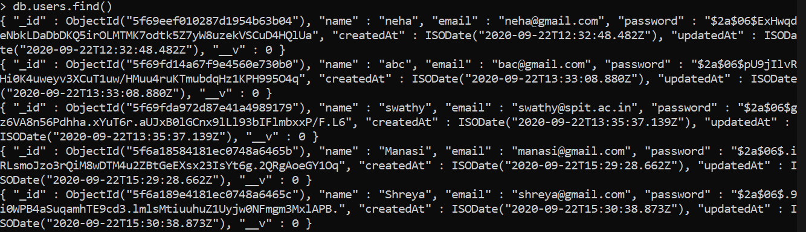

Ram registers using the Sign-Up page

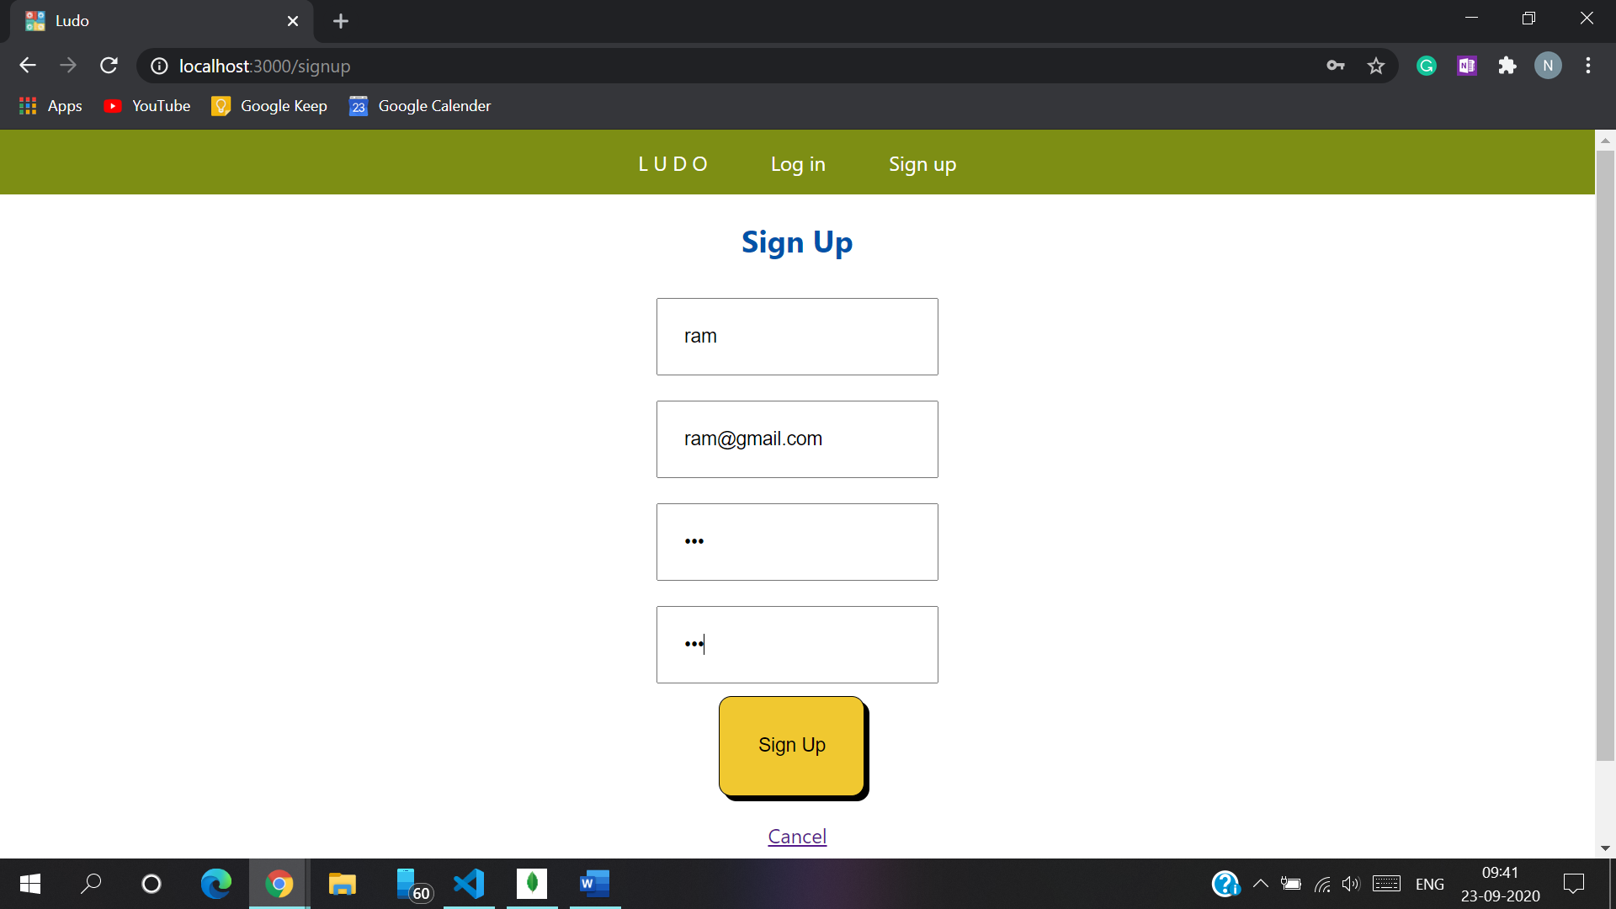

Ram details are inserted in users table

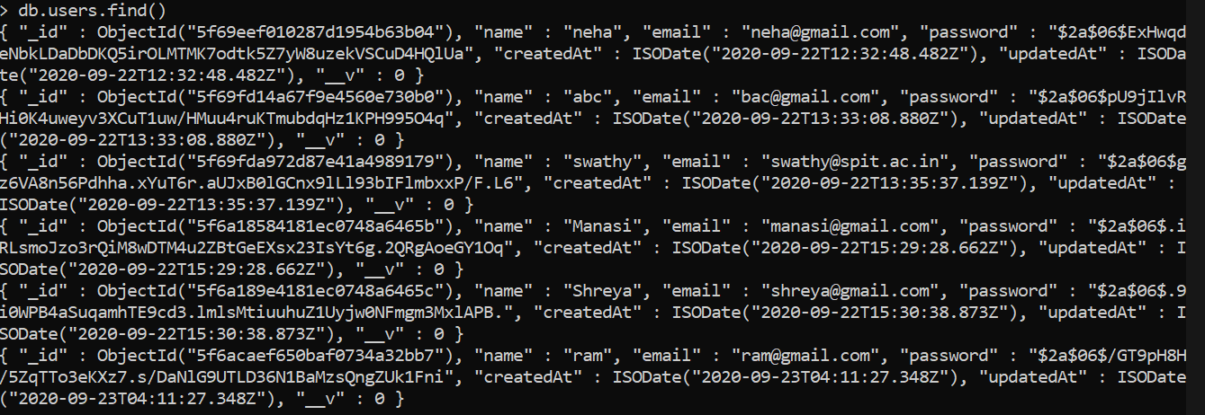

If the login credentials are incorrect, then the error is thrown showing Invalid Credentials

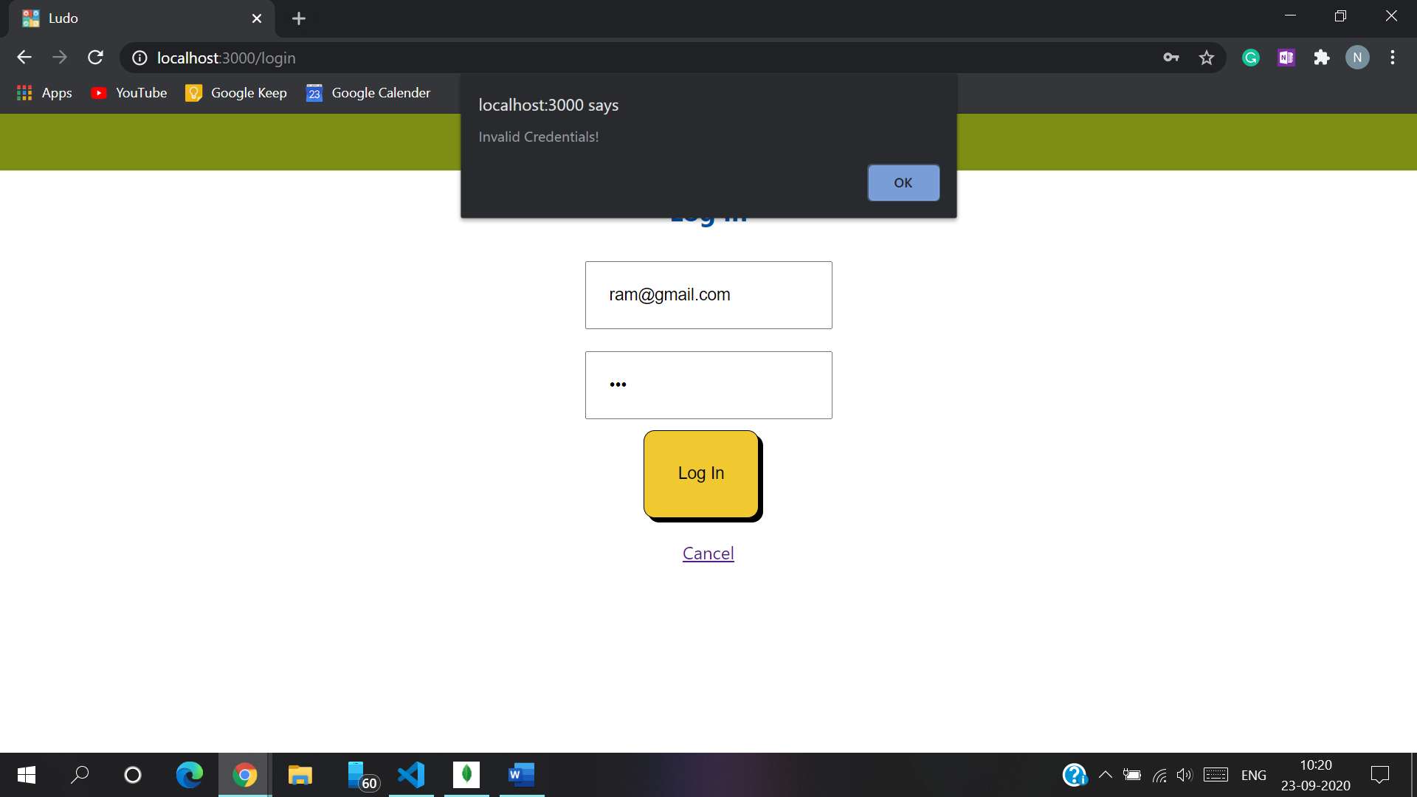

4 Players named Ram, Manasi, Neha, and Shreya have logged in.

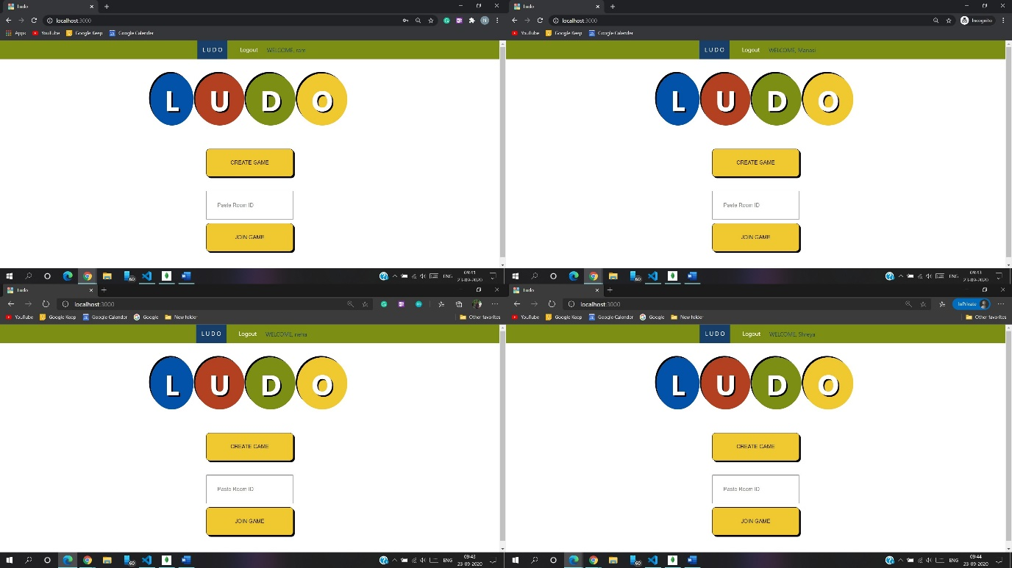

Ram creates game by clicking on “Create Game” Button. The code is generated to invite other players. He can share the code with his friends.

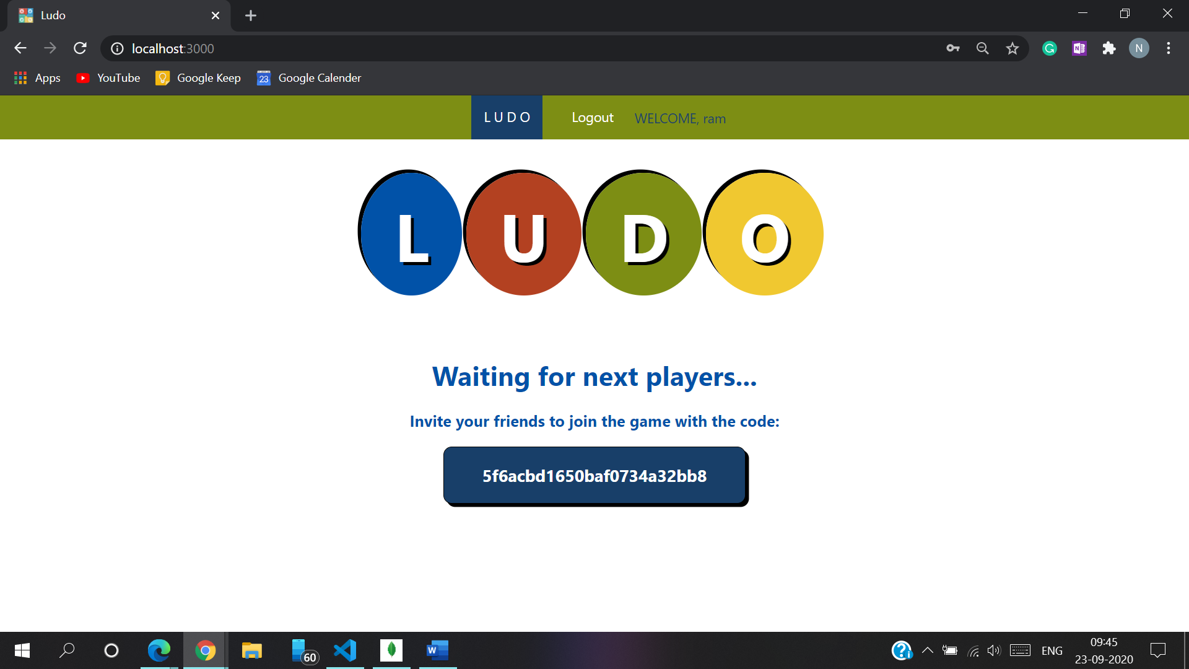

Other players will join by the code mentioned above

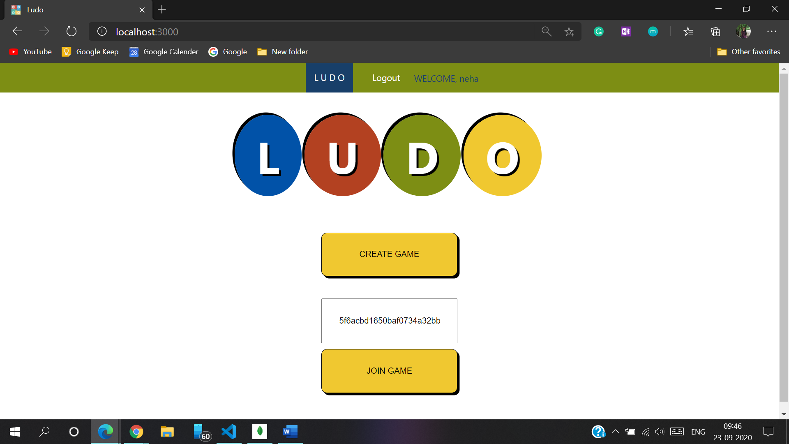

All the players have joined the game by the code shared by Ram

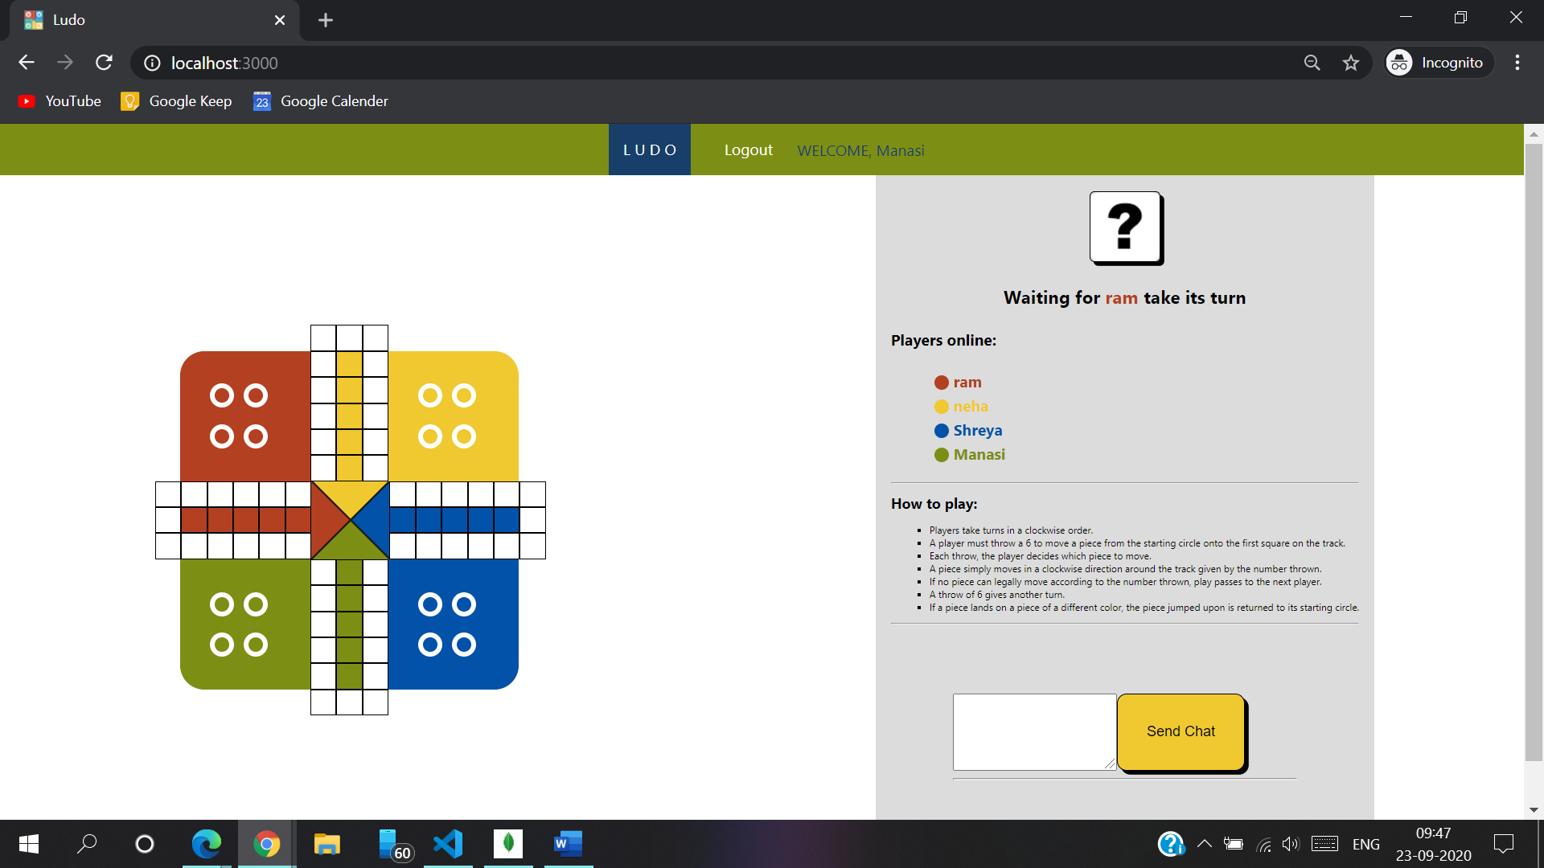

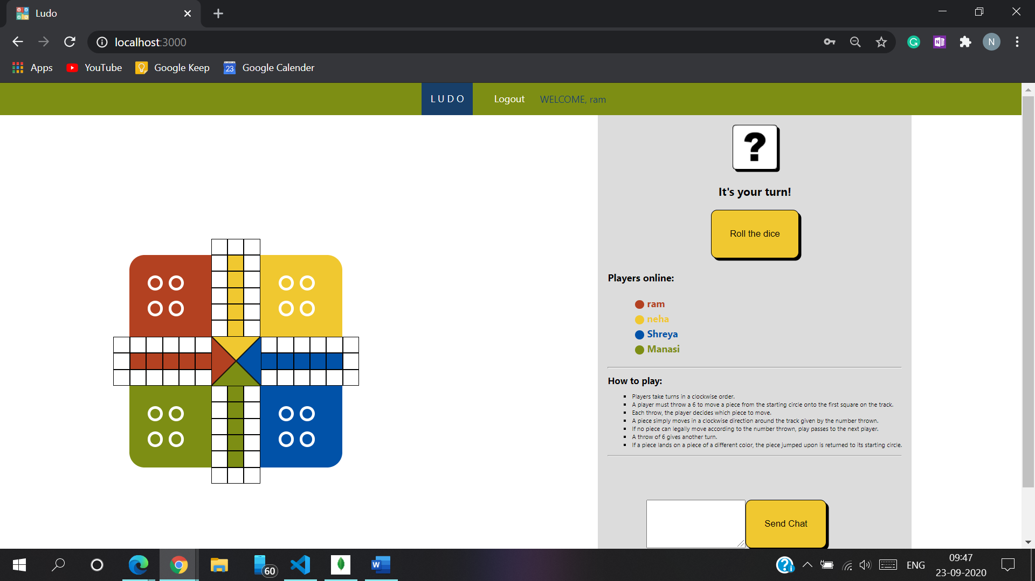

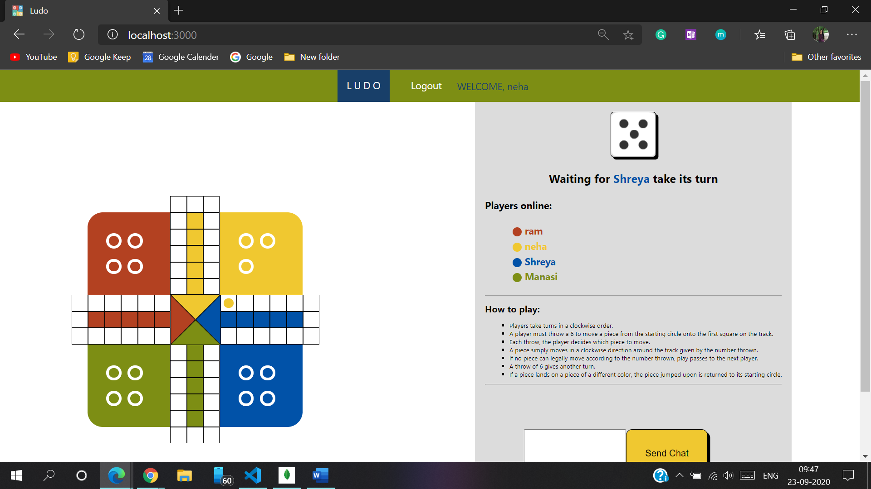

While playing, all the players can chat with each other.

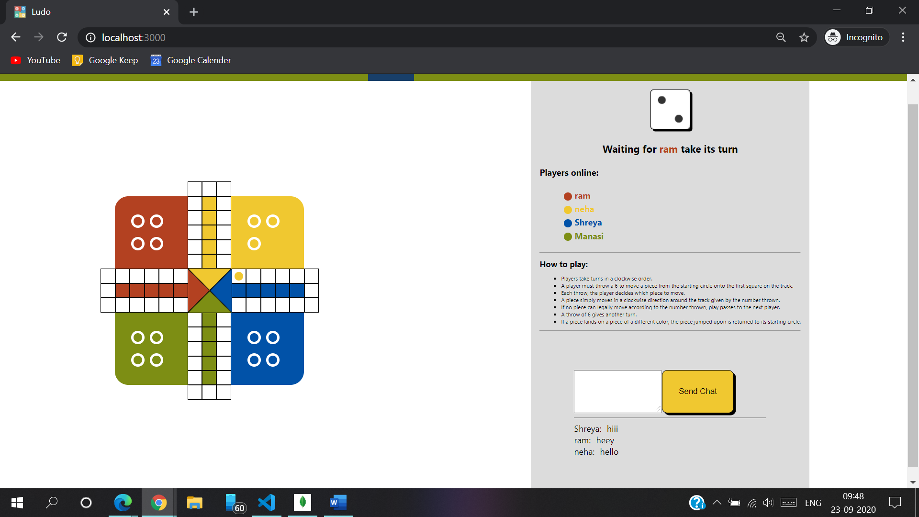

This is the existing records in the games table

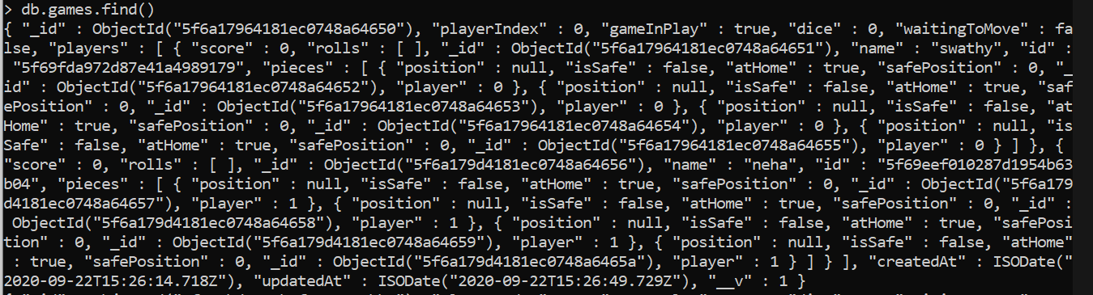

New records are getting inserted after every new game

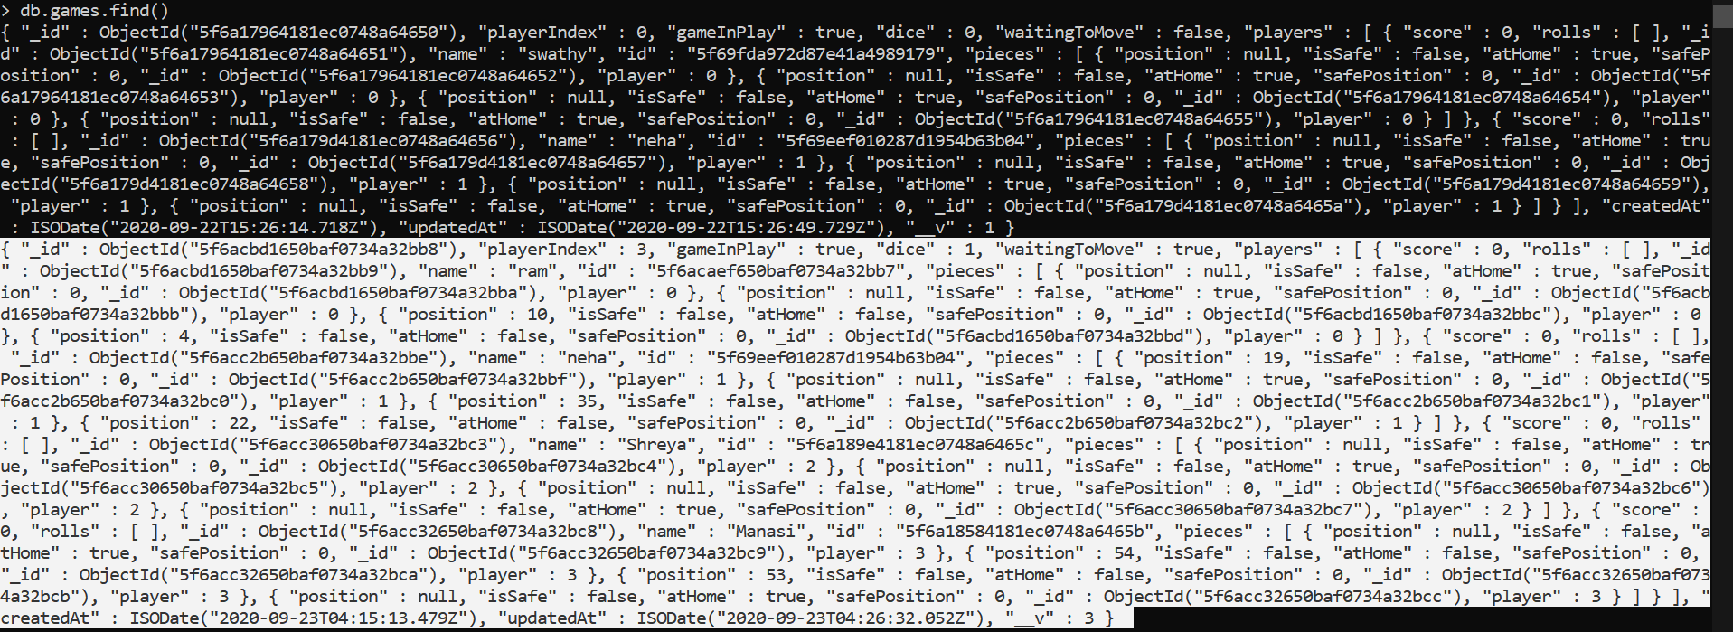

**Conclusion:**

By applying the concepts of socket programming, we have implemented multiplayer Ludo Game.