**Shreyaa Darakh**

**J009**

**B.Tech (Data Science) – 3rd Year**

**J1 Batch**

# Practical- 4

**Aim:**

To display images from various datasets for base of image classification.

**Observations:**

1. On the **CIFAR10 dataset**, following results were obtained:

Data was split as:

Train: X=(50000, 32, 32, 3), y=(50000, 1)

Test: X=(10000, 32, 32, 3), y=(10000, 1)

1. On the **CIFAR100 dataset**, following results were obtained:

Data was split as:

Train: X=(50000, 32, 32, 3), y=(50000, 1)

Test: X=(10000, 32, 32, 3), y=(10000, 1)

1. On the **MNIST dataset**, following results were obtained:

Data was split as:

Train: X=(60000, 28, 28), y=(60000,)

Test: X=(10000, 28, 28), y=(10000,)

1. On the **Fashion-MNIST dataset**, following results were obtained:

Data was split as:

Train: X=(60000, 28, 28), y=(60000,)

Test: X=(10000, 28, 28), y=(10000,)

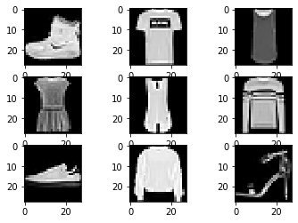

**Inference:**

Learnt how to work with different datasets and display image from the pixel datasets for image classification.