TASK: 1
Create a Digital Literacy Awareness Infographic
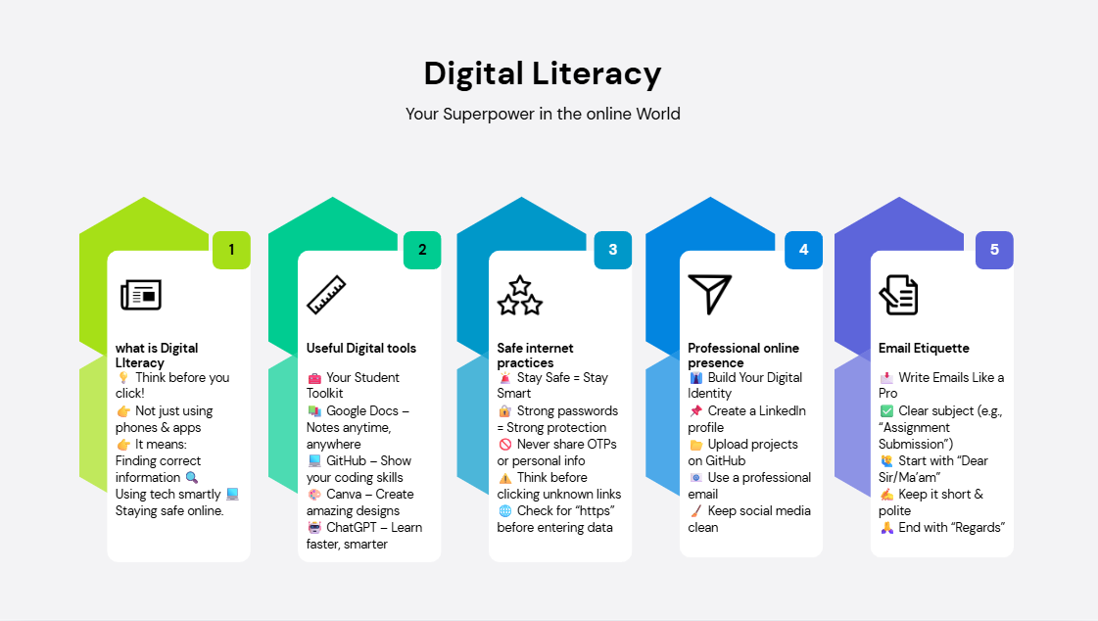
For this task, I created an informative and visually appealing infographic on the topic “Digital Literacy – Your Superpower in the Online World” using Canva. The purpose of the infographic was to spread awareness about the importance of digital literacy among students and encourage responsible online behavior.
The infographic is divided into five key sections: understanding digital literacy, useful digital tools, safe internet practices, professional online presence, and email etiquette. Each section highlights essential points such as thinking before clicking, using tools like Google Docs and GitHub, creating strong passwords, and maintaining a professional digital identity. I used simple language, icons, and colors to make the content easy to understand and engaging.
This task helped me understand how to present information effectively and creatively. It also improved my awareness of online safety and the importance of responsible digital behavior in today’s world.
---------------------------------------------~------------------------------------------------
TASK: 2
Student Digital Portfolio
In For my digital portfolio, I chose platforms like LinkedIn, GitHub, and Kaggle to showcase my skills and build a strong online presence.
LinkedIn is a professional networking platform where I created my profile to highlight my education, skills, and achievements. It helps in connecting with professionals and exploring internship and job opportunities. GitHub is used to upload and manage coding projects. By sharing my work here, I can demonstrate my programming skills to recruiters and collaborate with other developers. Kaggle is mainly used for data science and machine learning. It allows me to practice on real datasets, participate in competitions, and improve my analytical skills.
These platforms will be very helpful for my future as they create a digital identity and act as an online portfolio. They will increase my visibility to recruiters, help me gain practical experience, and build credibility in my field. Overall, this task helped me understand the importance of maintaining a professional digital presence.
~~~~~~~~~~~~~~~~~~~~~~~~~~~~~~~~~~~~~~~~~~~~~~~~~~~~~~~~~~~~
TASK: 3
Coding & Collaboration Platforms
For this task, I used LeetCode to practice and improve my programming and problem-solving skills. I solved multiple coding problems and tracked my progress through my profile, which I also included as a screenshot in my submission.
LeetCode is an online platform designed to help students prepare for technical interviews and strengthen their understanding of data structures and algorithms. It provides a wide range of problems from easy to hard levels, allowing gradual learning and skill improvement. During this task, I practiced problems related to arrays, logic building, and basic algorithms, which helped me enhance my coding efficiency and thinking ability.
This platform is very beneficial for my academic growth as it strengthens my core programming concepts, which are essential for subjects like Data Structures and Algorithms. It also prepares me for coding interviews and competitive programming. Regular practice on such platforms improves logical thinking, speed, and accuracy.
Overall, this task helped me understand the importance of consistent practice and how digital platforms can support continuous learning and skill development in a structured way
~~~~~~~~~~~~~~~~~~~~~~~~~~~~~~~~~~~~~~~~~~~~~~~~~~~~~~~~~~~~~
TASK: 4
Email & Etiquette Guide
Email etiquette refers to the set of guidelines that help us write clear, polite, and professional emails. It is an important part of digital communication, especially in academic and professional environments. A good email should always include a clear subject line that reflects the purpose of the message. It should begin with a proper greeting and maintain a respectful tone throughout.
The content of the email should be concise and well-structured, avoiding unnecessary details. Proper grammar, punctuation, and spelling are essential to make the email look professional. It is also important to avoid using informal language, slang, or excessive abbreviations.
Before sending an email, one should always review it to check for errors or missing information. Ending the email with a polite closing and your name is also necessary. Following proper email etiquette creates a positive impression and ensures effective communication.
~~~~~~~~~~~~~~~~~~~~~~~~~~~~~~~~~~~~~~~~~~~~~~~~~~~~~~~~~~~~~~~
TASK: 5
Cybercrime Awareness Case Study & Prevention Guide
While working on this digital literacy project, the most surprising thing I discovered was how common and advanced online threats like phishing and UPI fraud have become. I realized that even small mistakes, such as clicking on unknown links or sharing personal information, can lead to serious consequences. This made me more aware of the risks present in everyday online activities.
One important habit I will personally change is being more cautious while using the internet, especially during online transactions and while opening emails or messages. I will make sure to verify sources before trusting them and avoid sharing sensitive information unnecessarily. I will also focus on using strong passwords and enabling security features like two-factor authentication.
This project has made me more responsible as a digital user and has encouraged me to follow safe practices consistently. It has also motivated me to spread awareness among others about staying safe online.
~~~~~~~~~~~~~~~~~~~~~~~~~~~~~~~~~~~~~~~~~~~~~~~~~~~~~~~~~~~~~~~

